Project Documentation

1. First, download Python latest version and the builds for the Tkinter modules

**Note**:

For Windows users −

pip install tkinter

or

pip install tk

For Linux or Mac users −

apt-get install python-tk

1. Second, create and activate the Python Virtual environment

**Code**:

Python3 -m venv venv

Source ./venv/bin/activate

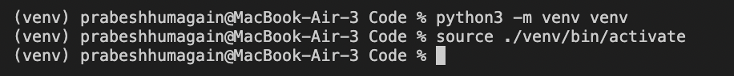

1. Next, Install all the requirements from the requirements.txt file

**Code**

pip install -r requirements.txt

1. Run the Python file

**Code**

Python car-rental-app.py

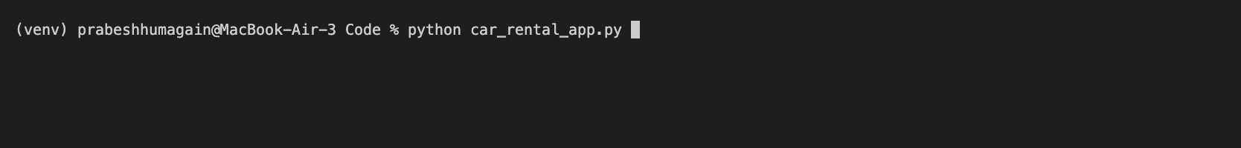

1. Afterwards, you should be able to see the GUI interface as below

