**Asynchronous Programming**

* **Asynchronous programming** is a means of parallel **programming** in which a unit of work runs separately from the main application thread and notifies the calling thread of its completion, failure or progress.
* There Are Few Ways To Work With Async Code:
  + Callbacks
  + Promises
  + Async / Await

**# AJAX**

* Asynchronous Javascript & XML.
* Set of Web Technologies.
* Send & Receive Data Asynchronously.
* Does Not Interfere With The Current Page.
* JSON Has Replaced XML For The Most Part.
* Make Async Requests In The Background.
* 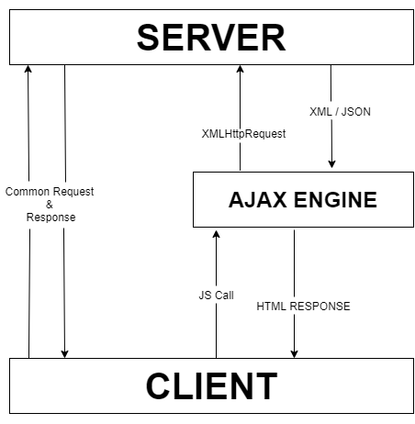No Page Reload / Refresh
* Fetch Data
* Very Interactive

**# XMLHttpRequest (XHR)**

* API in the form of an object.
* Provided by the browsers JS environment.
* Methods to transfer data between client / server.
* Can be used with other protocols than HTTP.
* Can work with data other than XML (JSON, plain text)
* Other Methods
  + Fetch API
  + Axios
  + Superagent
  + jQuery
  + Node HTTP

**# API**

* Application Programming Interface.
* Contract Provided By One Piece of Software To Another.
* Structured Request and Response.

**# REST**

* Representational State Transfer.
* Architecture Style For Designing Networked Applications.
* Relies on a stateless, client-server protocol, almost always HTTP.
* Treats server objects as resources that can be created or destroyed.
* Can be used by virtually any programming language.
* All APIs have their own rules and structure.