英文资料翻译
基于伪标签的半监督语义分割研究进展（译文）
Lingyan Ran，Yanya Li，Guoqiang，Yanning Zhang
西北工业大学计算机学院

摘要—语义分割是计算机视觉中一个重要而热门的研究领域，其重点是根据图像中像素的语义对其进行分类。然而，监督式深度学习需要大量的数据来训练模型，并且逐像素标记图像的过程既耗时又费力。本文旨在对半监督语义分割领域中伪标签方法的最新研究成果进行全面和有组织的综述，从不同的角度对其进行分类，并针对具体的应用领域提出具体的方法。此外，我们还探索了伪标签技术在医学和遥感图像分割中的应用。最后，针对目前存在的挑战，提出了未来可行的研究方向。

1.介绍
语义分割是计算机视觉领域中对图像中每个像素进行分类的重要研究方向，在医学图像分割[Li等人，2023a]和遥感图像分割[Wang等人，2022]等特定领域有着广泛的应用。在过去的几年里，许多工作在提高语义分割任务的有效性方面取得了重大进展。然而，由于监督式深度学习需要大量的数据来训练模型，并且逐像素标记图像的过程既耗时又费力。研究指出，对cityscape数据集中的一张精细标记图像进行注释需要花费数小时[Cordts等人，2016]。由于训练标签的成本，完全监督模型的性能可能无法得到显著提高。近年来，通过大量的相关研究，半监督学习已被应用于语义分割。
伪标签方法是半监督学习领域的一种知名技术，首次出现在[lee等人，2013]中，并在最近的计算机视觉研究中得到了普及，包括领域自适应[Li等人，2023b]，语义分割[Wu等人，2023]等。这些方法因其简单和令人深刻的性能而收到青睐。
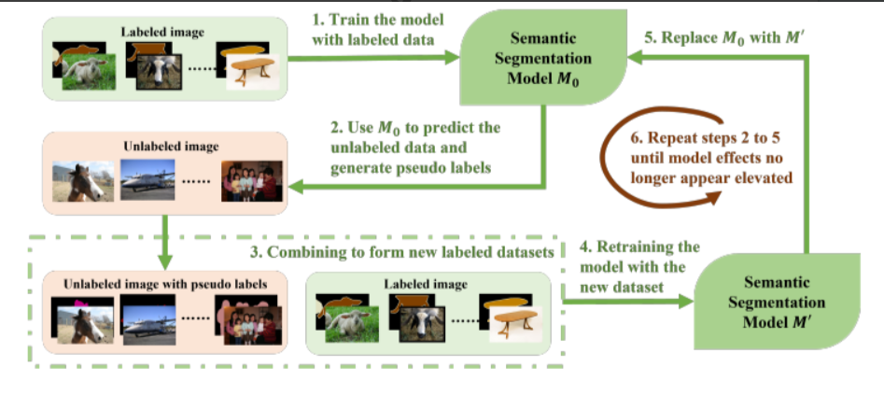
图1：伪标签法半监督语义分割最简单的过程。伪标签的获取和鉴定是该框架的主要关注点
该过程如图1所示。在语义分割中，伪标签方法被认为是一种比一致正则化更可靠的选择，而一致正则化可能受到不同程度的数据增强的影响。伪标签技术以其稳定性，可解释性和易于实现而闻名，使其成为一个具有越来越大潜力的研究领域。
在半监督域中使用伪标签方法已经进行了广泛的研究。然而，目前的一项调查[Pelaez-Vegas等人, 2023]仅仅对半监督语义分割技术进行了系统的分类，缺乏对伪标签方法的详细总结和分析。这一不足促使我们进行一项调查。
我们调查的主要目的是对最近的研究提供一个全面和有组织的总结，根据不同的观点对研究进行分类，并为特定的应用领域提出具体的方法。我们的主要贡献是:1.本文对半监督语义分割的伪标签方法的最新进展进行了综述。2.具体来说，我们研究了伪标签方法的三个关键方面，包括模型结构的设计、伪标签的改进和优化技术。3.此外，我们还讨论了该领域存在的需要关注的挑战，并提出了未来研究的潜在方向。

2.初步和问题表述

问题定义
在半监督语义分割的背景下，目标是通过考虑标记和未标记的数据集来最小化损失。标记的数据集，表示为D_{l}={(x_{l},y_{l})}^{p}，由p个具有相应标签的样本组成。未标记数据集，记为D_{u}={x_{u}}^{q},由q个图像组成，其中q显著大于p。损失函数L定义为两项的和:L^{l}表示标记数据集的损失，L^{u}表示未标记数据集的损失
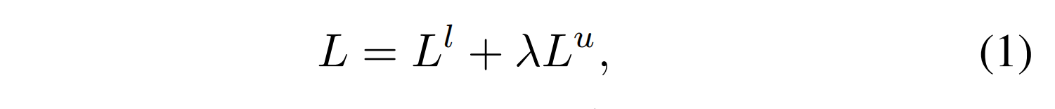
其中λ 表示平衡权衡的超参数。该超参数既可以事先指定一个固定值，也可以在训练过程中自适应调整。有监督损失L^{l}通常是指预测输入与相应的y^{l}之间计算的交叉熵损失，而无监督损失L^{u}可以根据所使用的具体方法采取各种形式。
最简单的伪标签方法是:首先，我们使用交叉熵损失L^{l}在标记数据集上D^{l}上训练初始模型M₀，在这个训练过程为标记的数据集D_{u}生成一个伪标记数据集$\check{D}$_{u=}{(x_{u},M₀(x_{u}))}^{q}，其中M₀(x_{u})表示x_{u}的伪标签。接下来，我们将标记数据集D_{l}与伪标签数据集$\tilde{D}$_{u}结合起来，形成一个综合数据集D=(D_{l}$\bigcup{\tilde{D}}$_{u})。最后，我们使用完整数据集D训练一个新模型M。上述简单的过程可以迭代执行，以不断提高生成的伪标签的质量。

数据设置
表1概述了几种常用的数据集，这些数据集在各种场景中都有应用。通常，使用5%、10%等比率选择那些完全注释的图像进行半监督学习。
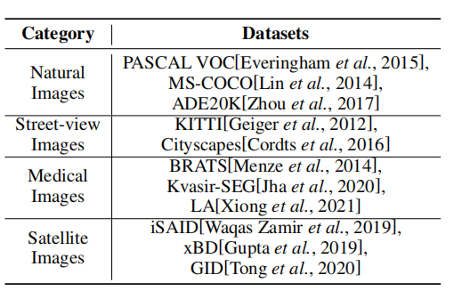
表1：半监督语义分割领域中常用数据集的汇编。

评价指标
•像素精度计算正确分类像素到像素总数的比例。虽然这个度量是简单和直观的，但当类别中存在不平衡时，它可能不能准确地反映模型的性能。
•Mean Accuracy考虑到每个类别的像素精度，并计算平均值以解决类别不平衡的问题。
•平均IoU计算所有类别的预测和实际情况之间的平均交集(mIoU):
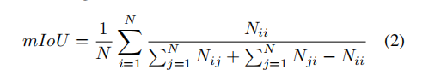
其中N为类别数，Nii为类别i的P(真阳性)数，Nij为类别i和j的F(假阳性)数，Nji为类别j和i的F N(假阴性)数。
•在某些类别需要给予更多重视的情况下，加权借据被用作对mIoU度量的修改。

3.分类
借鉴先前研究[Pelaez-Vegas等人, 2023]中对网络结构的伪标签方法分类，以及研究人员[Tarvainen and Valpola, 2017]对Mean Teacher结构的创新改进，我们的研究将集中在三个主要领域:基于模型的视角、伪标签的改进和优化措施。图2给出了各种伪标签技术的全面概述。
模型的视角。从本质上讲，生成伪标签的各种方法可以分为两类:单模型族和互模型族。图2 (a)说明了基于单一模型的方法，其中由单个模型生成的伪标签用于监督后续训练。例如，在MeanTeacher方法中，使用教师模型生成的伪标签来训练单个模型，其中包含一致性正则化。另一方面，基于多模型相互训练的方法旨在通过联合训练多个模型来提高模型性能。图2 (b)描述了这种方法，其中初始化了两个不同的网络，一个模型通过在未标记的数据上提供伪标签来监督另一个模型的训练。两种模型的交叉监督有助于定位和最小化伪标签中的错误。
伪标签的细化。我们将讨论对传统体系结构的增强，重点是改进伪标签以生成特定的标签。此外，我们将根据伪标签是否改变将这些改进伪标签的方法分为两组:标签更新和仅过滤。伪标签细化的简化架构如图2 (a)和(b)的蓝色区域所示。
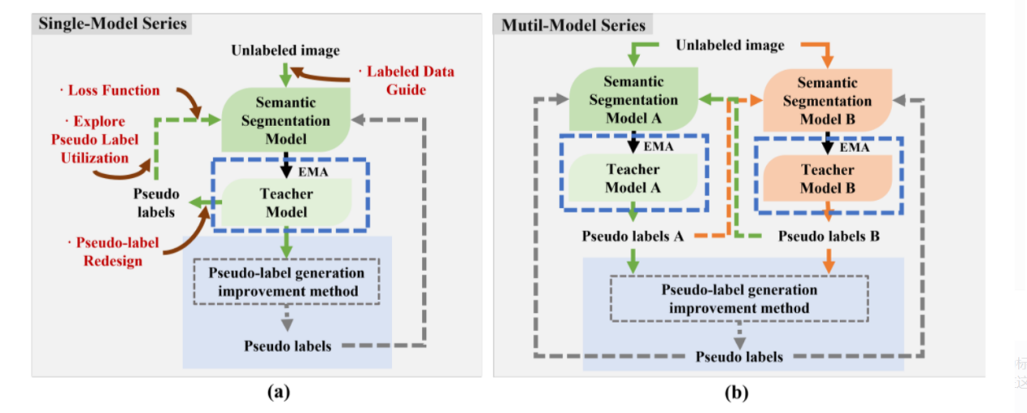
图2:主要分类的摘要。我们的回顾分为三个主要类别:生成模型(子图a和b)，伪标签的增强(蓝框)和优化的视角(暗红色箭头)。在伪标签生成的范畴内，我们研究了两种方法:单模型和多模型序列。此外，还采用了各种策略来选择或改进伪标签。最后，优化方法在这个领域也变得越来越流行。
优化。最后，我们还研究了一些新兴的优化技术，在图2 (a)中以暗红色表示。对这些方法的进一步阐述将在以下部分提供。

4.半监督语义分割的伪标签
在本节中，我们总结了表2中提到的基于伪标签的半监督语义分割的所有方法。
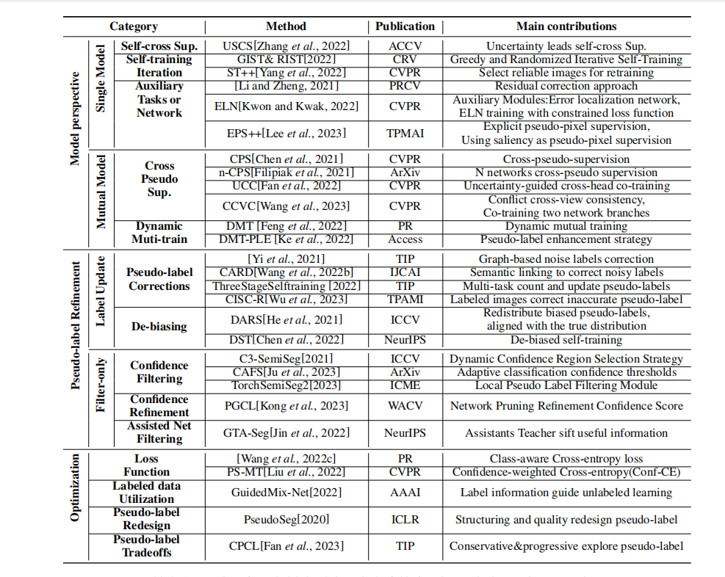
表2：半监督语义分割领域的伪标签技术综述

4.1模型视角
架构在深度学习中的重要性不能被夸大，因为它建立了这些模型中使用的神经网络的框架和布局。该架构在决定网络如何操纵和分析输入特征方面起着至关重要的作用，从而影响模型学习和生成精确预测的能力。选择合适的体系结构是构建成功的深度学习模型的重要方面。在本小节中，我们将研究有关单一模式家庭和协作互助模式家庭的论文。
Single-Model-Based方法
单模型自我训练方法最早由Yarowsky [Yarowsky, 1995]提出。后来，[Lee等人，2013]建议将自我训练与使用伪标签的神经网络结合起来。由于最初的单模型自我训练方法很简单，后续的研究集中在增强该网络结构的不同方面。自我训练迭代。GIST和RIST [Teh等人，2022]，可以解释为贪婪算法策略(GIST)和后续迭代自我训练策略(RIST)，在基础真理和伪标签之间交替。从自训练迭代的角度提出的另一种方法是st++ [Yang et al .， 2022]，其关键步骤是在迭代过程中选择性再训练。由于在监督训练阶段，分割性能与生成的伪标签的进化稳定性呈正相关，因此可以在训练过程中通过进化选择更可靠的未标记图像。稳定性指标基于每个早期伪掩码和最终掩码之间的平均IOU:
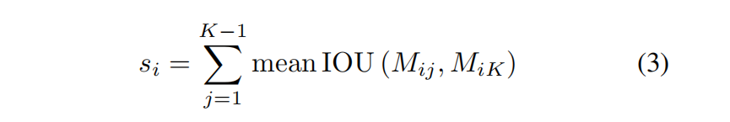
然后获得所有未标记图像的稳定性分数，并对整个未标记集进行排序，选择得分最高的R张图像进行第一阶段的再训练。st++基于可靠性的渐近变化预测鲁棒性，从而消除了手动选择逐像素滤波的置信阈值的需要。
选用性能监督。[Zhang等人，2022]提出了一种称为不确定性引导自交叉监督(USCS)的半监督语义分割方法。该方法利用多输入多输出(MIMO)分割模型的结果进行自交叉监督，从而显著降低了参数和计算成本。
辅助任务框架。由于伪标签方法的另一个关键是建立辅助任务框架监督，因此从这个角度提出了一些方法。此前，[Li and Zheng, 2021]引入残差网络来扩展自训练结构。标记的数据被送入辅助残差网络，以预测原始分割结果的残差。虽然后来提出的ELN [Kwon and Kwak, 2022]主要是帮助定位错误，但辅助模块被训练来识别可能不正确的像素点。图像和分割结果作为输入。具体的ELN结构包括主分割网络(编码器和解码器)和辅助解码器(D1, D2，…)。DK)。主分割网络采用标准交叉熵损失训练，辅助解码器采用受限交叉熵损失训练:
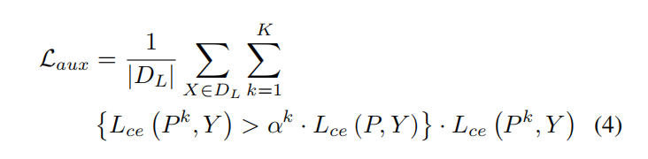
因此，辅助解码器的表现将比主解码器差得多，因为它包含各种错误，然后将其用作ELN的输入，以训练ELN定位标记错误，类似于手动创建一些错误数据进行训练。EPS++[Lee et al .， 2023]通过显著性检测模型生成的显著性图提供丰富的边界，并结合图像级标注信息进行联合训练，辅助模型从像素级反馈进行训练。
多模型方法
几种半监督学习方法依赖于伪监督，特别是产生伪标签的自训练方法。然而，在自我训练中，单个模型生成的伪标签往往是不可靠的。这是因为通常只使用单个模型的预测置信度来过滤掉低置信度的伪标签，这可能会留下高置信度的错误并浪费许多低置信度自信正确的标签。双模型互训练方法针对单模型自训练方法固有的问题，即单个模型无法检测和纠正其错误，可能导致偏差的积累，最终影响训练和分割效果，提出了两个或多个模型根据差异相互训练，对其错误进行局部化，并相互纠正的互训练[Zhang等人， 2018]。
交叉伪监督。经典的交叉训练视角是双模型交叉监督，如CPS [Chen等人，2021]方法对两个网络使用不同的初始化方法，其中一个网络输出的伪标签监督另一个分割网络。随后提出的n-CPS [Filipiak等人，2021]是将CPS扩展到n个子网络的结果，实验表明，网络集成显着提高了性能。在交叉监督的基础上，[Fan等人，2022]引入了不确定性引导监督，提出了UCC (uncertainty-guided Cross-head Co-training of Cross-head)，通过共享编码器进一步提高了泛化能力。[Wang等人，2023]设计了一个基于冲突的交叉尝试一致性(CCVC)来强制两个子网从不相关的视图中学习知识。他们提出了一种新的交叉视图一致性策略，以鼓励两个结构相似但不共享参数的子网从相同的输入图像中学习不同的特征。他们引入了特征差损失来实现这一点。对于未标记的数据，他们使两个子网使用彼此的伪标签进行模型学习。
动态Muti-training。除了同步训练的交叉监督外，其他研究人员还提出了基于双网络结构的动态相互训练，其中两个网络是异步训练的。DMT [Feng et al .， 2022]指出单个模型很难克服自身的误差。因此，他们使用两个具有不同初始化的模型，其中一个模型为另一个模型生成离线伪标签。为了有效地训练机器学习模型，识别标签错误非常重要。他们通过比较两种不同模型的预测并量化它们之间的差异来做到这一点，这样他们就可以在训练期间动态调整减重，以提高模型的准确性。动态损失率W_{u}定义如下:
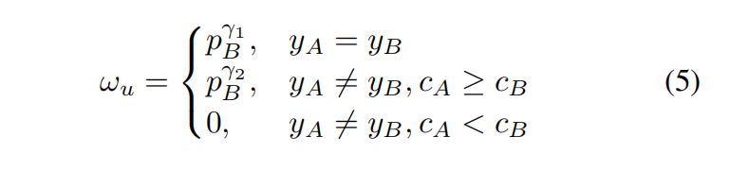
针对伪标签技术中的噪声问题，DMT方法提出给样本分配不同的权重，而不是丢弃它们。该方法旨在保留低置信度数据，但它可能无法有效解决伪标签方法中高噪声率的问题。此外，神经网络的“灾难性遗忘问题”无法完全解决，因为这些网络的基本组成部分是由固定的结构和参数组成的。但是，可以通过各种缓解技术降低这个问题的严重性。DMT-PLE[Zhou等人, 2022]方法扩展了伪标签增强策略从之前的DMT方法，主要是为了上述目的。他们提到，当处理具有不同类型的多个像素的输入时，模型保留它所学到的知识是具有挑战性的。为 了防止模型对最后学习到的类别产生偏见，他们使用了一种称为伪标签增强(PLE)的策略。该技术利用前一阶段模型生成的伪标签来细化当前模型生成的伪标签。

4.2伪标签微调模型
伪标签更新方法
伪标签方法有时会导致在训练过程中出现不正确的预测或包含不准确的伪标签，这会导致错误的积累，使学习到的伪标签无法指导后续的学习，最终影响分割模型的训练结果。为了解决这一问题，一些研究提出了更新伪标签的方法来缓解噪声问题，并取得了良好的效果。
伪标签修正
一开始，一些作品将该任务表述为像素级标签噪声的学习问题。Yi等人[2021]引入了一种基于图的标签噪声检测和校正框架，该框架利用类激活图(CAMs)生成的像素级标签作为弱标注噪声标签，训练强标注分割模型从上述噪声标签中检测干净标签，然后使用干净标签监督图注意(GAT)网络对噪声标签进行校正。然后使用干净标签监督图注意网络对噪声标签进行校正。同样，为了解决有噪声的标签校正问题，[Wang等人，2022b]提出了一种基于图像特征之间可靠语义关联的类别独立关系网络来校正标签。他们通过增加特征之间的关系来获得相关估计。为了有效地校正噪声标签，弱相关性的预测被丢弃。
与上述方法的观点不同，一些改进方法从训练阶段开始。Ke等人[2022]提出了一种ThreeStageSelftraining方法，他们试图通过三个阶段的自我训练来提取未标记数据的初始伪标签信息，同时以多任务方式强制分割一致性，以生成更高质量的伪标签。除了上述传统补救措施外，[Wu等人， 2023]考虑到同类样本具有高像素级对应性，提出了使用标记图像校正噪声伪标签的CISC-R方法。受st++的启发[Yang等人，2022]，他们使用了一种基于ciscc的图像选择方法，该方法考虑了类间特征差异和在训练开始时纠正噪声伪标签的难度。首先，对于每个类别k，使用初始模型从标记图像集中提取该类的锚向量ak l:
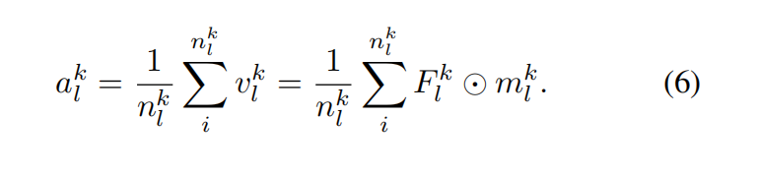
通过这个平均生成，生成一个ak l来表示标记图像的分类锚点。具体来说，通过标记图像x的ak l与高级特征之间的余弦相似度生成CISC映射m '。
消除偏差 训练中的偏差既来自网络本身，也来自对可能不正确的伪标签的不当训练，这些伪标签会在迭代过程中积累误差。[He等人，2021]提出了分布式对齐和随机抽样(Distributed Alignment and Random Sampling, DARS)方法，这是一种简单有效的方法，可以重新分配有偏差的伪标签，使伪标签与真实情况对齐，并提高噪声标签对训练的影响。将它们的分布与真实分布对齐可以改进半监督语义分割。随后，为了最小化偏差，Chen等人[2022]建议进行去偏见自我训练(DST)。该方法的关键在于两个参数无关的分类器头将伪标签的生成和利用过程解耦，只使用干净的标签进行训练，提高了伪标签的质量。
伪标签过滤方法
此外，一些研究人员提出通过过滤带有噪声的伪标签来增强分割效果，这些方法没有对带有噪声的标签进行更新。
置信度阈值。Zhou等人[2021]提出了C3SemiSeg，它提出了一种动态置信区域选择策略，专注于高置信区域进行损失计算。此外，还结合了交叉集对比学习来提高特征表示。然而，为了解决现有的基于高置信度的伪标签方法丢失大部分信息的问题，Ju等人[2023]提出了一种用于半监督语义分割的类自适应半监督框架(CAFS)，该框架允许在标记的数据集上构建验证集，以利用每个类的校准性能。这包括一个核心操作:自适应逐类置信阈值(ACT)，它不再强调使用校准分数来自适应地调整可靠性置信阈值。最近，TorchSemiSeg2[Chen等人，2023]引入了一个局部伪标签过滤模块，使用鉴别器网络来评估区域级伪标签的可靠性。他们还提出了一种动态区域损失校正，以进一步评估使用网络多样性的伪标签的可靠性，并评估网络的收敛方向。
置信度提炼。由于前面提到的许多工作大多基于置信度阈值来评估伪标签数据，因此在训练开始时存在的置信度模糊问题可能在很大程度上限制了后续的更新。最近，Kong等人引入了PGCL[2023]，其目的是解决网络剪枝中模糊置信度分数的问题，通过使用粗糙策略，从简单到困难的例子逐步训练网络。
辅助网络过滤。此外，有些方法利用辅助结构进行过滤操作。例如，GTA-Seg[Jin等人，2022]选择了一种辅助结构，称为温和的教学助理。GTA直接从教师网络生成的伪标签中学习，只将过滤后的有利信息传递给学生网络，以协助监督学生网络的训练。

4.3优化方法
除了上述方法外，一些研究人员还提出了独特的优化技术来提高分割结果。这些技术包括损失函数改进、伪标签重新设计等。
损失函数。Wang等人[2022c]建议通过感知交叉熵(CCE)和渐进式交叉训练(PCT)来提高伪标签的质量。CCE比传统的交叉熵更能简化伪标签的生成。PCT逐渐引入高质量的预测作为对网络训练的额外监督。PS-MT[Liu等人， 2022]采用更严格的置信度加权交叉熵(Conf-CE)来解决交叉熵损失训练容易过拟合预测误差的问题
标记数据利用率。值得注意的是，[Tu等人，2022]认为分别处理标记和未标记的数据通常会导致丢弃大量从标记示例中学习到的先验知识。因此，他们提出了一种名为GuidedMix-Net的方法，该方法通过使用标记信息来指导未标记示例的学习，从而学习更高质量的伪标签。类似地，我们前面提到的CISCR[Wu等人，2023]通过估计未标记图像与查询的标记图像之间的像素相似性并生成CISC地图来校正伪标签的像素级校正。
伪标签利用率。邹等人[2020]专注于伪标签的结构化和定性设计方法，并提出了一种单阶段一致性训练框架PseudoSeg，它从两个分支生成伪标签:分割模型的输出和类激活图(CAM)的输出。他们提出了一种伪标签重新设计策略，该策略通过校准的融合策略将来自两个源的伪标签组合在一起，即给
定一批解码器输出$\hat{p}$=f_{θ}(w(x))和基于弱增强数据w(x)计算的SGC映射，生成伪标签$\hat{y}$。
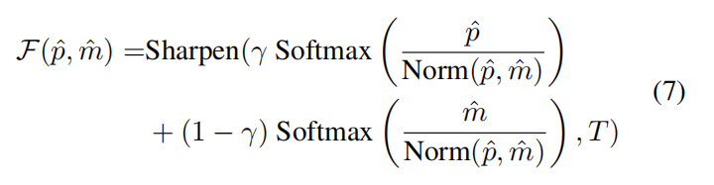
PseudoSeg通过实现一种新的伪标签重新设计策略来生成校准良好的高质量伪标签，从而促进随后的模型训练。对于有限的可用标记数据，校准良好的伪标签可以大大提高分割。为了进一步改进校准，他们建议探索多模态数据融合等先进技术。
[Fan等人，2023]从双模型相互训练的角度发展保守渐进式协作学习(CPCL)，其中保守分支使用高质量伪标签进行交叉监督，以实现基于保守协议的进化。渐进分支由一个union监督，利用大量的标签来实现对分歧的渐进探索。

5. 其他领域的伪标签方法

5.1 医学图像分割
由于缺乏足够的标签，医学图像分割是医学图像分析中一项非常困难的任务，该任务涉及识别CT或MRI图像中与器官或病变相对应的像素。许多研究已经提出使用伪标签，当应用于特定的医疗数据集时，产生了有希望的结果。在他们最近的工作中，[Huo等人，2021]引入了一种称为异步师生优化(ATSO)的新方法来挑战传统的学习策略。他们提出将未标记的训练数据分成两个子集，而不是交替训练两个模型。这种方法特别适用于3D医学图像，其中每个3D身体被分成代表冠状、矢状和轴向视图的2D切片。然后使用2D网络进行分割，并将结果输出堆叠形成3D体。半监督医学图像分割的一个常见问题是标记数据和未标记数据分布之间的差异。先前的研究主要是孤立地或不一致地处理标记和未标记的数据，这可能导致忽视从标记数据中获得的知识。在他们的研究中，[Bai等人，2023]提出了一种直接的方法来缓解这一问题，即使用称为BCP的Mean-Teacher模型在两个方向上合并标记和未标记的数据。

5.2 遥感图像分割
高分辨率遥感卫星图像的标记过程是一项需要大量时间和精力的任务。这个限制影响了分割模型的性能。为了解决这个问题，一些报告建议使用依赖于半监督学习的伪标签技术。这些方法旨在辅助遥感图像的分割。[Li等人，2023a]在论文中提出了一种提高有限样本高分辨率遥感图像分割精度的技术。他们通过使用两个网络(即UNet和DeepLabV3)来预测伪标签并有效地过滤它们来实现这一点。在他们最近的工作中，[Cui等人，2023]提出了一种利用双交换熵一致性和师生结构的新方法。由于存在多个类别，复杂的地形，类别之间的显著重叠以及模糊的特征，这项任务具有挑战性。为了解决这些挑战，作者将通道注意(CA)机制纳入教师编码网络。该CA模块有效地过滤了特征映射，抑制了噪声干扰，从而约束了特征提取，降低了编码网络产生的信息熵。

6. 挑战与未来展望
在进行彻底的检查后，很明显，伪标签技术已经冒险进入各种图像分割技术，产生显著的结果。尽管如此，本节将集中讨论伪标签方法在半监督语义分割中遇到的困难，并强调潜在的研究方向。
使用基础模型提高质量。基金会模型已经改变了人工智能，为知名的聊天机器人和生成式人工智能提供了动力。最近，一种名为Segment Anything model (SAM)的尖端交互式提示模型[Kirillov et al .， 2023]被集成到语义分割任务中。预计未来将利用SAM的提示功能，进一步提高伪标签的效率和有效性。
附加信息的利用。目前，低质量伪标签的使用仅限于单一类型的监督信号，而忽略了其他像素中存在的有价值的信息。因此，有机会将替代形式的监控信号集成到模型中，增强其有效利用粗标记和细标记数据的能力。我们预计未来的研究将通过采用更全面的监督方法来提高分割性能。
参与主动选择并完善过程。伪标签技术难以有效地解决有噪声数据的问题。主动学习等策略不是在整个数据集上训练模型，而是选择最具信息量的数据点的子集来查询额外的标签。这种方法更有效，成本效益更高，因为它允许模型从最有信息的例子中学习，而不需要对整个数据集进行标记。当主动选择和改进策略结合在一起时，未来看起来很有希望。
探索复杂的分割场景。将伪标签模型的应用扩展到更广泛的现实世界情况是至关重要的。虽然在理论研究方面取得了显著进展，但目前伪标签方法的使用仅限于特定的数据集，如PASCAL VOC 2012[2015]，其中仅包含20个常见的类别。为了推进这一领域，研究更好地代表现实生活场景的数据集是至关重要的。例如，ADE20K [Zhou等人，2017]包含超过150类对象信息，可以作为未来探索的更具代表性的数据集。

7.总结
我们是第一个对半监督语义分割领域的伪标签技术进行全面概述和分类的人。我们的分类是基于模型的观点，提炼伪标签的方法和创新的优化方法。此外，我们已经检查了各种伪标签技术用于医学和遥感图像分割。最后，我们确定了这一领域当前的障碍，并提出了潜在的未来方向。我们也提出了解决这些挑战的研究途径。
英文资料翻译
Semi-Supervised Semantic Segmentation Based on Pseudo-Labels: A Survey（原文）
Lingyan Ran , Yali Li , Guoqiang Liang , Yanning Zhang
School of Computer Science, Northwestern Polytechnical University

Abstract—Semantic segmentation is an important and popular research area in computer vision that focuses on classifying pixels in an image based on their
semantics. However, supervised deep learning requires large amounts of data to train models and the process of labeling images pixel by pixel is timeconsuming and laborious. This review aims to provide a first comprehensive and organized overview of the state-of-the-art research results on pseudo label methods in the field of semi-supervised semantic segmentation, which we categorize from different perspectives and present specific methods for specific application areas. In addition, we explore the application of pseudo-label technology inmedical and remote-sensing image segmentation.Finally, we also propose some feasible future research directions to address the existing challenges.

1.INTRODUCTION
Semantic segmentation is an important and well-received research area in the field of computer vision to classify every pixel in an image, and it has a wide range of applications in specific areas such as medical image segmentation [Li et
al., 2023a] and remote sensing image segmentation [Wang et al., 2022a]. Over the past few years, many works have made significant progress in improving the effectiveness of semantic segmentation tasks. However, supervised deep learning requires large amounts of data to train models and the process of labeling images pixel by pixel is time-consuming and labor-intensive. Studies have pointed out that it takes hours to annotate just one finely labeled image from the Cityscapes dataset [Cordts et al., 2016]. The performance of fully supervised models may not be able to be improved significantly due to the cost of training labels. In recent times, semi supervised learning has been applied to semantic segmenta tion through numerous associated research studies.
The pseudo-label method is a well-known technique in the semi-supervised learning field that first appeared in [Lee and others, 2013] and has gained popularity in recent computer vision research, including domain adaptation [Li et al., 2023b], semantic segmentation [Wu et al., 2023], etc., which are favored for their simplicity and impressive performance.

Figure 1: The plainest process of semi-supervised semantic segmentation with pseudo-label method. The acquisition and qualification of pseudo-labels are the main focus of the framework.
The process is depicted in Figure 1. In semantic segmentation, the pseudo-label method is considered to be a more dependable option than consistent regularization, which may be affected by different levels of data augmentation. Pseudo label technology is renowned for its stability, interpretability, and ease of implementation, making it an area of research with increasing potential.
Extensive research has been conducted on the use of the pseudo-label method in semi-supervised domains. Nevertheless, a current survey [Pelaez-Vegas et al.,2023] merely classifies semi-supervised semantic segmentation techniques systematically, lacking detailed summaries and analyses of pseudo-label methods. This deficiency has motivated us to undertake a survey.
Our survey’s primary objective is to offer a thorough and structured summary of recent research, categorizing the studies based on various perspectives, and presenting specific methods for specific application areas. Our main contributions are: 1. In this paper, we provide a comprehensive review of the recent advancements in the pseudo-label methods for semi-supervised semantic segmentation. 2. Specifically, we investigate three key aspects of the pseudo-label methods,which include the design of the model structure, refinement of pseudo-labels, and optimization techniques. 3. Furthermore, we discuss the existing challenges in this field that require attention and propose potential directions for future research.

2.Preliminary and Problem Formulation

Problem Definition
In the context of semi-supervised semantic segmentation, the objective is to minimize the loss by considering both labeled and unlabeled datasets. The labeled dataset, denoted as D_{l}={(x_{l},y_{l})}^{p},consists of p samples with corresponding labels. The unlabeled dataset, denoted as Du =D_{u}={x_{u}}^{q} , consists of q images, where q is significantly larger than p. The loss function L is defined as the sum of two terms: L_{l}which represents the loss on the labeled dataset, and L_{u} which represents the loss on the unlabeled dataset.

where λ represents a hyper-parameter that balances the tradeoff. This hyper-parameter can either be assigned a fixed value beforehand or adaptively adjusted during the training process. The supervised loss L_{l} typically refers to the cross-entropy loss computed between the predicted output and the corresponding y_{l} , while the unsupervised loss L u can take on various forms depending on the specific method being used.
The plainest pseudo-label method would be: First, we train the initial model M0 on the labeled dataset D_{l} using the cross-entropy loss L_{l} .This training process generates a pseudo-labeled dataset $\check{D}$_{u=}{(x_{u},M₀(x_{u}))}^{q} for the unlabeled dataset D_{u}，where M₀(x_{u})represents the pseudo-label of x_{u}，Next, we combine the labeled dataset D_{l} with the pseudo-labeled dataset $\tilde{D}$_{u},to form a comprehensive dataset D=(D_{l}$\bigcup{\tilde{D}}$_{u}).Finally, we train a new model M using the complete dataset D. The aforementioned straightforward procedure can be iteratively performed to consistently improve the quality of the generated pseudo-labels.
The process can be significantly influenced by the generation, selection, and improvement of the pseudo-labels due to the unexpected distribution gap and the unsatisfactory performance of pre-trained models.

Datasets
Table 1 presents an overview of several commonly utilized datasets that find application in various scenarios. Typically, those fully annotated images are partially selected for semi supervised learning using ratios such as 5%, 10%, and so on.
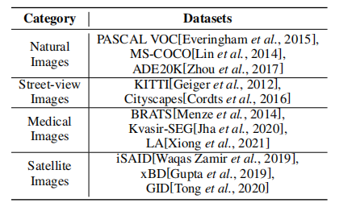
Table 1: A compilation of the frequently utilized datasets in the domain of semi-supervised semantic segmentation.

Performance Metrics
• Pixel Accuracy calculates the ratio of correctly classified pixels to the total number of pixels. Although this metric is simple and intuitive, it may not accurately reflect the model’s performance when there is an imbalance in the categories.
• Mean Accuracy takes into account the pixel precision for each category and calculates the average to address the issue of class imbalance.
• Mean IoU calculates the average Intersection over Union (mIoU) between the prediction and ground truth for all categories

where N is the number of categories, Nii is of T P(True Positive) number for category i, Nij is F P(False Positive) number for categories i as j, and Nji is F N(False Negative) number for categories j as i.
• Weighted IoU is used as a modification to the mIoU metric in situations where certain categories need to be given more importance.

3.Categorization
Drawing on the categorization of network structures for pseudo-label method in previous research [Pelaez-Vegas et al., 2023], as well as the innovative refinement of the Mean Teacher structure proposed by researchers [Tarvainen and Valpola, 2017], our investigation will focus on three main areas: the model-based perspective, pseudo-labels refinement,and optimization measures. Figure 2 presents a comprehensive overview of the various types of pseudo-label techniques.
Model perspective. Essentially, the various methods for generating pseudo-labels can be divided into two categories: the single-model family and the mutual-model family. Figure 2 (a) illustrates the single-model-based approach, where pseudo-labels generated by a single model are used for supervised subsequent training. For example, in the Mean Teacher method, a single model is trained using pseudolabels generated by the teacher model, which incorporates consistency regularization. On the other hand, multi-model mutual-training-based approaches aim to improve model performance by jointly training multiple models. Figure 2 (b) depicts this approach, where two different networks are initialized and one model supervises the training of the other model by providing pseudo-labels on unlabeled data. The cross-supervision of the two models helps localize and minimize errors in the pseudo-labels.
Refinement of pseudo-labels. We will discuss enhance ments to the conventional architecture by focusing on refining pseudo-labels to generate specific labels. Furthermore, we will categorize these methods of refining pseudo-labels into two groups based on whether the pseudo-labels are changed:label updating and filtering only. The simplified architecture for pseudo-labels refinement is depicted in the blue areas of Figure 2 (a) and (b).

Figure 2: A summary of the primary classifications. Our review is organized into three primary categories: the model for generation (subfigures a and b), the enhancement of pseudo-labels (blue boxed), and the perspective of optimization (dark red arrows). Within the category of the pseudo-labels generation, we investigate two approaches: single-model and multi-model series. Furthermore, various strategies are employed for the selection or refinement of pseudo-labels. Lastly, optimization methods are also becoming more prevalent in this field.
Optimization. Lastly, we also investigated a few emerging optimization techniques, which are depicted in dark red in Figure 2 (a). Further elaboration on these methods will be provided in the following sections.

4 .Pseudo-Label for Semi-supervised Semantic Segmentation
In this section, we provide a summary of all the methods for semi-supervised semantic segmentation based on pseudolabels mentioned in Table 2.

Table 2: An overview of pseudo-label techniques in the field of semi-supervised semantic segmentation.

4.1 Model perspective
The significance of architecture in deep learning cannot be overstated as it establishes the framework and layout of the neural networks employed in these models. The architecture plays a crucial role in determining how input features are manipulated and analyzed by the network, thereby impacting the model’s capacity to learn and generate precise predictions. Selecting an appropriate architecture is a vital aspect of constructing a successful deep-learning model. In this subsection, we examine papers pertaining to single-model families and collaborative mutual-model families.

Single-Model-Based Methods
The initial proposal of the single-model self-training approach was made by Yarowsky [Yarowsky, 1995]. Later on, [Lee and others, 2013] suggested combining self-training with neural networks using pseudo-labels. Since the initial single-model self-training approach was straightforward, subsequent research has focused on enhancing different aspects of this network structure.
Self-training Iteration. GIST & RIST [Teh et al., 2022], which can be explained as a greedy algorithmic strategy (GIST) and a follow-along iterative self-training strategybased strategy (RIST) that alternates between ground truth and pseudo-labels. Another approach proposed from a selftraining iterative perspective is ST++ [Yang et al., 2022], where the key step is selective retraining during the iteration process. Since segmentation performance is positively correlated with the evolutionary stability of the generated pseudolabels during the supervised training phase, more reliable unlabeled images can be selected by evolution during the training process. The stability metric is based on the average IOU between each early pseudo-mask and the final mask:
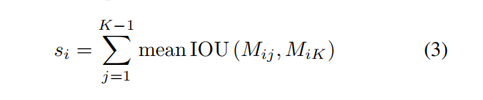
The stability scores of all unlabeled images are then obtained and the entire unlabeled set is ranked accordingly, and the R images with the highest scores are selected for the first stage of retraining. ST++ predicts robustness based on asymptotic changes in reliability, thus eliminating the need to select confidence thresholds for pixel-by-pixel filtering manually.
Self-cross Supervision. [Zhang et al., 2022] proposes a method called uncertainty-guided self-cross-supervision (USCS) for semi-supervised semantic segmentation. This approach utilizes the results of a multiple-input multipleoutput (MIMO) segmentation model to perform self-crosssupervision, resulting in significant reductions in parameter and computation costs.
Auxiliary Tasks Framework. Since another key to the pseudo-label approach is to set up auxiliary task frame supervision, some approaches have been proposed from this perspective. Earlier, [Li and Zheng, 2021] introduced residual networks to extend the self-training structure. The labeled data is fed into an auxiliary residual network to predict the residuals from the original segmentation results. While the later proposed ELN [Kwon and Kwak, 2022] is mainly to assist in locating errors, the auxiliary module is trained to identify the pixel points that may be incorrect by taking the images and segmentation results as inputs. The specific ELN structure contains the main segmentation network (encoder and decoder) and the auxiliary decoder (D1, D2, . . . , DK). The main segmentation network is trained by standard cross-entropy loss, while the auxiliary decoder is trained by restricted cross-entropy loss:
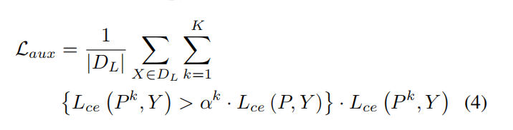
As a result, the auxiliary decoder will perform much worse than the primary decoder because it contains various errors, which are then used as inputs to the ELN to train the ELN to locate the labeling errors, similar to manually creating some error data for training. EPS++[Lee et al., 2023] provides rich boundaries through the saliency map generated by the saliency detection model, which is combined with image-level labeling information for joint training, assisting the model in being trained from pixel-level feedback.

Mutil-model-based Methods
Several semi-supervised learning methods rely on pseudosupervision, particularly self-training methods that generate pseudo-labels. However, the pseudo-labels generated by a single model in self-training can often be unreliable. This is because it is common to use only a single model’s prediction confidence to filter out low-confidence pseudo-labels, which can leave behind high-confidence errors and waste many low confidence correct labels. The dual-model mutual-training method aims at the problems inherent in the single-model self-training method, i.e., a single model is unable to detect and correct its errors, which may result in the accumulation of bias and ultimately affect the training and segmentation effects, mutual-training [Zhang et al., 2018] by which two or more models train each other according to their differences, localize their errors, and correct each other is proposed.
Cross-Pseudo-Supervision. A classical inter-training perspective is dual-model cross-supervision, such as CPS [Chen et al., 2021] approach uses different initialization methods for two networks, where the pseudo-labels output by one network supervise the other segmentation network. The subsequently proposed n-CPS [Filipiak et al., 2021] is the result of extending the CPS to n sub-networks, and experiments demonstrate that network integration significantly improves performance. Based on cross-supervision, [Fan et al., 2022] introduces uncertainty-guided supervision and proposes UCC(Uncertainty-guided Cross-head Co-training of cross-heads), which further improves the generalization ability by sharing encoders. [Wang et al., 2023] design a conflict-based cross-try consistency (CCVC) to force two subnets to learn knowledge from unrelated views. They propose a new crossview consistency strategy to encourage two subnets, which are structurally similar but do not share parameters, to learn different features from the same input image. They introduce a feature difference loss to achieve this. For unlabeled data, they make the two subnets use each other’s pseudo-labels for model learning.
Dynamic Muti-training. In addition to cross-supervision for synchronous training, other researchers have proposed dynamic mutual training based on a two-network structure, where two networks are trained asynchronously. DMT [Feng et al., 2022] points out that it is difficult for a single model to overcome its own errors. Therefore, they use two models with different initializations, one of which generates offline pseudo-labels for the other proposed. To effectively train machine learning models, it is important to identify labeling errors. This they do by comparing the predictions of two different models and quantifying the differences between them, so that they can dynamically adjust the weight loss during training to improve the accuracy of the model. Dynamic loss weight w_{u} is defined as follows:
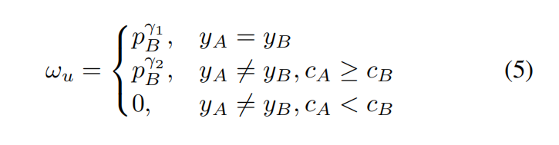
Regarding the issue of noise in the pseudo-label technology, the DMT method proposes assigning different weights to the samples, rather than discarding them. This approach is intended to preserve low-confidence data, but it may not be effective in addressing the problem of high noise rates in the pseudo-label method. Additionally, the ”catastrophic forgetting problem” in neural networks cannot be fully resolved, since the basic components of these networks consist of fixed structures and parameters. However, the severity of this problem can be reduced through various mitigation techniques. The DMT-PLE[Zhou et al., 2022]method extends the pseudo-label enhancement strategy from the previous DMT method, mainly for the purpose mentioned above. They mention that it’s challenging for a model to retain the knowledge it has learned when processing input with multiple pixels of varying types. To prevent the model from developing a bias towards the last learned category, they use a strategy called Pseudo-Label Enhancement (PLE). This technique utilizes the pseudo-labels generated by the model in the previous stage to refine pseudo-labels generated by the current model.

4.2 Pseudo-label Refinement Methods

Pseudo-label Update Methods
The pseudo-label method sometimes leads to incorrect predictions or inaccurate pseudo-labels being included in the training process, which can accumulate errors and make the learned pseudo-labels ineffective in guiding the subsequent learning, and ultimately affect the training results of the segmentation model. To solve this problem, some studies have proposed methods for updating pseudo-labels to alleviate the noise problem with good results.
Pseudo-label Corrections. In the beginning, some works formulated the task as a learning problem of pixel-level label noise. Yi et al. [2021] introduce a graph-based label noise detection and correction framework, which utilizes pixel-level labels generated by class activation maps (CAMs) as weakly annotated noise labels, trains a strongly annotated segmentation model to detect clean labels from the above noisy labels, and then corrects the noisy labels using a clean label supervised graph attention (GAT) network. The clean label supervised graph attention network is then used to correct the noise labels. Similarly, to address the problem of noisy label correction, [Wang et al., 2022b] propose a categoryindependent relational network to correct labels based on reliable semantic associations between image features. They obtained relational estimates by augmenting the relationships between features. The predictions with weak correlations are discarded for effective noise label correction.
Unlike the perspectives of the above approaches, some of the improvement methods start with the training phase. Keet al.[2022] advance a ThreeStageSelftraining method, where they attempted to extract initial pseudo-labels information on unlabeled data through three stages of self-training while enforcing segmentation consistency in a multitasking manner to generate higher quality pseudo-labels. In addition to the traditional remedies described above, [Wu et al., 2023] raise the CISC-R method using labeled images to correct noisy pseudo-labels, considering that samples of the same kind have a high pixel-level correspondence. Inspired by ST++ [Yang et al., 2022], they used a CISC-based image selection method that takes into account inter-class feature differences and the difficulty of correcting noisy pseudo-labels at the beginning of training. First, for each class k, an initial model is used to extract the anchor vector a k l for that class from the set of labeled images:
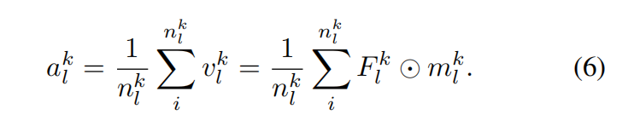Through this average generation, ak l is generated to represent the categorized anchor points of the labeled images. Specifically, a CISC mapping m′ is generated by cosine similarity between a k l of the labeled image x and the high-level feature.
De-biasing Bias in training comes both from the network itself and from improper training of potentially incorrect pseudo-labels, which accumulate errors throughout iterations. [He et al., 2021] propose Distributed Alignment and Random Sampling (DARS), a simple and effective method to redistribute biased pseudo-labels, to align pseudo-labels with the ground truth, and to improve the effect of noisy labels on training. Aligning their distribution with the true distribution improves semi-supervised semantic segmentation. Subsequently, to minimize the bias, Chen et al.[2022] suggest the debiased self-training (DST). The key of this method is that two parameter-independent classifier headers decouple the process of generating and utilizing pseudo-labels, and only clean labels are used for training, which improves the quality of pseudo-labels.

Pseudo-label Filtering-only Methonds
In addition, some researchers have proposed to enhance the segmentation effect by filtering the noisy pseudo-labels, and such methods do not perform the update of the noisy labels.
Confidence Filtering. Zhou et al.[2021] propose C3- SemiSeg, which presents a dynamic confidence region selection strategy to focus on high-confidence regions for loss computation. In addition, cross-set contrast learning is also integrated to improve feature representation. However, to address the problem that existing high-confidencebased pseudo-label methods lose most of the information, Ju et al.[2023] propose a class-adaptive semi-supervised framework (CAFS) for semi-supervised semantic segmentation, which allows the construction of a validation set on the labeled dataset to take advantage of the calibration performance of each class. This includes a core operation: adaptive class-by-class confidence thresholding (ACT), which de-emphasizes the use of calibration scores to adaptively adjust reliability confidence thresholds. Recently, TorchSemiSeg2[Chen et al., 2023] introduces a localized pseudo-labels filtering module to assess the reliability of region-level pseudo-labels using a discriminator network. They also propose a dynamic region loss correction to further assess the reliability of pseudo-labels using network diversity and to evaluate the direction of convergence of the network.
Confidence-level Refinement. Since much of the previous work mentioned above evaluated pseudo-label data mostly based on confidence thresholds, the problem of confidence ambiguity that exists at the beginning of training may largely limit subsequent updates. Recently, Kong et al. introduced the PGCL [2023], which aims to solve the issue of fuzzy confidence scores in network pruning, by gradually teaching the network from easy to hard examples using a coarse strategy.
Assisted Net Filtering. In addition, some methods utilize auxiliary structures for filtering operations. For example, GTA-Seg[Jin et al., 2022] selects an auxiliary structure known as the gentle Teaching Assistant. The GTA learns directly from the pseudo-labels generated by the teacher’s network, and only filtered, favorable information is passed on to the student’s network to assist in supervising the training of the student’s network.

4.3 Optimization Methods
In addition to the above methods, some researchers have proposed unique optimization techniques to improve segmentation results. These techniques include loss function improvement, pseudo-labels redesign, etc.
Loss Function. Wang et al. [2022c] advise improving the quality of pseudo-labels through perceptual cross-entropy(CCE) and progressive cross-training (PCT). CCE can simplify the pseudo-label generation more than traditional crossentropy. PCT gradually introduces high-quality predictions as additional supervision for network training. PS-MT[Liu et al., 2022] uses a stricter confidence-weighted cross-entropy (Conf-CE) to address the problem that cross-entropy loss training can easily overfit prediction errors.
Labeled data Utilization. It’s worth noting that [Tu et al., 2022] considers that dealing with labeled and unlabeled data separately usually results in discarding a large amount of a priori knowledge learned from labeled examples. So they proposed a method called GuidedMix-Net, which learns higher-quality pseudo-labels by using labeling information to guide the learning of unlabeled examples. Similarly, CISCR[Wu et al., 2023], which we mentioned earlier, corrects the pixel-level correction of pseudo-labels by estimating the pixel similarity between the unlabeled image and the queried labeled image and generating the CISC map.
Pseudo-label Utilization. Zou et al.[2020] focus on structured and qualitative design methods for pseudo-labels and proposed a single-stage consistency training framework, PseudoSeg, which generates pseudo-labels from two branches: the output of the segmentation model and the output of the class activation maps (CAM). They propose a pseudo-labels redesign strategy that combines pseudo-labels from two sources through a calibrated fusion strategy, i.e., given a batch of decoder outputs $\hat{p}$=f_{θ}(w(x))and SGC mappings computed based on the weakly augmented data w(x), pseudo-labels$\hat{y}$are generated:
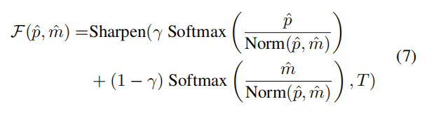
PseudoSeg generates well-calibrated, high-quality pseudo labels by implementing a novel pseudo-labels redesign strategy that facilitates subsequent model training. With limited available labeled data, well-calibrated pseudo-labels can greatly improve segmentation. To further improve the calibration, they suggested exploring advanced techniques such as multi modal data fusion.
[Fan et al., 2023] develop Conservative Progressive Collaborative Learning (CPCL) from the perspective of dual model mutual training, where the conservative branch is cross-supervised using high-quality pseudo-labels to achieve conservative protocol-based evolution. The progressive branch is supervised by a union utilizing a large number of labels to achieve progressive exploration of divergence.

5. Pseudo label Methods in Other Area
Pseudo-label method is widely used in semantic segmentation because of its simplicity and effectiveness. The methods we summarized in the previous section are mainly focused on natural image segmentation, but there is no doubt that it is important to continue research and promotion of image segmentation in more fields. In this section, we focus on pseudo label techniques applied to some specific domains, including medical images and remote sensing image segmentation.

Medical Image Segmentation
Segmenting medical images, which involves identifying the pixels corresponding to organs or lesions in images like CT or MRI images, is a highly difficult task in medical image analysis due to a lack of sufficient labels. Numerous studies have proposed the use of pseudo-labels, yielding promising outcomes when applied to specific medical datasets. In their recent work, [Huo et al., 2021] introduces a novel approach called asynchronous teacher-student optimization (ATSO) to challenge the conventional learning strategy. Instead of training two models alternately, they propose dividing the unlabeled training data into two subsets. This approach is particularly applied to 3D medical images, where each 3D body is divided into 2D slices representing coronal, sagittal, and axial views. A 2D network is then employed for segmentation, and the resulting output is stacked to form 3D bodies. A common issue in semi-supervised medical image segmentation is the discrepancy between the distribution of labeled and unlabeled data. Prior studies have primarily addressed labeled and unlabeled data in isolation or with inconsistency, which can result in disregarding the knowledge gained from the labeled data. In their research, [Bai et al., 2023] propose a straightforward approach to alleviate this problem by incorporating labeled and unlabeled data in both directions using a Mean-Teacher model called BCP.

Remote Sensing Image Segmentation
The process of labeling high-resolution remote-sensing satellite images is a task that requires a significant amount of time and effort. This limitation affects the performance of segmentation models. To address this issue, certain reports propose the utilization of pseudo-label techniques that rely on semi-supervised learning. These methods aim to assist in the segmentation of remote-sensing images. In their paper, [Li et al., 2023a] propose a technique for enhancing the segmentation accuracy of limited-sample high-resolution remote sensing images. They achieve this by utilizing two networks, namely UNet and DeepLabV3 , to predict pseudo-labels and filter them effectively. In their recent work, [Cui et al., 2023] propose a novel approach that utilizes bicommutative entropy consistency and a teacher-student structure. This task is challenging due to the presence of multiple classes, complex terrain, significant overlap between classes, and indistinct features. To address these challenges, the authors incorporate a channel attention (CA) mechanism into the teacher codingnetwork. This CA module effectively filters the feature mapping and suppresses noise interference, thereby constraining feature extraction and reducing the information entropy generated by the coding network.

6.Challenges and Future Perspectives
Upon conducting a thorough examination, it is evident that pseudo-label techniques have ventured into various techniques for image segmentation, yielding remarkable outcomes. Nevertheless, this section will concentrate on the difficulties encountered in the pseudo-label method for semi supervised semantic segmentation and emphasize potential research directions.
Quality enhancement using foundation models. Foundation models have transformed AI, powering prominent chat bots and generative AI. A cutting-edge interactive promptbased model called Segment Anything Model (SAM) [Kirillov et al., 2023] has recently been integrated into semantic segmentation tasks. It is anticipated that in the future, the prompt functionality of SAM will be leveraged to further improve the efficiency and effectiveness of the pseudo-label.
Utilization of additional information. At present, the use of low-quality pseudo-labels is limited to a single type of supervised signal, disregarding the valuable information present in other pixels. Hence, there is an opportunity to integrate alternative forms of supervisory signals into the model,enhancing its capacity to effectively utilize both coarse and fine-labeled data. We anticipate that future studies will enhance segmentation performance by adopting a more holistic approach to supervision.
Engage in the active selection and refine the process. Pseudo-label techniques struggle to effectively resolve the problem of noisy data. Instead of training the model on the entire dataset, strategies like active learning involve selecting a subset of the most informative data points to query for additional labels. This approach is more efficient and costeffective because it allows the model to learn from the most informative examples without requiring the entire dataset to be labeled. The future looks promising when active selection and refinement strategies are incorporated.
Explore complex segmentation scenarios. Expanding the application of pseudo-label models to a wider range of realworld situations is essential. While there has been notable advancement in theoretical research, the current utilization of pseudo-label methods is limited to specific datasets such as PASCAL VOC 2012 [2015], which consists of only 20 commonly occurring categories. To advance this field, it is crucial to investigate datasets that better represent real-life scenarios. For example, ADE20K [Zhou et al., 2017] contains over 150 classes of object information and could serve as a more representative dataset for future exploration.

7 Conclusion
We are the first to provide a comprehensive overview and categorization of pseudo-label techniques in the realm of semi-supervised semantic segmentation. Our categorization is based on the viewpoint of the model, methods for refining
pseudo-labels, and innovative optimization approaches. Furthermore, we have examined various pseudo-label techniques employed in medical and remote-sensing image segmentation. Lastly, we have identified the current obstacles in this domain and proposed potential future directions. We have also put forth research avenues to tackle these challenges.

