**Ans 1 a)**

**Rotation matrix is:**

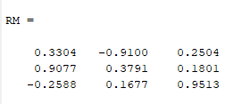

**Ans 1 b)**

**What are components of F in global X, Y, and Z directions?**

Gf stands for global frame. Units are in Newtons

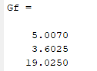

As a check: (5.007^2) + (19.6025^2) + (19.025^2) = 399.99868025 ~ 20^2

Also, it felt weird not providing work so I am including my matlab script and the answers that I got. This way, if I get something wrong, you can at least see my train of thought!

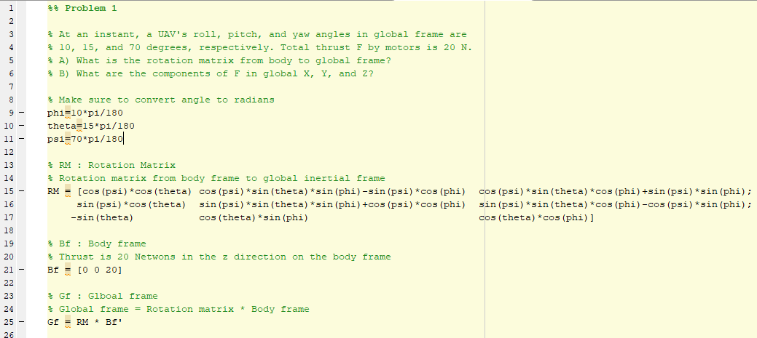

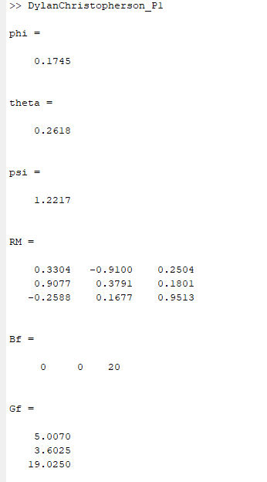

Also, this was a fun test! Thank you – Dylan Christopherson