Freedom Touch Software

<https://www.nxp.com/support/developer-resources/evaluation-and-development-boards/freedom-development-boards/adaptors/touch-software:FREESCALE-TOUCH-SOFTWARE>

RTOS – Real-time operating system is an operating system intended to serve real-time applications that process data as it comes in, typically without buffer delays.

With PWM_Init() and Init_RGB_LEDs, we have two conflicting pins and ports…

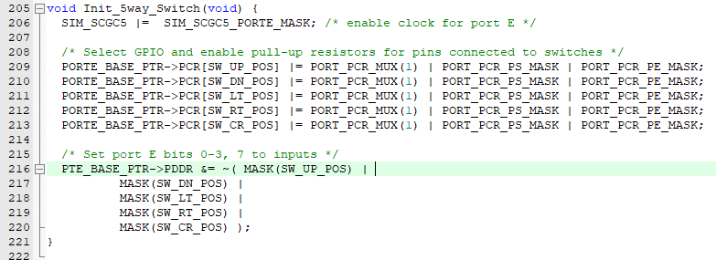

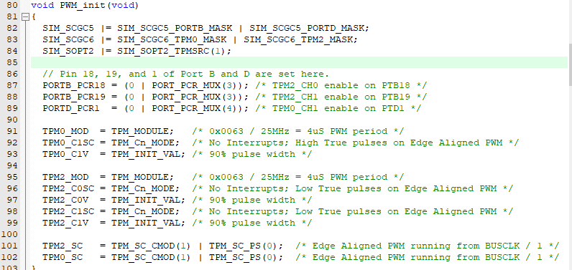

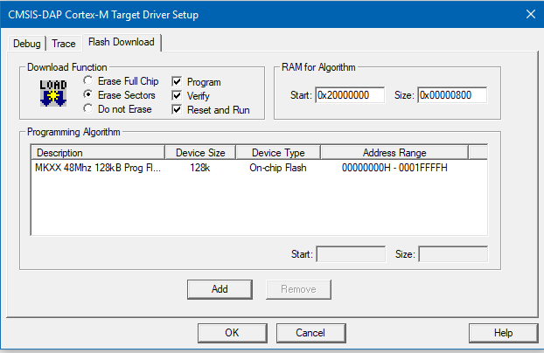From complicated project

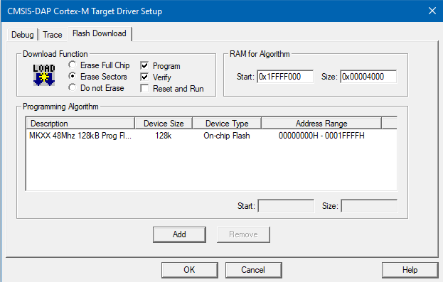

In events.c there is a function called TSS1_fCallBack1(TSS_CONTROL_ID u8ControlId)

