Lab 10

Name: Dylan Christopherson

Dr. Liu

CEE-345 Microprocessor System Design

4/6/2019

Introduction:

The goal of this lab was to implement code to run an LCD screen. The LCD was used the same as how it was used with the Atmel board. We’d initialize the LCD, clear it, then set the cursor to a given position on the LCD. This position would indicate where we wanted to start our words.

**LCD wiring**

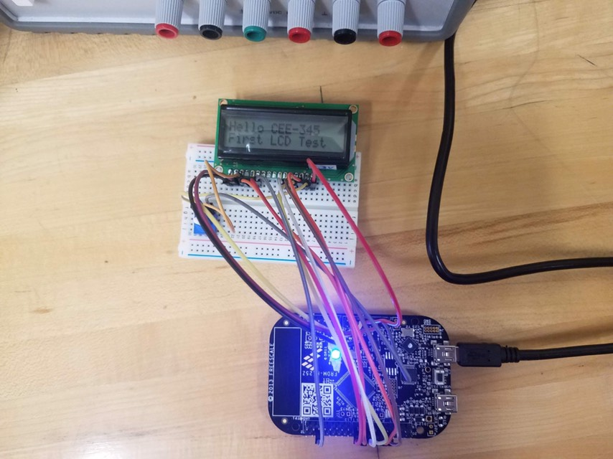

**LCD_4bit.h**

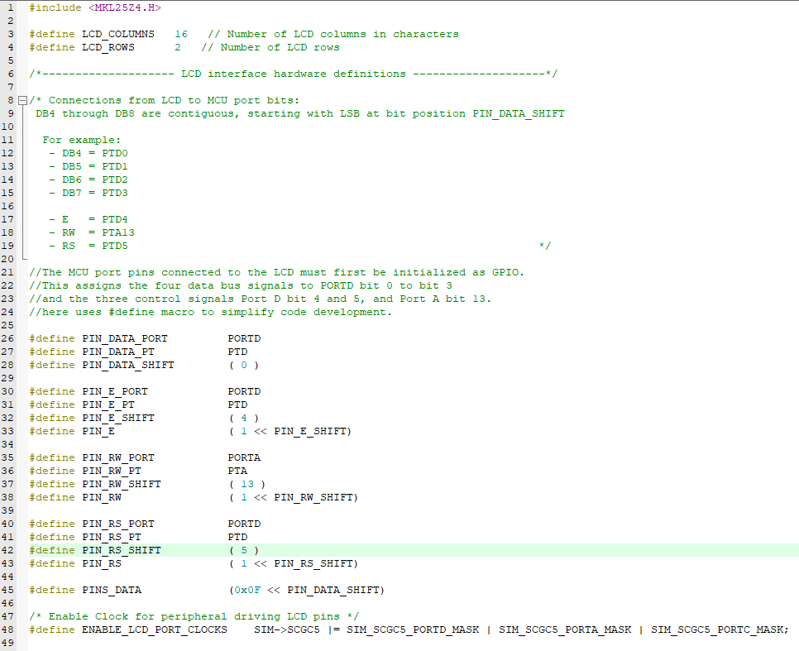

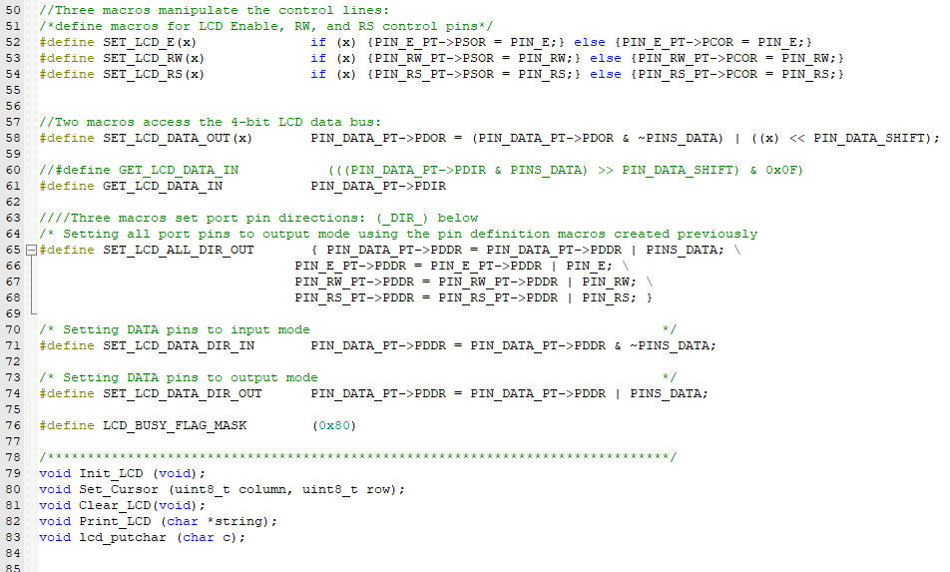**gpio_def.h**

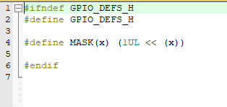

**uv5_LCD.c**

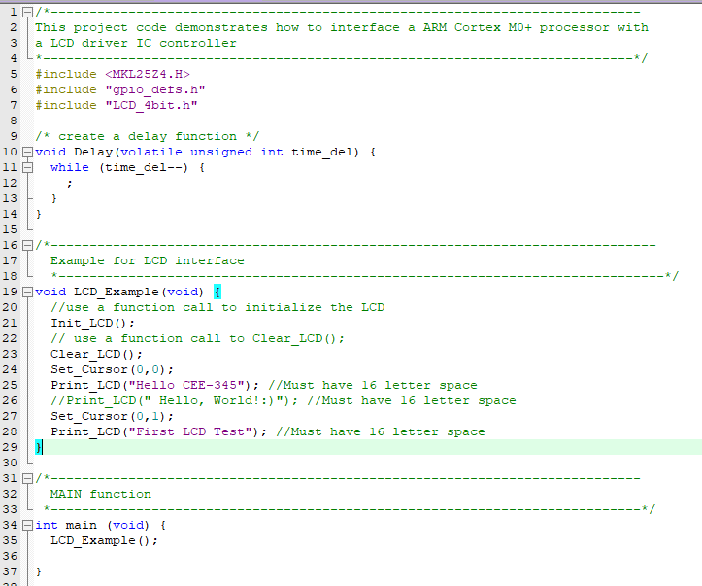

**LCD_4bit.c**

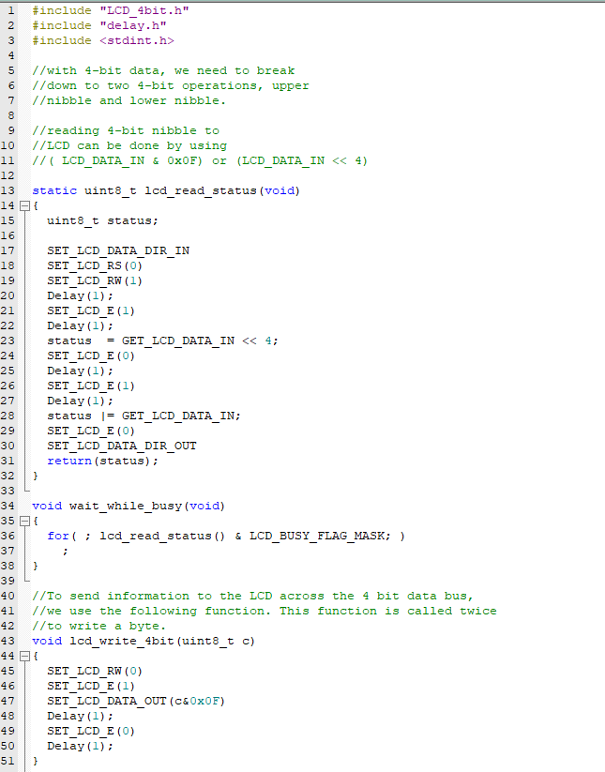

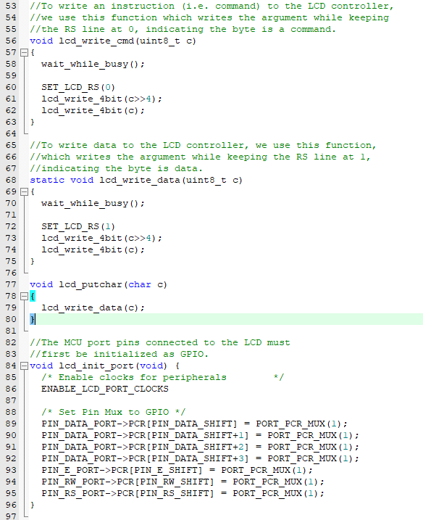

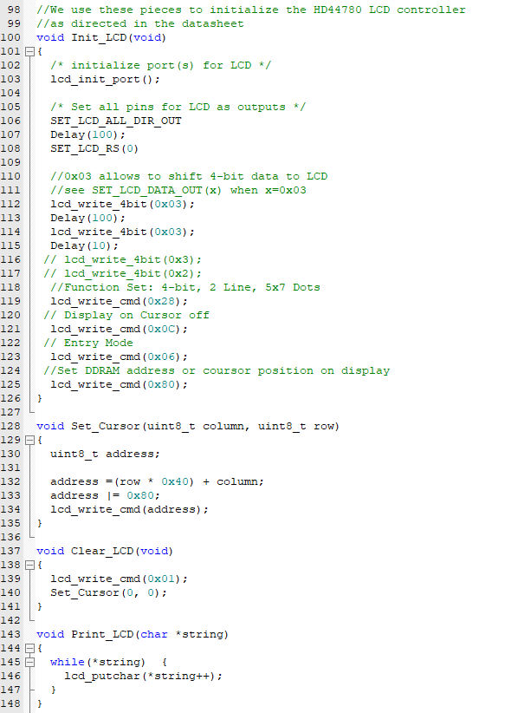

Conclusion:

This lab was very cool once I had gotten it working. However, I struggled with an issue while setting up this lab. When I looked in the project folder, there were 6 files under the source. However, in my project, there were only 4. So using the add sources, I added the files delay.h and delay.c. However, I eventually found out that this caused errors and was incorrect. I’m not exactly sure why but the delay.h and delay.c files couldn’t be included in the source group 1 folder of the project. It caused errors. After I removed the files, things worked swell.