Lab 4

Name: Dylan Christopherson

Dr. Liu

CEE-345 Microprocessor System Design

2/20/2019

Introduction:

The goal of this lab was to implement a PmodKeypad and a stepper motor using C. The user pressed a digit on the keypad which ranges from 0 to D. The output of the keypad was sent into DDRD and PORTD. The AVR board parses the data, and then sends the output to the main function. The main function looks for when the letter F, for forward, and B, for backward are pushed. When F is pressed, the runForward function is called which runs the motor though a specific sequence of numbers which rotates the motor. When B is pressed, the runBackward function is called which runs the motor though a specific sequence of numbers which rotates the motor. The speed that the motor rotates can be changed by changing the delay time in the runForward and runBackward functions. The amount of rotation can be changed by changing the value in the while loop which currently says “j<300”. By increasing the 300 value, the amount of rotation of the stepper changes.

LDI – Stands for Load Immediate. This loads an 8 bit constant directly to register 16 to 31.

SPL – Stack Pointer Low

SPH – Stack Pointer High

RAMEND – A label that represents the last memory address in SRAM. It’s a 16 bit word so we use the functions to split 16 bits into 8 bits so it can be handled.

Using low() and high(), we can return the low byte and high byte respectively of a 16-bit word

rol (Rotate left): The MSB is rotated to the carry flag, the carry flag is rotated to the lsb, all other bits are shifted left. The carry flag is initially 0.

brne: branch not equal

breq: branch equal

xor: eor

What’s the difference between mov and ldi?

Comments are in code on page

**C**

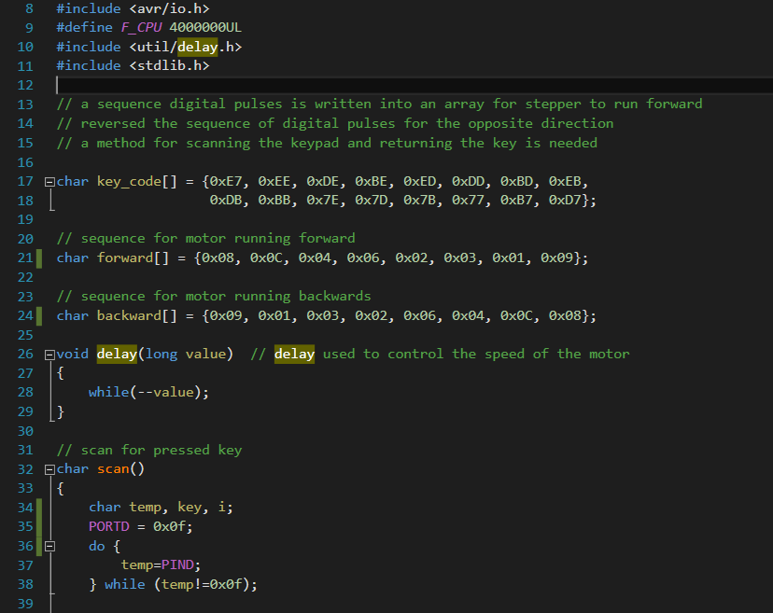

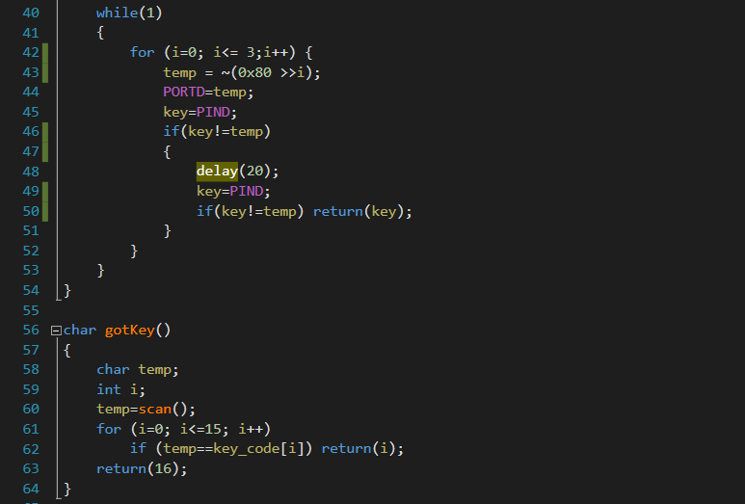

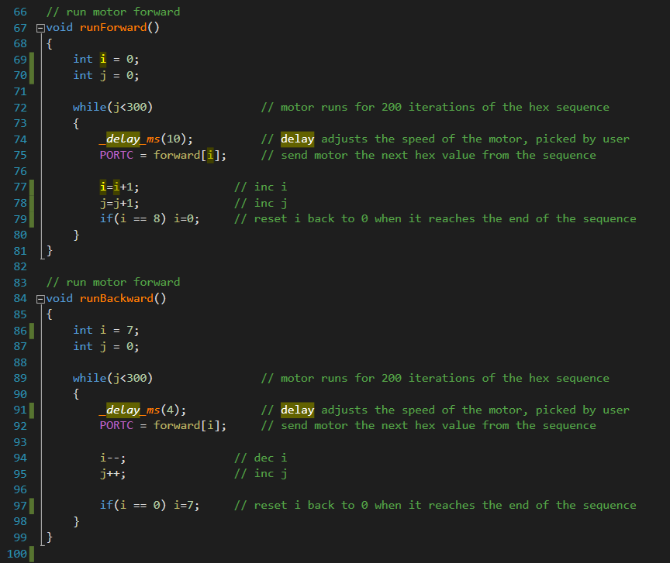

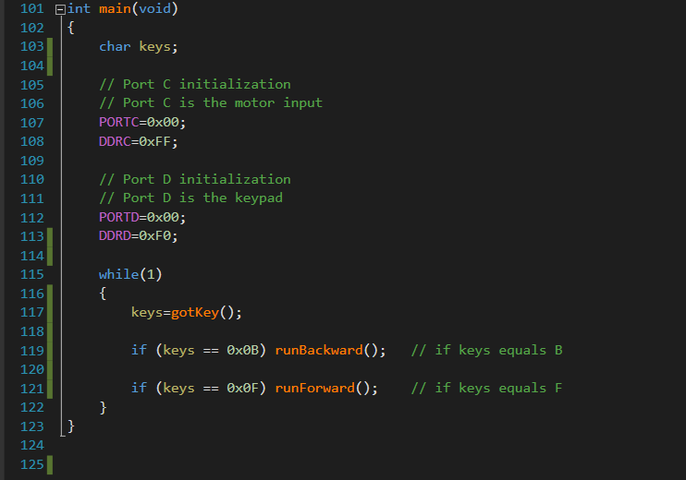

Conclusion:

This lab had its difficulties. The C program wasn’t too bad. The hardest part was understanding how the values were scanned on the keypad and how the values were sent to the AVR board. I thought it was cool to learn how the stepper motors were rotated as well. A lot of the code could be reused from the initial keypad lab which made this lab go quite smoothly.