Lab 5

Name: Dylan Christopherson

Dr. Liu

CEE-345 Microprocessor System Design

2/252019

Introduction:

The goal of this lab was to implement an LCD screen using the AVR Microcontroller. The LCD screen attached to the PORTA and PORTC ports on the AVR board.

LDI – Stands for Load Immediate. This loads an 8 bit constant directly to register 16 to 31.

SPL – Stack Pointer Low

SPH – Stack Pointer High

RAMEND – A label that represents the last memory address in SRAM. It’s a 16 bit word so we use the functions to split 16 bits into 8 bits so it can be handled.

Using low() and high(), we can return the low byte and high byte respectively of a 16-bit word

rol (Rotate left): The MSB is rotated to the carry flag, the carry flag is rotated to the lsb, all other bits are shifted left. The carry flag is initially 0.

brne: branch not equal

breq: branch equal

xor: eor

What’s the difference between mov and ldi?

Comments are in code on page

**C**

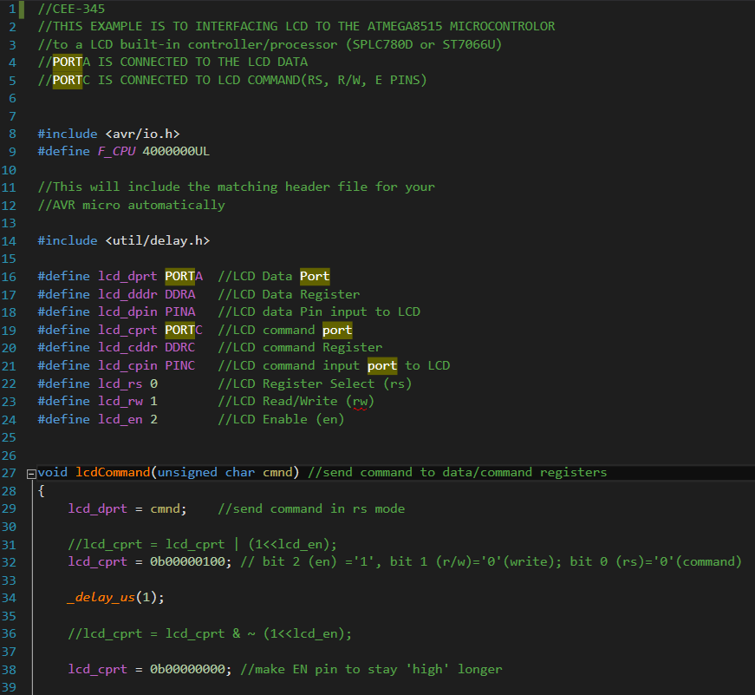

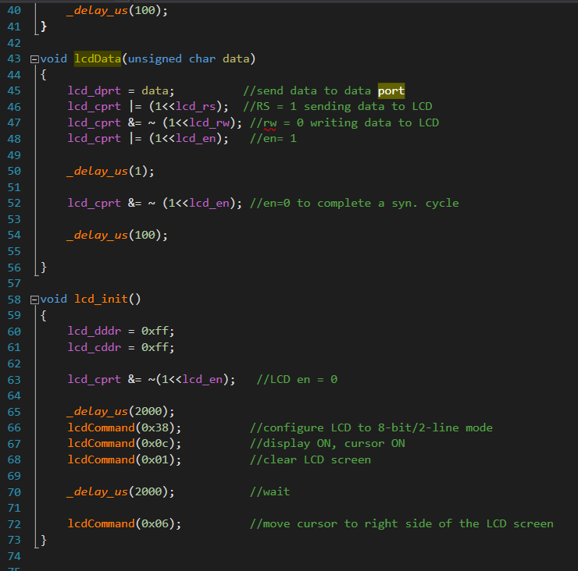

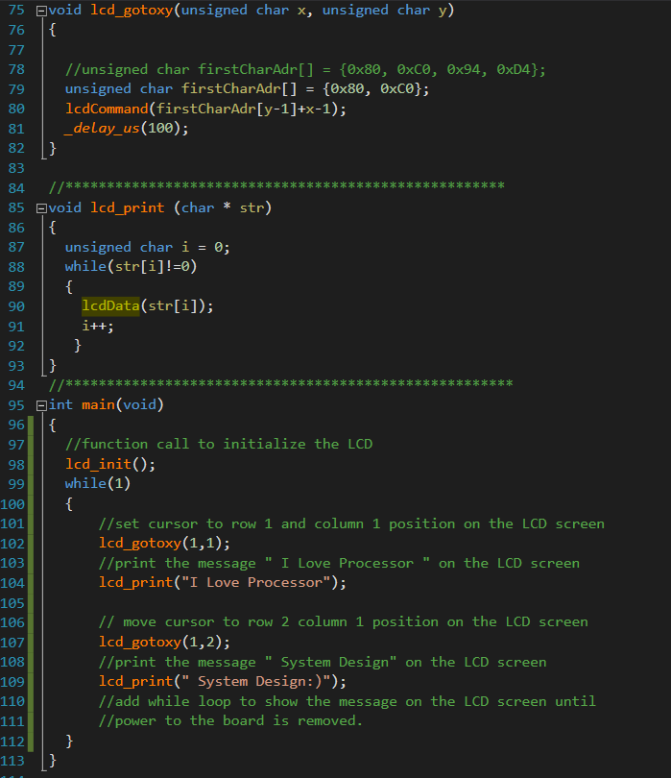

Conclusion:

This lab didn’t have many difficulties. The main issues were making sure I was using the right functions in the right locations. Also, the x and y positions didn’t start at 0, they started at 1.