Lab 7

Name: Dylan Christopherson

Dr. Liu

CEE-345 Microprocessor System Design

3/7/2019

Introduction:

The goal of this lab was to implement a Keymod keypad using our Freedom boards. First, we need to implement just sensing a touch and then flashing a blue LED. Then we had to sense which keys were being pressed and turn on and off red and green lights based on what was pressed.

Comments are in code on page

**C**

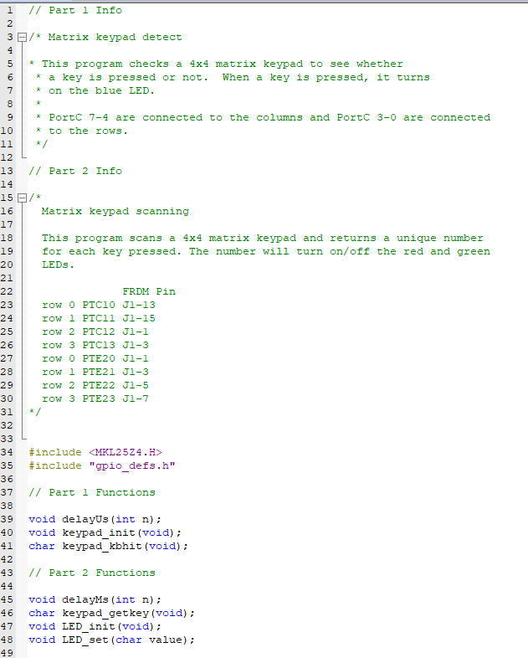

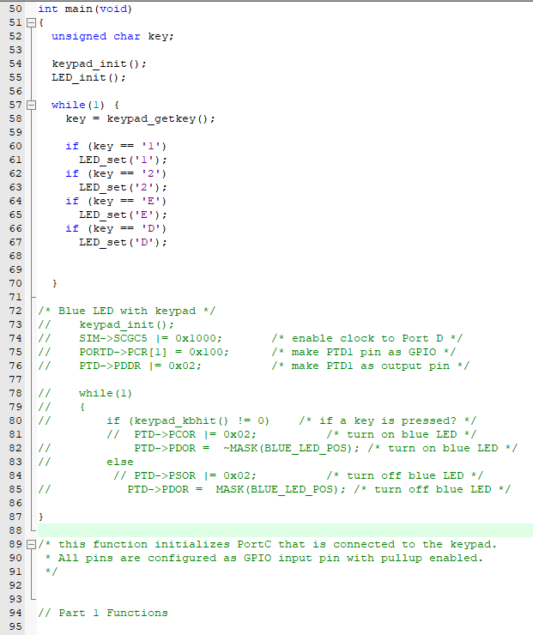

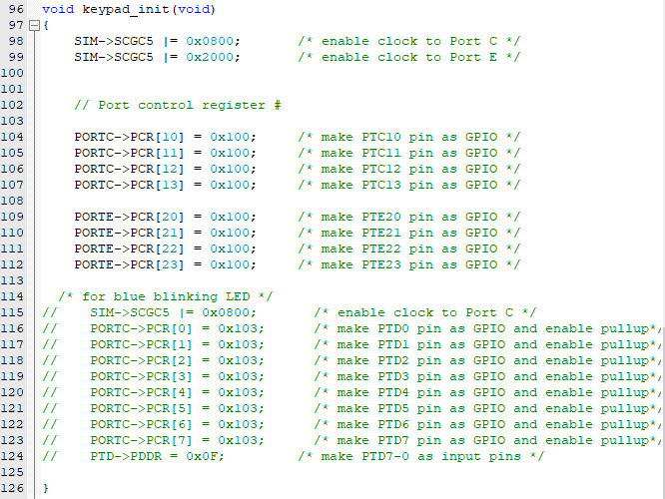

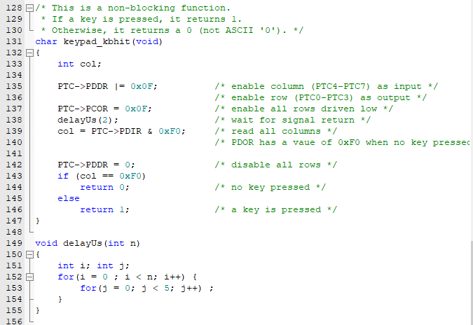

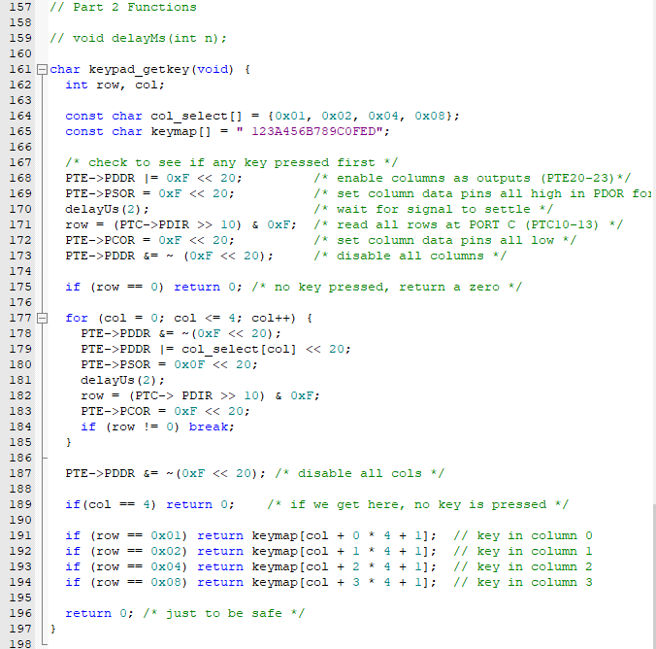

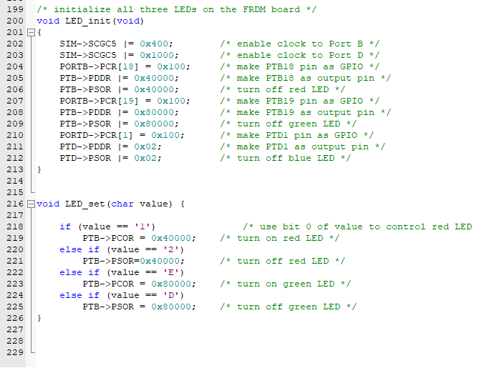

Conclusion:

This lab was a little tricky. Adjusting to the new syntax is taking a bit of time. I would like to go through the Freedom manual on D2L to hopefully learn a bit more about how to program the Freedom board. It’s a work in progress!