Lab 8

Name: Dylan Christopherson

Dr. Liu

CEE-345 Microprocessor System Design

3/18/2019

Introduction:

The goal of this lab was to implement an IR sensors with LEDs output. As an object moves closer to the IR LED, the sensor senses that it’s closer. As an object moves closer to the sensor LED, the color of the RGB on board LED on the Freedom board changes to represent the distance of the object from the sensor.

**IR_LEDs.c**

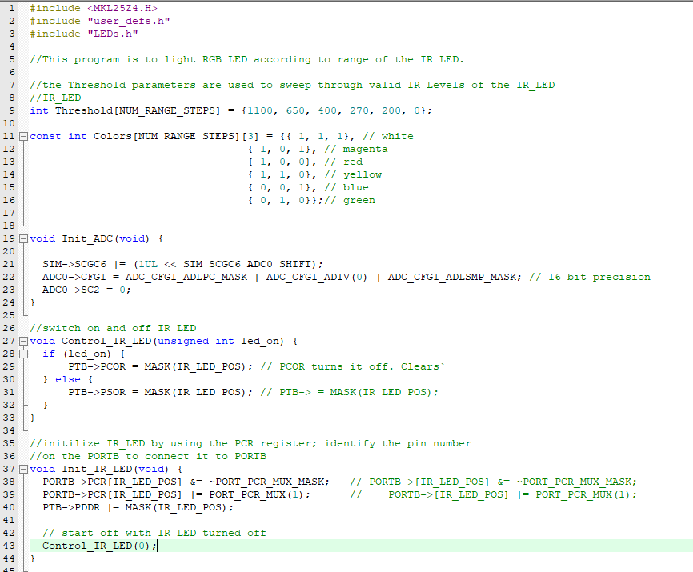

**LEDs.c**

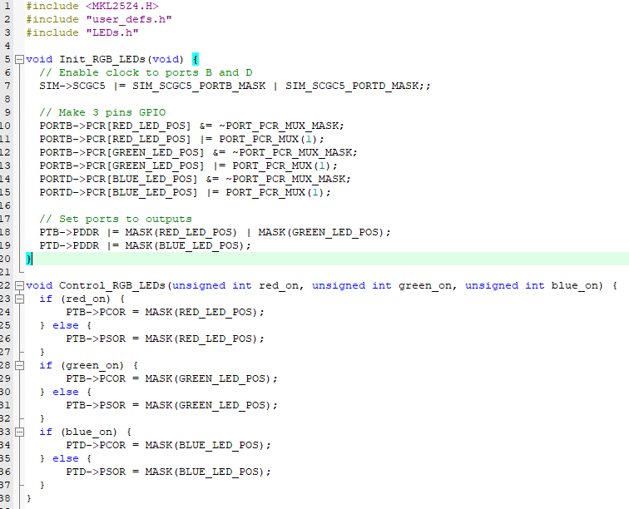

**LEDs.h**

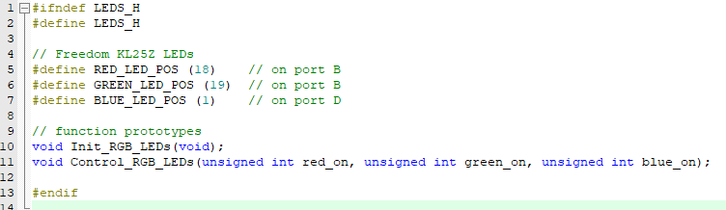

**User_def.h**

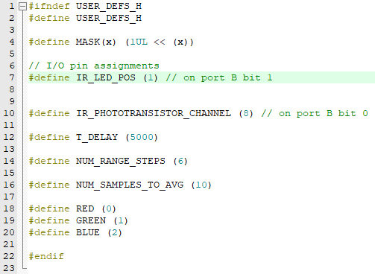

Conclusion:

This lab was difficult. The hardest part is picking up syntax in c that corresponds with the different pins and components on the board. With a little bit of help from the TA, I was able to figure out what needed to be done and was able to get the code working. After, it was relatively simple to wire up the sensor LED and the IR LED with resistors and connect them to the correct pins based on the wiring diagrams.