Lab 9

Name: Dylan Christopherson

Dr. Liu

CEE-345 Microprocessor System Design

3/18/2019

Introduction:

The goal of this lab was to implement code to take input from push buttons to change the color of the onboard LED on the Freedom board. The switches are connected to ground so when the switches aren’t pressed, the LEDs are off. When the switches are pressed, it connects the pins to ground, grounds the pins, and turns on the LEDs based off of what button you pressed.

**Main.c**

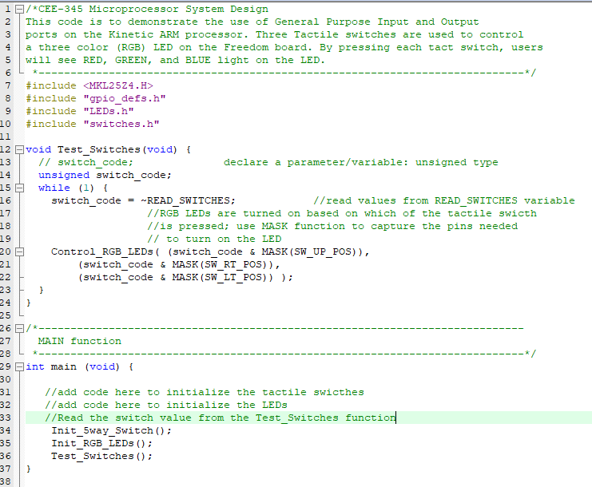

**Leds.c**

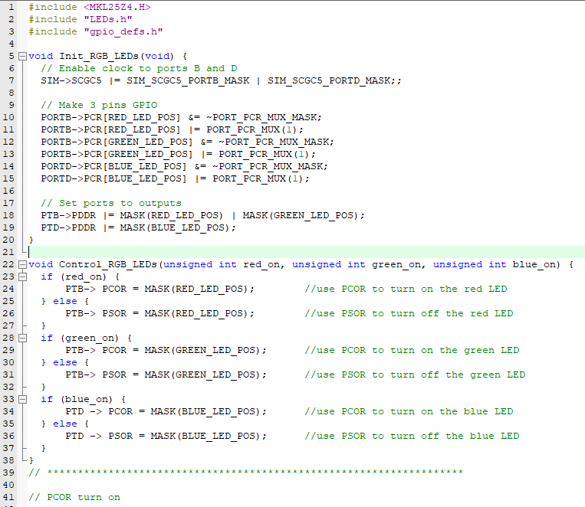

**Leds.h**

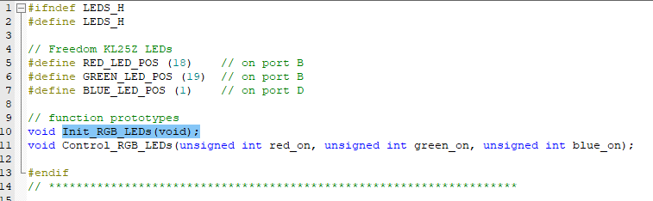

**Switches.c**

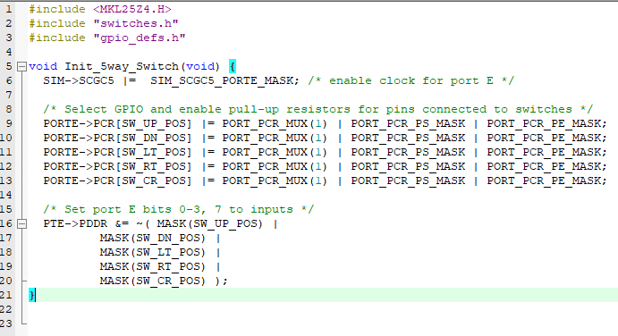

**Switches.h**

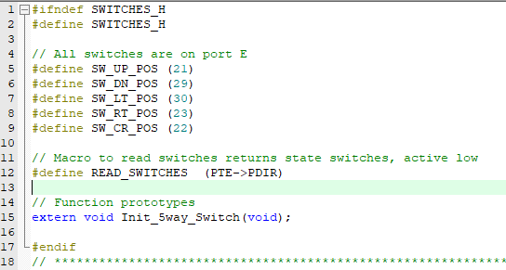

**Gpio_defs.h**

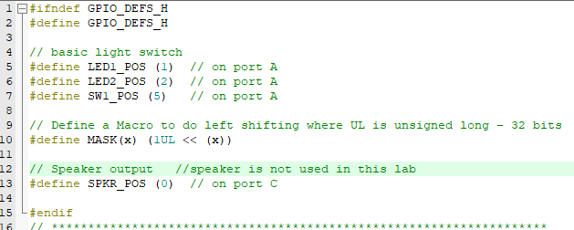

Conclusion:

This lab was a lot of fun! It was really cool to light up an LED with different colors with a push button. This lab was tough cause there are a bunch of different files with lots of different lines of code. I’ll have to make sure I spend some time learning what each of them do and what everything does.