**Testing macro-ecological and macro-evolutionary patterns of biodiversity across the Hawaiian archipelago**

Dylan Craven1,2,3*, Tiffany M. Knight4,1,2, Kasey E. Barton5, Lalasia Bialic-Murphy5,6 , Jonathan M. Chase,2,7

1 Department of Community Ecology, Helmholtz Centre for Environmental Research – UFZ, Theodor-Lieser-Straße 4, 06120 Halle (Saale), Germany

2 German Centre for Integrative Biodiversity Research (iDiv) Halle-Jena-Leipzig, Deutscher Platz 5e, 04103, Leipzig, Germany

3 Biodiversity, Macroecology & Biogeography, Faculty of Forest Sciences and Forest

Ecology, University of Göttingen, 37077 Göttingen, Germany

4 Institute of Biology, Martin Luther University Halle-Wittenberg, Am Kirchtor 1, 06108, Halle (Saale), Germany

5 Department of Botany, University of Hawai'i at Mānoa, Honolulu, Hawai'i, USA

6 Ecology and Evolutionary Biology, University of Tennessee Knoxville, Tennessee, USA

7 Department of Computer Science, Martin Luther University, Halle-Wittenberg

* Corresponding author: dylan.craven@aya.yale.edu

Classification: Biological Sciences (Ecology)

**Keywords**: Hawaii, biodiversity, forests, island biogeography, island age, habitat heterogeneity, island area

# Abstract

Globally, biodiversity patterns emerge as a consequence of both evolutionary and ecological processes. Their relative importance is frequently tested on model ecosystems, such as oceanic islands, that vary in both. However, the coarse-scale data used to perform such analyses have limited inferential power to separate the effects of historical biogeographic factors, such as island age, from those of ecological ones, such as island area and habitat heterogeneity. Here, we describe biodiversity patterns of native plants from across the Hawaiian archipelago, where these volcanic islands differ in age by several millions of years. Using a database of more than 400 local forest plots from across the archipelago, we analyzed diversity patterns at a finer resolution than can be accomplished with typical macroecological and macroevolutionary studies. We show that, after controlling for factors such as island area and heterogeneity, the oldest islands (Kaua’i and O’ahu) that have had longer time for species diversification have greater species diversity per unit area than younger islands (Maui and Hawai’i), indicating an important role for macroevolutionary patterns in driving not just whole-island differences in species diversity, but also local community assembly. Further, we find that this pattern emerges because older islands have a greater number of rare species that are more spatially clumped (i.e., higher within-island  diversity) than younger islands. Our approach demonstrates that macroevolutionary factors shape not just regional-scale biodiversity, but also local-scale community assembly patterns and processes in a model archipelago ecosystem, and can be applied to disentangle biodiversity drivers in other systems.

# Significance statement

Integrating evolutionary and ecological factors is an essential step towards reaching a more complete understanding of the mechanisms that underlie biodiversity patterns. While oceanic islands are often used as natural laboratories because they are discrete spatial units and vary in age, island- (or archipelago-) level, typical analyses at the whole-island level lack information about species abundances and distributions within islands that is necessary to disentangle the effects of biogeographical and ecological factors on biodiversity patterns. Here, we analyze forest plot data from across the Hawaiian archipelago and show that the effects of island age on diversity patterns of native plant species percolate across spatial scales via the distribution of rare species. In doing so, we show that species diversity patterns across a biodiversity hotspot reflect the joint influence of contemporary and historical drivers.

**Introduction**

Biodiversity is unequally distributed across the globe. For example, the number of co-occurring tree species ranges from boreal forests of only a few species that spread across thousands of hectares (1) to tropical forests with upwards of 1,000 species co-occurring within only tens to hundreds of hectares (2). This variation in biodiversity has emerged over evolutionary time (3) and also reflects current patterns of available habitat area, climate and disturbance (including anthropogenic disturbances)(4–6), as well as historical patterns of climate, interactions with other species, and biogeography (7–10).

Research on oceanic islands has generated some of the most influential theories on biodiversity dynamics via evolutionary (11, 12) and ecological processes (13). For example, historical biogeographic factors can play an important role in driving diversity patterns, such as differences in island age resulting from volcanic processes or differences in historical connections to mainland areas (14–16). At the same time, ecological factors such as island area and heterogeneity, as well as climatic factors, also explain a large amount of the variation in biodiversity across islands (17, 18). While it is impossible to fully separate evolutionary effects from contemporary ecological effects in driving patterns of biodiversity on islands (10, 19–21), islands have served as a model system in which to evaluate their relative importance, to understand how biodiversity is maintained, and to predict how it may change in the face of ongoing anthropogenic factors.

The Hawaiian archipelago, and similar hotspot archipelagos, provides an ideal testing ground for studying the interplay between ecological and evolutionary processes generating and maintaining island-level diversity (e.g., 22–25). This is because such archipelagos form over volcanic hotspots that create a temporal sequence of islands of different ages. Among the main Hawaiian islands, Kaua’i is ~5 million years old, O’ahu is ~3 million years old, Maui Nui (the combination of Maui, Moloka’i and Lana’i, which until ~20,000 years ago, was a single island) is 1-2 million years old, and the island of Hawai’i is less than 0.5 million years old and still growing (26). While this age gradient has served as a natural experiment for studies examining the influence of time for diversification on contemporary diversity patterns (27, 28), hotspot archipelagos such as Hawai’i do not allow for a perfect test of island age because there are at least two ecological factors that co-vary with island age: island area and island heterogeneity. The youngest island (Hawai’i) is the largest and the most heterogeneous (e.g., largest elevational gradient), while the oldest island (Kaua’i) is smaller and has lost much of its heterogeneity due to erosion (26). These co-varying ecological and evolutionary factors are repeated on hotspot archipelagos around the world, and as a result, evolutionary radiations and species extinctions appear to track ontogenetic changes in island characteristics (25); clades rapidly accumulate species as islands grow and subsequently lose species as islands decay.

While the conceptual framework for the interplay between evolutionary and ecological factors in driving patterns of biodiversity on islands is compelling (29), the data used to test these hypotheses are often limited. For example, macroecological and biogeographic data, such as species richness and endemism patterns, are used at very coarse scales (e.g., from island checklist data) and thus cannot allow for robust inference regarding within-island confounded variables, such as island heterogeneity. Therefore, more detailed information on the abundances and small-scale distributions of species is required to disentangle these ecological and evolutionary hypotheses. While a few studies have begun to apply smaller-scale data to larger-scale eco-evolutionary questions on islands, these studies have been greatly limited in scope (e.g., few sampling locations across gradients of island age), and thus not have not been able to fully disentangle the effects of island age, area, and heterogeneity on patterns of biodiversity (21, 23, 30, 31).

Our primary objectives are to describe patterns of plant biodiversity in the Hawaiian archipelago across spatial scales and to distinguish the roles that island age and habitat heterogeneity likely play in determining these observed patterns. We used two lines of evidence to compare patterns of species diversity across the archipelago. First, we used data on the total number of native woody species, as well as single-island endemic species ( i.e., the number of species endemic to an island (29)), from the flora of the Hawaiian archipelago (32) to illustrate island-wide patterns of biodiversity. Second, we used a database of forest plots collected using similar methods from across the Hawaiian archipelago (33). This database consisted of 429 sampling plots containing 23,570 individuals of 104 native species (Fig. 1). To describe diversity patterns of native plant communities, we removed alien species from the original database and excluded heavily invaded plots (see Materials and Methods). Because this database provided data on the number of individuals of each species and the spatial location of plots, we were able to use an array of complementary analyses, specifically rarefaction curves and relative abundance distributions, to disentangle factors that correlate with biodiversity patterns (34–38) that are not possible in macroecological studies that typically use island-level species checklists.

# Results & Discussion

At the island-level, our results are consistent with the idea that island age plays an important role in generating biodiversity patterns (Fig. 2). The youngest island, Hawai’i, has the fewest numbers of native woody species and the fewest single island endemic species. Kaua’i, the oldest island, has the highest number of single island endemic species. However, these island-level patterns cannot fully disentangle island age from ecological effects. For example, Hawai’i is considerably larger, yet has lower diversity than the other islands. Controlling for island area, therefore, may accentuate differences in species diversity between it and the other islands in the archipelago. Likewise, Maui Nui (the second youngest island) has more total woody species than any of the other islands. This may, in part, be due to its relatively large area and high levels of habitat heterogeneity compared to the older islands. As such, to disentangle the effects of island age (and time for diversification) from island area and habitat heterogeneity in driving patterns of biodiversity and community assembly, it was necessary to more finely dissect patterns of diversity.

For rarefaction analyses, it is critical to establish appropriate sampling scenarios prior to analysis to avoid misinterpretations of diversity patterns. For example, if we simply used the entire database, we would have falsely concluded that there were more species per unit area on the younger, larger islands (Hawai’i and Maui Nui) and fewer species per unit area on the smaller, older islands (Kaua’i and O’ahu) (Fig. S1). However, this result is a product of there being many more sample plots on the larger, younger islands (Fig. 1; Table S1). Even when we rarefied species richness to a seemingly standardized sampling effort of 10,000 individuals, estimated species richness remained higher for Hawai’i compared to Kaua’i (Fig. S1). This pattern is similarly misleading because the plots on the larger islands are located along broader environmental gradients than the plots on the smaller islands (Table S1). Consequently, species richness estimated via rarefaction (which randomizes individuals from across the entire extent of sampling for each island) is confounded by higher levels of heterogeneity among plots.

To more appropriately unveil the influence of island age from other confounded ecological factors, such as total sampling effort and habitat heterogeneity, on island diversity patterns, a more controlled sampling process is necessary. Specifically, we wanted to know whether macroevolutionary processes influenced local community assembly patterns, and thus the numbers, relative abundances, and spatial distributions of species on islands of different ages, after controlling for differences in sampling effort. To accomplish this, we compared species richness patterns across islands using two nested sampling scenarios.

First, we controlled for differences in sampling effort alone, but not habitat heterogeneity or island age, by randomly selecting a fixed (seven) number of sampling plots with a standardized area (0.54-0.60 ha) (‘Het+Age’; Table S2). Standardizing sampling at this scale, we found that the older, smaller islands have steeper rarefaction curves with higher asymptotes than the younger, larger islands (Fig. 3a). This indicates that, after controlling for differences in sampling effort, the older islands (especially Kaua’i) have more species than younger islands. These differences are also reflected in the shapes of the relative abundance distributions (RADs) across islands. Specifically, the RADs indicate that the two older islands (Kaua’i and O’ahu) have proportionately more rare species (39) than the two younger islands (Maui and Hawai’i) (Fig. 3c). While results from this sampling scenario are suggestive of an island age effect driving local patterns of diversity and relative abundance, island age and habitat heterogeneity are often confounded in oceanic archipelagos, both of which can influence diversity patterns (29, 40).

Next, we controlled for sampling effort and habitat heterogeneity simultaneously to isolate the effects of island age alone (‘Age’). We did this by randomly selecting seven plots with a standardized area and similar levels of habitat heterogeneity (Table S2). We inferred heterogeneity using potential evapotranspiration (PET) as a proxy because it integrates variation in elevation and precipitation (see Materials and Methods). Here, we found patterns similar to the sampling scenario above for both the rarefaction curves (Fig. 3b) and the shape of the RADs (Fig. 3d). Diversity patterns estimated under this sampling scenario, which controls for both habitat heterogeneity and sampling effort, indicate that there is a strong effect of island age. Specifically, when controlling for other confounding ecological factors, we found that there are more species per unit area on the older islands and this is because they have more rare species, as depicted by changes in the shape of their RADs. This suggests that it is likely that not only the total numbers of species on these islands, but also patterns of richness and species’ relative abundances at local scales are influenced by island age via differences in time for diversification.

The analysis above (Fig. 3) implies that the older islands have higher species richness per unit area, but might have lower levels of diversity using other measures that account for species’ relative abundances. We examined this pattern by comparing Hill numbers (41), which differentially consider both the numbers and relative abundances of species. Specifically, the most familiar Hill numbers correspond to (i) species richness (q=0), where species’ relative numbers are not considered; (ii) an Effective Number of Species (ENS) given Shannon’s diversity index, which weights common and rare species differently (q=1); (iii) an ENS given evenness, which weights common species much more heavily than rare species (q=2 ). As communities become more uneven, ENS for q=1 will become lower than for species richness (q=0), and even more so for ENS when q=2. Comparing these measures across islands (Fig. 4), we found that the differences among the islands in diversity declined as the weight of common relative to rarer species increased (i.e., from q=0 to q=2). Specifically, there was a strong signal of increasing species richness (q = 0) with island age (Fig. 4a and b). However, when relative abundances were taken into account using ENS measures, the island age signal remained only for the oldest island (Kaua’i) (Fig. 4c-f). This suggests that much of the island age effect on species diversity in native forests across Hawai’i, Maui Nui, and O’ahu is attributable to differences in rarer, rather than more common species, such that diversity measures higher than q=0 were not influenced. However, on Kaua’i, the combination of rarer species was sufficient to influence diversity measures that penalize rarer species (q=1 and 2).

Finally, we examined how spatial variation in species’ relative abundances among local sites (i.e., beta diversity) influenced observed differences in local-scale species diversity among islands (Figs. 3 and 4).When we compared beta diversity among islands using q = 0 (i.e., traditional Whittaker-type beta diversity; 42, 43), we found higher levels of beta diversity on the older islands (Kaua’i and O’ahu) for both sampling scenarios (Fig. 5a and b). When we calculated beta diversity with q=2 for both sampling scenarios (Fig. 5c and d), we found that the oldest island (Kaua’i) had the highest beta diversity. This indicates that it is likely that the higher levels of diversity on this island are due to both increased levels of local coexistence (Fig. 4) and higher levels of spatial aggregation in species abundances.

Overall, our analyses show that once sampling effort and heterogeneity are controlled for, we detected a strong effect of island age on diversity patterns of native forest communities across the Hawaiian archipelago at local scales that echoes diversity patterns observed at macro-ecological scales (44). The oldest islands, Kaua’i and O’ahu, have more species per unit area and within similar habitats than the youngest islands, Maui Nui and Hawai’i. The higher species richness per unit area on the older islands seems to be primarily a result of there being more rare species per unit area on the older islands relative to the younger islands. Moreover, the higher level of rarity on older islands appears to be spatially distributed, such that rare species are more aggregated on older islands than on younger islands. This latter result – greater beta diversity on older islands – could have emerged for a number of reasons. For example, higher levels of beta diversity of rare species could reflect that longer time for divergence on the older islands has allowed for higher rates of allopatric speciation with little secondary contact (27, 28, 45). Higher levels of beta diversity also could result if eco-evolutionary and frequency-dependent feedbacks (e.g., interspecific interactions or interactions with enemies), have created higher levels of spatial dispersion among otherwise similar species (46, 47). Because we use data from native forests that have been largely undisturbed (i.e., in protected areas), we interpret these patterns of diversity across islands as being primarily a result of historical and contemporary community assembly processes rather than anthropogenic processes.

The identification of ecological and evolutionary mechanisms are needed to fully explain the effects of island age on species diversity patterns across the Hawaiian archipelago. A promising path forward would be to compile and combine extant genetic and phylogenetic data (48) from well-studied clades that have undergone adaptive radiation in Hawaii, such as the silversword alliance (27), to link species’ ages and diversification rates with community-level (phylogenetic and taxonomic) diversity patterns. The greater species diversity per unit area found on older islands, once controlling for sampling effort and habitat heterogeneity, also suggests that communities may partition resources at finer spatial scales on older islands than on younger ones. On older islands there may be less trait overlap and greater trait divergence at local scales than on younger islands, particularly for traits associated with water and nutrient acquisition (e.g., 49, 50). To test for such fine-scale patterns, data for native and alien woody plants would need to be compiled using locally collected traits because the steep environmental gradients that occur across the Hawaiian archipelago lead to high intraspecific trait variation (51, 52), which may not be captured when using trait values from large plant trait databases (53).

# Conclusion

Integrating evolutionary and ecological factors has been considered an essential step (10, 19, 54) towards deepening current understanding of biodiversity patterns and the mechanisms that underpin them. Here we leverage a comprehensive database of forest plots distributed across the Hawaiian archipelago and use it to show that the effects of island age on diversity patterns percolate across scales, from macroecological to local, via the spatial distribution of rare species. In doing so, we provide further evidence that species diversity patterns across islands bear the imprint of both contemporary ecological and historical evolutionary factors. Our approach can be readily applied to other systems for which there is local scale sampling of communities across relevant ecological gradients.

# Materials and Methods

**Data acquisition and description*.***

To estimate species richness of native woody species and single island endemic species, i.e., the number of species endemic to an island (29), for each island across the Hawaiian archipelago, we classified all plant species in the flora of the Hawaiian Islands (32) as native or alien and woody, herbaceous, or variable using the Global Woodiness Database (55, 56). Species not found in the Global Woodiness Database were classified using the same methodology by consulting electronic sources (32, 57).

We assembled a database containing 429 plots and 104 native plant species, including trees, shrubs, and tree ferns from publicly available sources and published studies with forest plot data in Hawaii where species identity and size of individuals ≥ 5 cm diameter at 1.3 m were reported (33). Forest plots range in area from 100 to 1018 m2 (median = 1000 m2) and are unevenly distributed across the main islands of the archipelago (75.3% of all plots are located on Hawai’i Island; Fig.1). Consequently, sampled area per island also varies strongly, from approximately 1.0 ha on Kaua’i Island to 24.8 ha on Hawai’i Island (Table S1). Mean annual temperature and precipitation (58), elevation (59), and mean potential evapotranspiration (60) were extracted for each plot at a 1 km resolution (Table S1). Species names were standardized using The Plant List v 1.1 (61) and native status was obtained from the flora of the Hawaiian Islands (32). Species abundances were calculated on a per hectare basis in each plot to facilitate data aggregation; we removed all alien species from the original database, as well as heavily invaded plots ( > 75% alien species). Throughout our analysis, we treat islands in the Maui Nui complex, i.e. Maui, Moloka’i, Lana’i, and Kaho’olawe, as one island because they have formed a single landmass during most of its history (62).

**Sampling scenarios for dissecting species diversity patterns.**

To examine the impacts of island age and habitat heterogeneity on biodiversity patterns at the small spatial scale of native woody plants across Hawaiian Islands, we use data generated from two nested sampling scenarios. Each sampling scenario represents a hypothesized driver of biodiversity patterns across islands. In the first sampling scenario (‘Het+Age’), we control for sampling effort, i.e. differences in sampled area across islands, by randomly selecting seven plots per island one hundred times but do not control for habitat heterogeneity or island age (Table S2). To further ensure that sampled area is similar across islands, we exclude iterations whose sampled area was less than or greater than the 90th and 10th quantiles of sampled area of Kaua’i, the island with the fewest number of plots in our database (Table S1); across the one hundred samples, mean sampled area per island ranges from 0.54 to 0.60 ha. In the second sampling scenario (‘Age’), we control for sampling effort and habitat heterogeneity simultaneously by randomly selecting seven plots per island (as described above) where the range in PET (PETrange = PETmax - PETmin) among selected plots was below 200 mm yr-1 one hundred times (Table S2). Given the strong effects of elevation and precipitation on the distribution of habitat types across Hawaii (62), selecting plots within a limited range of PET is equivalent to selecting plots within a particular habitat type. The PETrange threshold was chosen because it is the minimum range in PET observed across plots in Kaua’i, the island with the fewest number of plots in our database (Table S1). To test the sensitivity of the observed patterns to the sampled area per island, we performed the same analyses but varied the number of plots selected at random. Results are consistent with those presented in the main text (see Figs. S2- S7,Tables S3 and S4).

**Data analysis.**

For all analyses, we pooled plot data per island to ensure sufficiently large sample sizes for sample completeness and estimation of species diversity (63). We first estimated species richness for native plants of each island using sample-based rarefaction for 100, 1,000, 10,000, and all individuals (drawn from all plots) with ‘vegan’ (64). For each island and iteration of both sampling scenarios, we estimated species accumulation curves (SACs) up to 1,000 individuals using coverage-based interpolation and extrapolation with ‘iNEXT’ (34, 65). We calculated relative abundance distributions (RADs) using empirical cumulative distributions functions, which depict proportional changes in species abundances as a function of their rank within a community because they facilitate comparison among communities by correcting for different species diversities (39). We fit SACs and rarefaction curves across all iterations of each sampling scenario for each island separately using generalized additive mixed-effects with a Gaussian distribution where iteration was the random group effect using ‘gamm4’ (66). We calculated 95% simultaneous confidence intervals for each model using a simulation-based approach, which have better coverage properties than point-wise 95% confidence intervals (67).

Species diversity for Hill numbers 0, 1, and 2 were estimated using sample-based interpolation for 1,000 individuals for the ‘Het+Age’ and ‘Age’ sampling scenarios to facilitate comparisons of diversities across communities. Hill numbers 0, 1, and 2 give increasing weight to species abundance and are equivalent to species richness, Shannon diversity, and evenness, respectively. Diversity estimates were made using ‘iNEXT’ (65). Beta diversity was estimated using species richness (S; q = 0), which gives equal weight to the contribution of rare species, and the effective number of species conversion of the Probability of Interspecific Encounter (ENSPIE; q = 2), which is based on species’ relative abundance and emphasizes common species (35, 36). Both measures of beta diversity were calculated multiplicatively as the turnover between local () and island () scales using ‘mobr’ (36). Species and beta diversity estimates are expressed in terms of effective numbers of species (41). Means and 95% confidence intervals of species and beta diversities were estimated using 1,000 bootstrap samples with ‘rms’ (68); differences among islands are considered significant if confidence intervals do not overlap. To test the sensitivity of our results to sampled area per island, we performed the same analyses but varied the number of plots selected at random . All data manipulation and analyses were performed using R 3.4.4 (69).

**Data and code availability.**

Data supporting the findings of this study are available for download from (33) and the code used for all analyses and figures are available via GitHub (<https://github.com/idiv-biodiversity/Hawaii_diversity>).

# Acknowledgements

DC, TMK, and JC acknowledge funding by the German Centre for Integrative Biodiversity Research (iDiv) Halle-Jena-Leipzig funded by the German Research Foundation (FZT 118). TMK also acknowledges support from the Alexander von Humboldt Foundation. TMK and KB also acknowledge support from the National Geographic Society and the Pacific Island Climate Science Center. All authors thank data providers for collecting the data.

# Author contributions

DC, TMK, and JC conceived and developed the project. DC analysed the data with substantial input from TMK and JC. DC, TMK, and JC wrote the paper with input from all co-authors.

# References

1. Gauthier S, Bernier P, Kuuluvainen T, Shvidenko AZ, Schepaschenko DG (2015) Boreal forest health and global change. *Science* 349(6250):819–822.

2. Anderson‐Teixeira KJ, et al. (2015) CTFS‐ForestGEO: a worldwide network monitoring forests in an era of global change. *Global Change Biology* 21(2):528–549.

3. Schluter D, Pennell MW (2017) Speciation gradients and the distribution of biodiversity. *Nature* 546(7656):48–55.

4. Rosenzweig ML (1995) *Species diversity in space and time* (Cambridge University Press).

5. Gaston KJ (2000) Global patterns in biodiversity. *Nature* 405(6783):220.

6. Ricklefs RE (2004) A comprehensive framework for global patterns in biodiversity. *Ecology Letters* 7(1):1–15.

7. Kier G, et al. (2009) A global assessment of endemism and species richness across island and mainland regions. *Proceedings of the National Academy of Sciences* 106(23):9322–9327.

8. Sandel B, et al. (2011) The influence of Late Quaternary climate-change velocity on species endemism. *Science* 334(6056):660–664.

9. LaManna JA, et al. (2017) Plant diversity increases with the strength of negative density dependence at the global scale. *Science* 356(6345):1389–1392.

10. Whittaker RJ, Fernández-Palacios JM, Matthews TJ, Borregaard MK, Triantis KA (2017) Island biogeography: Taking the long view of nature’s laboratories. *Science* 357(6354). doi:10.1126/science.aam8326.

11. Darwin C (1859) *On the origins of species by means of natural selection* (John Murray, United Kingdom).

12. Lack D (1947) *Darwin’s finches* (CUP Archive).

13. MacArthur RH, Wilson EO (1967) *The Theory of Island Biogeography* (Princeton University Press).

14. Emerson B (2002) Evolution on oceanic islands: molecular phylogenetic approaches to understanding pattern and process. *Molecular ecology* 11(6):951–966.

15. Gillespie RG (2016) Island time and the interplay between ecology and evolution in species diversification. *Evolutionary Applications* 9(1):53–73.

16. Weigelt P, Steinbauer MJ, Cabral JS, Kreft H (2016) Late Quaternary climate change shapes island biodiversity. *Nature* 532(7597):99–102.

17. Kreft H, Jetz W, Mutke J, Kier G, Barthlott W (2008) Global diversity of island floras from a macroecological perspective. *Ecology Letters* 11(2):116–127.

18. Triantis Kostas A., Economo Evan P., Guilhaumon François, Ricklefs Robert E. (2015) Diversity regulation at macro‐scales: species richness on oceanic archipelagos. *Global Ecology and Biogeography* 24(5):594–605.

19. Losos JB, Ricklefs RE (2009) Adaptation and diversification on islands. *Nature* 457:830.

20. Warren BH, et al. (2015) Islands as model systems in ecology and evolution: prospects fifty years after MacArthur-Wilson. *Ecol Lett* 18(2):200–217.

21. Rominger AJ, et al. (2016) Community assembly on isolated islands: macroecology meets evolution. *Global Ecology and Biogeography* 25(7):769–780.

22. Gillespie R (2004) Community assembly through adaptive radiation in Hawaiian spiders. *Science* 303(5656):356–359.

23. Gruner DS (2007) Geological age, ecosystem development, and local resource constraints on arthropod community structure in the Hawaiian Islands. *Biol J Linn Soc* 90(3):551–570.

24. Price JP, Wagner WL (2011) A phylogenetic basis for species–area relationships among three Pacific Island floras. *American Journal of Botany* 98(3):449–459.

25. Lim JY, Marshall CR (2017) The true tempo of evolutionary radiation and decline revealed on the Hawaiian archipelago. *Nature* 543(7647):710–713.

26. Clague DA, Sherrod DR (2014) Growth and degradation of Hawaiian volcanoes. *Characteristics of Hawaiian Volcanoes* (US Geological Survey Reston, VA), pp 97–146.

27. Baldwin BG, Sanderson MJ (1998) Age and rate of diversification of the Hawaiian silversword alliance (Compositae). *Proceedings of the National Academy of Sciences* 95(16):9402–9406.

28. Givnish TJ, et al. (2009) Origin, adaptive radiation and diversification of the Hawaiian lobeliads (Asterales: Campanulaceae). *Proceedings of the Royal Society of London B: Biological Sciences* 276(1656):407–416.

29. Whittaker RJ, Triantis KA, Ladle RJ (2008) A general dynamic theory of oceanic island biogeography. *Journal of Biogeography* 35(6):977–994.

30. Borges PAV, Hortal J (2009) Time, area and isolation: factors driving the diversification of Azorean arthropods. *Journal of Biogeography* 36(1):178–191.

31. Ibanez T, et al. (2018) Regional forcing explains local species diversity and turnover on tropical islands. *Global Ecol Biogeogr*:1–13.

32. Wagner WL, Herbst DL, Lorence DH (2005) Flora of the Hawaiian Islands website. Available at: http://botany.si.edu/pacificislandbiodiversity/hawaiianflora/index.htm [Accessed May 1, 2017].

33. Craven, D, et al. (2018). OpenNahele: the open Hawaiian forest plot database. *Biodiversity Data Journal*, *6*, e28406.

34. Chao A, Jost L (2012) Coverage‐based rarefaction and extrapolation: standardizing samples by completeness rather than size. *Ecology* 93(12):2533–2547.

35. Chase JM, Knight TM (2013) Scale-dependent effect sizes of ecological drivers on biodiversity: why standardised sampling is not enough. *Ecology Letters* 16:17–26.

36. McGlinn DJ, et al. (2018) MoB (Measurement of Biodiversity): a method to separate the scale-dependent effects of species abundance distribution, density, and aggregation on diversity change. *bioRxiv*. doi:10.1101/244103.

37. Gotelli NJ, Colwell RK (2001) Quantifying biodiversity: procedures and pitfalls in the measurement and comparison of species richness. *Ecology Letters* 4(4):379–391.

38. Chase JM, et al. (2018) A framework for dissecting ecological mechanisms underlying the island species-area relationship. *bioRxiv*. doi:10.1101/410126.

39. Magurran AE, McGill BJ (2011) *Biological diversity: frontiers in measurement and assessment* (Oxford University Press)

40. Borregaard, M.K, et al. (2017). Oceanic island biogeography through the lens of the general dynamic model: assessment and prospect. *Biological Reviews*, *92*(2), 830–853.

41. Jost L (2006) Entropy and diversity. *Oikos* 113(2):363–375.

42. Jost L (2007) Partitioning Diversity into Independent Alpha and Beta Components. *Ecology* 88(10):2427–2439.

43. Tuomisto H (2010) A diversity of beta diversities: straightening up a concept gone awry. Part 1. Defining beta diversity as a function of alpha and gamma diversity. *Ecography* 33(1):2–22.

44. Rosenzweig ML, Ziv Y The echo pattern of species diversity: pattern and processes. *Ecography* 22(6):614–628.

45. Price JP, Clague DA (2002) How old is the Hawaiian biota? Geology and phylogeny suggest recent divergence. *Proceedings of the Royal Society of London B: Biological Sciences* 269(1508):2429–2435.

46. Ricklefs RE (2010) Host–pathogen coevolution, secondary sympatry and species diversification. *Philosophical Transactions of the Royal Society of London B: Biological Sciences* 365(1543):1139–1147.

47. Ricklefs RE (2015) Intrinsic dynamics of the regional community. *Ecology Letters* 18(6):497–503.

48. Smith SA, Brown JW (2018) Constructing a broadly inclusive seed plant phylogeny. *American Journal of Botany* 105(3):302–314.

49. Cornwell WK, Ackerly DD (2009) Community assembly and shifts in plant trait distributions across an environmental gradient in coastal California. *Ecological Monographs* 79(1):109–126.

50. Fortunel C, Valencia R, Wright SJ, Garwood NC, Kraft NJB (2016) Functional trait differences influence neighbourhood interactions in a hyperdiverse Amazonian forest. *Ecology Letters* 19(9):1062–1070.

51. Cordell S, Goldstein G, Mueller-Dombois D, Webb D, Vitousek PM (1998) Physiological and morphological variation in Metrosideros polymorpha, a dominant Hawaiian tree species, along an altitudinal gradient: the role of phenotypic plasticity. *Oecologia* 113(2):188–196.

52. Ares A, Fownes JH (1999) Water supply regulates structure, productivity, and water use efficiency of Acacia koa forest in Hawaii. *Oecologia* 121:458–466.

53. Kazakou E, et al. (2014) Are trait-based species rankings consistent across data sets and spatial scales? *Journal of Vegetation Science* 25(1):235–247.

54. Donoghue MJ (2008) A phylogenetic perspective on the distribution of plant diversity. *PNAS* 105(Supplement 1):11549–11555.

55. Zanne A, et al. (2013) *Data from: Three keys to the radiation of angiosperms into freezing environments* (Dryad Digital Repository) doi:10.5061/dryad.63q27.2.

56. Zanne AE, et al. (2014) Three keys to the radiation of angiosperms into freezing environments. *Nature* 506(7486):89.

57. USDA NRCS (2018) The PLANTS Database (http://plants.usda.gov). Available at: http://plants.usda.gov.

58. Karger DN, et al. (2017) Climatologies at high resolution for the earth’s land surface areas. *Scientific Data* 4:170122.

59. Jarvis A, Reuter H, Nelson A, Guevara E (2008) *SRTM 90m Digital Elevation Database v4. 1* (CGIAR-CSI).

60. Trabucco A, Zomer R (2010) Global soil water balance geospatial database. *CGIAR Consortium for Spatial Information Published online, available from the CGIAR-CSI GeoPortal at: http://www cgiar-csi org*.

61. Cayuela L, Stein A, Oksanen J (2017) *Taxonstand: taxonomic standardization of plant species names* Available at: https://CRAN.R-project.org/package=Taxonstand.

62. Price JP (2004) Floristic biogeography of the Hawaiian Islands: influences of area, environment and paleogeography. *Journal of Biogeography* 31(3):487–500.

63. Chao A, Chiu C, Jost L (2016) Statistical challenges of evaluating diversity patterns across environmental gradients in mega‐diverse communities. *Journal of Vegetation Science* 27(3):437–438.

64. Oksanen J, et al. (2013) Package ‘vegan.’ *Community ecology package, version* 2(9).

65. Hsieh T. C., Ma K. H., Chao Anne, McInerny Greg (2016) iNEXT: an R package for rarefaction and extrapolation of species diversity (Hill numbers). *Methods in Ecology and Evolution* 7(12):1451–1456.

66. Wood S, Scheipl F (2017) *gamm4: Generalized Additive Mixed Models using “mgcv” and “lme4”* Available at: https://CRAN.R-project.org/package=gamm4.

67. Ruppert D, Wand MP, Carroll RJ (2003) Semiparametric Regression. Cambridge Series in Statistical and Probabilistic Mathematics 12. *Cambridge: Cambridge Univ Press Mathematical Reviews (MathSciNet): MR1998720*.

68. Harrell Jr. FE (2017) *rms: regression modeling strategies* Available at: https://CRAN.R-project.org/package=rms.

69. R Core Team (2018) *R: A Language and Environment for Statistical Computing* (R Foundation for Statistical Computing, Vienna, Austria) Available at: https://www.R-project.org/.

# Figures

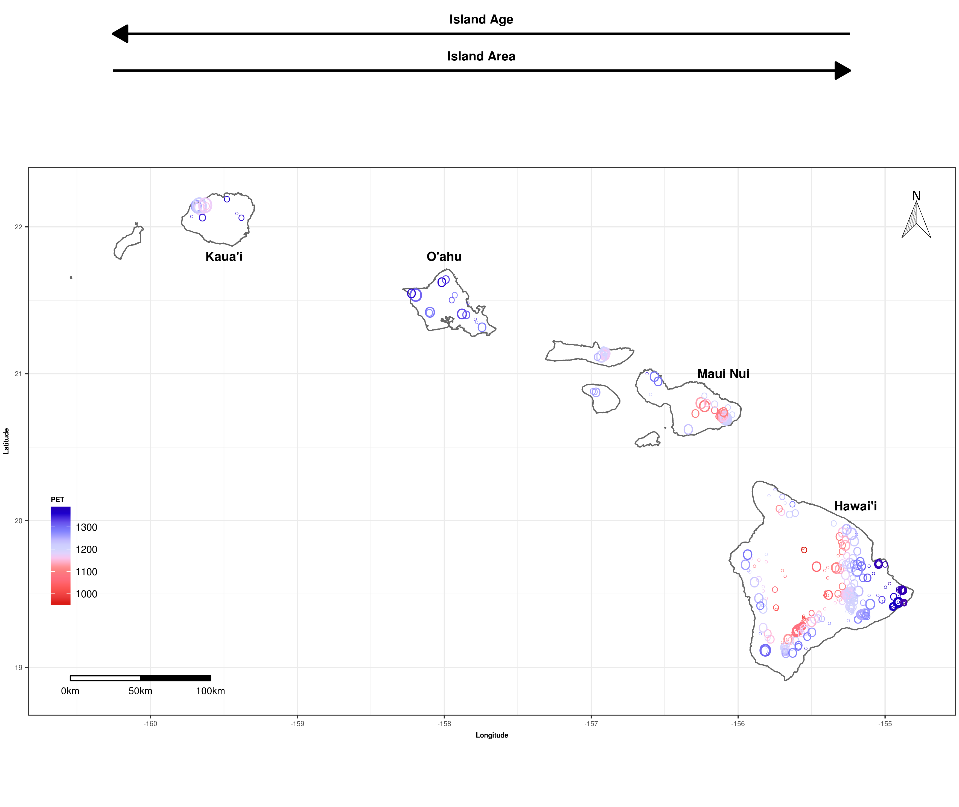

**Fig. 1.** Species diversity patterns of native plants across Hawaiian Islands at local spatial scales. Each point represents a forest plot (*n* = 429) that is scaled by species diversity estimated using asymptotic estimates of richness and whose color corresponds to potential evapotranspiration (PET; mm-1 yr-1).

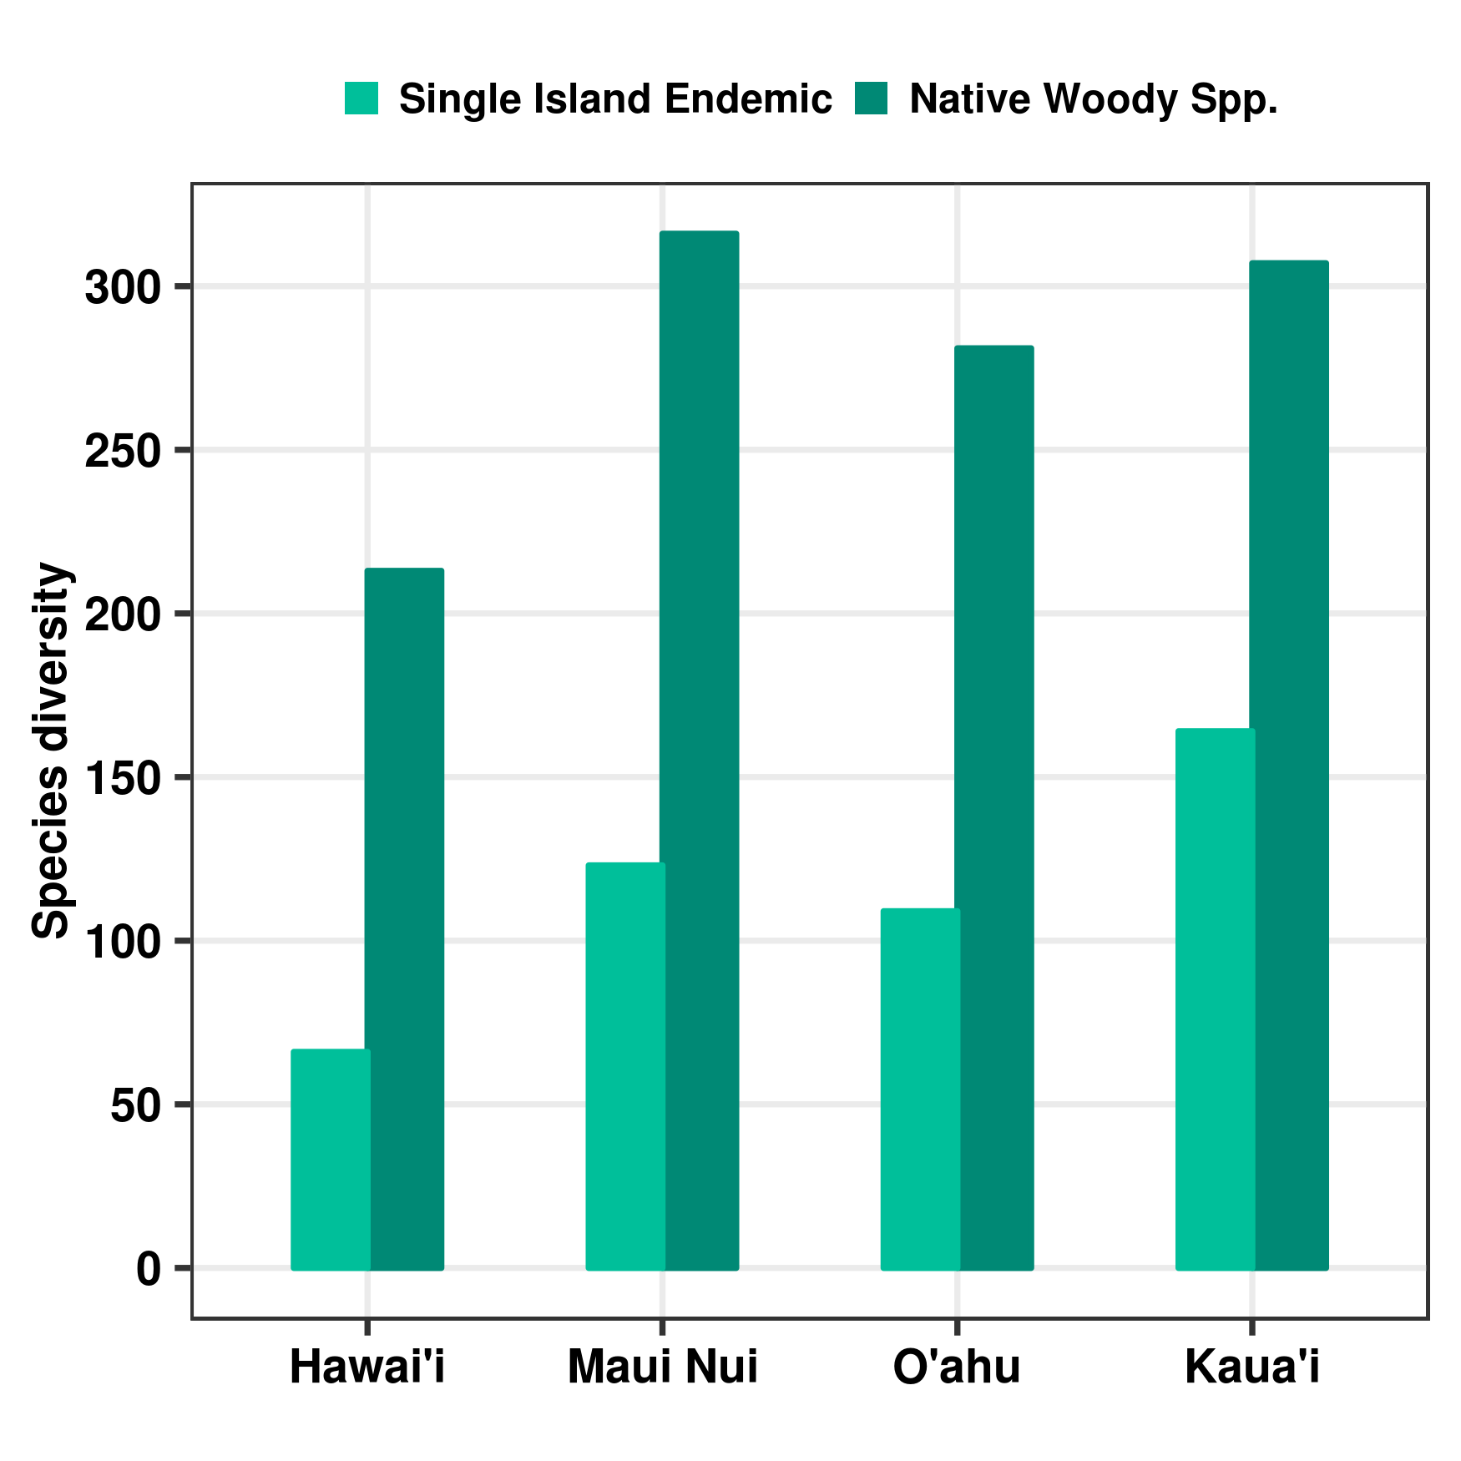

**Fig. 2.** Species diversity patterns of native plants across the Hawaiian archipelago at the island scale. Species diversity is estimated for native woody species and single island endemic species using an island-level checklist of the Hawaiian flora. Islands are ordered by age from youngest to oldest (left to right).

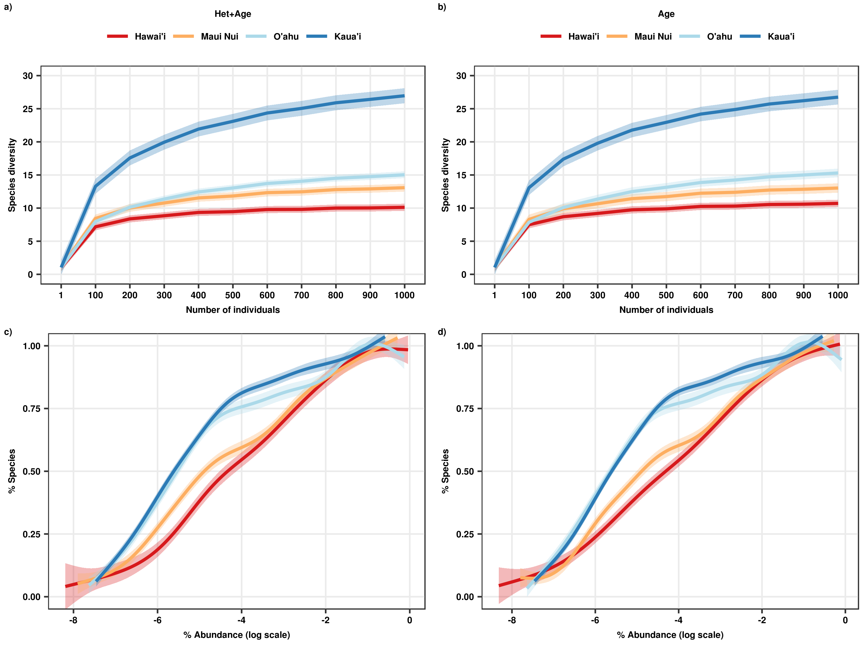

**Fig. 3**. Rarefaction curves and relative abundance distributions of native forest communities across the Hawaiian archipelago, estimated under two sampling scenarios that influence biodiversity. In the first scenario ('Het+Age' ; **a** & **c**) sampling effort is controlled for and in the second scenario, both sampling effort and environmental heterogeneity are controlled for ('Age' ; **b** & **d**). Individual-based rarefaction curves (**a** and **b**) were estimated with interpolation and extrapolation up to 1,000 individuals. Relative abundance distributions (**c** & **d**) are presented as re-scaled empirical cumulative distribution functions. Individual-based rarefaction curves and relative abundance distributions were estimated for the 'Het+Age' and 'Age' scenarios by randomly selecting seven plots per island one hundred times to control for sampled area. For the ‘Age’ scenario, environmental heterogeneity was controlled for by randomly selecting seven plots per island whose range in PET was less than 200 mm year-1. Colored bands are 95% simultaneous confidence intervals and solid lines are fitted using generalized additive mixed-effects models.

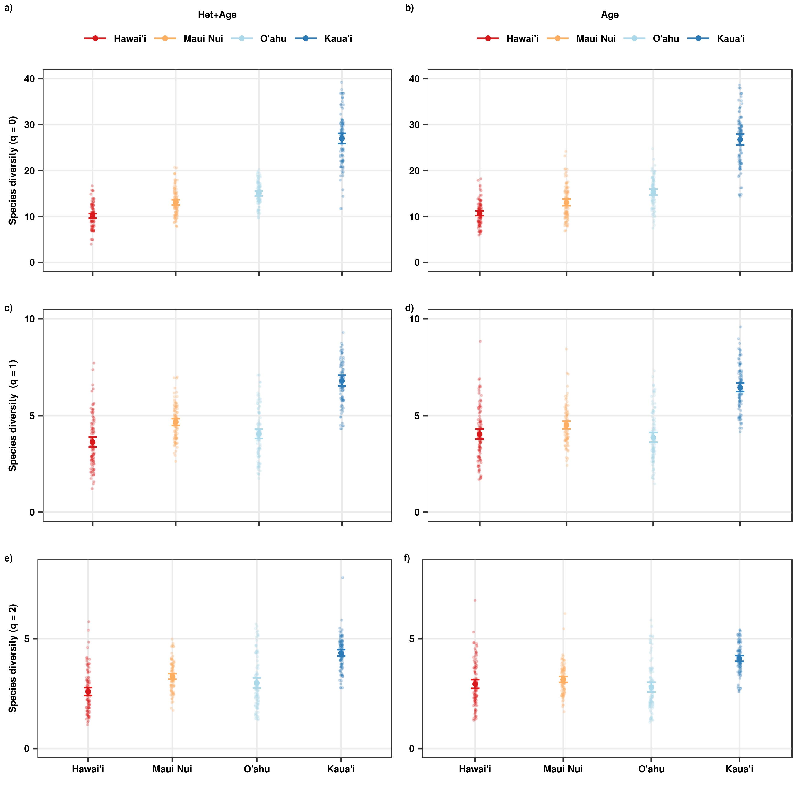**Fig. 4**. Species diversity patterns of native forest communities across the Hawaiian archipelago estimated under two sampling scenarios controlling for factors that influence biodiversity. Species diversity was estimated using Hill numbers 0 (**a** & **b**), 1 (**c** & **d**) and 2 (**e** & **f**) that give increasing weight to abundance and is expressed in terms of effective species numbers. In the first scenario ('Het+Age' ; **a**, **c, e**) sampling effort is controlled for by selecting a fixed number of plots per island, and in the second scenario sampling effort and environmental heterogeneity ('Age'; **b, d, f**) are controlled for by selecting a fixed number of plots per island that have a restricted amount of environmental heterogeneity. For the 'Het+Age' scenario, seven plots were randomly selected per island one hundred times to control for sampled area. For the ‘Age’ scenario, environmental heterogeneity was controlled for by randomly selecting seven plots per island one hundred times whose range in PET was less than 200 mm year-1. Species diversity is estimated using 1,000 individuals for both scenarios. Whisker bars are 95% bootstrapped confidence intervals.

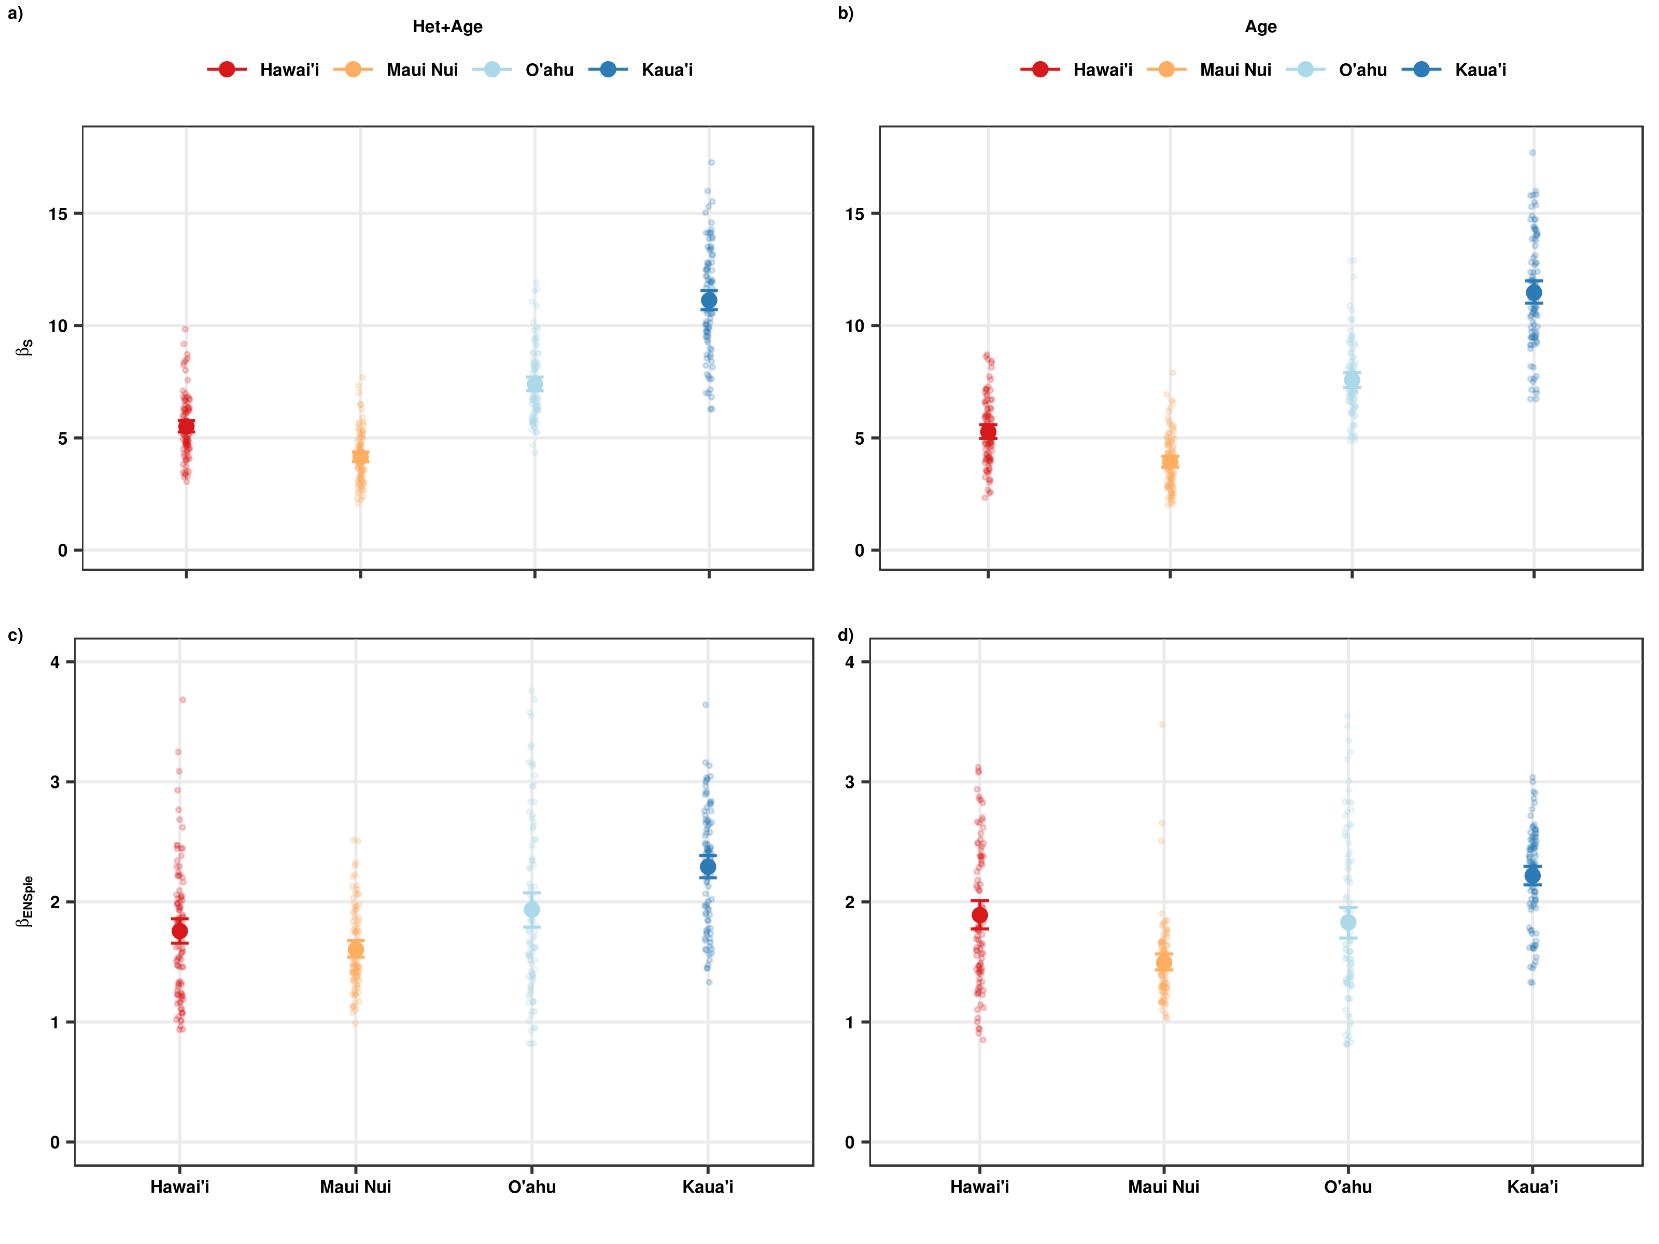**Fig. 5**. Beta diversity patterns of native forest communities across the Hawaiian archipelago estimated under two sampling scenarios controlling for factors that influence biodiversity. Beta diversity was calculated as S (**a** & **b**) and ENSPIE (**c** & **d**); the former highlights contributions of rare species (Hill number= 0) while the latter emphasizes contributions by common species (Hill number = 2). In the first scenario ('Het+Age' ; **a** & **c**) sampling effort is controlled for by selecting a fixed number of plots per island, and in the second sampling effort and environmental heterogeneity ('Age'; **b** & **d**) are controlled for by selecting a fixed number of plots per island that have a restricted amount of environmental heterogeneity. For the 'Het+Age' scenario, seven plots were randomly selected per island one hundred times to control for sampled area. For the ‘Age’ scenario, environmental heterogeneity was controlled for by randomly selecting seven plots per island one hundred times whose range in PET was less than 200 mm year-1. Whisker bars are 95% bootstrapped confidence intervals.