Testing macro-ecological and macro-evolutionary patterns of biodiversity across the Hawaiian archipelago
Dylan Craven^{1,2,3*}, Tiffany M. Knight^{4,1,2}, Kasey E. Barton⁵, Lalasia Bialic-Murphy⁵ , Jonathan Chase^{52,6}
1 Department of Community Ecology, Helmholtz Centre for Environmental Research – UFZ, Theodor-Lieser-Straße 4, 06120 Halle (Saale), Germany
2 German Centre for Integrative Biodiversity Research (iDiv) Halle-Jena-Leipzig, Deutscher Platz 5e, 04103, Leipzig, Germany
3 Biodiversity, Macroecology & Biogeography, Faculty of Forest Sciences and Forest
Ecology, University of Göttingen, 37077 Göttingen, Germany
4 Institute of Biology, Martin Luther University Halle-Wittenberg, Am Kirchtor 1, 06108, Halle (Saale), Germany
5 Department of Botany, University of Hawai'i at Mānoa, Honolulu, Hawai'i, USA
6 Department of Computer Science, Martin Luther University, Halle-Wittenberg
* Corresponding author: dylan.craven@aya.yale.edu

Classification: Biological Sciences (Ecology)

Keywords: Hawaii, biodiversity, forests, island biogeography, island age, habitat heterogeneity, island area, sampling effects

Abstract
Globally, biodiversity patterns emerge as a consequence of both evolutionary and ecological processes. Their relative importance is frequently tested on model ecosystems such as oceanic islands that vary in both. However, the coarse-scale data used to perform such analyses have limited inferential power to separate the effects of historical biogeographic factors, such as island age, from those of ecological ones, such as island area and habitat heterogeneity. Using a comprehensive database of forest plots across the Hawaiian archipelago, we describe biodiversity patterns of native plants across multiple spatial scales and then disentangle the effects of island age, area, and habitat heterogeneity that shape these patterns. At both island and local scales, we find evidence that island age strongly influences species diversity patterns. Our results indicate that, once accounting for the effects of area and habitat heterogeneity, greater species diversity per unit area on older islands emerges due to a greater number of rare species that are heterogeneously distributed in space. Our approach clearly demonstrates that both ecological and evolutionary factors shape biodiversity patterns in a model archipelago ecosystem, and can be applied to disentangle biodiversity drivers in other systems.

Significance statement

Integrating evolutionary and ecological factors is an essential step towards reaching a more complete understanding of the mechanisms that underlie biodiversity patterns. While oceanic islands are often used as natural laboratories because they are discrete spatial units and vary in age, island- (or archipelago-) level species checklists lack information about species abundances and distributions within islands that is needed to disentangle the effects of biogeographical and ecological factors on biodiversity. Here, we present forest plot data from across the Hawaiian archipelago and show that the effects of island age on diversity patterns of native plant species percolate across spatial scales via the distribution of rare species. In doing so, we show that species diversity patterns across a hotspot archipelago, such as Hawai'i, reflect the joint influence of contemporary and historical drivers.

Introduction
Biodiversity is unequally distributed across the globe. For example, the number of co-occurring tree species ranges from boreal forests of only a few species that spread across thousands of hectares (1) to tropical forests with upwards of 1,000 species co-occurring within only tens to hundreds of hectares (2) . This variation in biodiversity has emerged over evolutionary time (3)and also reflects current patterns of available habitat area, climate and disturbance (including anthropogenic disturbances) (4–6), as well as historical patterns of climate, interactions with other species, and biogeography (7–10).
Research on oceanic islands has generated some of the most influential theories on biodiversity dynamics via evolutionary (11, 12) and ecological processes (13). For example, historical biogeographic factors can play an important role in driving diversity patterns, such as differences in island age resulting from volcanic processes or differences in historical connections to mainland areas (14–16). At the same time, ecological factors such as island area and heterogeneity, as well as climatic factors, also explain a large amount of the variation in biodiversity across islands (17, 18). While it is impossible to fully separate evolutionary effects from contemporary ecological effects in driving patterns of biodiversity on islands (10, 19–21), islands have served as a model system in which to evaluate their relative importance, to understand how biodiversity is maintained, and to predict how it may change in the face of ongoing anthropogenic factors.
The Hawaiian archipelago, and similar hotspot archipelagos, provides an ideal testing ground for studying the interplay between ecological and evolutionary processes generating and maintaining island-level diversity (e.g., 22–25). This is because such archipelagos form over volcanic hotspots that create islands of different ages. Among the main Hawaiian islands, Kaua’i is ~5 million years old, O’ahu is ~3 million years old, Maui Nui is 1-2 million years old, and the island of Hawai’i is less than 0.5 million years old and still growing (26). While this age gradient has served as a natural experiment for studies examining the influence of time for diversification on contemporary diversity patterns (27, 28), hotspot archipelagos such as Hawai’i do not allow for a perfect test of island age because there are at least two ecological factors that co-vary with island age: island size and island heterogeneity. The youngest island (Hawai’i) is also the largest and most heterogeneous (e.g., largest elevational gradient), while the oldest island (Kaua’i) is smaller and has lost much of its heterogeneity due to erosion (26). These co-varying ecological and evolutionary factors are repeated on hotspot archipelagos around the world, and as a result, evolutionary radiations and species extinctions appear to track ontogenetic changes in island characteristics (25); clades rapidly accumulate species as islands grow and subsequently lose species as islands decay.
While the conceptual framework for the interplay between evolutionary and ecological factors in driving patterns of biodiversity on islands is compelling (29), the data used to test these hypotheses are often limited. For example, macroecological and biogeographic data, such as species richness patterns and patterns of endemism, are used at very coarse scales (e.g., from island checklist data) and thus cannot allow for robust inference regarding within-island confounded variables, such as island heterogeneity. Therefore, more detailed information on the abundances and small-scale distributions of species is required in order to disentangle these ecological and evolutionary hypotheses. While a few studies have begun to apply smaller-scale data to larger-scale eco-evolutionary questions on islands, these studies have been greatly limited in scope, e.g., few sampling locations across gradients of island age, and thus not have not been able to fully disentangle the effects of island age, area, and heterogeneity on patterns of biodiversity (21, 23, 30, 31).
Our primary objectives are to describe patterns of biodiversity in the Hawaiian archipelago at multiple spatial scales and to distinguish the roles that island age, area, and habitat heterogeneity likely play in determining these observed patterns. We focus on native forest communities (trees, shrubs, and tree ferns) because they have been intensively sampled using similar methods across the Hawaiian archipelago (32) and to minimize alien plant impacts on plant communities (33). We collated data from multiple studies into a common dataset with a total of 429 sampling plots that consists of 23,570 individuals of 104 species (Fig. 1, 32). Because we had data on numbers of individuals of each species, we were able to use an array of complementary analyses, specifically rarefaction curves and relative abundance distributions, to disentangle factors that correlate with biodiversity patterns (34–38) that are not possible in macroecological studies that typically use island-level species checklists.

Results & Discussion
At the large (island-level) spatial scale, we find evidence consistent with the idea that island age plays an important role in generating biodiversity patterns using checklists of native woody plant species on each island (Fig. 2). The youngest island, Hawai’i, has the fewest numbers of native woody species and the fewest single island endemic species. Kaua’i, the oldest island, has the highest number of single island endemics, suggesting an important role for diversification processes in generating contemporary patterns of island-level biodiversity (15, 19).
At the small (plot-level) spatial scale, however, we find a pattern that is opposite to that observed using island-level species checklists (Fig. 3a). Across all sampling plots, there are more species observed on the youngest islands (Hawai’i and Maui Nui) and fewer species on the smaller, older islands (Kaua’i and O’ahu). This result is strongly influenced by sampling intensity; there were many more sample plots on Hawai’i and fewer on the smaller, older islands (Fig. 1; Table S1). When we rarefied species richness to standardize sampling effort across the islands to 10,000 individuals using individual-based rarefactions, the difference in species richness (per 10,000 individuals) remained higher for Hawai’i compared to Kaua’i (Fig. S1). However, when we rarefied to smaller sample sizes (100 or 1,000 individuals), the observed differences among the islands disappeared. This suggests that Hawai’i likely has more observed species across all of its sampling plots because (i) it is larger, which allows for the sampling of more individuals and thus the detection of more species and/or (ii) as a result of its bigger size, it is more heterogeneous and has more habitat types than smaller islands.
How can we disentangle the influence of island age from other confounded ecological factors, such as island size and habitat heterogeneity on diversity patterns across islands? To unveil the influence of these drivers of species richness differences across the islands, we compared species richness patterns on islands using three nested sampling scenarios. First, we used data from all sampling plots, which includes differences in all three factors that can influence the numbers of observed species: area (a proxy for sampling intensity), habitat heterogeneity, and island age (‘Area+Het+Age’). We compared across individual-based rarefaction curves to eliminate the effect of the higher sampling effort on bigger islands (Fig. 3a; Fig. S1). We find that the rarefaction curves were similar at lower numbers of individuals, but increasingly diverged at higher numbers of individuals, where the younger, larger islands accumulate species at greater rates than the older, smaller islands. In addition, we calculated relative abundance distributions (RADs), which depict proportional changes in species abundances as a function of their rank within a community. We find that the younger islands, Hawai’i and Maui Nui, appear to have more rare species (39) than the older islands, Kaua’i and O’ahu (Fig. 3d).
We next controlled for differences in sampling effort and island area, but not habitat heterogeneity or island age,by randomly selecting a fixed (seven) number of sampling plots (‘Het+Age’; Table S2), and found a dramatic reversal of the pattern. At a standardized area (between 0.54 – 0.67 ha), the older, smaller islands have steeper rarefaction curves with higher asymptotes than the younger, larger islands (Fig. 3b). This is also reflected in their RADs, where the older islands have more rare species per standardized sample than the younger islands (Fig. 3e). Finally, we sampled plots where we controlled for area and habitat heterogeneity simultaneously by randomly selecting seven plots per island with similar habitat heterogeneity (‘Age’), inferred using potential evapotranspiration (PET) as a proxy because it integrates variation in elevation and precipitation (see Materials and Methods). Here, we found similar patterns for both the rarefaction curves (Fig. 3c) and the shape of the RADs (Fig. 3f). This final sampling scenario, controlling for both habitat heterogeneity and area, indicates that there is a strong effect of island age. Specifically, when controlling for other confounding ecological factors, there are more species per unit area on the older islands and this is because they have more rare species, depicted by changes in the shape of their RADs.
We next compared values of diversity using the same sampling scenarios as above. Diversity values can be compared via Hill numbers (40), the most familiar of which are q=0 (species richness), q=1 (Shannon diversity), and q=2 (Simpson diversity). The increasing order from richness (q=0) to Simpson (q=2) places greater emphasis on evenness. Across native Hawaiian forests, species richness (q=0) is highest on the youngest, largest island of Hawai’i (Fig. 4a), whereas the oldest, smallest island of Kaua’i was the most diverse when evenness was considered (Fig. 4d & g). However, when we controlled for differences in area (‘Het+Age’) and heterogeneity (‘Age’) via re-sampling, the oldest, smallest island (Kaua’i) was the most diverse and the youngest, largest island (Hawai’i) was the least diverse in all metrics (Fig. 4b, c, e, f, h and i). Species richness (q = 0) was higher on older, smaller O’ahu than on Maui (Fig. 4b and c), but both islands were similarly diverse when q = 1 or 2 (Fig. 4e, f, h, and i). This again indicates that once we control for ecological factors, island age plays a critical role in driving the numbers of species, and in particular, the numbers of rare species.
Finally, we examined whether island age simply influenced the relative evenness of species on islands, or if these patterns emerged from differences in the spatial distributions of species on the different islands. We calculated beta diversity using two Hill numbers (41, 42), 0 and 2, to determine how site-to-site variation in species composition influenced the observed patterns. When q=0, we found that Hawai’i had significantly greater beta diversity than the other three islands when all three drivers of diversity were included (‘Area+Het+Age’; Fig. 5a). This pattern shifted markedly when we controlled for differences in area (‘Het+Age’; Fig. 5b) and habitat heterogeneity (‘Age’ ; Fig 5c); in both of these sampling scenarios, we found significantly higher levels of beta diversity on the older islands. When we calculated beta diversity at q=2 (Fig. 5d, e, and f), where common species drive the patterns, we found that the two older islands consistently exhibited higher levels of beta diversity than the two younger islands when controlling for differences in area and habitat heterogeneity (Fig. 5e and f). This indicates that rare species, unlike common species, are heterogeneously distributed in space after controlling for differences in area and habitat heterogeneity.
Our analyses show that once area and heterogeneity are controlled for, we can detect a strong effect of island age on diversity patterns of native forest communities across the Hawaiian archipelago at local scales that echoes diversity patterns observed at macro-ecological scales (43). The oldest islands, Kaua’i and O’ahu, have more species per unit area and within similar habitats than the youngest islands, Maui Nui and Hawai’i. The higher species richness per unit area on the older islands seems to be primarily a result of there being more rare species per unit area on the older islands relative to the younger islands. Moreover, the higher level of rarity on older islands appears to be spatially distributed, such that rare species are more aggregated on older islands than on younger islands. This latter result, i.e. greater beta diversity on older islands, could have emerged for a number of reasons. For example, higher levels of beta diversity of rare species could reflect that longer time for divergence on the older islands has allowed for higher rates of allopatric speciation with little secondary contact (27, 28, 44). Higher levels of beta diversity also could result if eco-evolutionary and frequency-dependent feedbacks, e.g., interspecific interactions or interactions with enemies, have created higher levels of spatial dispersion among otherwise similar species (45, 46). Additionally, beta diversity patterns may reflect greater habitat loss for native species due to land-use change on the older islands of Kaua’i and O’ahu (47).
The identification of ecological and evolutionary mechanisms are needed to fully explain the effects of island age on species diversity patterns across the Hawaiian archipelago. Based on our findings, we expect that species’ ages would increase with island age, while diversification rates would decrease (14, 25). However, a highly-resolved molecular phylogeny of the complete Hawaiian flora is not currently available. A promising path forward would be to compile and combine extant genetic and phylogenetic data (48) from well-studied clades that have undergone adaptive radiation in Hawaii, such as the silversword alliance (27). The greater species diversity per unit area found on older islands, once controlling for area and habitat heterogeneity, also suggests that communities may partition resources at finer spatial scales on older islands than on younger ones. On older islands there may be less trait overlap and greater trait divergence at local scales than on younger islands, particularly for traits associated with water and nutrient acquisition (e.g., 49, 50). To test for such fine-scale patterns, a comprehensive database of native and alien woody plants would need to be compiled using locally collected traits because the steep environmental gradients that occur across the Hawaiian archipelago likely lead to high intraspecific trait variation (51, 52), which may not be captured when using trait values from large plant trait databases (53).

Conclusion
Integrating evolutionary and ecological factors has been considered an essential step (10, 19, 54) towards deepening current understanding of the mechanisms that underpin biodiversity patterns. Here we leverage a comprehensive database of forest plots distributed across the Hawaiian archipelago and use it to show that the effects of island age on diversity patterns percolate across scales, from macroecological to local, via the spatial distribution of rare species. In doing so, we provide further evidence that species diversity patterns across islands bear the imprint of both contemporary ecological and historical evolutionary factors. Our approach can be readily applied to other systems for which there is local scale sampling of communities across relevant ecological gradients.

Materials and Methods
Data acquisition and description.
To estimate species richness of native woody species and single island endemics for each island across the Hawaiian archipelago, we classified all plant species in the flora of the Hawaiian Islands (55) as native or alien and woody, herbaceous, or variable using the Global Woodiness Database (56, 57). Species not found in the Global Woodiness Database were classified using the same methodology by consulting electronic sources (55, 58).
We assembled a database containing 429 plots and 104 native plant species, including trees, shrubs, and tree ferns from publicly available sources and published studies with forest plot data in Hawaii where species identity and size of individuals ≥ 5 cm diameter at 1.3 m were reported (32). Forest plots range in area from 100 to 1018 m² (median = 1000 m²) and are unevenly distributed across the main islands of the archipelago (75.3% of all plots are located on Hawai’i Island; Fig.1). Consequently, sampled area per island also varies strongly, from 1.0 ha on Kaua’i Island to 24.8 ha on Hawai’i Island (Table S1). Mean annual temperature and precipitation (59), elevation (60), and mean potential evapotranspiration (61) were extracted for each plot at a 1 km resolution (Table S1). Species names were standardized using The Plant List v 1.1 (www.theplantlist.org, 62) and native status was obtained from the flora of the Hawaiian Islands (55). Species abundances were calculated on a per hectare basis in each plot to facilitate data aggregation and heavily invaded plots ( > 75% alien species) were excluded. Throughout our analysis, we treat islands in the Maui Nui complex, i.e. Maui, Moloka’i, Lana’i, and Kaho’olawe, as one island because they have formed a single landmass during most of its history (63).
Sampling scenarios for dissecting species diversity patterns.
To examine the impacts of the sampling effects and habitat heterogeneity on biodiversity patterns of native woody plants across Hawaiian Islands, we use data generated from three nested sampling scenarios. Each sampling scenario represents a hypothesized driver of biodiversity patterns across islands. In the first sampling scenario (‘Area+Het+Age’), we use all plot data such that resulting biodiversity patterns across islands reflect the influence of sampled area, habitat heterogeneity, and island age. In the second sampling scenario (‘Het+Age’), we control for area effects by randomly selecting seven plots per island one hundred times but do not control for habitat heterogeneity or island age (Table S2). In the third sampling scenario (‘Age’), we control for area and habitat heterogeneity simultaneously by randomly selecting seven plots per island where the range in PET (PET_{range} = PET_{max} - PET_{min}) among plots was below 200 mm yr⁻¹ one hundred times (Table S2). Given the strong effects of elevation and precipitation on the distribution of habitat types across Hawaii (56), selecting plots within a limited range of PET is equivalent to selecting plots within a particular habitat type. The PET_{range} threshold was chosen because it is the minimum range in PET observed across plots in Kaua’i, the island with the fewest number of plots in our database (Table S1). To test the sensitivity of the observed patterns to the sampled area per island, we performed the same analyses but varied the number of plots selected at random. Results are consistent with those presented here (see Figs. S2- S7, Tables S3 and S4).
Data analysis.
For all analyses, we pooled plot data per island to ensure sufficiently large sample sizes for sample completeness and estimation of species diversity (64). We first estimated species richness for native plants of each island using sample-based rarefaction for 100, 1,000, 10,000, and all individuals with ‘vegan’ (65). For each island and iteration of all sampling scenarios, we estimated species accumulation curves (SACs) using coverage-based interpolation and extrapolation with ‘iNEXT’ (35, 66). We calculated relative abundance distributions (RADs) using empirical cumulative distributions functions, which depict proportional changes in species abundances as a function of their rank within a community because they facilitate comparison among communities by correcting for different species diversities (67). We fit rarefaction curves across all iterations of each sampling scenario and island using generalized additive mixed-effects with a Gaussian distribution where iteration was the random group effect using ‘gamm4’ (68).
Species diversity for Hill numbers 0, 1, and 2 were estimated using sample-based interpolation for 10,000 individuals for the ‘Area+Het+Age’ sampling scenario and 1,000 individuals for the ‘Het+Age’ and ‘Age’ sampling scenarios to facilitate comparisons of diversities across communities. Hill numbers 0, 1, and 2 give increasing weight to species abundance and are equivalent to species richness, Shannon diversity, and evenness, respectively. Diversity estimates were made using ’iNEXT’ (66). Beta diversity was estimated using species richness (S; q = 0), which gives equal weight to the contribution of rare species, and the effective number of species conversion of the Probability of Interspecific Encounter (ENS_{PIE}; q = 2), which is based on species’ relative abundance and emphasizes common species (36, 37). Both measures of beta diversity were calculated multiplicatively as the turnover between local () and island () scales using ‘mobr’ (35). Species and beta diversity estimates are expressed in terms of effective numbers of species (40). Means and 95% confidence intervals of species and beta diversities were estimated using 1,000 bootstrap samples with ‘rms’ (69); differences among islands are considered significant if confidence intervals do not overlap. To test the sensitivity of our results to sampled area per island, we performed the same analyses but varied the number of plots selected at random . All data manipulation and analyses were performed using R 3.4.4 (70).
Data and code availability.
Data supporting the findings of this study are available for download from (32) and the code used for all analyses and figures are available via GitHub (https://github.com/idiv-biodiversity/Hawaii_diversity).

Acknowledgements
DC, TMK, and JC acknowledge funding by the German Centre for Integrative Biodiversity Research (iDiv) Halle-Jena-Leipzig funded by the German Research Foundation (FZT 118). TMK also acknowledges support from the Alexander von Humboldt Foundation. TMK and KB also acknowledge support from the National Geographic Society and the Pacific Island Climate Science Center. All authors thank data providers for collecting the data.

Author contributions
DC, TMK, and JC conceived and developed the project. DC analysed the data with substantial input from TMK and JC. DC, TMK, and JC wrote the paper with input from all co-authors.

References
1. Gauthier S, Bernier P, Kuuluvainen T, Shvidenko AZ, Schepaschenko DG (2015) Boreal forest health and global change. Science 349(6250):819–822.
2. Anderson‐Teixeira KJ, et al. (2015) CTFS‐ForestGEO: a worldwide network monitoring forests in an era of global change. Global Change Biology 21(2):528–549.
3. Schluter D, Pennell MW (2017) Speciation gradients and the distribution of biodiversity. Nature 546(7656):48–55.
4. Rosenzweig ML (1995) Species diversity in space and time (Cambridge University Press).
5. Gaston KJ (2000) Global patterns in biodiversity. Nature 405(6783):220.
6. Ricklefs RE (2004) A comprehensive framework for global patterns in biodiversity. Ecology Letters 7(1):1–15.
7. Kier G, et al. (2009) A global assessment of endemism and species richness across island and mainland regions. Proceedings of the National Academy of Sciences 106(23):9322–9327.
8. Sandel B, et al. (2011) The influence of Late Quaternary climate-change velocity on species endemism. Science 334(6056):660–664.
9. LaManna JA, et al. (2017) Plant diversity increases with the strength of negative density dependence at the global scale. Science 356(6345):1389–1392.
10. Whittaker RJ, Fernández-Palacios JM, Matthews TJ, Borregaard MK, Triantis KA (2017) Island biogeography: Taking the long view of nature’s laboratories. Science 357(6354). doi:10.1126/science.aam8326.
11. Darwin C (1859) On the origins of species by means of natural selection (John Murray, United Kingdom).
12. Lack D (1947) Darwin’s finches (CUP Archive).
13. MacArthur RH, Wilson EO (1967) The Theory of Island Biogeography (Princeton University Press).
14. Emerson B (2002) Evolution on oceanic islands: molecular phylogenetic approaches to understanding pattern and process. Molecular ecology 11(6):951–966.
15. Gillespie RG (2016) Island time and the interplay between ecology and evolution in species diversification. Evolutionary Applications 9(1):53–73.
16. Weigelt P, Steinbauer MJ, Cabral JS, Kreft H (2016) Late Quaternary climate change shapes island biodiversity. Nature 532(7597):99–102.
17. Kreft H, Jetz W, Mutke J, Kier G, Barthlott W (2008) Global diversity of island floras from a macroecological perspective. Ecology Letters 11(2):116–127.
18. Triantis Kostas A., Economo Evan P., Guilhaumon François, Ricklefs Robert E. (2015) Diversity regulation at macro‐scales: species richness on oceanic archipelagos. Global Ecology and Biogeography 24(5):594–605.
19. Losos JB, Ricklefs RE (2009) Adaptation and diversification on islands. Nature 457:830.
20. Warren BH, et al. (2015) Islands as model systems in ecology and evolution: prospects fifty years after MacArthur-Wilson. Ecol Lett 18(2):200–217.
21. Rominger AJ, et al. (2016) Community assembly on isolated islands: macroecology meets evolution. Global Ecology and Biogeography 25(7):769–780.
22. Gillespie R (2004) Community assembly through adaptive radiation in Hawaiian spiders. Science 303(5656):356–359.
23. Gruner DS (2007) Geological age, ecosystem development, and local resource constraints on arthropod community structure in the Hawaiian Islands. Biol J Linn Soc 90(3):551–570.
24. Price JP, Wagner WL (2011) A phylogenetic basis for species–area relationships among three Pacific Island floras. American Journal of Botany 98(3):449–459.
25. Lim JY, Marshall CR (2017) The true tempo of evolutionary radiation and decline revealed on the Hawaiian archipelago. Nature 543(7647):710–713.
26. Clague DA, Sherrod DR (2014) Growth and degradation of Hawaiian volcanoes. Characteristics of Hawaiian Volcanoes (US Geological Survey Reston, VA), pp 97–146.
27. Baldwin BG, Sanderson MJ (1998) Age and rate of diversification of the Hawaiian silversword alliance (Compositae). Proceedings of the National Academy of Sciences 95(16):9402–9406.
28. Givnish TJ, et al. (2009) Origin, adaptive radiation and diversification of the Hawaiian lobeliads (Asterales: Campanulaceae). Proceedings of the Royal Society of London B: Biological Sciences 276(1656):407–416.
29. Whittaker RJ, Triantis KA, Ladle RJ (2008) A general dynamic theory of oceanic island biogeography. Journal of Biogeography 35(6):977–994.
30. Borges PAV, Hortal J (2009) Time, area and isolation: factors driving the diversification of Azorean arthropods. Journal of Biogeography 36(1):178–191.
31. Ibanez T, et al. (2018) Regional forcing explains local species diversity and turnover on tropical islands. Global Ecol Biogeogr:1–13.
32. Craven, D., et al. (2018) OpenNahele: the open Hawaiian forest plot database. Biodiversity Data Journal.
33. Vilà M, et al. (2011) Ecological impacts of invasive alien plants: a meta-analysis of their effects on species, communities and ecosystems. Ecology Letters 14(7):702–708.
34. Gotelli NJ, Colwell RK (2001) Quantifying biodiversity: procedures and pitfalls in the measurement and comparison of species richness. Ecology Letters 4(4):379–391.
35. Chao A, Jost L (2012) Coverage‐based rarefaction and extrapolation: standardizing samples by completeness rather than size. Ecology 93(12):2533–2547.
36. Chase JM, Knight TM (2013) Scale-dependent effect sizes of ecological drivers on biodiversity: why standardised sampling is not enough. Ecology Letters 16:17–26.
37. McGlinn DJ, et al. (2018) MoB (Measurement of Biodiversity): a method to separate the scale-dependent effects of species abundance distribution, density, and aggregation on diversity change. bioRxiv. doi:10.1101/244103.
38. Chase, J., et al. (2018) A framework for dissecting possible ecological mechanisms underlying the island species-area relationship. bioRxiv.
39. Rabinowitz, D. (1981) Seven forms of rarity. The Biological Aspects of Rare Plant Communities (John Wiley & Sons), pp 205–217.
40. Jost L (2006) Entropy and diversity. Oikos 113(2):363–375.
41. Jost L (2007) Partitioning Diversity into Independent Alpha and Beta Components. Ecology 88(10):2427–2439.
42. Tuomisto H (2010) A diversity of beta diversities: straightening up a concept gone awry. Part 1. Defining beta diversity as a function of alpha and gamma diversity. Ecography 33(1):2–22.
43. Rosenzweig ML, Ziv Y The echo pattern of species diversity: pattern and processes. Ecography 22(6):614–628.
44. Price JP, Clague DA (2002) How old is the Hawaiian biota? Geology and phylogeny suggest recent divergence. Proceedings of the Royal Society of London B: Biological Sciences 269(1508):2429–2435.
45. Ricklefs RE (2010) Host–pathogen coevolution, secondary sympatry and species diversification. Philosophical Transactions of the Royal Society of London B: Biological Sciences 365(1543):1139–1147.
46. Ricklefs RE (2015) Intrinsic dynamics of the regional community. Ecology Letters 18(6):497–503.
47. Jacobi JD, Price JP, Fortini LB, Gon SM, Berkowitz P (2017) Baseline land cover. Baseline and projected future carbon storage and carbon fluxes in ecosystems of Hawai’i US Geological Survey Professional Paper 1834 Reston, VA: US Department of the Interior, US Geological Survey:9–20.
48. Smith SA, Brown JW (2018) Constructing a broadly inclusive seed plant phylogeny. American Journal of Botany 105(3):302–314.
49. Cornwell WK, Ackerly DD (2009) Community assembly and shifts in plant trait distributions across an environmental gradient in coastal California. Ecological Monographs 79(1):109–126.
50. Fortunel C, Valencia R, Wright SJ, Garwood NC, Kraft NJB (2016) Functional trait differences influence neighbourhood interactions in a hyperdiverse Amazonian forest. Ecology Letters 19(9):1062–1070.
51. Cordell S, Goldstein G, Mueller-Dombois D, Webb D, Vitousek PM (1998) Physiological and morphological variation in Metrosideros polymorpha, a dominant Hawaiian tree species, along an altitudinal gradient: the role of phenotypic plasticity. Oecologia 113(2):188–196.
52. Ares A, Fownes JH (1999) Water supply regulates structure, productivity, and water use efficiency of Acacia koa forest in Hawaii. Oecologia 121:458–466.
53. Kazakou E, et al. (2014) Are trait-based species rankings consistent across data sets and spatial scales? Journal of Vegetation Science 25(1):235–247.
54. Donoghue MJ (2008) A phylogenetic perspective on the distribution of plant diversity. PNAS 105(Supplement 1):11549–11555.
55. Wagner WL, Herbst DL, Lorence DH (2005) Flora of the Hawaiian Islands website. Available at: http://botany.si.edu/pacificislandbiodiversity/hawaiianflora/index.htm [Accessed May 1, 2017].
56. Zanne A, et al. (2013) Data from: Three keys to the radiation of angiosperms into freezing environments (Dryad Digital Repository) doi:10.5061/dryad.63q27.2.
57. Zanne AE, et al. (2014) Three keys to the radiation of angiosperms into freezing environments. Nature 506(7486):89.
58. USDA NRCS (2018) The PLANTS Database (http://plants.usda.gov). Available at: http://plants.usda.gov.
59. Karger DN, et al. (2017) Climatologies at high resolution for the earth’s land surface areas. Scientific Data 4:170122.
60. Jarvis A, Reuter H, Nelson A, Guevara E (2008) SRTM 90m Digital Elevation Database v4. 1 (CGIAR-CSI).
61. Trabucco A, Zomer R (2010) Global soil water balance geospatial database. CGIAR Consortium for Spatial Information Published online, available from the CGIAR-CSI GeoPortal at: http://www cgiar-csi org.
62. Cayuela L, Stein A, Oksanen J (2017) Taxonstand: taxonomic standardization of plant species names Available at: https://CRAN.R-project.org/package=Taxonstand.
63. Price JP (2004) Floristic biogeography of the Hawaiian Islands: influences of area, environment and paleogeography. Journal of Biogeography 31(3):487–500.
64. Chao A, Chiu C, Jost L (2016) Statistical challenges of evaluating diversity patterns across environmental gradients in mega‐diverse communities. Journal of Vegetation Science 27(3):437–438.
65. Oksanen J, et al. (2013) Package ‘vegan.’ Community ecology package, version 2(9).
66. Hsieh T. C., Ma K. H., Chao Anne, McInerny Greg (2016) iNEXT: an R package for rarefaction and extrapolation of species diversity (Hill numbers). Methods in Ecology and Evolution 7(12):1451–1456.
67. Magurran AE, McGill BJ (2011) Biological diversity: frontiers in measurement and assessment (Oxford University Press).
68. Wood S, Scheipl F (2017) gamm4: Generalized Additive Mixed Models using “mgcv” and “lme4” Available at: https://CRAN.R-project.org/package=gamm4.
69. Harrell Jr. FE (2017) rms: regression modeling strategies Available at: https://CRAN.R-project.org/package=rms.
70. R Core Team (2018) R: A Language and Environment for Statistical Computing (R Foundation for Statistical Computing, Vienna, Austria) Available at: https://www.R-project.org/.

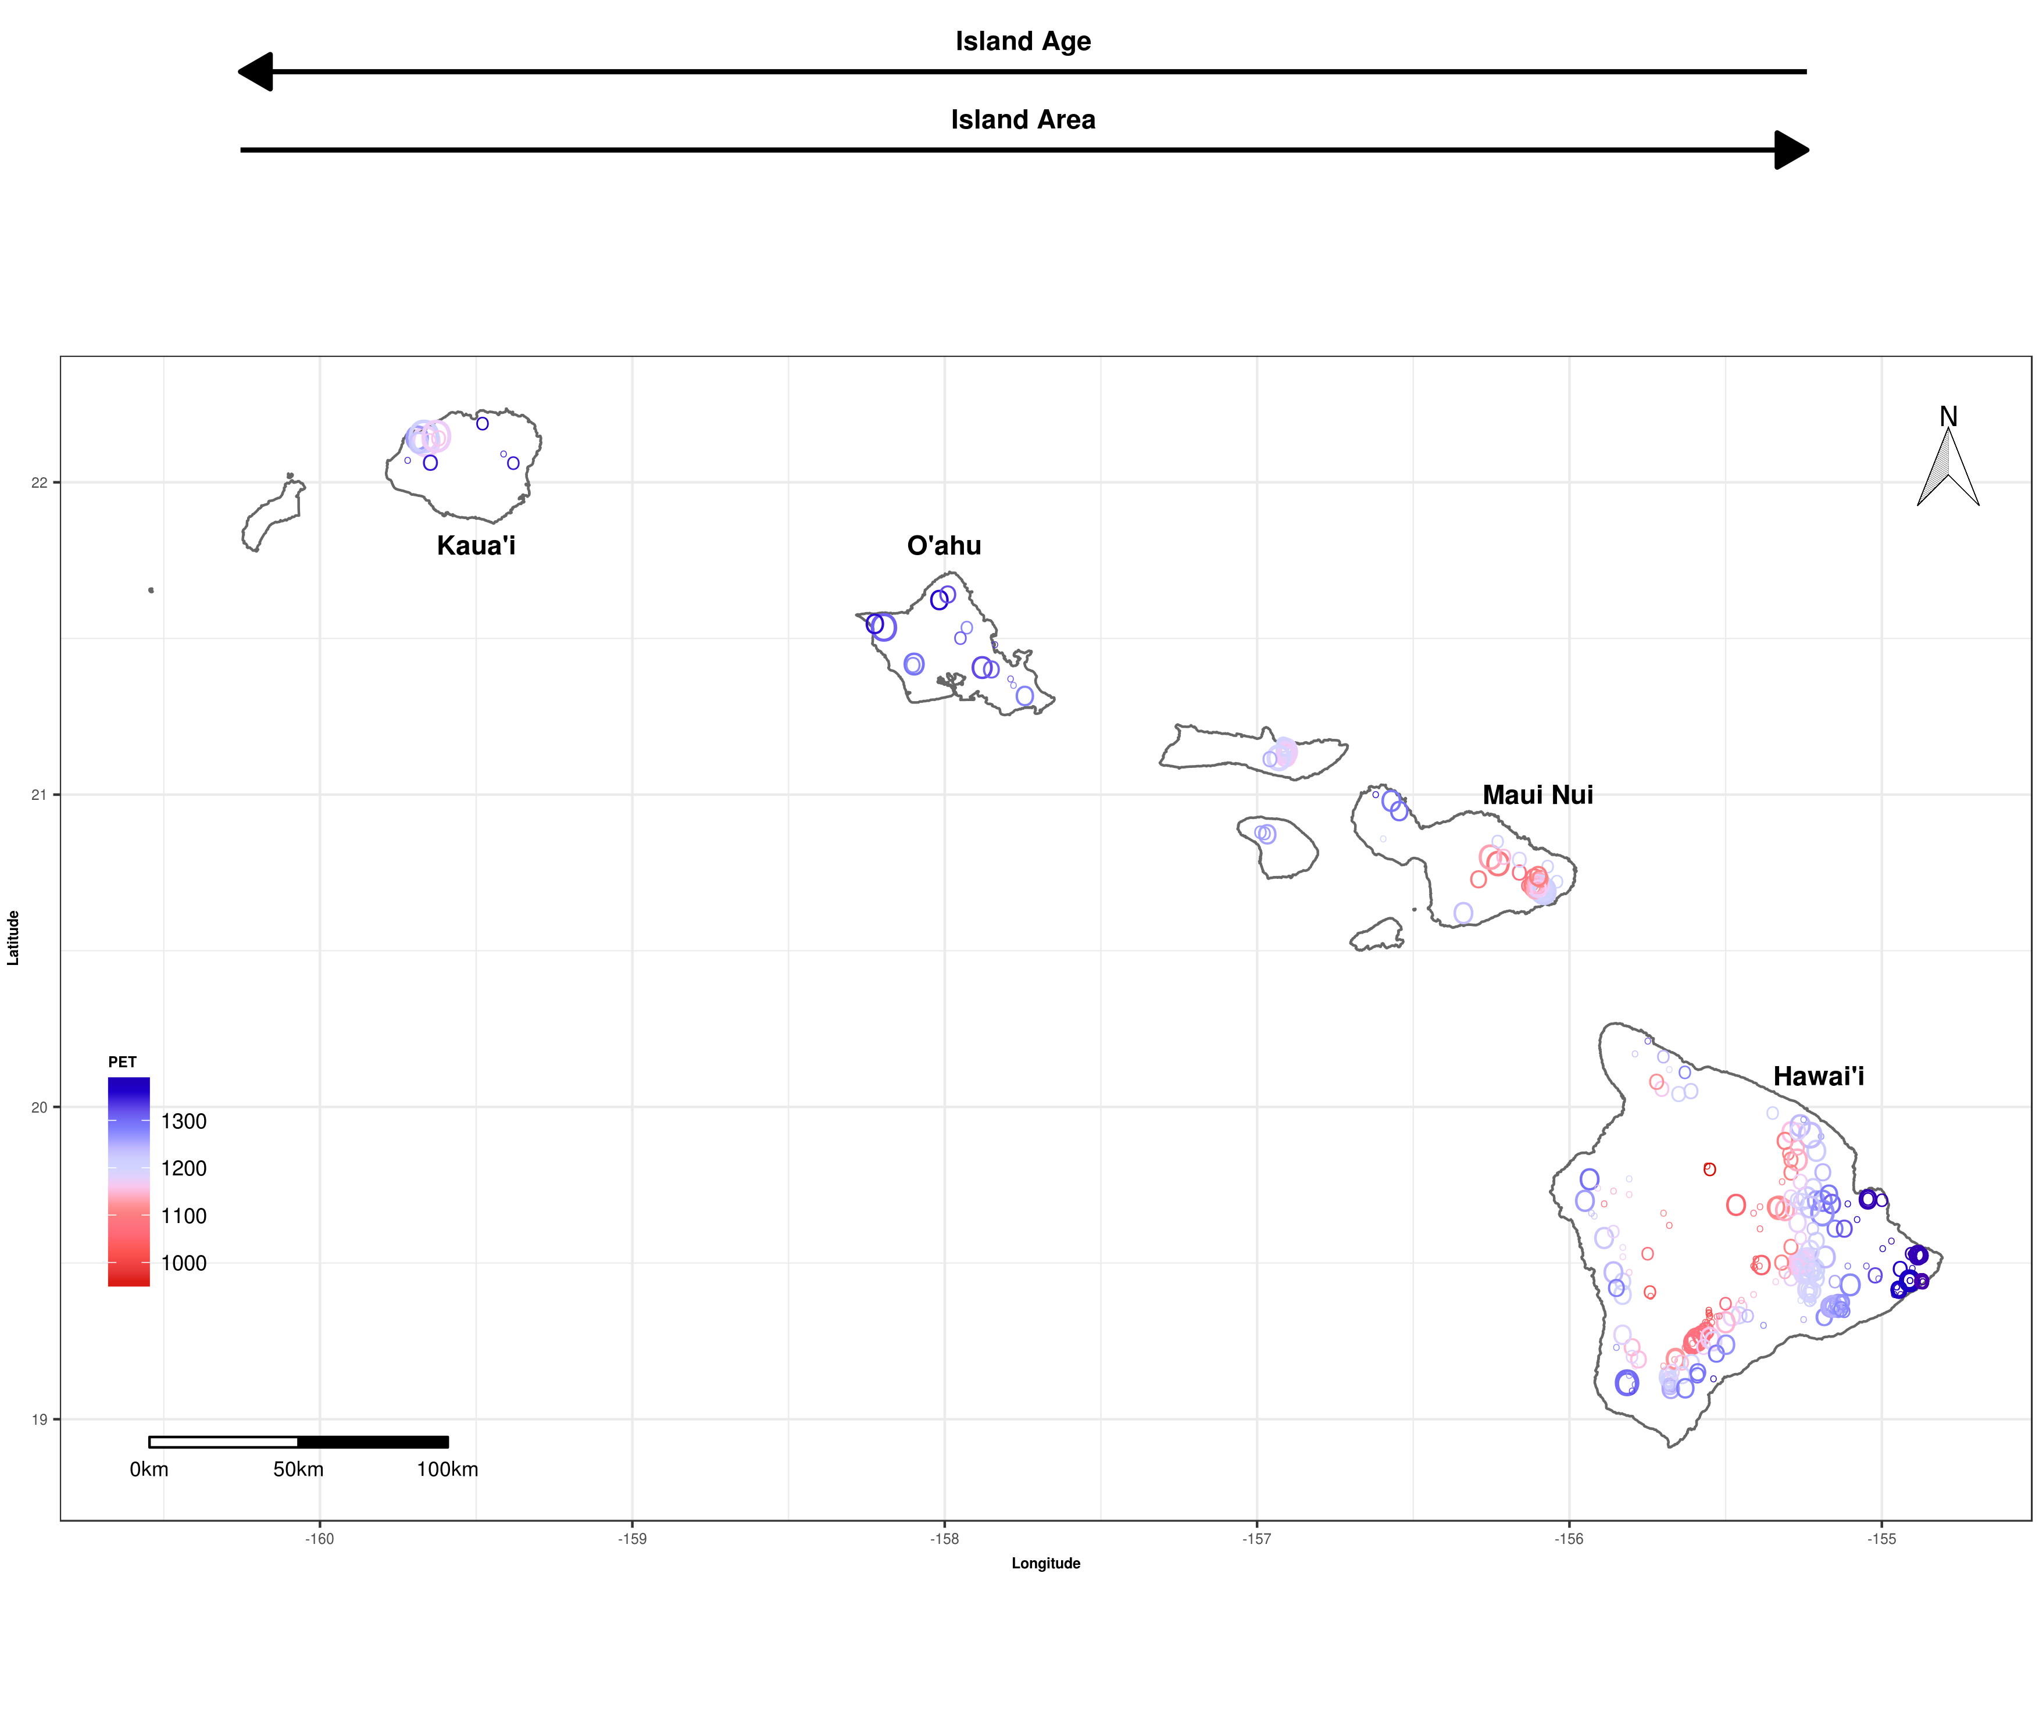
Figures
Fig. 1. Species diversity patterns of native plants across Hawaiian Islands at local spatial scales. Each point represents a forest plot (n = 429) that is scaled by species diversity estimated as extrapolated asymptotic richness and whose color corresponds to PET (mm⁻¹ yr⁻¹).

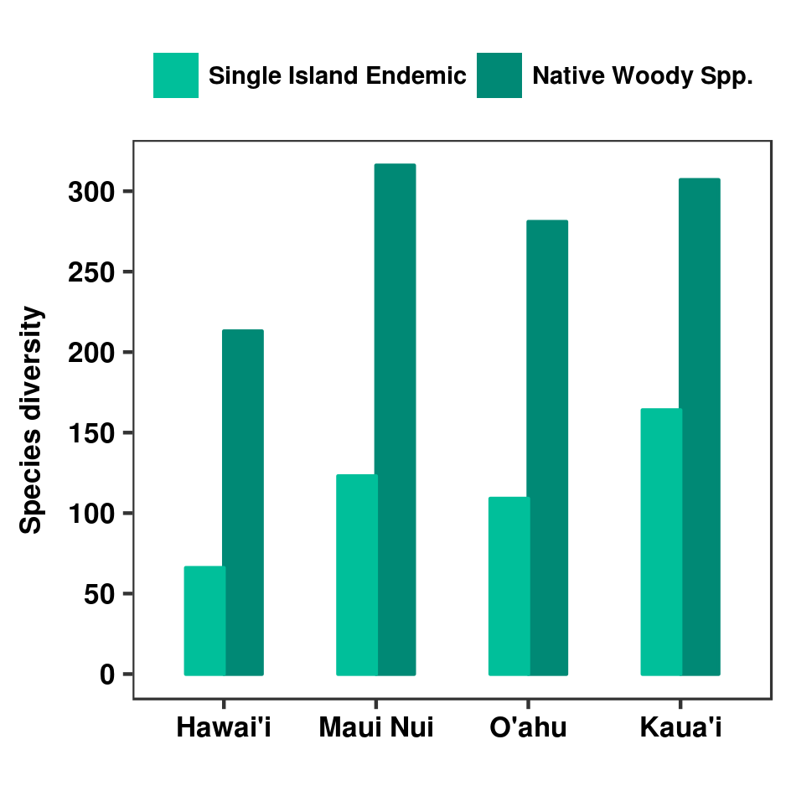

Fig. 2. Species diversity patterns of native plants across the Hawaiian archipelago at the island scale. Species diversity is estimated for native woody species and single island endemic species using an island-level checklist of the Hawaiian flora. Islands are ordered by age from youngest to oldest (left to right).

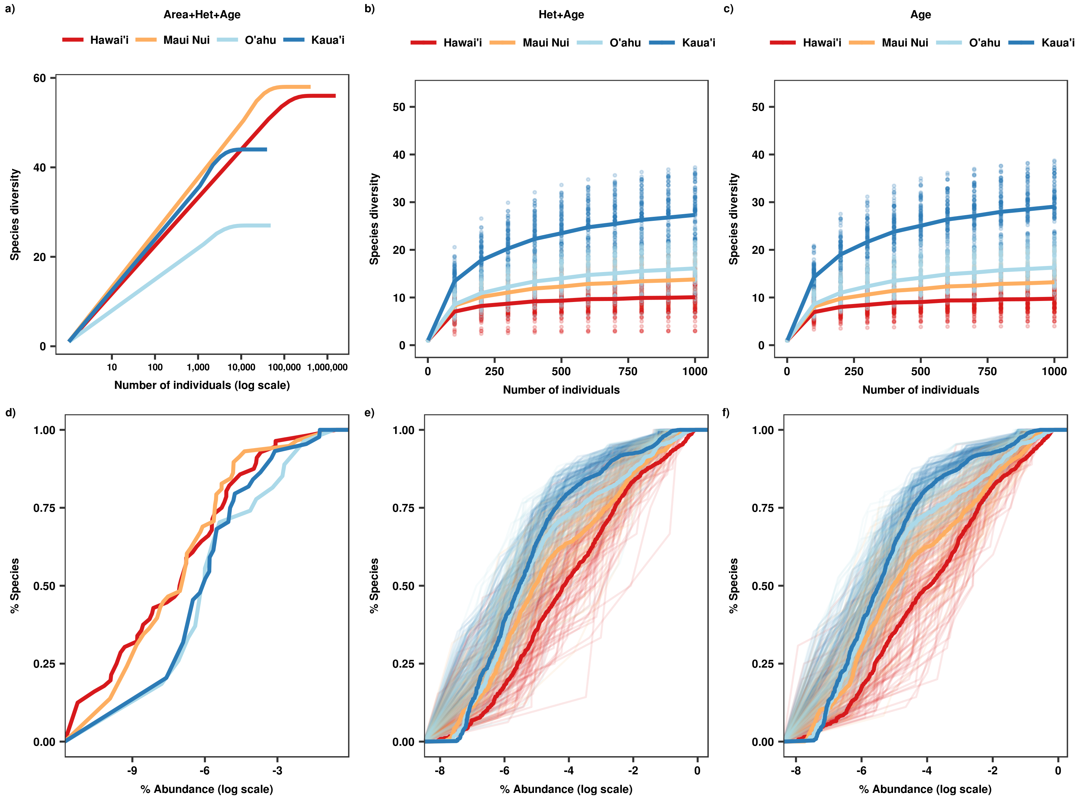
Fig. 3. Rarefaction curves and relative abundance distributions of native forest communities across the Hawaiian archipelago, estimated under three sampling scenarios that influence biodiversity. In the first scenario ('Area+Het+Age' ; a, d), no variable is controlled, while in the second scenario sampled area is controlled ('Het+Age' ; b, e), and in the last scenario sampled area and environmental heterogeneity are controlled for ('Age' ; c, f). Rarefaction curves (a, b, c) were estimated with interpolation and extrapolation. Note that individual-based rarefaction curves are estimated using all individuals for a) but up to 1,000 individuals for b) and c). Relative abundance distributions (d, e, f) are presented as re-scaled empirical cumulative distribution functions. Thick lines are empirical cumulative distribution functions fit across all iterations of each sampling scenario for each island; thin lines are empirical cumulative distribution functions fit of each iteration for each island. Individual-based rarefaction curves and relative abundance distributions were estimated for 'Het+Age' and 'Age' scenarios by randomly selecting seven plots per island one hundred times to control for sampled area. For the ‘Age’ scenario, environmental heterogeneity was controlled for by randomly selecting seven plots per island whose range in PET was less than 200 mm year-1.

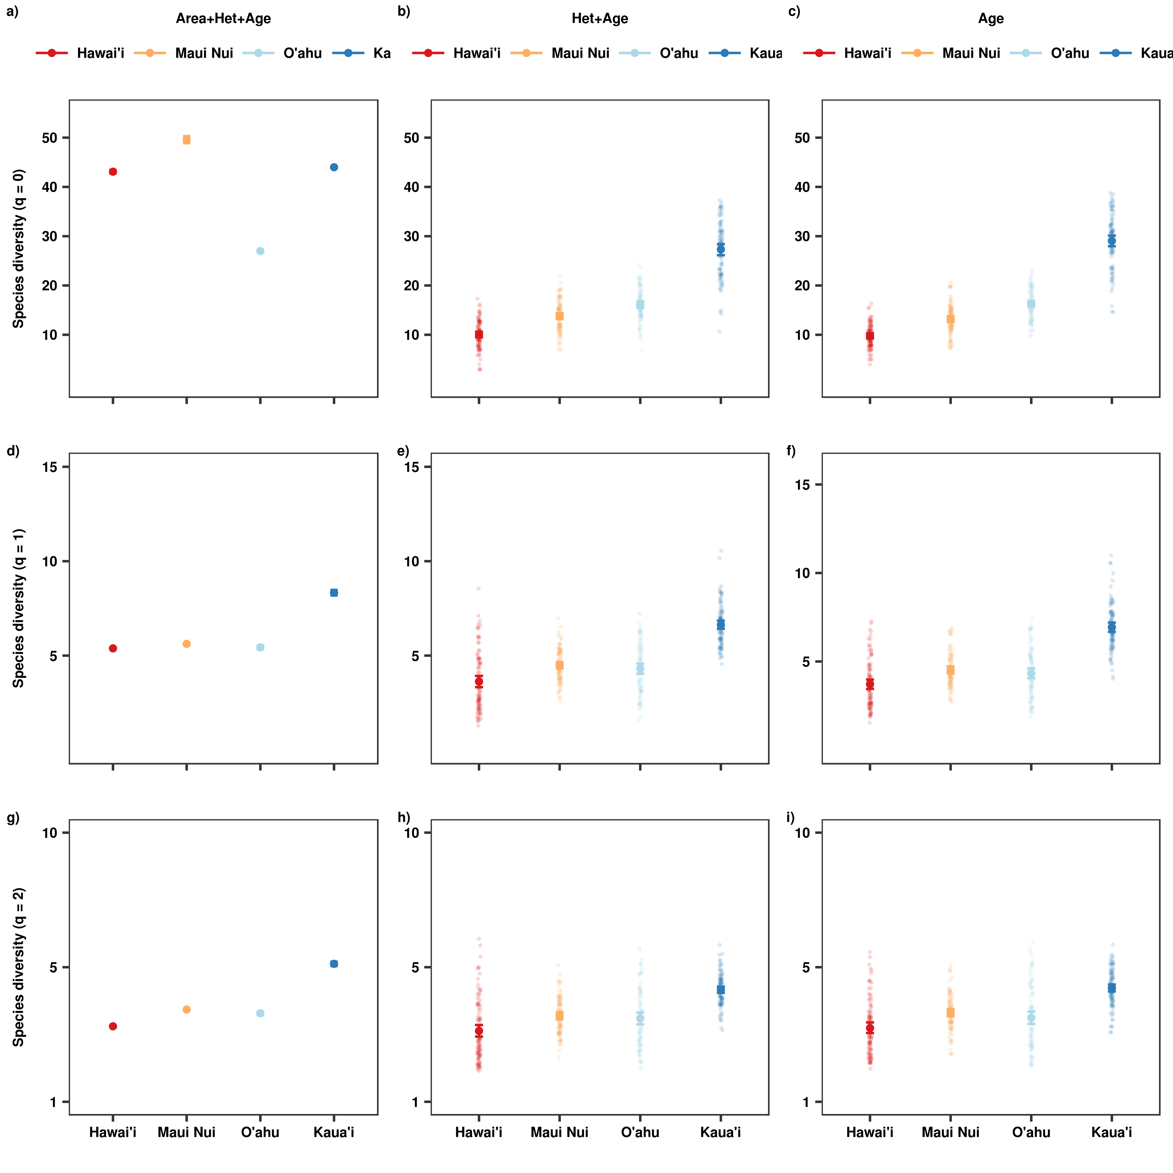
Fig. 4. Species diversity patterns of native forest communities across the Hawaiian archipelago estimated under three scenarios controlling for factors that influence biodiversity. Species diversity was estimated using Hill numbers 0 (a, b, c), 1 (d, e, f) and 2 (g, h, i) that give increasing weight to abundance and is expressed in terms of effective species numbers. In the first scenario ('Area+Het+Age'; a, d, g), no variable is controlled and all forest plots are used, while in the second ('Het+Age' ; b, e, h) sampled area is controlled for by selecting a fixed number of plots per island, and in the last sampled area and environmental heterogeneity ('Age'; c, f, i) are controlled for by selecting a fixed number of plots per island that have a restricted amount of environmental heterogeneity. For the 'Het+Age' scenario, seven plots were randomly selected per island one hundred times to control for sampled area. For the ‘Age’ scenario, environmental heterogeneity was controlled for by randomly selecting seven plots per island one hundred times whose range in PET was less than 200 mm year-1. Note that species diversity is estimated using 10,000 individuals for the first scenario (a, d, g) but 1,000 individuals for the second and third scenarios (b, c, e, f, h, i).

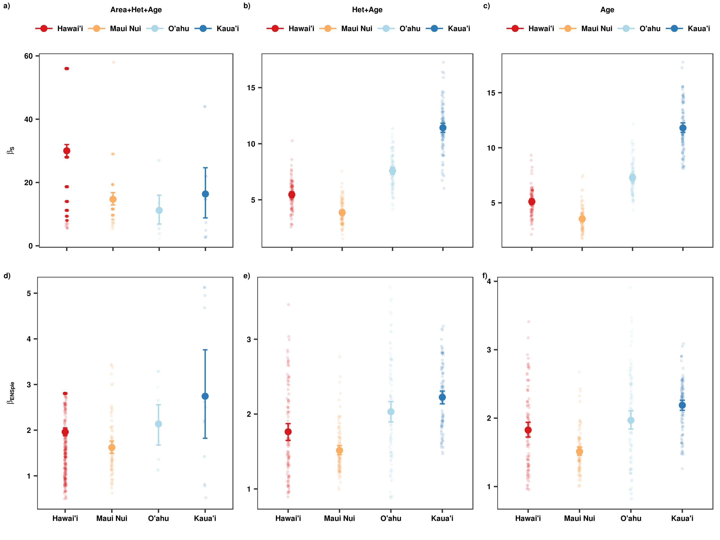
Fig. 5. Beta diversity patterns of native forest communities across the Hawaiian archipelago estimated under three scenarios controlling for factors that influence biodiversity. Beta diversity was calculated as S (a, b, c) and ENS_{PIE} (d, e, f); the former highlights contributions of rare species (Hill number= 0) while the latter emphasizes contributions by common species (Hill number = 2). In the first scenario ('Area+Het+Age'; a & d), no variable is controlled and all forest plots are used, while in the second ('Het+Age' ; b & e) sampled area is controlled by selecting a fixed number of plots per island, and in the last sampled area and environmental heterogeneity ('Age'; c & f) are controlled for by selecting a fixed number of plots per island that have a restricted amount of environmental heterogeneity. For the 'Het+Age' scenario, seven plots were randomly selected per island one hundred times to control for sampled area. For the ‘Age’ scenario, environmental heterogeneity was controlled for by randomly selecting seven plots per island one hundred times whose range in PET was less than 200 mm year-1.

