Lab 0: Installing an Operating System

Part 1: Installing Linux (15 pts)

Create a virtual machine in virtual box and install Ubuntu Gnome.

Within the Linux environment, change your desktop background.  
  
Post a screenshot of your modified desktop in this document.

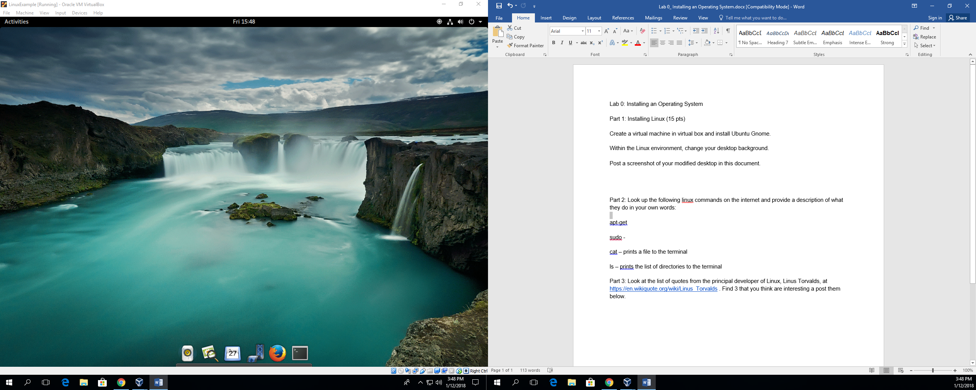

Part 2: Look up the following linux commands on the internet and provide a description of what they do in your own words:

apt-get – allows the user to install software

sudo – allows the user to run specific commands

cat – prints a file to the terminal

ls – prints the list of directories to the terminal

Part 3: Look at the list of quotes from the principal developer of Linux, Linus Torvalds, at <https://en.wikiquote.org/wiki/Linus_Torvalds> . Find 3 that you think are interesting a post them below.

1. “Talk is cheap. Show me the code.”
2. “Those that can, do. Those that can't, complain.”
3. “I am a lazy person, which is why I like open source, for other people to do work for me.”