The linux command line is a powerful tool. To launch the command line, open a terminal window from your launcher.   
  
Try running the following commands, and explain what they do:

ls - Prints out list of directories

ls –l – prints out list of all files

mkdir test – creates a new directory called test

cd test – changes current directory to test

touch example.txt – creates new empty file called example.txt

ls -l >> example.txt -

cat example.txt – prints out the content of example.txt to terminal

find example.txt – searches for file called example.txt in current directory, returns filename

On your linux environment, use apt-get from the command line to install the following software and post a screenshot of them running:

Command: apt-get install <software>

Plank

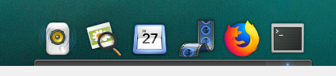

vlc

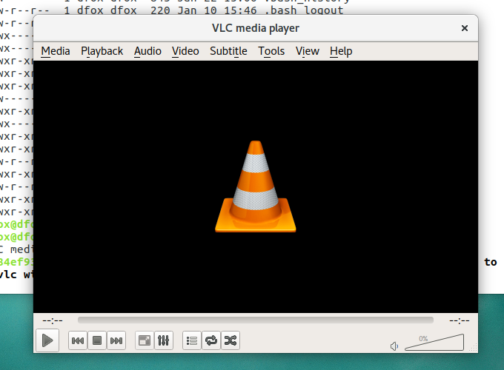

Sometimes, to install software, you will need to run a command to add a repository. Look online for the command to install sublime text and install it.

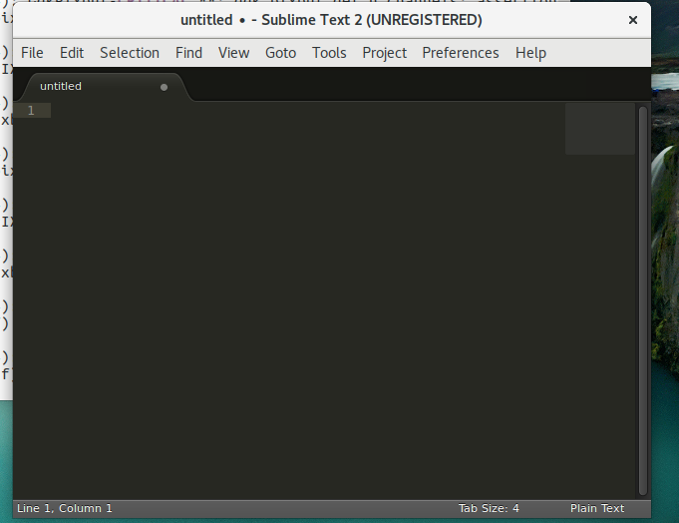

Print your current working directory. Paste the results and the command you used below.



Print out a list of all the files in long format. Paste the command you used below.

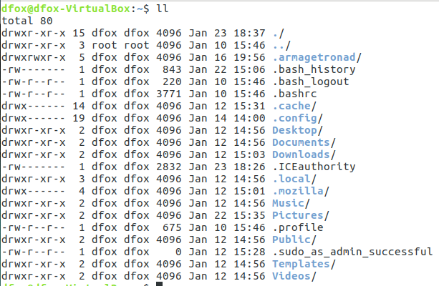

What information about a file is given when using ll? Give a list of column headers.

The column headers tell the user about the:

File permissions, number of links, owner name, owner group, file size, and last modified, and file/directory names

Make a new directory and name it *unixLearning*. Give the command.

Mkdir unixLearning

Change the working directory to the new unixLearning directory & Print out the path. Paste the command and the path below.

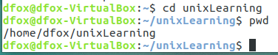

Change working directory back to your home directory & paste the command below.



Remove the *unixLearning* directory and paste the command you used below.



How do you identify a hidden file in linux?

The file name starts with a “.”.