Lab 3: Windows Administration

Complete the following tasks and include a screenshot of your desktop:

Change desktop Background

Move Taskbar to a different border

Increase Icon size by at least 50%

Change Desktop icon font to courier bold.

Create a new folder named 'secrets' and make the folder hidden

Modify windows settings so hidden folders are visible

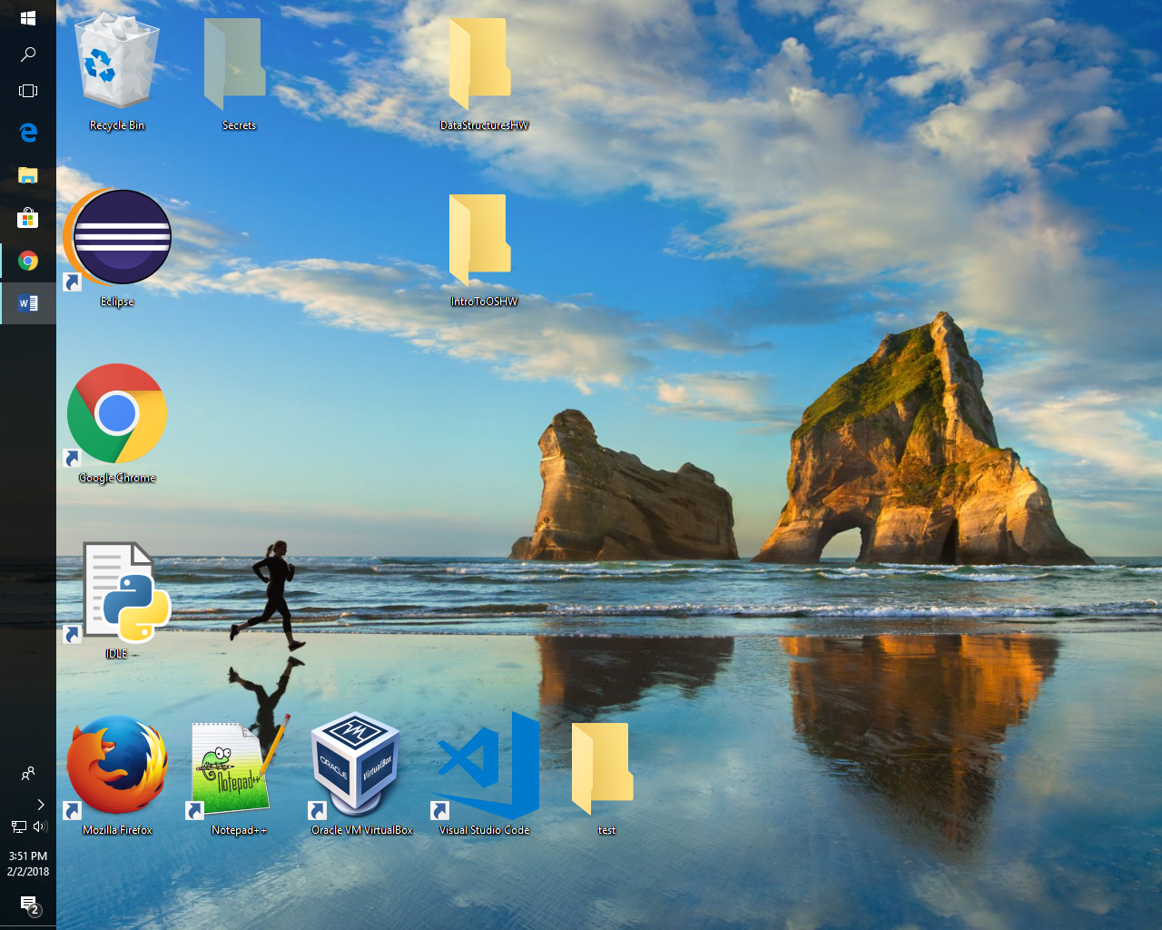

Run the following commands in windows and describe what they are, and what the purpose of the tools are: (2-3 sentences each).

Resmon: This command opens the resource monitor. It’ll show information about the CPU performance, memory, and disk. .

Psr: This command opens the Steps Recorder program that records the screen.

Msconfig: This command opens the System Configuration where the user can determine what services are running at the startup of the operating system.

Regedit: This command opens the registry which is hierarchical database for low-level setting for the operating system and applications that choose to use it.

Create a new folder on your desktop and give it the following name precisely: What happens when you open the folder?

**GodMode.{ED7BA470-8E54-465E-825C-99712043E01C}**

This folder will create a shortcut to all the settings for the Windows operating system.