Assignment: Process Management

Reproduce the state chart that we discussed in class below:

Create Gantt charts for the following algorithms and processes. Calculate out their throughput, wait time, turnaround time, total overhead delay, as well as the averages for each. Assume a Delay of 1 unless otherwise stated

Algorithms:

First-Come First-Serve / Delay 2

Shortest Job First / Delay 2

Shortest Remaining Time

Round Robin Delta 1

Round Robin Delta 3

Processes:

|  |  |  |
| --- | --- | --- |
| Process Name | Arrival Time | Time to Completion |
| Task A | 0 | 6 |
| Task B | 2 | 3 |
| Task C | 4 | 3 |
| Task D | 5 | 9 |

FCFS

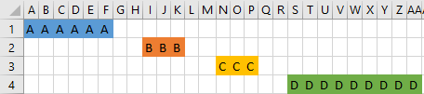

|  |  |  |  |  |  |
| --- | --- | --- | --- | --- | --- |
|  | A | B | C | D | Average |
| Throughput |  |  |  |  |  |
| Wait Time | 0 | 8 | 13 | 18 | 9.75 |
| Turnaround | 6 | 11 | 16 | 27 | 15 |
| Overhead |  |  |  |  |  |

Shortest Job First

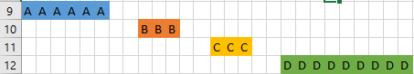

|  |  |  |  |  |  |
| --- | --- | --- | --- | --- | --- |
|  | A | B | C | D | Average |
| Throughput |  |  |  |  |  |
| Wait Time | 0 | 8 | 13 | 18 | 9.75 |
| Turnaround | 6 | 11 | 16 | 27 | 15 |
| Overhead |  |  |  |  |  |

Shortest Remaining Time

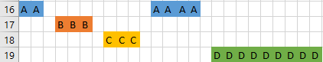

|  |  |  |  |  |  |
| --- | --- | --- | --- | --- | --- |
|  | A | B | C | D | Average |
| Throughput |  |  |  |  |  |
| Wait Time | 0 | 3 | 7 | 16 | 6.5 |
| Turnaround | 15 | 6 | 10 | 25 | 14 |
| Overhead |  |  |  |  |  |

Round Robin Delta 1

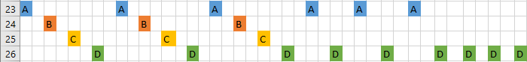

|  |  |  |  |  |  |
| --- | --- | --- | --- | --- | --- |
|  | A | B | C | D | Average |
| Throughput |  |  |  |  |  |
| Wait Time | 0 | 2 | 4 | 6 | 3 |
| Turnaround | 33 | 19 | 21 | 41 | 28.5 |
| Overhead |  |  |  |  |  |

Round Robin Delta 3

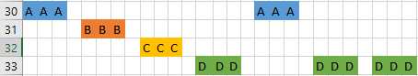

|  |  |  |  |  |  |
| --- | --- | --- | --- | --- | --- |
|  | A | B | C | D | Average |
| Throughput |  |  |  |  |  |
| Wait Time | 0 | 4 | 8 | 12 | 6 |
| Turnaround | 19 | 7 | 11 | 27 | 16 |
| Overhead |  |  |  |  |  |