# Estimation

The team estimates that a completed product fulfilling all customer requirements will contain the following components:

* User Web Interface
  + Allows user to submit a new repository to watch and analyze
  + Allows user to review data of currently watched repositories
* Web Backend
  + Handle all user requests from the User Web Interface
  + Adjust Metadata into user-friendly format for viewing or export
* Git Cloner Component
  + Clone and update watched git repositories to server disk
* Metadata Parser Component
  + Parse git repositories on disk, collecting metadata used in analysis
* Database
  + Store the metadata collected by Metadata Parser Component
  + Return requested data to Web Backend
* Git repository (Provided by User)
  + Provided by user in User Web Interface
  + Cloned by Git Cloner Component

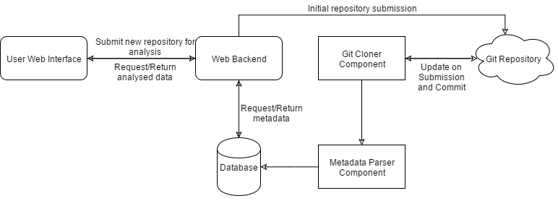

Illustration 1. High-Level Architecture of Estimated Components