**SR04**

**for the**

**Hotspotter Bug Prediction Software**

**CS 425 / CS 499 Senior Project**

**by**

**Nathan Reinhardt**

**Spencer Smith**

**Dylan Williams**

**of**

**Team HotSpotter**

**SR04**

**Revision 1.1**

**As Of: 08 December 2015**

During sprint 4, our team had 51 total hours estimated for the sprint. The hours primarily were all project based with very minor work to be done for finishing up the presentation. The total time we spent 25.5 hours and unfortunately we didn’t finished everything we had planned this sprint but we were able to finished everything we planned for this semester.

The items that were produced by the end of this sprint were as follows:

* Completed Prototype
  + This was the primary objective of the sprint. Since having a working prototype were we can check out a git repository and be able to see the ‘hot’ spots in the code was the key aspect of our entire project. During this sprint Nate and Spencer worked on completing the project. Nate spent 15 hours modifying the UI and file view structure while Spencer worked 8 hours configuring the scoring algorithm.
* Finished Final Presentation
  + The final presentation was needed to be finished by the Friday at the end of the sprint. After our initial practice, we needed to make tweaks. Dylan was in charge of making sure the presentation was ready and in its final state. He spent a total of 2.5 hours cleaning up the presentation and it was his main goal during this sprint.

After the completion of these tasks, we updated our client Dr. Igor Crk. He was satisfied with our progress and is eager for us to hit the ground running with this prototype during the implementation phase next semester.

The major risked we came up against this sprint was prioritizing what we need to get done. As we were approaching the end of the semester, the team members started to have other obligations that needed attended to with other classes. This caused us to not finish what we wanted to finish this sprint. The item that we were not able to finish was optimizing the CSS. We chose not to do this because it was not needed to finish our requirements this semester and was just a ‘nice thing to have’. We mitigated this risk by prioritizing everything that was crucial to finishing the prototype for this semester.

The team’s general consensus of the projects status is very proud. We were able to learn an entirely new stack and execute what we needed to do to finish our goals for this semester.

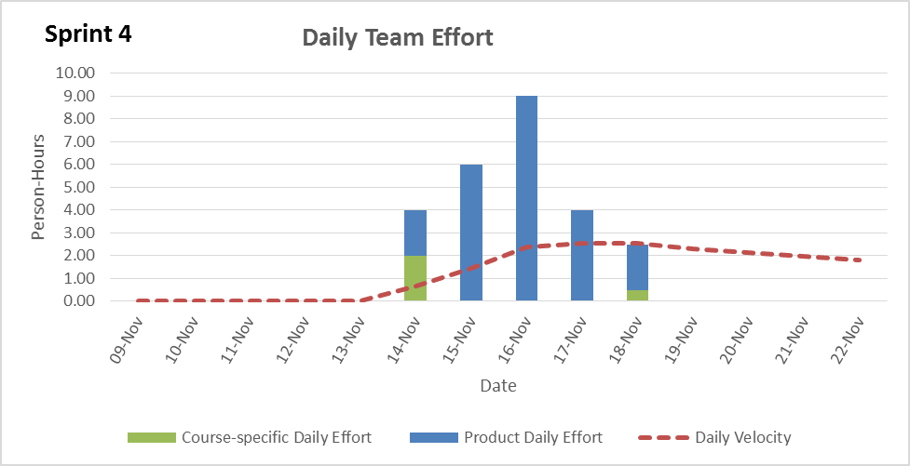

**Reviewed and Approved by:**

Name Signature Date

Nathan Reinhardt _______________________ _________

Spencer Smith _______________________ _________

Dylan Williams _______________________ _________