
University of Nairobi
School of Computing and Informatics

MAKUTANO: A Video-Driven Machine Learning Pipeline for Predictive Adaptive Signal Control at a Nairobi Intersection

By DYLAN GATHIA GACHUGU
Registration Number: SCS3/146838/2023

Supervised by Elisha O. Abade

October 2026
This project proposal has been submitted in partial fulfilment of the requirements of the Bachelor of Science in Computer Science as offered by the University of Nairobi.
Table of Contents
CHAPTER 1: INTRODUCTION 1
1.1. Background 1
1.2. Problem Statement 2
1.3. Objectives 2
1.3.1. Research Objectives 3
1.3.2. System Objectives 4
1.4. Project Justification 5
1.5. Scope 5
1.6. Assumptions 6
CHAPTER 2: LITERATURE REVIEW 8
2.1. Digital Twins and Traffic Models of Intersections 8
2.2. Vehicle Detection and Tracking in Mixed Traffic 8
2.3. Short-Term Traffic Prediction 9
2.4. Microsimulation and Signal Control 9
2.5. Reinforcement Learning for Signal Control 10
2.6. Transport Research in the Kenyan Context 10
2.7. Implications of Literature Review 10
CHAPTER 3: METHODOLOGY 12
3.1. System Development Methodology 12
3.2. Technologies 18
3.3. Evaluation Plan 19
3.4. Risks and Mitigation 20
3.5. Ethical and Legal Considerations 21
3.6. Project Schedule 22
References 25

List of Tables
Table 1: Tools and technologies 19
Table 2: Claims and the evidence for each 20
Table 3: Risks and mitigation 21
Table 4: Project schedule 23
Table 5: Project checkpoints 24

List of Figures
Figure 1: Level 0 DFD 12
Figure 2: System architecture 13
Figure 3: Gantt chart 23

CHAPTER 1: INTRODUCTION

1.1. Background
Kenya's Transport ministry and the Nairobi Metropolitan Area Transport Authority estimate that lost productivity in Nairobi's traffic jams costs about one billion US dollars a year ("State Moves to Tame City Traffic With Rail Plan," 2024). Road crashes add a human cost: the World Health Organization estimates 14,926 road traffic deaths in Kenya in 2021 (World Health Organization, 2023). Even this toll is poorly measured. For 2016, the National Transport and Safety Authority recorded 2,965 deaths, because it counts only people who die at the scene of a crash, while WHO estimated 13,463 for the same year, about four times as many (Africa Check, 2018; World Health Organization, 2018).
Urban traffic control in Nairobi is decided at intersections. Signal timings are fixed and do not change with demand, even during rush hours, and at many junctions traffic police override the signals by hand. The Kenya Urban Roads Authority (KURA) and the Nairobi Metropolitan Area Transport Authority (NaMATA) have published plans and guidelines, but no accurate data is collected at intersection level, which makes it hard to measure whether these initiatives work.
Nairobi's traffic also differs from the traffic most tools are designed for. Matatus, boda bodas, handcarts, private cars and pedestrians share the same road space and rarely keep to lanes. Many vehicle detection models were trained on European or North American roads and perform poorly on scenes like these.
Signals that respond to traffic, from simple actuated controllers to controllers that learn, depend on a continuous stream of data from road sensors such as inductive loops, radar or connected vehicles. That infrastructure does not exist at most Nairobi junctions and is unlikely to be funded soon. The open question is whether ordinary video, processed by machine learning, can supply what responsive signal control needs.
This proposal is to build Makutano, a machine learning pipeline for one Nairobi intersection, made of three modules. The first module sees: a detector fine-tuned on local footage identifies each road user's type and turns video into measurements of the arrivals and queues on each approach. The second predicts: a learned model forecasts how much traffic each approach will receive, from the next minute to the rest of the peak, based on the time of day and what the camera has just seen. The third controls: a deep reinforcement learning agent chooses the signal phase using the current and predicted state of the junction, and is stress-tested under high-pressure conditions such as heavier demand, sudden surges, a blocked lane and a camera failure. A learning controller cannot be trained by trial and error on a live road, so it is trained and tested in a SUMO microsimulation of the junction that has been calibrated against the video.

1.2. Problem Statement
Nairobi's traffic signals cannot respond to traffic. They run fixed timings or are overridden by hand, and no data shows how a junction performs. Three gaps stand between today's signals and responsive control:
- No sensing. Junctions have no detectors, and off-the-shelf vision models are trained on traffic that contains no matatus, few motorcycles and far fewer pedestrians in the carriageway. Their accuracy on Nairobi footage is unknown and undocumented.
- No anticipation. Even where queues can be seen, control can only react once they have formed. There are no models that predict how much traffic a Nairobi junction will receive at a given time of day or in the next few minutes.
- No safe way to develop and stress-test smarter control. A controller that learns needs thousands of hours of trial and error, and its behaviour in a surge or a breakdown has to be known before it is trusted. Neither can be done on a live junction, and no calibrated model of a Nairobi junction exists in which they could be done instead.
There is a need for a pipeline that turns low-cost video into the sensing, prediction and control that a responsive signal needs, developed and proven in a calibrated model before any trial on the road.

1.3. Objectives
The general objective of this project is to design, implement and evaluate a machine learning pipeline that perceives traffic at a selected Nairobi intersection from video, predicts the traffic it will receive, and controls its signals with a reinforcement learning agent, trained, evaluated and stress-tested in a simulation calibrated against the video.
The project is built around three research questions:
- Perception: how much does fine-tuning a pre-trained detector on local footage improve the detection and tracking of Nairobi mixed traffic?
- Prediction: how accurately can a learned model forecast each approach's arrivals, from the next minute to the rest of the peak, from the time of day and recent video-derived measurements, compared with simple baselines?
- Control: does a deep reinforcement learning controller outperform fixed-time, re-timed and actuated control in the calibrated model, does giving it predictions improve its performance, and how does each controller cope under high-pressure conditions?
The project does not need the learned controller to win. It needs a method that can reliably show whether it wins, by how much, and under what conditions.

1.3.1. Research Objectives
(i) To build an annotated video dataset of mixed traffic at a Nairobi intersection.
The dataset will cover the morning peak, midday and evening peak periods and six road-user classes found in Kenyan mixed traffic: matatu, boda boda, private car, truck or bus (one class for large vehicles, which are few at a single junction), handcart and pedestrian. It will record the conditions under which it was collected, including camera height and angle, so that it can be reused beyond this project.
(ii) To measure how much fine-tuning on local footage improves detection and tracking compared with an off-the-shelf detector.
A YOLO-family detector will be fine-tuned on the annotated data and compared with the same detector before fine-tuning, using mean average precision for each class and standard multi-object tracking metrics against manually annotated ground truth. The tracks are then turned into per-approach measurements of arrivals and queue length, each checked against independent manual observations, because an accurate detector does not guarantee accurate measurements.
(iii) To develop and evaluate a traffic prediction model.
The measurements form a time series of arrivals for each approach, stamped with the time of day. A learned model (a long short-term memory or gated recurrent unit network) will forecast each approach's arrivals over two ranges: the next 1, 5 and 15 minutes, which the controller uses, and the 15-minute profile for the rest of the peak, which describes what traffic at that time of day is likely to be and generates realistic demand for the simulation. It is compared with three simpler predictors: persistence (the future equals the present), the historical average for that time of day, and gradient-boosted trees. Models are trained on some recording days and evaluated on days they have not seen. If the learned model cannot beat the simpler predictors, that is reported and the best predictor is used in the rest of the pipeline.
(iv) To build and validate a calibrated SUMO model of the intersection as the controller's training environment.
A reinforcement learning agent learns only what its environment teaches it, so the simulation must behave like the real junction. The SUMO model is calibrated against the video measurements from one period (the morning peak) and validated, without further tuning, on a period it was not fitted to (the evening peak), using acceptance thresholds fixed before any tuning begins. If the model cannot meet them, the size of the gap is reported rather than hidden.
(v) To train a deep reinforcement learning signal controller and compare it with alternative strategies.
The agent observes the queues and arrivals a camera could measure, the predicted queues and the current signal phase, and every few seconds decides whether to keep the current phase or switch to another. A safety layer outside the agent enforces minimum and maximum green times, clearance intervals and a maximum waiting time for every approach and for pedestrians, so the agent cannot choose an unsafe or unfair action. The agent is compared with today's observed plan, a re-timed fixed-time plan, SUMO's built-in queue-actuated control and a hand-designed rule-based controller. The same agent is also trained without predictions, to measure whether prediction adds value. Finally, every controller is stress-tested under high-pressure conditions the agent was not trained on: much heavier demand, sudden surges, a blocked lane, a surge of pedestrians and a camera that stops sending data.

1.3.2. System Objectives
To develop a machine learning pipeline that will:
- Detect, classify and track the six road-user classes (matatu, boda boda, private car, truck or bus, handcart and pedestrian) in recorded video.
- Compute per-approach arrivals and queue lengths over time, together with the volumes, speeds and delays needed to calibrate the simulation.
- Predict each approach's arrivals for the next 1 to 15 minutes and for the rest of the peak, from the time of day and recent measurements.
- Calibrate a SUMO model of the junction and expose it as a training environment for a reinforcement learning agent.
- Control the junction's signals in simulation with a trained agent operating within fixed safety constraints, compare it with alternative strategies over many random seeds, and stress-test every strategy under high-pressure conditions.
- Present the measured data, the prediction accuracy and the controller comparisons in a simple dashboard that clearly separates measured values from simulated ones.

1.4. Project Justification
Responsive signal control usually depends on road sensors that Nairobi's junctions do not have. If ordinary video, processed by machine learning, can supply the sensing and the anticipation such control needs, responsive signals become affordable without new roadside hardware.
The contribution of this project is not a new machine learning architecture. It is an evaluation of whether a chain of established methods (locally tuned detection, short-horizon prediction and deep reinforcement learning) works under Nairobi's conditions, with each stage evaluated on its own and the controller proven in a calibrated model before it touches a real signal. Training the agent with and without predictions shows directly whether the prediction stage earns its place.
The annotated dataset is also a contribution in its own right. African traffic scenes are underrepresented in the data used to train standard detectors, and a labelled dataset of Nairobi mixed traffic can be reused by other researchers if it can be released safely.
The project has been designed for one student in one academic year. It needs no roadside hardware: footage is recorded from a public, elevated vantage point, all the software used is open source, and model training runs on a cloud GPU (Google Colab) or a university lab machine.

1.5. Scope
The project covers one intersection in Nairobi, selected for its traffic volume, mixed-mode use and the availability of a safe elevated filming position. The following are within its scope:
- Recorded video collected by the student from public vantage points, covering the morning peak, midday and evening peak periods.
- Detection, tracking and classification of the road-user classes present at that junction.
- Measurement of per-approach arrivals and queues, and of the volumes, speeds and delays needed for calibration.
- Prediction of arrivals for each approach, from the next minute to the rest of the peak, for the periods filmed.
- A calibrated SUMO model of the junction, used to train and test signal controllers.
- A deep reinforcement learning controller, its comparison with fixed-time, re-timed, actuated and rule-based control, and stress tests of every controller under high-pressure conditions.
- A dashboard presenting measured and simulated results.
The following are outside the scope of this project:
- Installation of fixed cameras or any roadside hardware. The system is designed so that a fixed camera feed could replace recorded video, but no deployment is attempted.
- Control of live traffic signals. Controllers are evaluated in simulation only; connecting one to real signal hardware would need the road authority's approval and is identified as future work.
- Forecasting for periods that were not filmed, such as weekends, holidays or other seasons, which would need months of continuous data.
- Crash detection. A single junction shows too few crashes in a few hours of footage to train or validate a detector.
- Automatic number plate recognition, and any enforcement against individuals. Plates are personal data and are not needed for any part of the pipeline.
- Network-wide or city-wide modelling. Only the single junction and its approaches are modelled.

1.6. Assumptions
The following assumptions are held as true in the development of this system:
- A suitable junction with a safe, lawful vantage point can be secured within the first three weeks.
- Six to ten hours of footage, sampled across periods and traffic conditions, is sufficient to fine-tune a detector, set simulation demand and train a short-horizon predictor. The pilot will test this, and the number of annotated frames and instances per class will be set after it.
- OpenStreetMap geometry for the selected junction is accurate enough to correct by hand rather than survey.
- A model validated against the real junction is a reasonable guide to how controllers rank against each other there. Confirming their absolute benefit on the road would need a field trial.

CHAPTER 2: LITERATURE REVIEW

2.1. Digital Twins and Traffic Models of Intersections
Kritzinger et al. (2018) distinguish three levels of integration between a physical system and its digital counterpart. In a digital model, data moves between the two by hand. In a digital shadow, data flows automatically from the physical system to the model. In a digital twin, data flows automatically in both directions, so the model can act on the physical system. Makutano works from recorded video and does not control real signals, so under this classification its simulation is a digital model, and this proposal uses that term.
Digital twins of intersections are a well-researched field, but existing work assumes instrumentation that does not exist in Nairobi. A 2025 review of 85 studies of intersection digital twins (Bagabaldo & Hackl, 2025) describes multi-layered architectures that fuse real-time data from loop detectors, LiDAR, radar, connected-vehicle GPS traces and signal states, sometimes over vehicle-to-everything (V2X) links such as DSRC and C-V2X, and that model traffic in microsimulators such as SUMO and CARLA. Where twins are built on real data, they rely on fixed, modern instrumentation: a SUMO-based digital twin of an Irish motorway segment, for example, fuses data from inductive loops, GPS probes and toll records (Wang et al., 2025).

2.2. Vehicle Detection and Tracking in Mixed Traffic
Video-based vehicle detection is now well established for uniform, lane-following traffic. Single-stage detectors from the YOLO family (Jocher et al., 2023) are fast, well documented and can be fine-tuned on a modest dataset. Tracking-by-detection methods such as ByteTrack (Zhang et al., 2022) keep object identities through partial occlusion by associating low-confidence detections as well as high-confidence ones.
Detection is much less reliable in mixed traffic that includes motorcycles, passenger minibuses and pedestrians, particularly in African traffic scenes. Public datasets used to train standard detectors underrepresent object classes common on African roads, such as boda bodas, tuk-tuks and minibus taxis, which lowers the performance of models trained on them (Mutabarura et al., 2025; Muzata et al., 2026). Both studies improved detection by training on locally collected images, which supports fine-tuning on Nairobi footage. Detection accuracy is normally reported as mean average precision for each class, and tracking accuracy with multi-object tracking metrics such as MOTA (Bernardin & Stiefelhagen, 2008) and HOTA (Luiten et al., 2021).
To turn tracked objects into measurements, their image positions are mapped to ground-plane coordinates with a planar homography estimated from reference points of known position (Hartley & Zisserman, 2004). This allows distances, speeds and queue lengths to be measured in metres from a single camera.

2.3. Short-Term Traffic Prediction
Short-term traffic forecasting has a long history, reviewed by Vlahogianni et al. (2014). Most work forecasts flows or speeds on motorways and urban networks minutes to an hour ahead, using months of data from loop detectors or other fixed sensors. Recurrent neural networks, in particular the long short-term memory (LSTM) network (Hochreiter & Schmidhuber, 1997), have been applied widely; Ma et al. (2015), for example, used an LSTM to predict traffic speed from microwave sensor data and reported better accuracy than several classical methods. Vlahogianni et al. (2014) stress the importance of rigorous comparison, which is why Makutano compares its learned model with simple baselines rather than assuming it will be better.
This project's setting differs from most of that work in three ways: it predicts arrivals at a single intersection rather than across a network, it combines very short horizons for control with a time-of-day profile for the peak, and it uses video-derived measurements of mixed traffic rather than fixed sensors. The available data is also far smaller, a few days of peak periods rather than months, which limits model size and makes strong baselines essential.

2.4. Microsimulation and Signal Control
This project uses SUMO (Simulation of Urban MObility), an open-source microscopic traffic simulator (Lopez et al., 2018). SUMO supports custom vehicle types, a sublane model in which vehicles can share a lane side by side, and programmable signal logic through its TraCI interface, which lets an external program read simulated detectors and set signal states at every step. These features make it suitable for representing boda bodas filtering between cars and for running a controller written in Python.
Fixed-time plans are conventionally timed with Webster's method, which sets the cycle length and green splits from measured flows (Webster, 1958). Actuated control instead extends or ends each green according to detected arrivals. Calibration of microsimulation models is commonly judged with the GEH statistic, which compares modelled and observed hourly flows; guidance on traffic microsimulation suggests a GEH value below 5 for most counted movements as an acceptance target (Dowling et al., 2004). Dasgupta et al. (2021) built a digital-twin-based adaptive signal controller in SUMO and evaluated it on drivers' cumulative waiting time against a connected-vehicle-based controller; like the twins reviewed above, it assumes connected-vehicle data that Nairobi junctions do not have.

2.5. Reinforcement Learning for Signal Control
Reinforcement learning has become a widely studied approach to adaptive signal control, in which an agent learns a timing policy by trial and error in simulation (Wei et al., 2021). Deep Q-networks (Mnih et al., 2015) and proximal policy optimisation (PPO; Schulman et al., 2017) are among the methods most often applied, and open-source tools now make such experiments practical: SUMO-RL wraps SUMO junctions as reinforcement learning environments (Alegre, 2019), and Stable-Baselines3 provides tested implementations of common algorithms (Raffin et al., 2021).
Wei et al. (2021) note that studies differ widely in how they evaluate learned controllers, which makes their results hard to compare. Much of the work also trains and tests agents on synthetic junctions with idealised traffic and assumes perfect detection. Few studies train on a model calibrated against a real junction, fewer still on mixed traffic of the kind found in Nairobi, and learned controllers are often compared only with a fixed plan rather than with well-timed and actuated alternatives. A learned policy can also choose actions that are unsafe; shielding (Alshiekh et al., 2018) addresses this by placing a layer outside the agent that blocks any action violating stated safety rules, which is the approach Makutano takes.

2.6. Transport Research in the Kenyan Context
Transport research in Nairobi has concentrated on network-level data. The Digital Matatus project mapped the routes of Nairobi's semi-formal matatu system using mobile phones and published them as open data (Williams et al., 2015). Research at the level of individual junctions has received far less attention, and there is little measured data on how Nairobi intersections perform.

2.7. Implications of Literature Review
Three gaps follow from the literature, and each maps to one research question. First, standard detectors are trained on traffic unlike Nairobi's, and their accuracy here is undocumented; the perception question addresses this by building a local dataset and measuring the benefit of fine-tuning. Second, short-term traffic prediction has been developed mainly for networks with fixed sensors and long histories; the prediction question tests whether useful forecasts can be made at a single junction from a few hours of video. Third, learned signal controllers are mostly trained on idealised simulations with perfect detection and compared with weak baselines; the control question addresses this by training on a model calibrated against the real junction, using camera-equivalent observations, and comparing with well-timed and actuated alternatives.
The individual techniques used here are established; the contribution is their evaluation together under Nairobi's conditions. This review found no published work that trains a reinforcement learning signal controller for an African intersection on a simulation calibrated from low-cost video, using a detector tuned to local traffic and short-horizon prediction, and evaluates it against well-timed alternatives. A wider search will be carried out during the project, and this claim will be revised if such work is found.

CHAPTER 3: METHODOLOGY

3.1. System Development Methodology
The project follows an experimental, iterative approach. Rather than building each stage in full before starting the next, a rough version of the whole pipeline is first run end to end on a short pilot clip, using a pre-trained detector, a persistence predictor and a fixed-time plan. This exposes problems with the camera position, the homography and the data formats early. Each later cycle then improves a stage that already works, and the reinforcement learning environment can be developed on the rough model while data collection and annotation continue.
Figure 1 shows the system boundary and the data exchanged with external entities. A camera at an elevated vantage point supplies recorded video and the camera pose. The annotator labels sampled frames and supplies ground control points, and receives frames to label and accuracy reports. OpenStreetMap supplies the base road geometry. Traffic planners, such as KURA and NaMATA, supply the current signal plan and receive the measurements, predictions and controller comparisons.
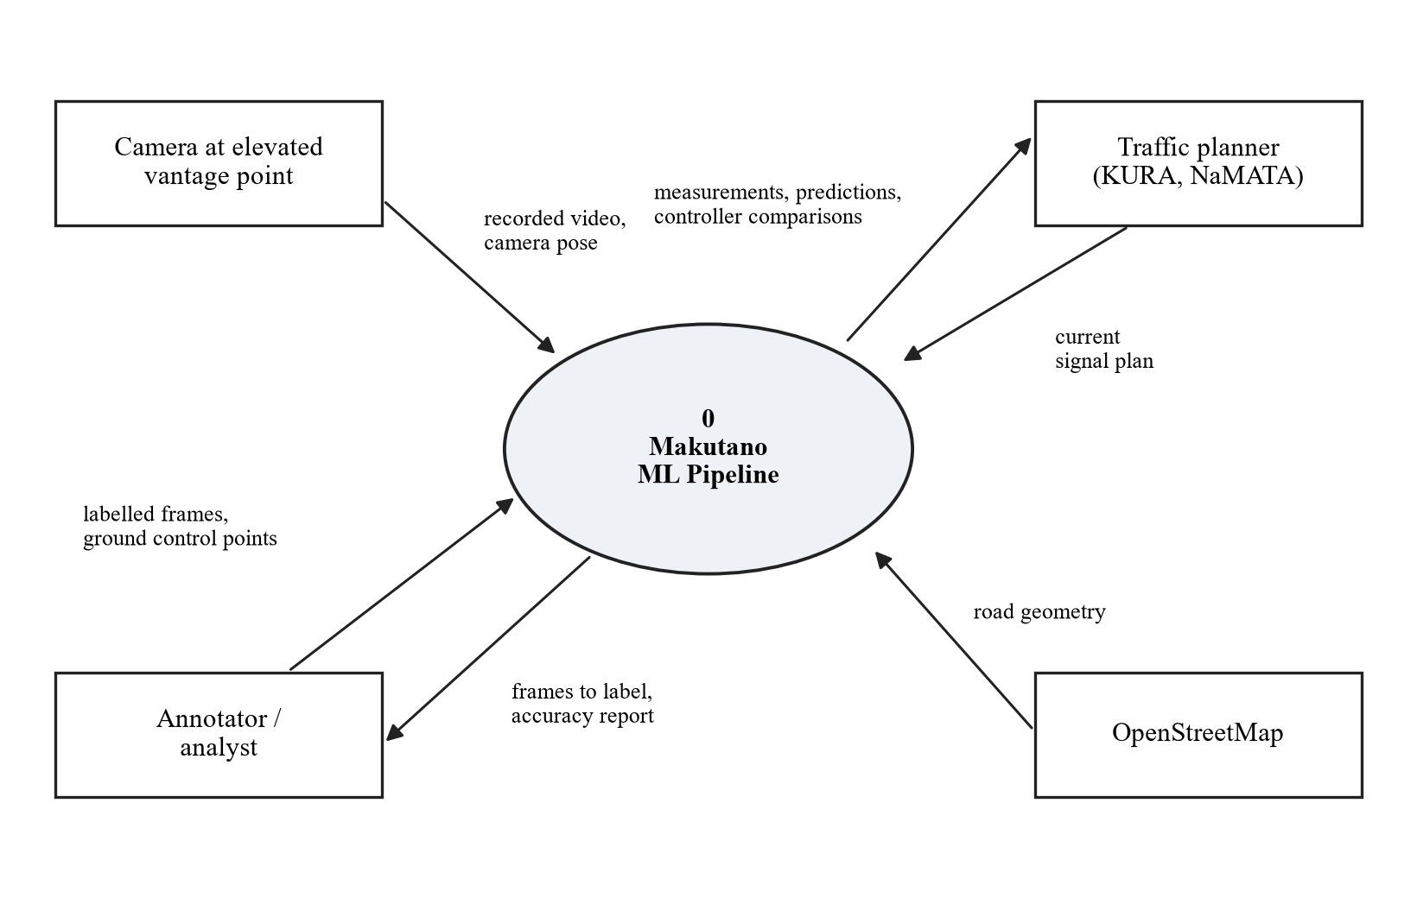
Figure 1: Level 0 DFD
Figure 2 shows the pipeline. Video passes through the three machine learning stages: seeing, predicting and controlling. The measurements from the first stage also calibrate the SUMO model, which serves as the environment in which the controller is trained and tested. Results from every stage are reported on the same dashboard.
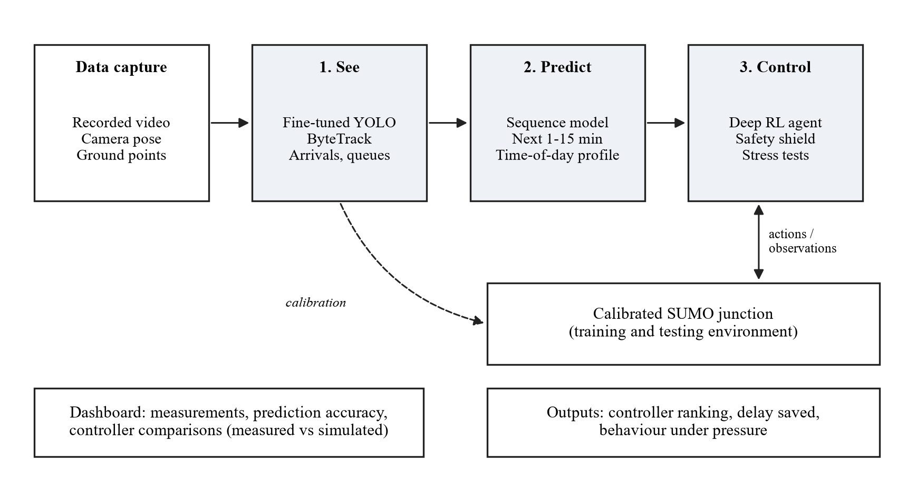
Figure 2: System architecture
Development Cycles
Each cycle builds on the output of the one before it. Below is a description of the activities that take place in each cycle.
(i) Site Selection and Data Collection
The chosen intersection must have enough traffic to produce reliable data, a safe filming position, and geometry simple enough to model. Three candidate junctions will be shortlisted, and a short pilot recording is made at the preferred one before committing to it. The pilot checks that every approach and the back of its queue are visible, and whether police regularly override the signals, since that decides what the baseline model has to represent. Video is then recorded in the morning peak, at midday and in the evening peak, over several days, and the camera's height and angle are recorded for later use.
(ii) Annotation
Frames are sampled across time periods, traffic densities, lighting and difficult cases such as occlusion and motorcycles riding close together, rather than taken from long continuous runs. They are labelled in CVAT (CVAT.ai Corporation, 2023) or Roboflow with bounding boxes for the classes matatu, boda boda, private car, truck or bus, handcart and pedestrian. Pre-trained model predictions are used as starting labels and corrected by hand. Training, validation and test sets are split by recording session, not by random frame, because neighbouring frames are nearly identical and a random split would leak test data into training. A sample of about 10% of frames is labelled twice to measure annotation agreement. The starting budget is 1,000 to 2,000 sampled frames, revised once the pilot shows how often each class appears. Every class must appear in the test sessions; a class with too few examples is either collected further or reported as having insufficient evidence.
(iii) Detection and Tracking (See)
A YOLO-family detector is fine-tuned on the labelled data and combined with a multi-object tracker (ByteTrack) to keep identities across frames. Detection accuracy is reported as mean average precision for each class on the held-out test sessions, and tracking accuracy with HOTA and MOTA on short manually annotated sequences. The fine-tuned and the unaltered pre-trained detector are evaluated with the same procedure on the same test set, so the comparison shows how much local fine-tuning helps.
(iv) Measurement and Validation
Tracked objects are transformed from image coordinates to ground-plane coordinates using a homography fitted to reference points located on satellite imagery. Its accuracy is reported as leave-one-out error in metres, which is more reliable than the error at the points used for fitting. From the ground-plane tracks, the pipeline produces a time series for each approach of arrivals and queue length in 5-second steps, the inputs to the prediction and control stages. It also produces the movement volumes, speeds and delays needed to calibrate the simulation. Each is checked against an independent reference:
- Arrivals and volumes: manual counts of each movement for sampled intervals, reported as count error.
- Queue length: queue positions read by hand at sampled instants, reported as error in metres.
- Speed: travel times measured by hand between road markings a known distance apart, reported as mean absolute error and root mean square error in km/h.
- Delay: travel times through the study zone measured by hand for a sample of vehicles, using the definition below.
Delay has one definition, used for both video and simulation: the time a vehicle spends inside a fixed study zone, from a line upstream of the longest observed queue to a line beyond the junction exit, minus the time it would take to cover the same path at free-flow speed. Free-flow speed is measured from off-peak footage for each vehicle class. Vehicles still inside the zone when a recording ends are excluded, and their number is reported. The SUMO network is clipped to the same zone, so SUMO's time-loss output measures the same quantity.
(v) Prediction Model (Predict)
For each approach, the inputs are the time of day and day of the week, the arrivals and queue length over the last five minutes, and the current signal phase. The targets are the arrivals in the next 1, 5 and 15 minutes, and the arrivals in each 15-minute interval for the rest of the peak. Four predictors are compared: persistence, the historical average for that time of day, gradient-boosted trees, and a small recurrent network (LSTM or GRU) trained in PyTorch. Data is split by recording day, so a model is always tested on a day it has never seen. Hyperparameters are chosen on the validation days, and the chosen model is frozen before it is evaluated on the test days. Accuracy is reported as mean absolute error and root mean square error for each horizon and approach.
The predictions have two uses. The short-range forecasts (1 to 15 minutes) go into the controller's observation. The time-of-day profiles generate realistic, varied demand for training and testing the controller in simulation, including the high-pressure scenarios in stage (vii). Inside the simulation, the predictor runs on the simulated detector readings, and its accuracy there is compared with its accuracy on real held-out video, as a further check that the simulated junction behaves like the real one. Predictions are only claimed for the times of day that were filmed.
(vi) Model Construction, Calibration and Validation
The junction geometry is built in SUMO from OpenStreetMap data (Haklay & Weber, 2008) using netconvert and corrected against the recorded video. Demand is generated from the measured movement volumes, and the observed signal timings, rather than the posted plan, are used for the baseline. The calibrated parameters are limited to a small, named set: driver speed factor and minimum gap for each vehicle class, the sublane parameters that control how boda bodas filter between vehicles, and matatu stopping time. All other parameters keep SUMO's defaults. Values are chosen by a bounded grid search over this set, minimising a weighted sum of the normalised errors in movement flows, queue length and delay, with the weights fixed in advance. The search stops when the grid is exhausted, and the best combination is kept and reported whether or not it meets the thresholds.
The model aims at a calibrated representation of a defined set of movements and behaviours, not a realistic simulation of every aspect of Nairobi traffic. The behaviours with the largest effect on queues and delay (boda boda filtering and matatu stops) are implemented first and checked against the video. Pedestrians are modelled as individual SUMO pedestrians using the marked crossings, with arrival rates counted from the video. Behaviours SUMO cannot reproduce, and those not modelled, such as pedestrians crossing away from marked crossings or drivers running red lights, are stated as limitations.
Acceptance thresholds are fixed before any tuning: GEH below 5 for at least 85% of turning movements, computed on hourly movement totals for the peak hour, a commonly used volume guideline (Dowling et al., 2004), with matched 15-minute counts reported alongside to show variation within the hour; and average delay and queue length within 15% of the measured values. The 85% and 15% figures are project criteria chosen in advance, not universal standards. Calibration uses the morning peak only. The calibrated model is then run on the evening peak without any further change, and its errors there are the validation result. The report states which parameters were fitted, how sensitive the results are to them, and where the model does not reproduce observed behaviour.
(vii) Reinforcement Learning Controller (Control)
The calibrated model is wrapped as a reinforcement learning environment using SUMO-RL (Alegre, 2019), and the agent is trained with Stable-Baselines3 (Raffin et al., 2021), using PPO or a deep Q-network, whichever trains more reliably in early experiments. Its design is:
- Observation: for each approach, the current queue length and recent arrivals, as the camera pipeline would measure them, with random error added to match the error found when validating that pipeline; the predicted arrivals for the next 1 and 5 minutes from stage (v); the current phase and the time spent in it; and the number of waiting pedestrians.
- Action: every 5 seconds, keep the current phase or switch to another permitted phase.
- Reward: the reduction in total vehicle waiting time since the last step, with a penalty for pedestrian waiting time, so the agent cannot improve vehicle delay at pedestrians' expense.
- Safety shield: a layer outside the agent, following the shielding approach of Alshiekh et al. (2018), which blocks any action that would break minimum or maximum green times, skip amber and all-red clearance intervals, or exceed the maximum waiting time for any approach or for pedestrians. Conflicting movements can never receive green together.
The agent is trained over many simulated peak periods, with demand drawn from the predicted time-of-day profiles and random seeds that are never used for evaluation, so that it cannot simply memorise the test conditions. Its behaviour is also inspected visually in SUMO's interface, to catch policies that exploit quirks of the simulator.
Its performance is compared with four alternatives: the calibrated baseline (today's observed plan), a re-timed fixed-time plan derived with Webster's method, SUMO's built-in queue-actuated control, and a hand-designed rule-based controller that serves the phase with the longest queues and waits, within the same safety rules. The rule-based controller is also the fallback if the agent fails to learn a good policy. To answer whether prediction helps, the agent is trained and evaluated twice, once with the predicted arrivals in its observation and once without.
Each strategy is run with at least 20 evaluation seeds, and the same seeds are used for every strategy so that differences come from the strategy rather than from random variation. Runs cover the measured demand and demand 20% higher and lower. Outcomes are average delay, queue length, throughput and pedestrian waiting time, with average delay as the primary outcome. For each scenario, results are computed as paired differences between strategies under the same seed, and their mean and 95% confidence interval are reported for that scenario, never pooled across scenarios. Differences are given in absolute terms, not only as percentages.
Stress tests. To show how each controller handles traffic under pressure, every strategy is also run in five high-pressure scenarios that the agent never saw in training:
- Heavy demand: demand 40% and 60% above the measured peak.
- Sudden surge: a 15-minute burst of traffic on one approach, as when a nearby event ends.
- Blocked lane: one lane on the busiest approach closed for 20 minutes, as by a breakdown or a matatu stopping.
- Pedestrian surge: pedestrian arrivals tripled at one crossing.
- Camera failure: the controller's input stops for five minutes, to check that the safety layer falls back to the re-timed plan and recovers cleanly.
The stress scenarios lie outside the conditions the model was calibrated on, so their results show how the controllers degrade and recover, and are reported as such rather than as predictions of exact delays. The same outcomes are measured, together with the time each controller takes to clear the queues after the disruption ends.
(viii) Dashboard
A simple dashboard built with Streamlit presents the measured indicators, the prediction accuracy, the model validation results and the controller comparisons. Measured and simulated values are labelled and styled differently throughout, so a simulated estimate is never presented as a measurement. The dashboard is a presentation layer and is built only after the model has passed validation.

3.2. Technologies
Table 1 lists the tools and technologies chosen for each component of the system and the reason for each choice.
Table 1: Tools and technologies
Component | Choice | Reason
Language | Python | Standard for the vision, machine learning and simulation toolchains
Detection | YOLO (Ultralytics), fine-tuned | Fast, well documented, trains on a modest dataset
Tracking | ByteTrack or equivalent | Maintains identity through partial occlusion
Vision utilities | OpenCV | Homography, frame extraction, geometry
Annotation | CVAT or Roboflow | Bounding-box labelling with class definitions
Prediction | PyTorch; scikit-learn | Recurrent networks; gradient-boosted tree baseline
Simulation | SUMO with the TraCI interface | Open source, supports custom vehicle types, sublane behaviour and external signal control
RL environment | SUMO-RL | Wraps a SUMO junction as a reinforcement learning environment
RL algorithms | Stable-Baselines3 | Tested implementations of PPO and deep Q-networks
Network build | OpenStreetMap via netconvert | Base junction geometry, corrected by hand
Analysis | pandas, NumPy | Measurement, calibration statistics and experiment analysis
Dashboard | Streamlit (Python) | Quick to build; keeps the dashboard a thin presentation layer
Training hardware | GPU via Google Colab or a university lab machine | Detector fine-tuning is not feasible on a CPU alone; reinforcement learning runs on CPU

3.3. Evaluation Plan
Each claim the project makes is tied to the evidence that will support it, as listed in Table 2. The calibration thresholds are stated in Section 3.1. Minimum thresholds for detection performance and for measurement error depend on what the footage allows, so they are set after the pilot and before the full evaluation, and recorded with the date they were set. In every case, procedures and thresholds are fixed before the data they apply to is examined.
Table 2: Claims and the evidence for each
Claim | Evidence
Local fine-tuning improves detection | Per-class mean average precision on held-out test sessions, using the same procedure before and after fine-tuning
Tracking is reliable | HOTA and MOTA on short manually annotated sequences
The video measurements are accurate | Error against independent manual counts, hand-read queue positions, and hand-timed speeds and delays
The learned predictor beats simple baselines | Mean absolute error and root mean square error at 1, 5 and 15 minutes and for the rest-of-peak profile on held-out days, against persistence, historical average and gradient-boosted trees
The model reproduces the junction | Calibration results on the morning peak, plus errors on the evening peak, which was not used for fitting
The learned controller improves traffic | Average delay, queue length, throughput and pedestrian waiting time over at least 20 paired seeds against four alternatives, as absolute differences with 95% confidence intervals
Prediction improves control | The same comparison between the agent trained with and without predicted arrivals
The results are robust | The same comparisons at demand 20% higher and lower
The controller copes under pressure | Delay, queue length and time to clear queues in the five stress scenarios, none of which were used in training

3.4. Risks and Mitigation
Table 3 lists the main risks to the project, their effect if they happen, and how each will be mitigated.
Table 3: Risks and mitigation
Risk | Effect if it happens | Mitigation
Annotation takes longer than planned | Detection work starts late and compresses everything after it | Annotate a smaller stratified sample first, get a working model, then expand the set
No safe elevated filming position at the preferred junction | Poor camera angle degrades detection and makes the homography unreliable | Shortlist three candidate junctions and confirm a vantage point before committing
Detection accuracy on boda bodas and pedestrians stays low | Measurements derived from those classes are untrustworthy | Report per-class accuracy honestly and restrict claims to classes that meet a stated threshold
The learned predictor does not beat simple baselines | The prediction stage appears to add little | Report it as a finding and use the best baseline in the controller
SUMO calibration does not converge to the measured indicators | The training environment cannot be validated | Reduce the geometry to the essential movements; report the calibration gap rather than hiding it
The reinforcement learning agent fails to learn a good policy | No learned controller to evaluate | Develop the environment early on the rough model; fall back to the rule-based controller, with and without predictions, and report the training results
The agent exploits quirks of the simulator | Results that would not hold on a real junction | Evaluate on unseen seeds and demand, use noisy camera-equivalent observations, and inspect its behaviour visually
Too few filmed days to predict time-of-day traffic reliably | Time-of-day profiles are noisy | Spread recordings over different weekdays; report uncertainty in the profiles; fall back to the historical average
Filming is questioned or stopped on site | Data collection is interrupted | Seek permission in advance from the building or facility owner; carry a letter from the department
Scope drifts toward multiple junctions or live operation | Nothing is finished to a defensible standard | Treat the scope as fixed; record extensions as future work
GPU access is limited | Detector training slows | Use a smaller model variant and lower input resolution; budget training runs rather than iterating freely

3.5. Ethical and Legal Considerations
Footage taken on public roads shows identifiable people and vehicles, so it contains personal data under Kenya's Data Protection Act (Republic of Kenya, 2019). The project reduces this exposure through its design rather than managing it afterwards.
Approvals. Before any filming, the student will confirm with the supervisor which approvals the study needs, including university ethics review and a research licence from the National Commission for Science, Technology and Innovation (NACOSTI), and will obtain them. Filming permission is sought from the owners or managers of private premises used for filming, and the relevant authority is notified when a public site is used.
Handling of footage.
- Raw footage is sensitive for as long as it exists. It is stored only on an encrypted drive held by the student, and only the student and the supervisor can access it.
- Faces and registration plates are blurred before any footage is copied elsewhere, including to cloud annotation or GPU services such as Roboflow or Google Colab. Only blurred footage leaves the encrypted drive.
- Raw footage is securely deleted once blurred copies have been checked, and in any case by the end of the project. Blurred footage is kept only as long as the project and its examination require.
- Registration plates are never read, retained or used, so no vehicle identity enters the process. The pipeline keeps only bounding boxes and tracks, never image crops of people or vehicles, and reports only aggregate measurements.
- Blurring does not guarantee anonymity, because people and vehicles can still be recognisable from context. Publication of the dataset is therefore not promised. It is conditional on the relevant permissions and a privacy review. If blurring cannot make it safe to release openly, it will be shared only on request under stated conditions of use, or not at all.
Surveillance technology can be used for enforcement. This project is designed to produce only aggregate measurements and does not keep information at the level of individuals.

3.6. Project Schedule
The schedule runs from 28th September 2026 to the final presentation on 24th April 2027. Dates are indicative and will be reset against the department's submission deadlines. Table 4 lists the phases, and Figure 3 shows them as a Gantt chart. The reinforcement learning environment is developed from January on the rough model, so that training on the calibrated model only has to be re-run once calibration is complete. The two-week contingency absorbs slippage from earlier stages; if it is not needed, it goes to report writing.
Table 4: Project schedule
Phase | Start | End
Proposal and site selection | 28 Sep 2026 | 17 Oct 2026
Data collection | 13 Oct 2026 | 7 Nov 2026
Annotation | 27 Oct 2026 | 28 Nov 2026
Detection and tracking | 17 Nov 2026 | 9 Jan 2027
Measurement and prediction | 4 Jan 2027 | 6 Feb 2027
SUMO model and calibration | 18 Jan 2027 | 27 Feb 2027
RL environment and agent development | 11 Jan 2027 | 27 Feb 2027
Controller training and experiments | 28 Feb 2027 | 20 Mar 2027
Dashboard | 9 Mar 2027 | 20 Mar 2027
Contingency | 21 Mar 2027 | 3 Apr 2027
Report writing | 16 Mar 2027 | 17 Apr 2027
Final presentation | 24 Apr 2027 | 24 Apr 2027
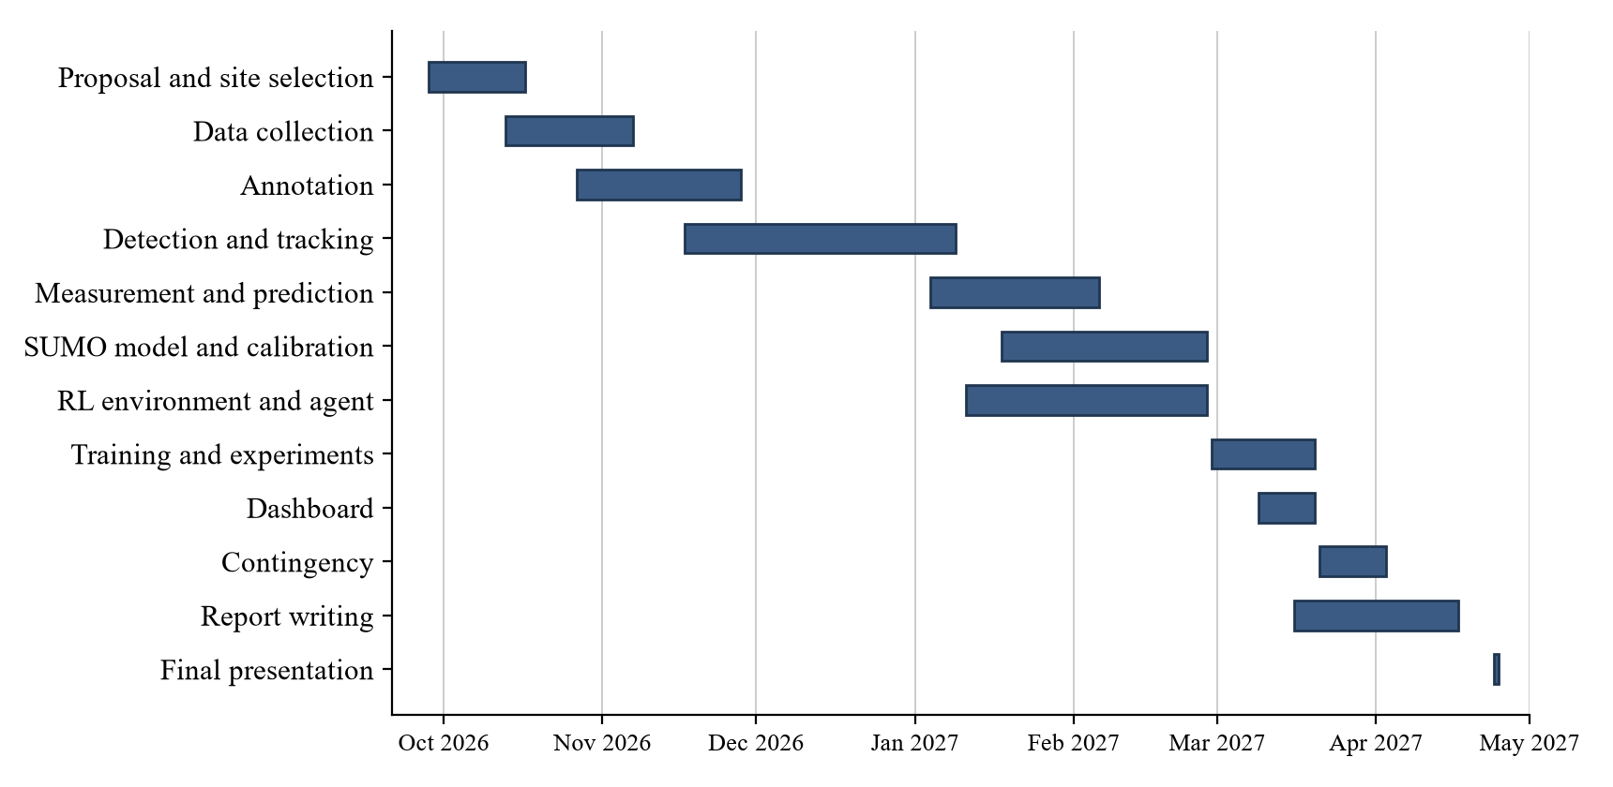
Figure 3: Gantt chart
Because each stage depends on the one before it, progress is controlled by five checkpoints, listed in Table 5. Work on a later stage does not take substantial time until the checkpoint before it is passed.
Table 5: Project checkpoints
Checkpoint | By | Passed when
1. Site and data feasibility | 24 Oct 2026 | The required approvals are obtained, filming access is confirmed, and the pilot shows every approach and its queue clearly. No full data collection starts before this.
2. Measurement and prediction | 6 Feb 2027 | Arrivals and queues meet their validation thresholds, and the predictors have been evaluated against the baselines
3. Model validity | 27 Feb 2027 | The model meets the calibration thresholds and its errors on the held-out evening peak are reported
4. Experiments complete | 20 Mar 2027 | All planned controller comparisons, including the with-and-without-prediction comparison, have been run and analysed
5. Reporting | 17 Apr 2027 | Results, limitations and corrections are written up in protected time

Work is prioritised in three tiers so that a complete, defensible project exists even if time runs short:
- Essential: the video dataset; the detection and tracking comparison; validated arrival and queue measurements; the prediction model and its comparison with baselines; the calibrated and validated SUMO model; the reinforcement learning controller, with and without predictions, compared with the four alternatives; and the heavy-demand stress test.
- If feasible: the remaining stress scenarios, vehicle speed estimates from the tracks (validated against hand timings), and a replay of the junction under each controller.
- Stretch: running the perception stage on a live video feed, and testing whether the trained agent transfers to a second junction. Live signal control remains future work.

References
Africa Check. (2018, April 3). Analysis: Why figures for Kenya's road death toll vary. https://africacheck.org/fact-checks/blog/analysis-why-figures-kenyas-road-death-toll-vary
Alegre, L. N. (2019). SUMO-RL [Computer software]. GitHub. https://github.com/LucasAlegre/sumo-rl
Alshiekh, M., Bloem, R., Ehlers, R., Könighofer, B., Niekum, S., & Topcu, U. (2018). Safe reinforcement learning via shielding. Proceedings of the AAAI Conference on Artificial Intelligence, 32(1). https://doi.org/10.1609/aaai.v32i1.11797
Bagabaldo, A. R., & Hackl, J. (2025). Digital twins for intelligent intersections: A literature review (arXiv:2510.05374). arXiv. https://doi.org/10.48550/arXiv.2510.05374
Bernardin, K., & Stiefelhagen, R. (2008). Evaluating multiple object tracking performance: The CLEAR MOT metrics. EURASIP Journal on Image and Video Processing, 2008, Article 246309. https://doi.org/10.1155/2008/246309
CVAT.ai Corporation. (2023). Computer Vision Annotation Tool (CVAT) [Computer software]. GitHub. https://github.com/cvat-ai/cvat
Dasgupta, S., Rahman, M., Lidbe, A. D., Lu, W., & Jones, S. (2021). A transportation digital-twin approach for adaptive traffic control systems (arXiv:2109.10863). arXiv. https://doi.org/10.48550/arXiv.2109.10863
Dowling, R., Skabardonis, A., & Alexiadis, V. (2004). Traffic analysis toolbox volume III: Guidelines for applying traffic microsimulation modeling software (Report No. FHWA-HRT-04-040). Federal Highway Administration.
Haklay, M., & Weber, P. (2008). OpenStreetMap: User-generated street maps. IEEE Pervasive Computing, 7(4), 12–18. https://doi.org/10.1109/MPRV.2008.80
Hartley, R., & Zisserman, A. (2004). Multiple view geometry in computer vision (2nd ed.). Cambridge University Press.
Hochreiter, S., & Schmidhuber, J. (1997). Long short-term memory. Neural Computation, 9(8), 1735–1780. https://doi.org/10.1162/neco.1997.9.8.1735
Jocher, G., Qiu, J., & Chaurasia, A. (2023). Ultralytics YOLO [Computer software]. GitHub. https://github.com/ultralytics/ultralytics
Kritzinger, W., Karner, M., Traar, G., Henjes, J., & Sihn, W. (2018). Digital twin in manufacturing: A categorical literature review and classification. IFAC-PapersOnLine, 51(11), 1016–1022. https://doi.org/10.1016/j.ifacol.2018.08.474
Lopez, P. A., Behrisch, M., Bieker-Walz, L., Erdmann, J., Flötteröd, Y.-P., Hilbrich, R., Lücken, L., Rummel, J., Wagner, P., & Wießner, E. (2018). Microscopic traffic simulation using SUMO. In 2018 21st International Conference on Intelligent Transportation Systems (ITSC) (pp. 2575–2582). IEEE. https://doi.org/10.1109/ITSC.2018.8569938
Luiten, J., Ošep, A., Dendorfer, P., Torr, P., Geiger, A., Leal-Taixé, L., & Leibe, B. (2021). HOTA: A higher order metric for evaluating multi-object tracking. International Journal of Computer Vision, 129(2), 548–578. https://doi.org/10.1007/s11263-020-01375-2
Ma, X., Tao, Z., Wang, Y., Yu, H., & Wang, Y. (2015). Long short-term memory neural network for traffic speed prediction using remote microwave sensor data. Transportation Research Part C: Emerging Technologies, 54, 187–197. https://doi.org/10.1016/j.trc.2015.03.014
Mnih, V., Kavukcuoglu, K., Silver, D., Rusu, A. A., Veness, J., Bellemare, M. G., Graves, A., Riedmiller, M., Fidjeland, A. K., Ostrovski, G., Petersen, S., Beattie, C., Sadik, A., Antonoglou, I., King, H., Kumaran, D., Wierstra, D., Legg, S., & Hassabis, D. (2015). Human-level control through deep reinforcement learning. Nature, 518(7540), 529–533. https://doi.org/10.1038/nature14236
Mutabarura, P., Muchuka, N., & Segera, D. (2025). Comparative evaluation of YOLO models on an African road obstacles dataset for real-time obstacle detection. Engineering, Technology & Applied Science Research, 15(1), 19045–19051. https://doi.org/10.48084/etasr.9135
Muzata, R., Nkundineza, C., & Kimotho, J. K. (2026). Region-specific road object detection in African environments: Dataset curation, benchmarking, and edge deployment. Engineering, Technology & Applied Science Research, 16(2), 34423–34430. https://doi.org/10.48084/etasr.17251
Raffin, A., Hill, A., Gleave, A., Kanervisto, A., Ernestus, M., & Dormann, N. (2021). Stable-Baselines3: Reliable reinforcement learning implementations. Journal of Machine Learning Research, 22(268), 1–8.
Republic of Kenya. (2019). The Data Protection Act, No. 24 of 2019. Government Printer.
Schulman, J., Wolski, F., Dhariwal, P., Radford, A., & Klimov, O. (2017). Proximal policy optimization algorithms (arXiv:1707.06347). arXiv. https://doi.org/10.48550/arXiv.1707.06347
State moves to tame city traffic with rail plan. (2024, July 10). The Star. https://www.the-star.co.ke/business/kenya/2024-07-10-state-moves-to-tame-city-traffic-with-rail-projects/
Vlahogianni, E. I., Karlaftis, M. G., & Golias, J. C. (2014). Short-term traffic forecasting: Where we are and where we're going. Transportation Research Part C: Emerging Technologies, 43, 3–19. https://doi.org/10.1016/j.trc.2014.01.005
Wang, H., Fennell, C., Poojary, S., & Liu, M. (2025). A SUMO-based digital twin for evaluation of conventional and electric vehicle networks (arXiv:2507.10280). arXiv. https://doi.org/10.48550/arXiv.2507.10280
Webster, F. V. (1958). Traffic signal settings (Road Research Technical Paper No. 39). Her Majesty's Stationery Office.
Wei, H., Zheng, G., Gayah, V., & Li, Z. (2021). Recent advances in reinforcement learning for traffic signal control: A survey of models and evaluation. ACM SIGKDD Explorations Newsletter, 22(2), 12–18.
Williams, S., White, A., Waiganjo, P., Orwa, D., & Klopp, J. (2015). The digital matatu project: Using cell phones to create an open source data for Nairobi's semi-formal bus system. Journal of Transport Geography, 49, 39–51.
World Health Organization. (2018). Global status report on road safety 2018. World Health Organization.
World Health Organization. (2023). Global status report on road safety 2023: Kenya country profile. https://cdn.who.int/media/docs/default-source/country-profiles/road-safety/road-safety-2023-ken.pdf
Zhang, Y., Sun, P., Jiang, Y., Yu, D., Weng, F., Yuan, Z., Luo, P., Liu, W., & Wang, X. (2022). ByteTrack: Multi-object tracking by associating every detection box. In S. Avidan, G. Brostow, M. Cissé, G. M. Farinella, & T. Hassner (Eds.), Computer vision – ECCV 2022 (Lecture Notes in Computer Science, Vol. 13682, pp. 1–21). Springer. https://doi.org/10.1007/978-3-031-20047-2_1

