Testing Log for Chess Project

The purpose of this document is to keep track of all the testing (manual or via a test suite) that you’ve performed on your chess game to ensure it works correctly. Use the below grid as you go to record each thing you tested. You should be sure to test all functions as fully as possible!

Manual Tests:
Name of function you’re testing | Action taken | Expected Response | Pass/Fail | Screen shot
Board constructor | Press “start” button | A board is displayed on the screen with a white square in the top left corner and a checkerboard pattern across the rest of the 8 rows/columns. | Pass | 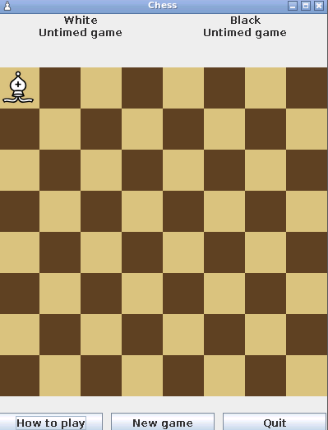
Get Controlled Squares | Shows all the pieces that a piece is controlling | Bishop is on a square | Pass | 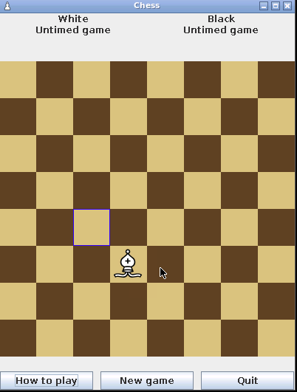
Legal Moves | If the bishop is moved to a square where it is illegal it won’t move to the square | Bishop gets moved back to original square it was on | Pass  In picture it moved back to original square after | 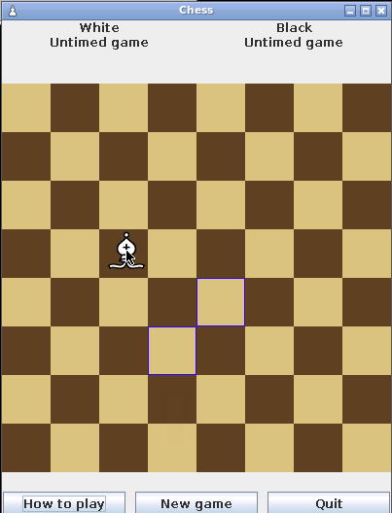

Code tests (optional):

If you made any JUnit Tests please copy and paste them here:

