|  |  |
| --- | --- |
|  | COS221 Practical 5 |
|  |  |
|  | Swing Steezy  June 2022 |

Contents

Task 1: Research 2

Overview 2

Structure 2

Task 2: (E)ER Diagram 2

Overview and Descriptions 2

Version 1 4

Final Version 4

Task 3: (E)ER Diagram to Relational Mapping 5

Task 4: Relational Exclusion 5

SQL Statements 5

Visual Database 6

Task 6: Sample Data 7

Task 7: Analyse and Optimise 7

Query 1 7

Query 2 7

Query 3 7

# Task 1: Research

### Overview

### Structure

# Task 2: (E)ER Diagram

### Overview and Descriptions

These tables contain the original ideas for what would be needed, in order to provide a sense of direction before beginning the final ER diagram. They were continuously updated as new requirements were discovered and used as the base for the ER diagram.

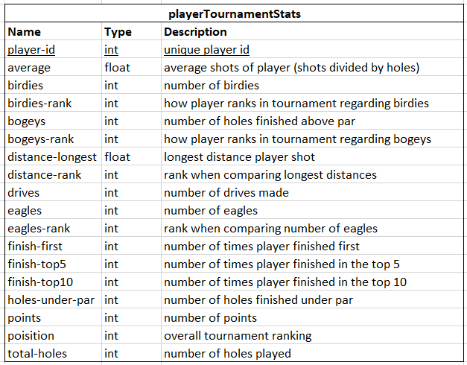

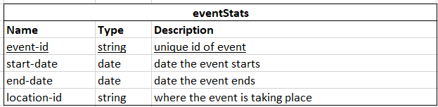

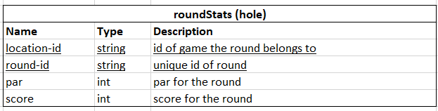

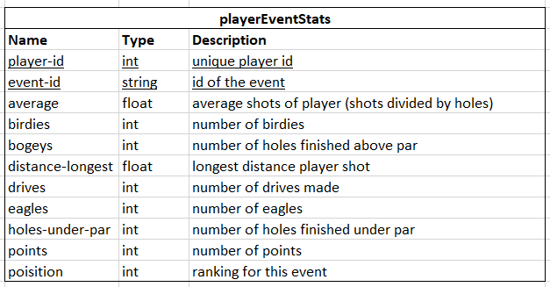

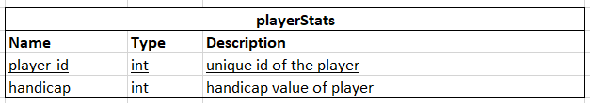

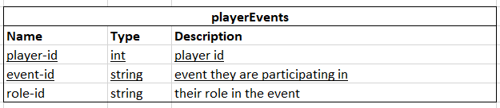

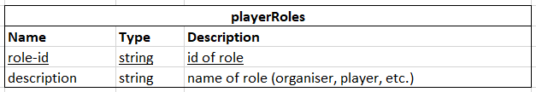

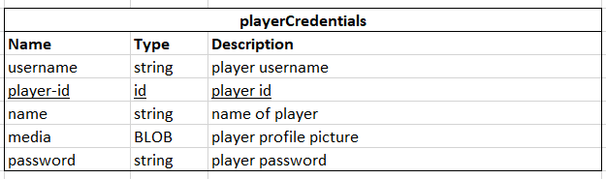

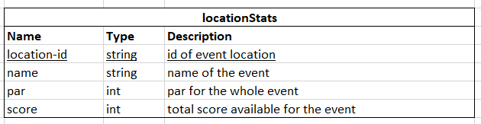

### Version 1

Below is the first draft of the ER diagram, drawn based on the above tables and later expanded upon.

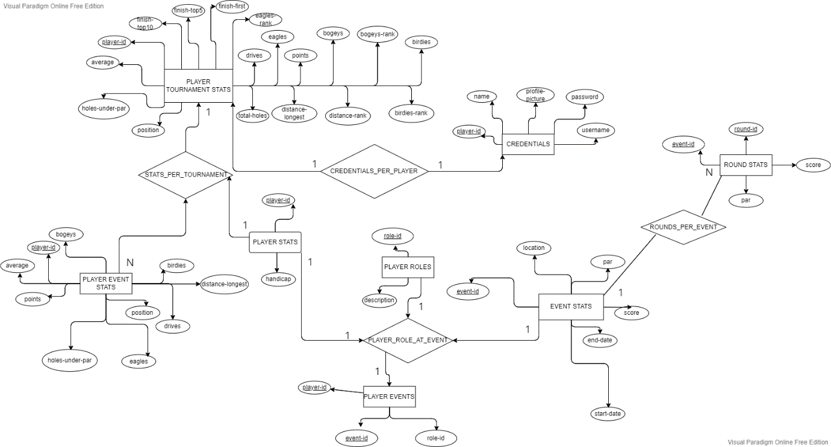

### Final Version

The final version of the ER diagram was generated using MySQL Workbench after the database had been created and contains all elements and relationships we created for the database extension.

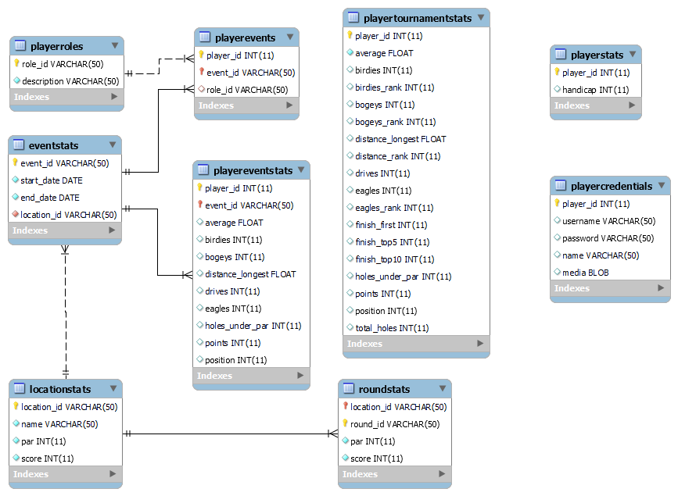

# Task 3: (E)ER Diagram to Relational Mapping

# Task 4: Relational Exclusion

### SQL Statements

create table locationStats (location_id varchar(50) not null primary key, name varchar(50) not null, par int not null, score int not null);

create table playerRoles (role_id varchar(50) not null primary key, description varchar(50) not null);

create table eventStats (event_id varchar(50) not null primary key, start_date date not null, end_date date not null, location_id varchar(50) not null, foreign key (location_id) references locationStats(location_id));

create table roundStats (location_id varchar(50) not null, round_id varchar(50) not null, par int not null, score int not null, primary key (location_id, round_id), foreign key (location_id) references locationStats(location_id));

CREATE TABLE `sportsdb`.`playerstats` (`player_id` INT NOT NULL, `handicap` INT NOT NULL, PRIMARY KEY (`player_id`), CONSTRAINT `playerStats_id` FOREIGN KEY (`player_id`) REFERENCES `sportsdb`.`persons` (`id`) ON DELETE NO ACTION ON UPDATE NO ACTION) ENGINE=MyISAM;

create table playertournamentstats (player_id int not null, average float not null, birdies int, birdies_rank int, bogeys int, bogeys_rank int, distance_longest float, distance_rank int, drives int, eagles int, eagles_rank int, finish_first int, finish_top5 int, finish_top10 int, holes_under_par int, points int, position int, total_holes int, primary key (player_id), foreign key (player_id) references persons(id)) engine=MyISAM;

create table playereventstats (player_id int, event_id varchar(50), average float, birdies int, bogeys int, distance_longest float, drives int, eagles int, holes_under_par int, points int, position int, primary key (player_id, event_id), foreign key (player_id) references persons(id), foreign key (event_id) references eventstats(event_id)) engine=MyISAM;

create table playerevents (player_id int, event_id varchar(50), role_id varchar(50), primary key (player_id, event_id), foreign key (player_id) references persons(id), foreign key (event_id) references eventstats(event_id), foreign key (role_id) references playerroles(role_id)) engine=MyISAM;

create table playercredentials (player_id int, username varchar(50), password varchar(50), name varchar(50), media blob, primary key (player_id), foreign key (player_id) references persons(id)) engine=MyISAM;

### Visual Database

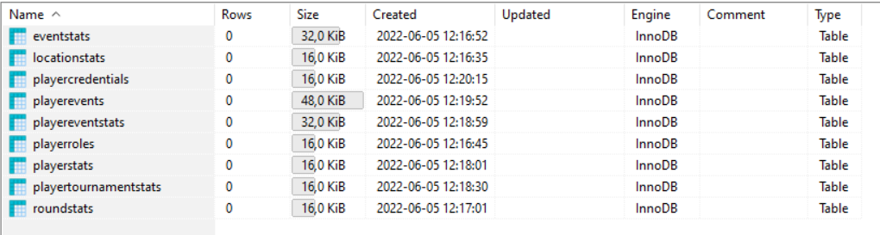

# Task 6: Sample Data

# Task 7: Analyse and Optimise

### Query 1

The original query is:

When executed in the database, the processing time is

### Query 2

### Query 3