Dylan Karman

Email: [Dylan.Karman90@gmail.com](mailto:Dylan.Karman90@gmail.com)

Mobile: (831)601-3553

**03/19/2021**

**Sample App Business Analysis**

Sample App can be found on the iOS App Store. Sample App made a change to a marketing campaign that impacted their App Store Search channel on 10/28/20. The developer of Sample App would like to know the following: What is the impact of the 10/28/20 store change?

The changes made to the marketing campaign were done to make Sample App’s search results more efficient in order to have more users on their platform. I think that impressions are a more important metric than app units in this case because, ““Impression” and “App Unit” metrics are most important when tracking your discoverability and conversion**. Impressions are a better measure of discoverability for Search**, since most users will download directly from Search without tapping to view your Product Page.“ [Source](https://www.businessofapps.com/insights/understanding-the-app-store-metrics/). The data ranges from 4/17/2017 – 2/1/2021 and the change on the app store took place on 10/28/2020. This means that there is only three months of data that is available to use, and I do not think that there is enough data to show a real quantifiable change. However, there are some trends for the App Store Search Impressions that show a steady rise in impressions for the prior four years, but a stagnant App Store Search App Unit rate and a massive drop in App Store Browse Impressions. All of which is apparent from before the change on the App Store.

Sample App has sent me their data in order to quantify a change to their app. I needed to get a better understanding of what the data was, and in order to do this effectively, I used the OSEMN (pronounced awesome) process. Obtain, Scrub, Explore, Model and iNterpret the data. Due to the fact that App Store Connect keeps such great and complete records, there was no missing data, which made the “obtain” and “scrub” parts of the OSEMN process very easy and fast. Upon examination of the data, I was a little worried. Sample App wants to quantify a change in their marketing campaign that should affect the App Store Search Channel, however, the data that was provided is very limited in that scope. The data ranges from 4/17/2017 to 2/1/2021. If the change to the app was made on 10/28/2020, this leaves only three full months of data that can be used to see the change. In my opinion, this is not enough time. I am assuming that the change to the marketing campaign was properly AB tested, but even AB testing needs a full business cycle to fully appreciate the changes that were made. Questions like, “are there any outside circumstances that have either increased or decreased the results?” can be asked, and with such little data, I cannot tell. This is why Sample App needs to observe the changes that they made for a longer period of time before a definitive answer can be made.

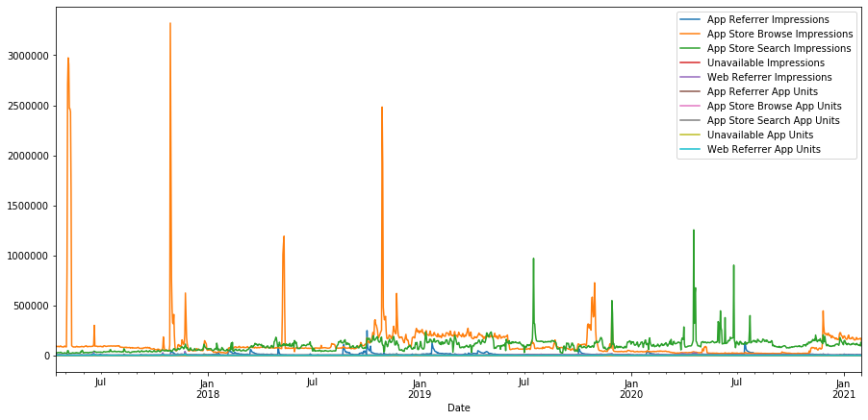

*Entire data set graphed. The box encompasses the months after the change was made.

No real fluctuation in data.

The three months that were affected by the new marketing campaign are November 2020, December 2020, and January 2021. A comparison of these months with each other from before and after the change should allow us to see if there is a difference that the yearly graph could not pick up because it is more precise; Months as opposed to Years. By using the median I can account for outliers more easily, and get a clearer picture by graphing the results.

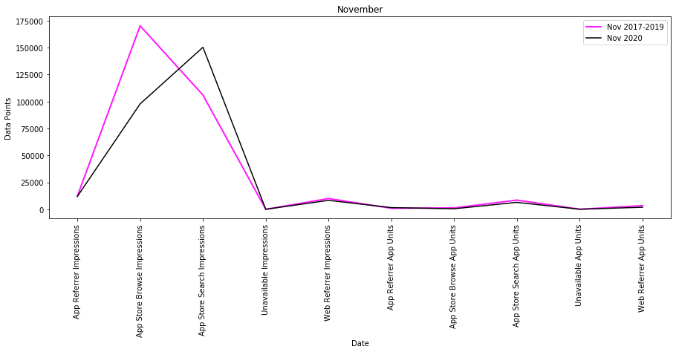

*The pink line shows November 2017-2019 concatenated and averaged. The Black line is for 2020, also averaged. There is a clear shift from App Store Browse Impressions towards App Store Search Impressions.

The data for comparing the three months from before and after the change is shown below.

(Nov 2020 mean) – (Nov 2017/2018/2019 combined mean)

App Referrer Impressions: -312.94

App Store Browse Impressions: -72457.06

**App Store Search Impressions: 44362.01**

Unavailable Impressions: 1.23

Web Referrer Impressions: -1689.71

App Referrer App Units: 642.12

App Store Browse App Units: -802.43

App Store Search App Units: -2085.44

Unavailable App Units: 13.74

Web Referrer App Units: -1482.86

(Dec 2020 Mean) – (Dec 2017/2018/2019 combined mean)

App Referrer Impressions -1922.94

App Store Browse Impressions 98615.37

**App Store Search Impressions 33462.32**

Unavailable Impressions 0.58

Web Referrer Impressions -622.41

App Referrer App Units -66.48

App Store Browse App Units -302.18

App Store Search App Units -1211.30

Unavailable App Units 24.94

Web Referrer App Units -620.37

(Jan 2021 mean) – (Jan 2018/2019/2020 combined mean)

App Referrer Impressions -7193.84

App Store Browse Impressions 53649.57

**App Store Search Impressions 1302.85**

Unavailable Impressions -0.11

Web Referrer Impressions 594.87

App Referrer App Units -205.11

App Store Browse App Units -65.21

App Store Search App Units -1206.76

Unavailable App Units -89.49

Web Referrer App Units -554.62

Comparing these averages is useful to see gains and losses. There is an **increase** in App Store Search Impressions for each month, which is a good sign that the marketing campaign is working. There is a **decrease** in the amount of App Units for all three months, which could possibly be an unintended consequence of the change.

It turns out that there is a clear trend present within the data with regards to App Store Search Impressions.

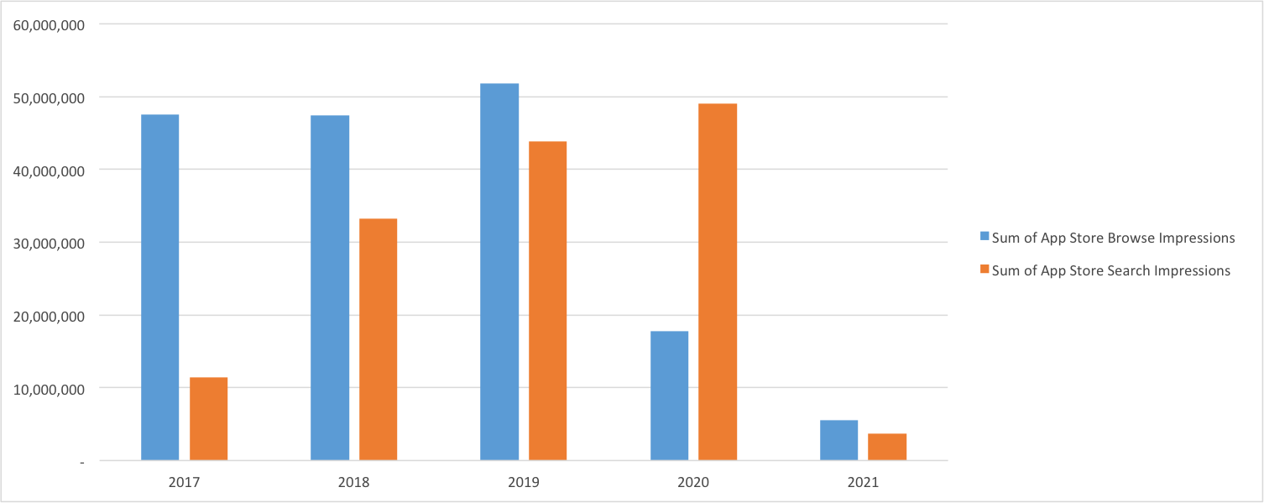

*Blue = Sum of App Store Browse Impressions

Orange = Sum of App Store Search Impressions

**2017 and 2021 are partial years due to limitations in the data set

Search impressions are consistently trending upwards, while Browse Impressions, which seemed stable, took a dive in 2020. This could possibly be from rising popularity with Sample App where people are searching for it more and browsing less. As seen in the graph below, there is no correlation between rising Impressions and App Unit rates.

Unfortunately, I cannot say whether the changes made on 10/28/2020 had any impact on their App Store Search Channel because there is not enough data. App Store Search Impressions are trending up, which suggests to me that the developers were right to strengthen their marketing campaign for where the bulk of their downloads are coming from. It seems that whatever the change was on the App Store is working but due to the fact that the App Store Search Impressions were trending up for years, and that there is a lack of data for after the change was made, I cannot say definitively that the change in the App Store is the cause of the gains in impressions, and conversely, the decrease in app units.

Please take a look at my [Full Project](https://github.com/dylankarman/Gummicube) here.