OpenCV + Python For windows system:

1. Download python for windows from this link.

<https://www.python.org/downloads/>

Open command prompt window and type ‘python’:

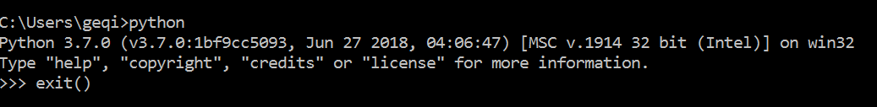

If you get version info displayed, you are all set with python.

Type ‘exit()’ to exit out of python.

1. Download library from this link, so we do not need to package source code ourselves.
2. Download Numpy from this link

<https://www.lfd.uci.edu/~gohlke/pythonlibs/#numpy>

1. Download OpenCV from this link

<https://www.lfd.uci.edu/~gohlke/pythonlibs/#opencv>

Note: download the same version for both numpy and opencv (i.e: cp36m).

1. Copy the path of the location of the downloaded files (Numpy and OpenCV). Run command prompt window as an administrator.

Type ‘cd’ followed by a space and paste URL. Press ‘Enter’ to get in this folder.

You can type ‘dir’ to display the files in this folder to make sure your downloaded files are in it:

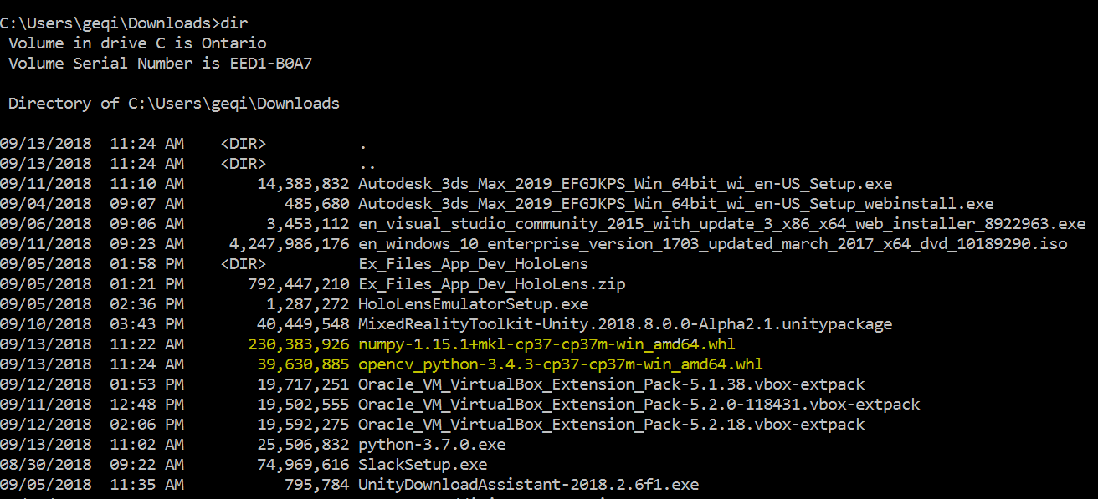

1. Type ‘pip install num’ and press Tab, the full name of file will be added automatically. Press ‘Enter’.

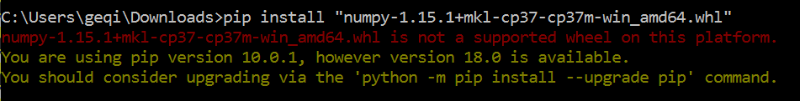

If you get red message in the picture, try to download a 32bit version, and redo it. You can update pip as the yellow message tells, which is not mandatory.

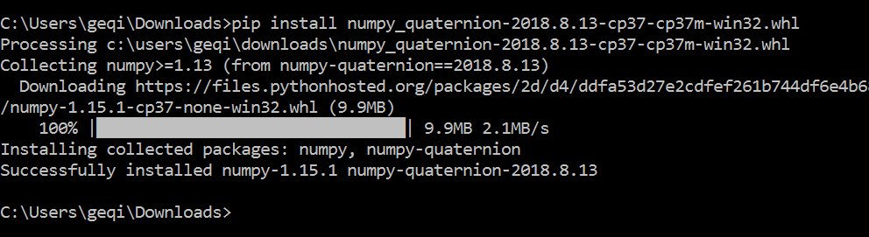

1. Type ‘pip install open’ followed by Tab to install OpenCV library.

Again, download 32bits version of OpenCV if it is not compatible.

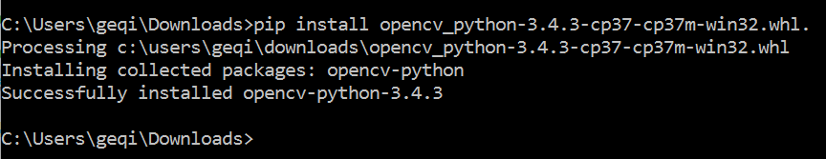

1. Test if everything is installed successfully(optional step):

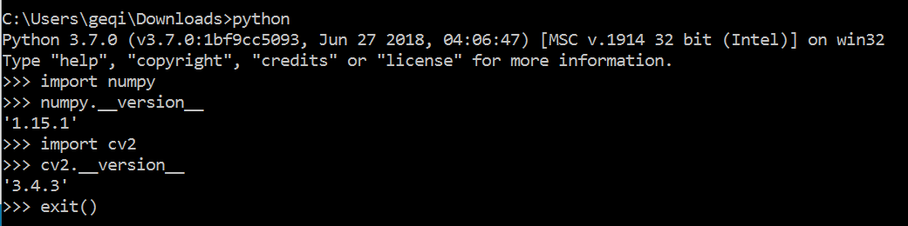

OpenCV + Python For linux system: (Lynda.com account needed)

https://www.lynda.com/Python-tutorials/Install-Linux-Prerequisites/601786/660466-4.html?srchtrk=index%3a1%0alinktypeid%3a2%0aq%3aopencv%0apage%3a1%0as%3arelevance%0asa%3atrue%0aproducttypeid%3a2

Installing and Running Traffic Counting Program For Windows

1. Download the whole package from the link below:

<https://github.com/creotiv/object_detection_projects>

1. Unzip it, install all the libraries in ‘requirements.txt’ using command:

‘pip install nameofthelibrary’ (eg: pip intall pandas)

in the command prompt of windows system.

Note: the version of the libraries in the txt file may be old, so it might be better to find a version which is compatible with version of Python and OpenCV. If there is any error of installation specific library, please try another version. You can find most of libraries of different versions here:

<https://www.lfd.uci.edu/~gohlke/pythonlibs/>

1. Copy the video file into the same location as ‘traffic.py’. Change the name of video file to ‘input.mp4’.
2. Using ‘cd’ command to change current location to the location containing ‘traffic.py’. Type ‘python traffic.py’ to run the program. If you get errors of ‘cannot find specific library’, please try to remove it using ‘pip unintall nameoflibrary’, and reinstall newest version.

Note: If you get error of ‘cannot find ffmpeg’, you need to do the following:

1. Download FFmpeg through this link:

<https://github.com/adaptlearning/adapt_authoring/wiki/Installing-FFmpeg>

The architecture should be the same as the OpenCV version, 32 or 64bits

The linking is Static.

1. Follow this link to set up environment variables:

<https://www.wikihow.com/Install-FFmpeg-on-Windows>

Basically, you need to find the inside folder which contains the library part, change the folder name to ‘FFmpeg’, copy the folder to C:\ drive, copy the URL of the ‘/bin’ path, and add it to the environment variable path.

1. Open command prompt as administrator. Type ‘ffmpeg -version’ to test if it is installed successfully.

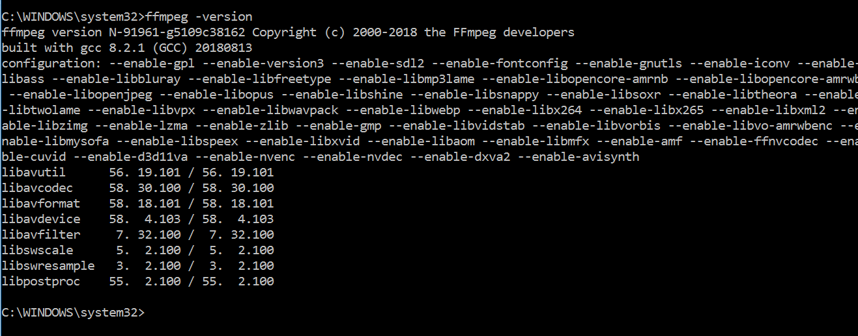

Note: If you get error ‘ffmpeg is not recognized as an internal or external command, operable program or batch file’, make sure the path is ‘C:\WINDOWS\system32>’

1. You should be able to use ‘python traffic.py’ to run the program now. Do not forget to switch to the location of the ‘traffic.py’ file using ‘cd’ command before running it.

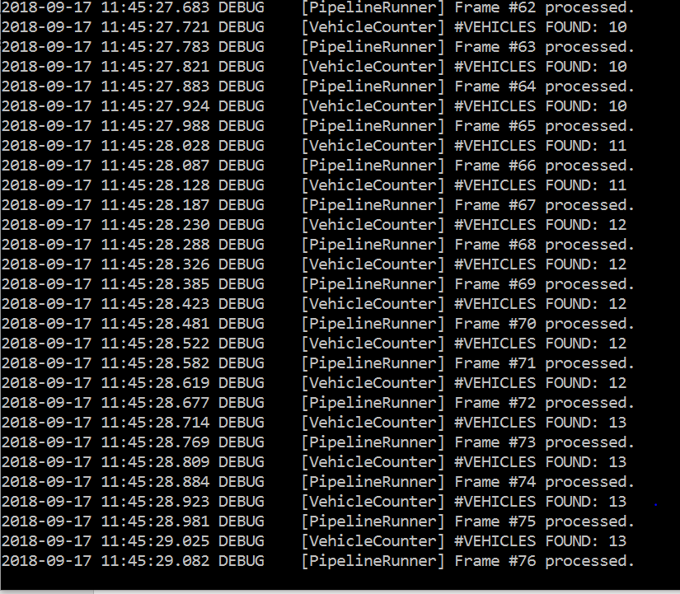

1. Go to ‘out’ folder to check picture captured for each frame. To combine those pictures into a video, double click ‘make_video.sh’, and wait until it finishes processing. A video file called ‘out.mp4’ will come out in the current folder.