**Meeting Manager Chatbot Lab Documentation**

by Qing Ge

1. **Objective**

To explore how Dialogflow and Firebase work by developing a meeting management chatbot. Do some testing to see if these tools have potential to improve the work process of the government.

1. **Tools**
2. **Dialogflow**

Dialogflow (formerly Api.ai, Speaktoit) is a Google-owned developer of human–computer interaction technologies based on natural language conversations.

1. **Firebase**

Firebase provides a realtime database and backend as a service. The service provides application developers an API that allows application data to be synchronized across clients and stored on Firebase's cloud.

1. **Slack**

Slack is a cloud-based set of proprietary team collaboration tools and services, founded by Stewart Butterfield.

1. **Function Flow Chart**

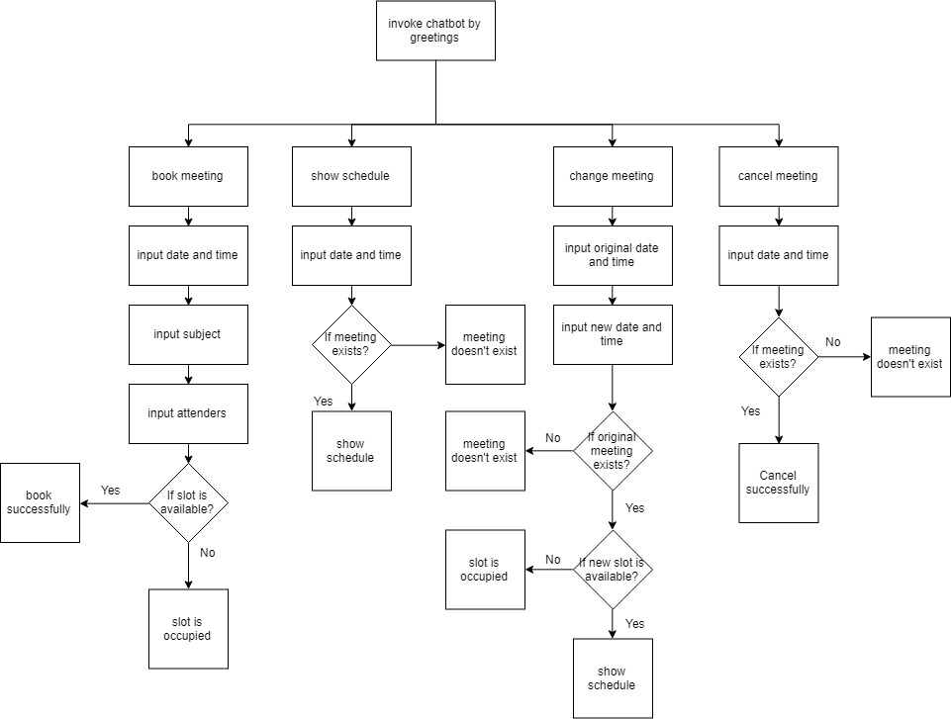

1. **Set up Dialogflow and Firebase**
2. **Create Intent**

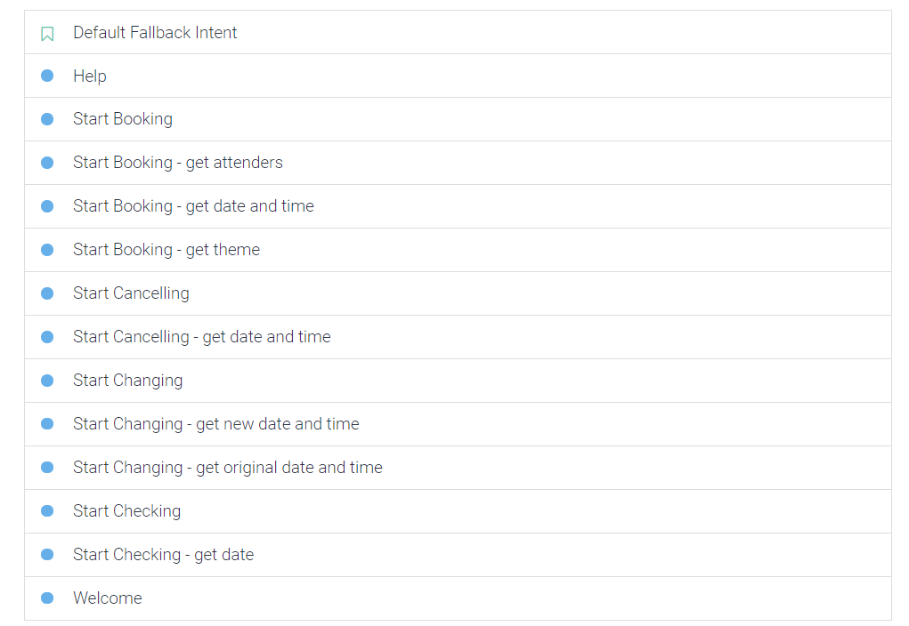

* **Context**: control access to different intents

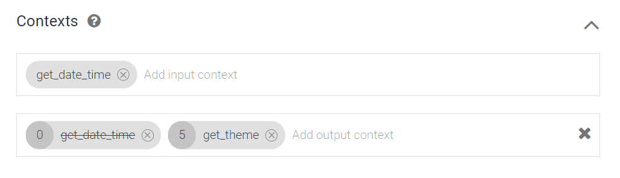

* **Training phases**: user input

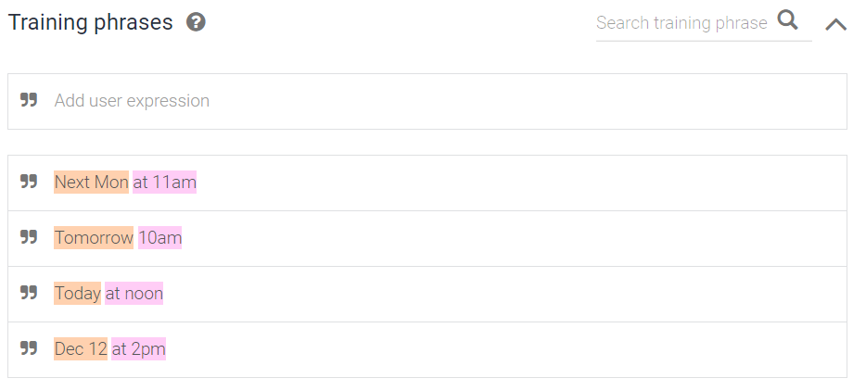

* **Action and parameters**: get key information

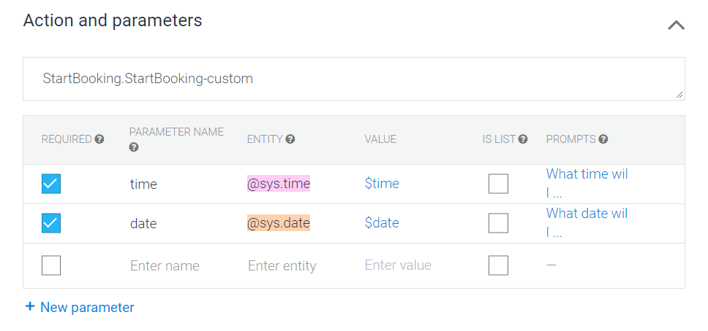

(Check both required to keep asking for information if any mendatory information is not given.)

* **Responses**: bot response

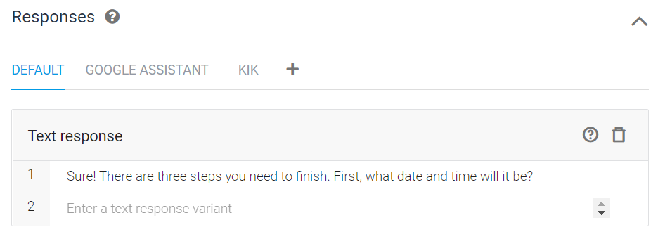

* **Fulfillment**: backend processing, use code to customize complex responses, connect database

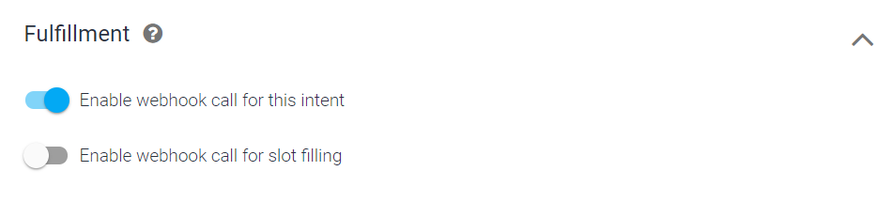

1. **Write fulfillment code (see source code files)**

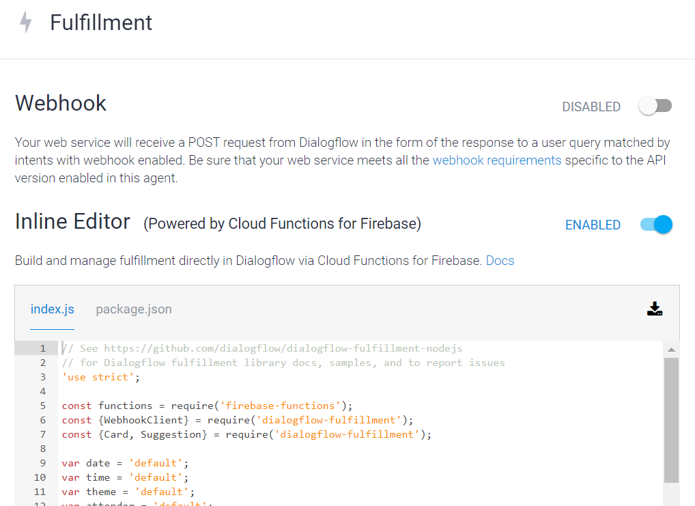

(You can connect another web server or just use Inline Editor.)

Important methods:

1. **Database structure**

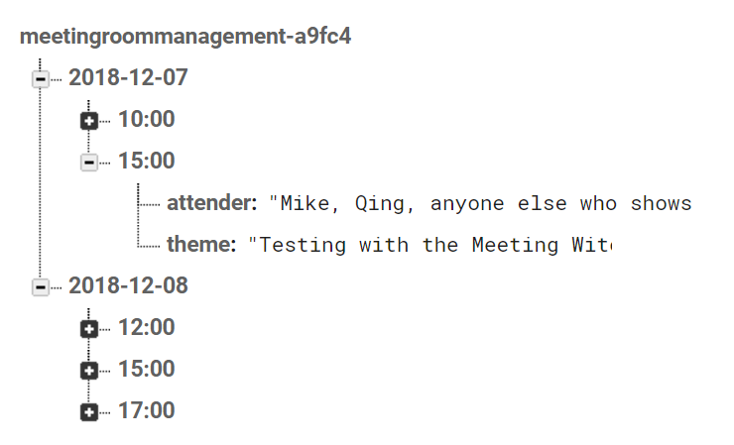

(Database name is generated automatically. Use date and time as its descendants.)

Notice:

1. Using same log-in account for Firebase and Dialogflow is easier. They will connect automatically. Extra setting up may be needed for using different accounts.
2. It is unnecessary to set up the database structure in advance. You can do it in the code.
3. You need a function to clean up the useless data in real-time database in periodical time since it gets slower when too much data accumulated.
4. Connect with Slack

By following this link: <https://dialogflow.com/docs/integrations/slack> to set up slack step by step. Then on your slack, add a new App inputting the bot’s name.

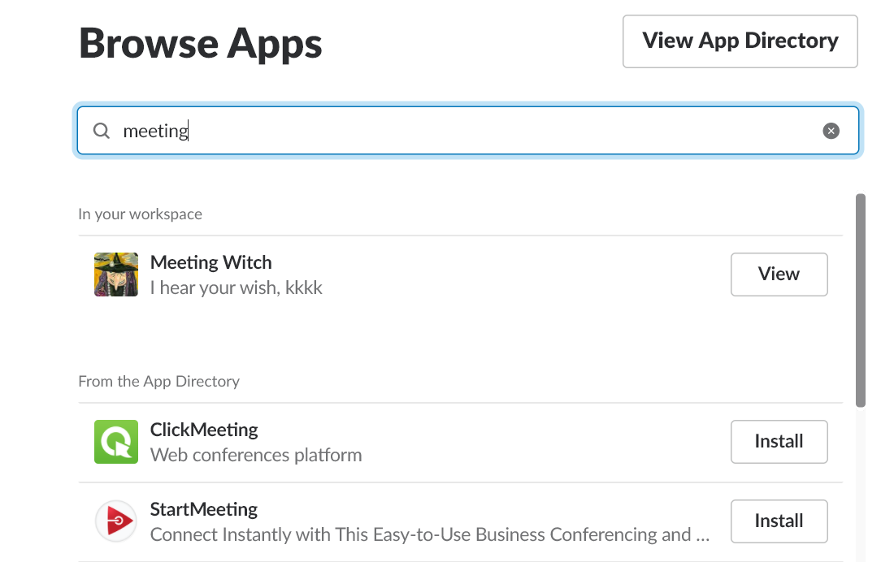

1. **Useful links**

<https://dialogflow.com/docs/tutorial-build-an-agent>

<https://www.youtube.com/watch?reload=9&v=F68HtCtJbGA>

<https://www.youtube.com/watch?v=biN00SoMRI8>

<https://www.youtube.com/watch?v=xWpHVbMnBXI>

<https://stackoverflow.com/questions/53655713/how-to-get-current-intents-name-in-dialogflow-fulfillment>