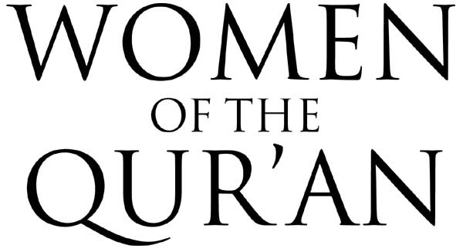
HAWWA - MARIAM - BILQIS & WOMEN IN THE STORY OF MUSA
A COURSE BY IMAM SUHAIB WEBB (USA)
25 MARCH 2006 • LONDON

ORGANISED BY ISLAMIC INSTITUTE FOR DEVELOPMENT & RESEARCH
APPLICATION FORM
PLEASE WRITE CLEARLY • USE BLOCK CAPITALS
Name
Address
Postcode

E-mail
Mobile
Telephone
Profession

How did you hear of the course?

Would you require the creche facility?
If yes, how many children do you have?

Please state how many tickets are required for employed people (@ £15.00 each)
Please state how many tickets are required for students (@ £10.00 each)
Total Payable £
All cheques should be made payable to ‘IIDR”. Post dated cheques cannot be accepted.
Fees inclusive of refreshment, lunch and use of créche facility

Please return your completed form with full payment to:
IIDR, Suite 72, 34 Buckingham Palace Road,
Belgravia, London SW1W 0RH
Find out more about our courses at www.iidr.org Telephone: 0709 230 6665 e-mail: info@iidr.org

