Forged By Progress

Dylan Steinhour

WDD 130

Overview

Purpose
The purpose of the website is to encourage and uplift other people on their own personal journeys, whether it be fitness, financial, mental, spiritual, whatever. As I progressed through my fitness goals, I learned valuable lessons that can be invaluable if applied with the proper effort and mindset.

Audience
My audience is anyone wishing to leave behind the natural man and embrace systems that permit real change in their lives.

Branding

Website Logo
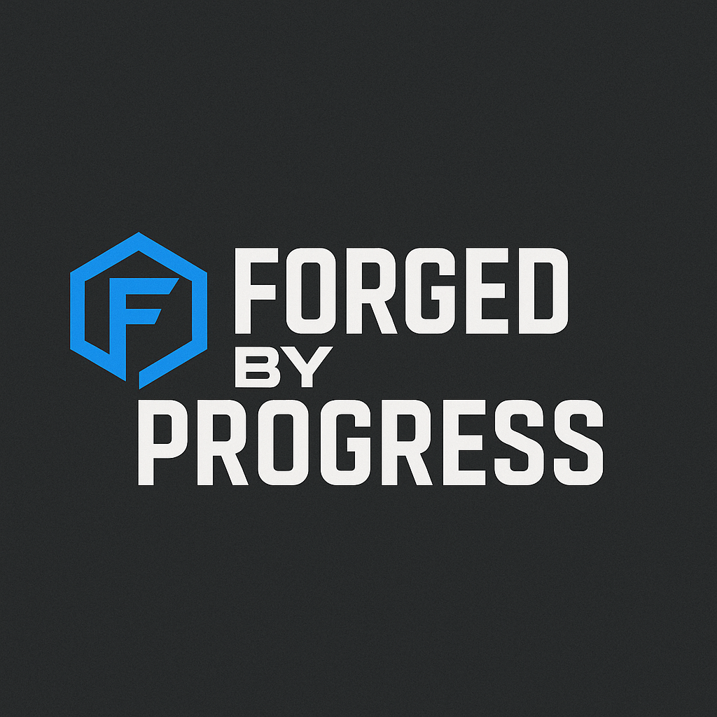

Style Guide

Color Palette
Primary | Secondary | Accent 1 | Accent 2
#3287FF  #1B1B1B | #2F2F2F  #3E4954 | #FF8A3D  #D64545  #1C5BBE | #FFFFFF  #F2F2F2  #A1A1A1

Typography

Heading Font: Oswald

Paragraph Font: Inter

Navigation
Home Page2 Page3

Content

1. Home – “Forged by Progress”
Hero section with:
- A powerful transformation photo (you now vs a year ago).
- A headline like:
“Transformation isn’t magic. It’s systems, discipline, and thousands of small wins.”
- Call to action: Start Coaching →
Sections:
- Your story in 60 seconds (short, punchy)
- Your fitness philosophy (structured, IT-style habits)
- Results preview (before/after slider or grid)
- Testimonials (even 1–2 early quotes helps)
- Coaching teaser

2. My Journey – “The Build Log”
This is where you go deeper:
- Before, during, after timeline
- Metrics (weight, BF%, lifts, miles, energy levels)
- “System architecture of change” (your fun twist):
  - Inputs (nutrition, training, sleep)
  - Monitoring (tracking habits like telemetry)
  - Feedback loops (weekly assessments)
  - Deployments (phased challenges)
- Obstacles
- Lessons learned
- What you're pursuing now (strength goals, running goals, long-term health)
This page builds credibility without bragging.

3. Coaching – “Let’s Build Your System”
Three coaching tiers:
- Tier 1: Habit Blueprint – for people who just want direction.
- Tier 2: Guided Transformation – weekly check-ins, programming.
- Tier 3: Elite Deep-Dive – fully personalized, metrics-driven, hands-on.
What makes your coaching different:
- Systems thinking
- No fad diets
- Incremental growth
- Straight answers
- Business-leader accountability style
- Structure and measurement
Add a simple intake form:
- Goals
- Pain points
- Experience level
- Schedule
- Why now?

4. Resources – “Tools That Actually Help”
A few freebies to capture email signups:
- Your daily habit tracker PDF
- A “starter workout guide”
- A macro-tracking cheat sheet
- A 7-day micro-challenge
- Blog posts (optional):
  - “What actually works”
  - “How to stop starting over”
  - “Systems thinking for fitness”

5. Contact
Clean and simple:
- Email
- Coaching inquiry form
- Social links (Instagram, TikTok, YouTube Shorts if you’re posting mini-updates)

Wireframes

Home
