Gaming Hub Site Plan
Tristan Zatylny
WDD 130

Overview

Purpose
The purpose of this site is to provide users with a simple and easy way to find multiplayer games to play together; to eliminate indecision when it comes to gaming with friends.

Audience
The target audience of the website is gamers who are indecisive when deciding which game they want to play together and those who lack knowledge about multiplayer in some games.

Branding

Website Logo


Style Guide

Color Palette
Primary | Secondary | Accent 1 | Accent 2
#001925 | #004159 | #E87F29 | #09809D

Typography
Heading Font: Oxanium
Paragraph Font: Lato

Navigation
Home Game Library FAQ

Content
Link to moqups page

Images:
Images can be downloaded from the moqups page

Home Page Images:
 | 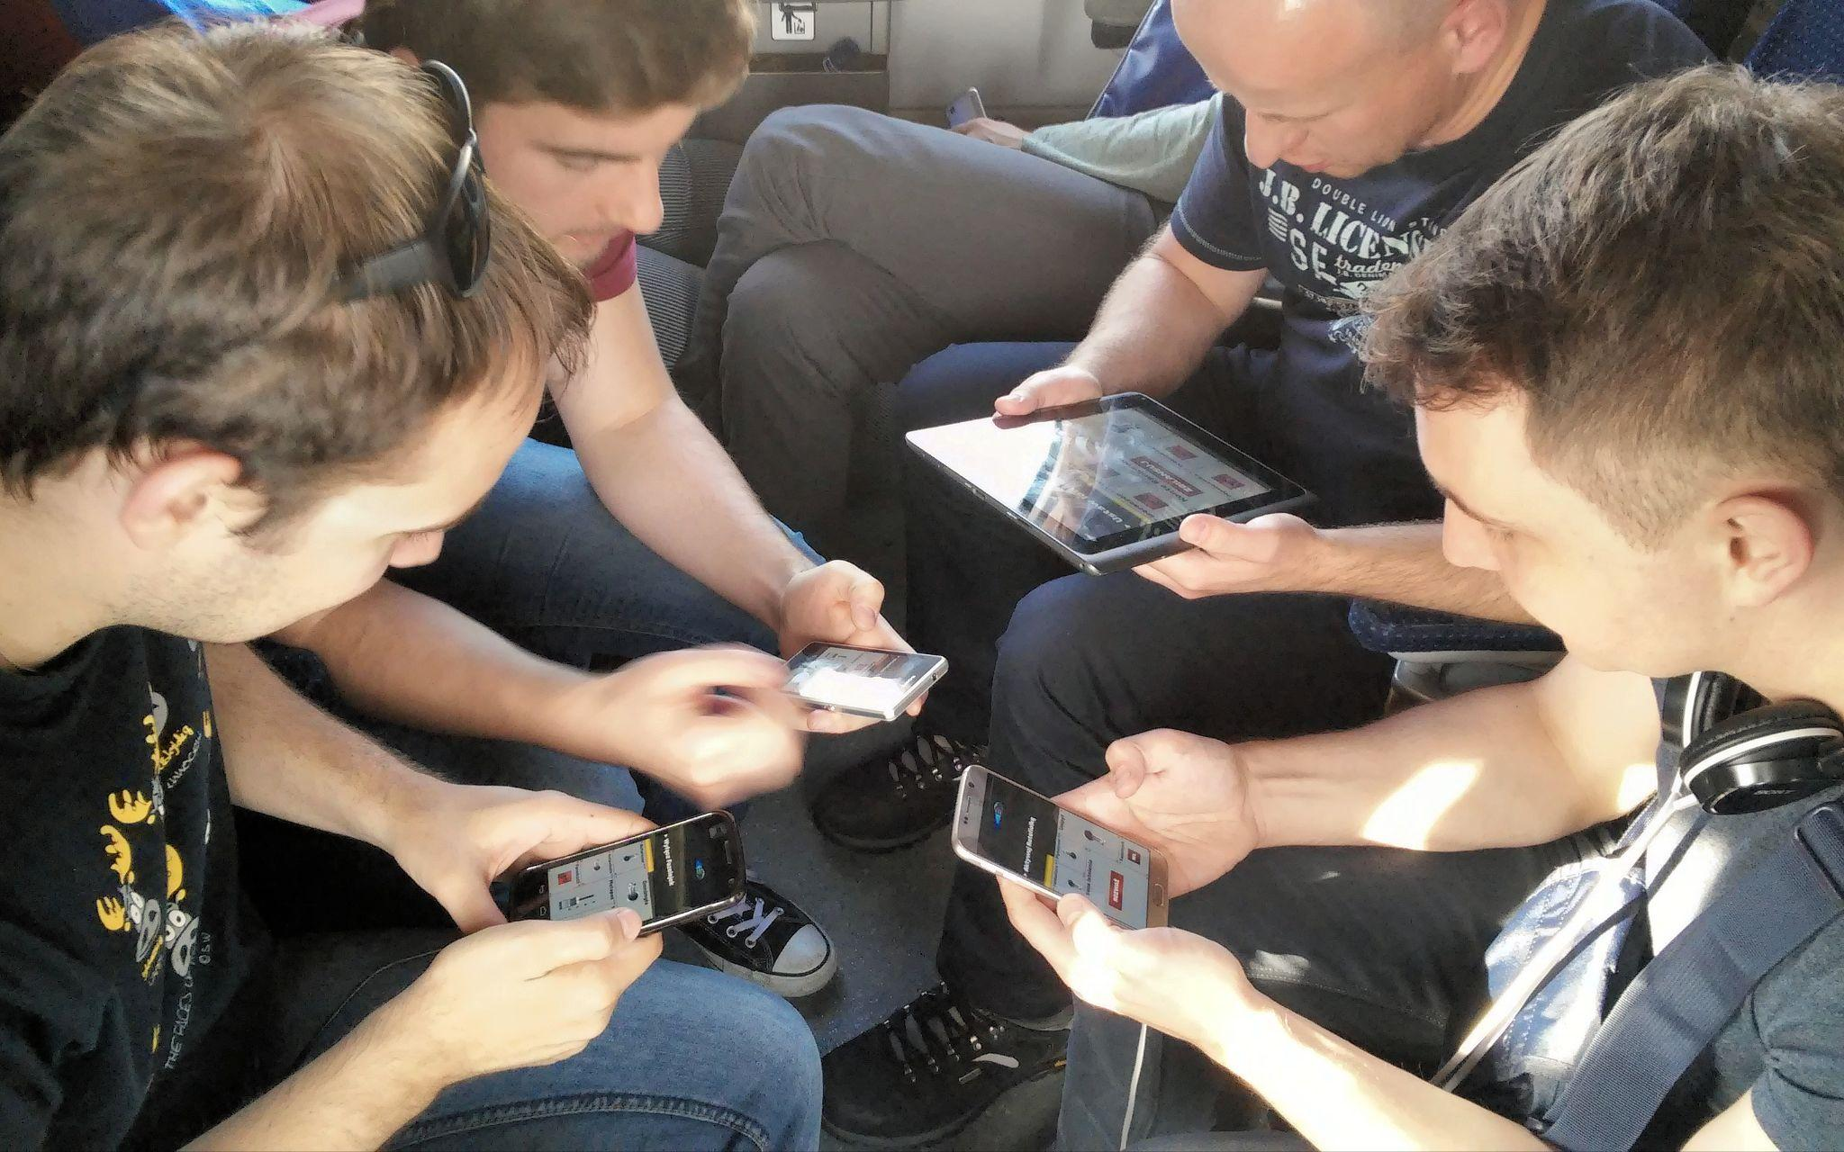
Game Library Page Images:
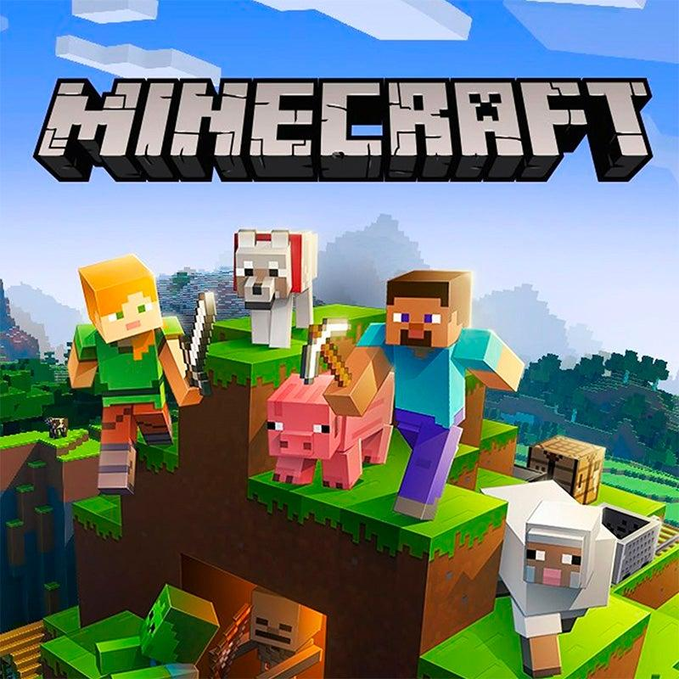 | 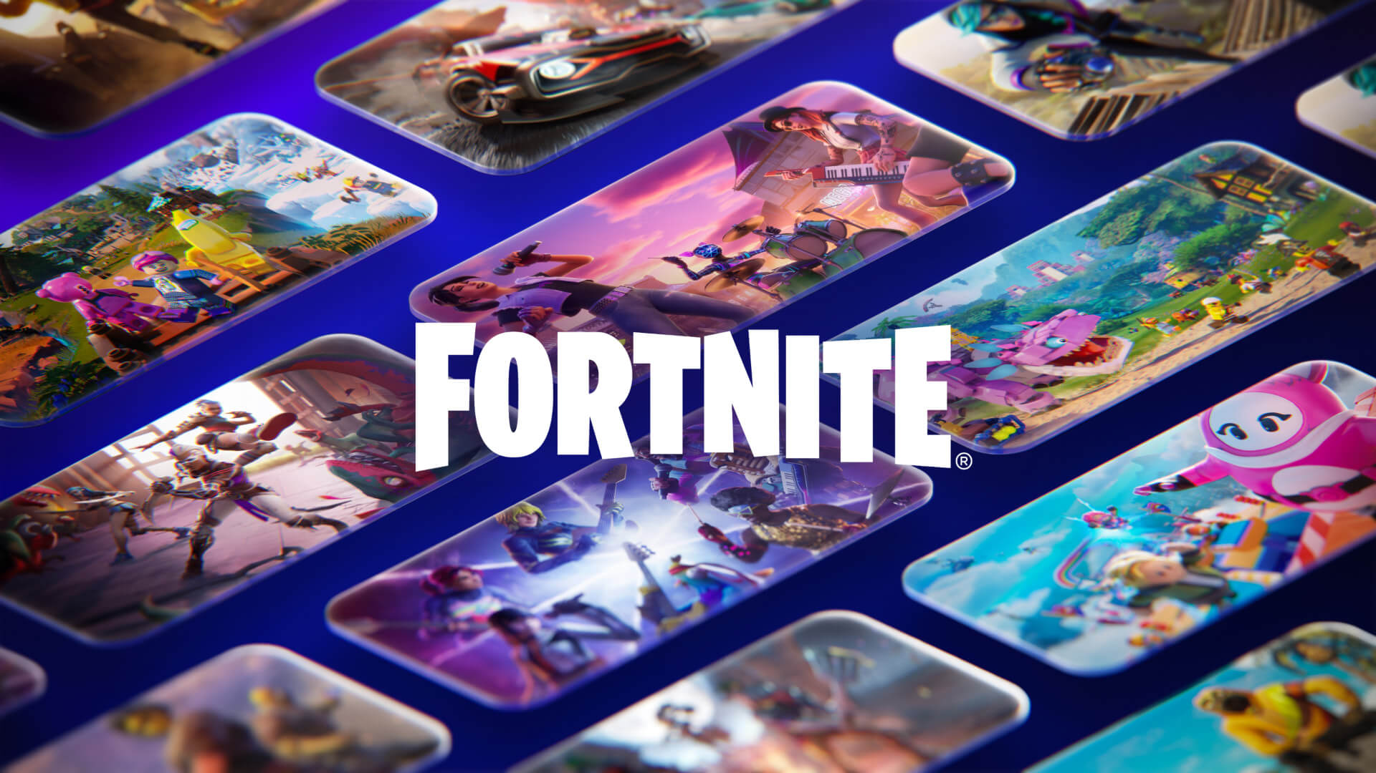
 | 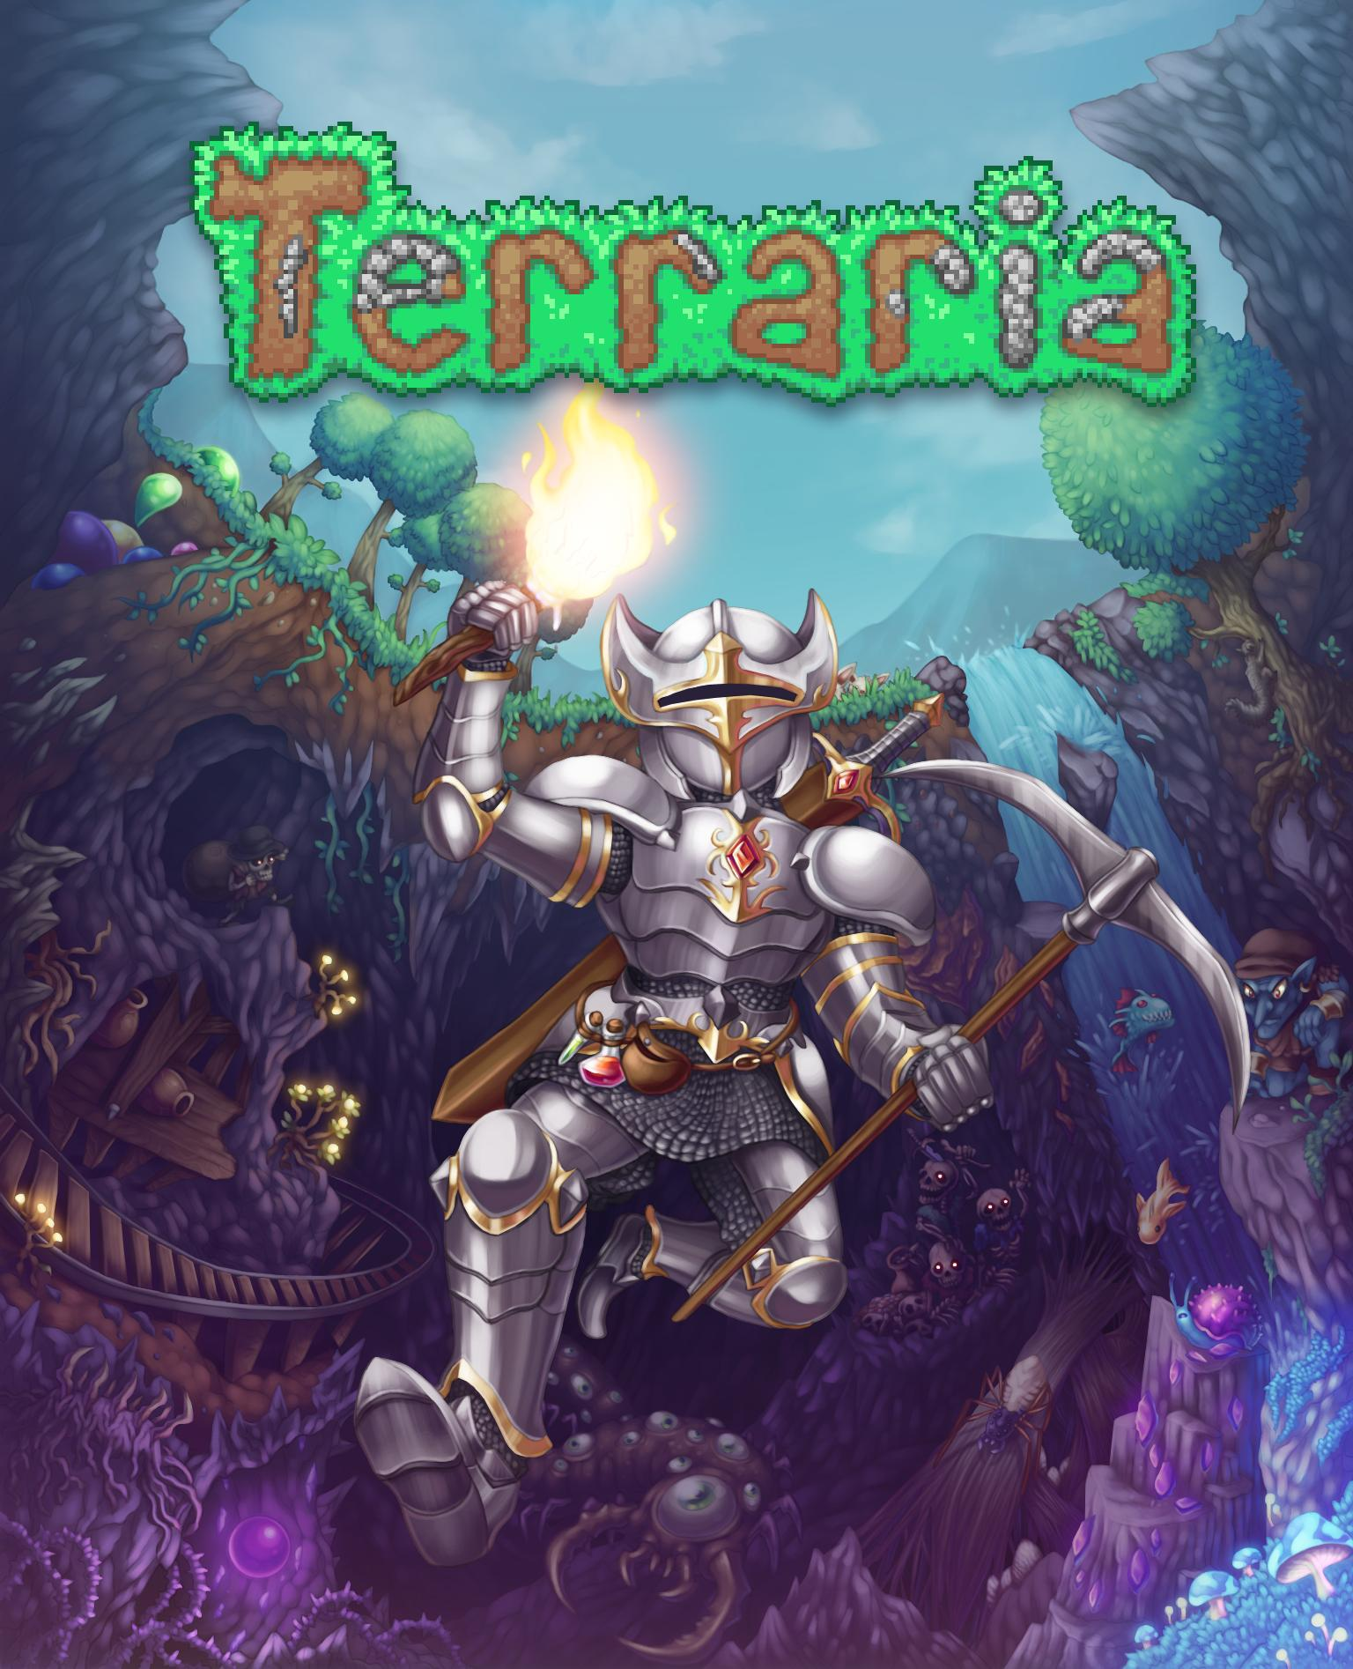
FAQ Page Images
 | 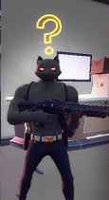

Text content:

Nav Bar:
(logo) Gaming Hub |  | Home Game Library FAQ
Home Page | Game Library Page | FAQ Page
Welcome to Gaming Hub | Game Library | Frequently Asked Questions
Find the right multiplayer game for your group | (Minecraft)  Players: 1+ (depends on server size)  Platforms: PC (Java, Bedrock), Xbox, PlayStation, Switch, Mobile  Crossplay: limited (Java-Java, Bedrock-Bedrock)  Price: $29.99 | My game isn’t listed!  Send us an email and we’ll add it.
Have questions about playing or setting up multiplayer? Check out our FAQ here: | (Fortnite)  Players: 1-4  Platforms: PC, Xbox, PlayStation, Switch, Mobile  Crossplay: full compatibility  Price: free | How do I set up crossplay for [game]?  Many games allow hosting private or dedicated servers. Sometimes, this comes with the benefit of allowing crossplay.
 | (Rocket League)  Players: 1-6  Platforms: PC, Xbox, PlayStation, Switch  Crossplay: full compatibility  Price: free | How do I set up a server for [game]?  Some games come with launchers for dedicated servers. Server hosting services can also be found online.
(Terraria)
Players: 1+ (depends on method used)
Platforms: PC, Xbox, PlayStation, Switch, Mobile
Crossplay: limited (same platform unless using dedicated server)
Price: platform dependent ($10-$30)
Footer:
© 2025 Gaming Hub |  | Home Back to Top

Wireframes

Home
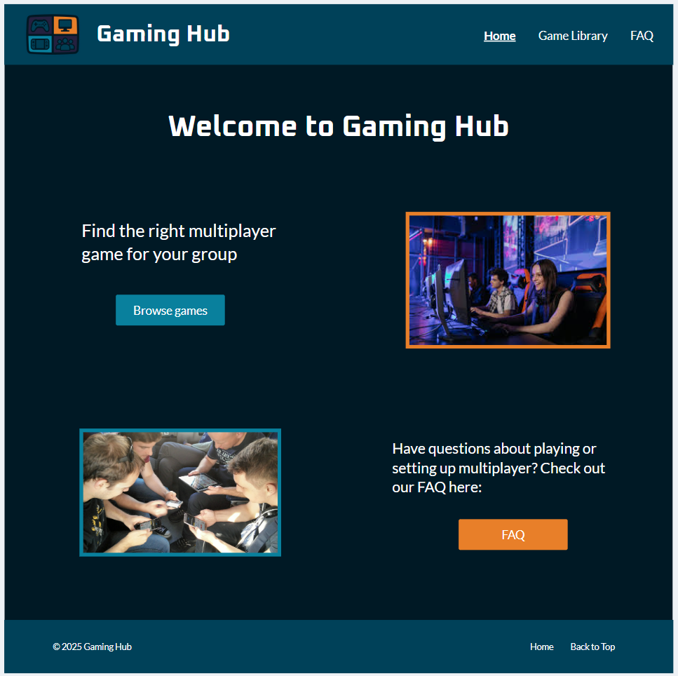

Game Library
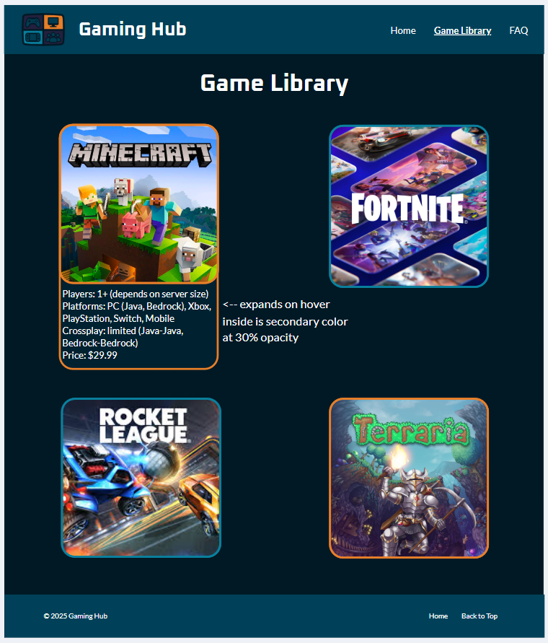

FAQ
Notes:
boxes expand on click
question background is secondary color at 80% opacity,
answer background is secondary color at 30% opacity
