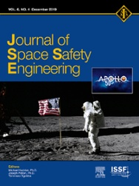
Dear Dr Anselmo,
As co-author of the article Monitoring the Orbital Decay of the Chinese Space Station Tiangong-1 from the Loss of Control until the Re-Entry into the Earth’s Atmosphere, we are pleased to let you know that the final version – containing full bibliographic details – is now available online.
To help you and the other authors access and share this work, we have created a Share Link – a personalized URL providing 50 days' free access to the article. Anyone clicking on this link before January 18, 2020 will be taken directly to the final version of your article on ScienceDirect, which they are welcome to read or download. No sign up, registration or fees are required.

Your personalized Share Link:
https://authors.elsevier.com/c/1a8qC_u8jxCR48
Click on the icons below to share with your network:


Free paper link valid 50 days:

https://www.sciencedirect.com/science/article/pii/S246889671930120X?dgcid=coauthor

