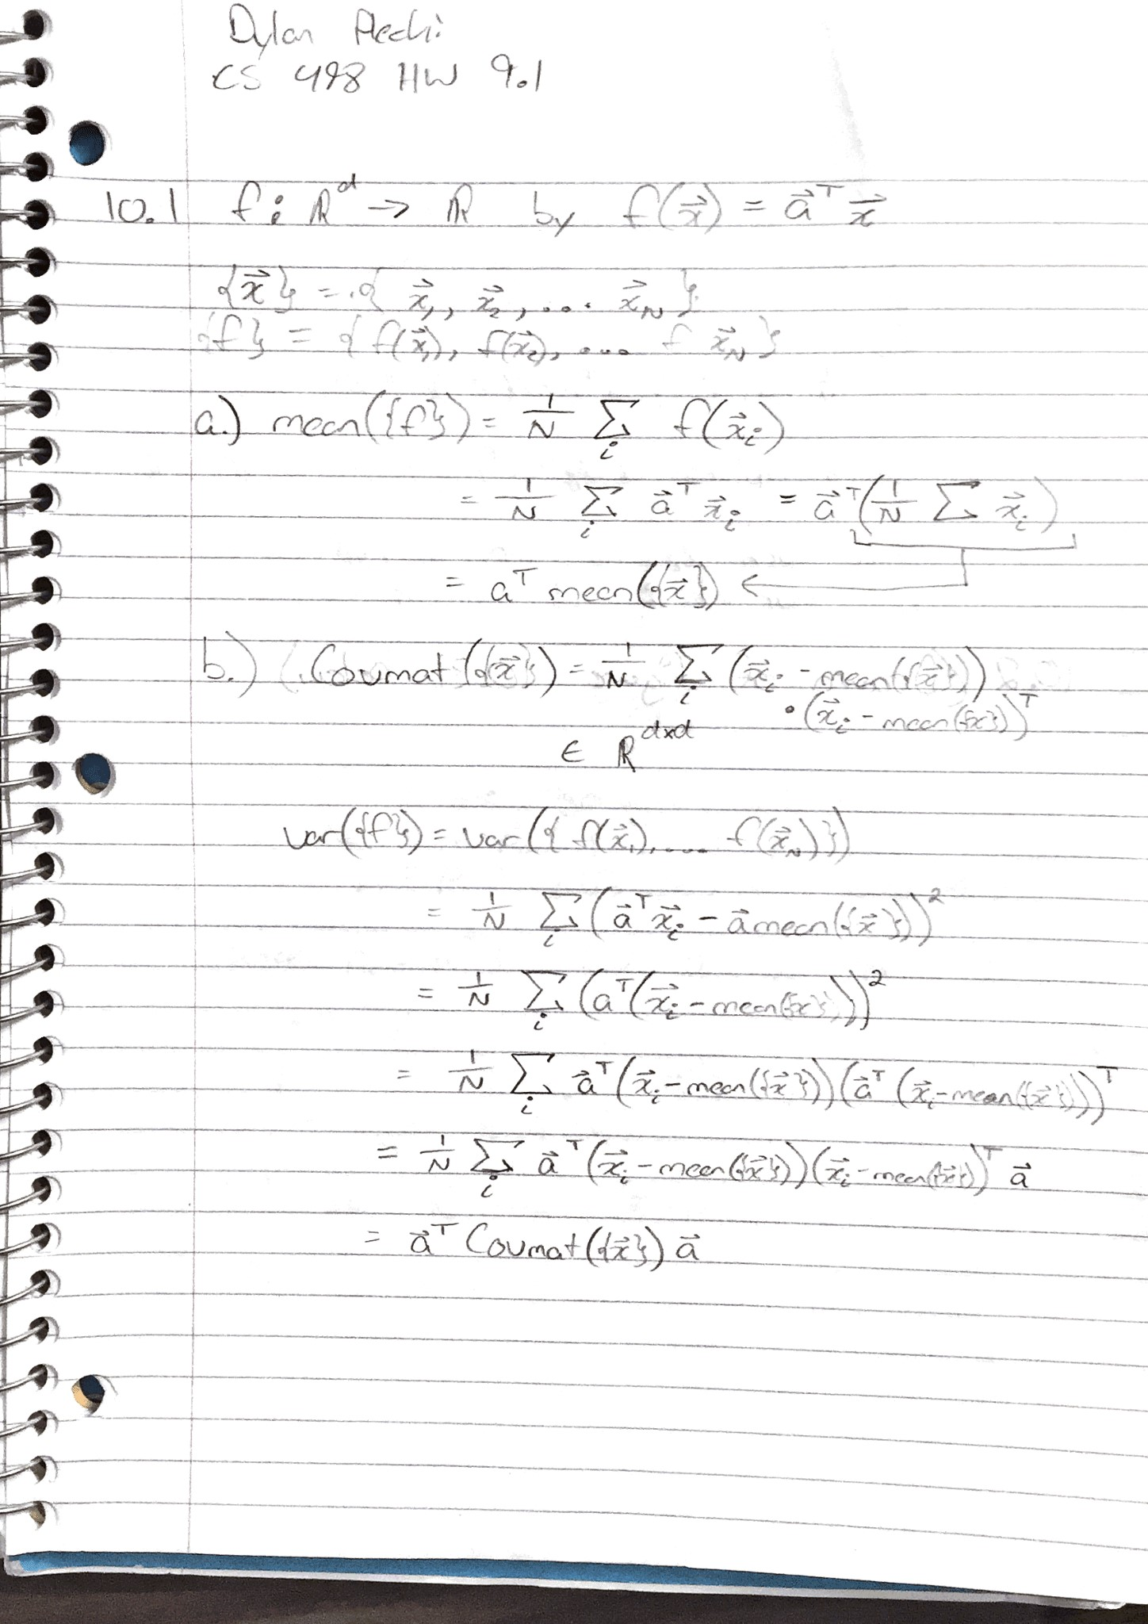

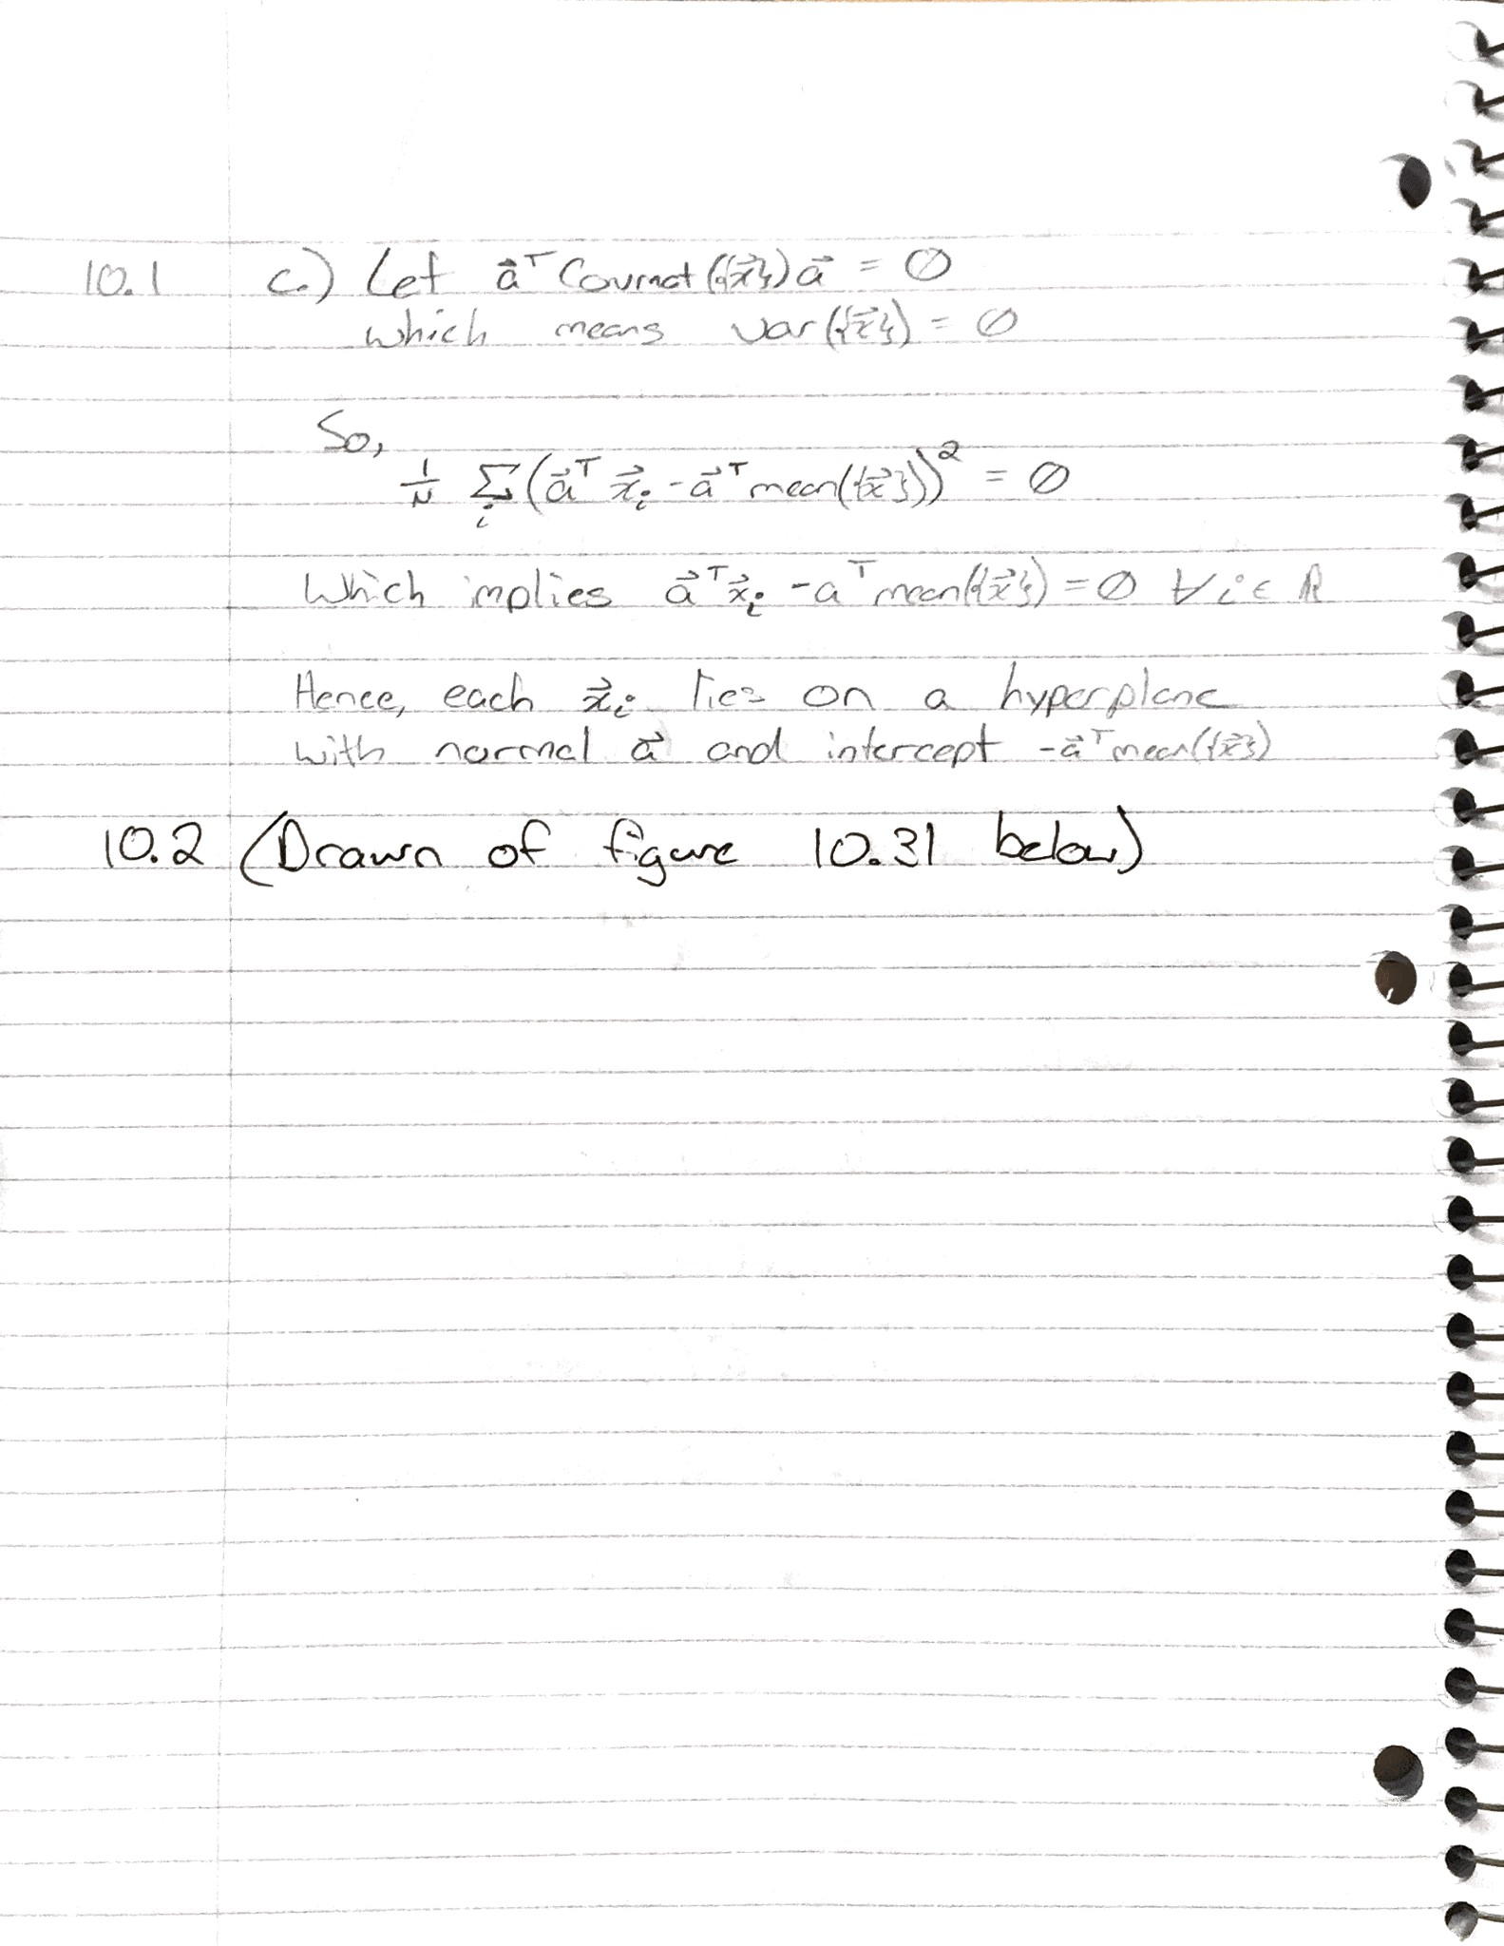

10.2) *Mark the mean of the dataset, the first principal component, and the second principal component.*

1st Principle Component

2nd Principle Component

Mean

