Dylan Howe
SER 216
24 March 2026

Creating a New Branch – Module Completion

Project used: PSP2 TicTacToe/Board Game project files
Branch created: add-instructions
File updated: ui/GameConsoleUI.java

Commands completed:
cd <project folder>
git init -b main
git add .
git commit -m "Initial commit for TicTacToe project"
git checkout -b add-instructions
Added an instruction comment to ui/GameConsoleUI.java
git add ui/GameConsoleUI.java
git commit -m "Add instruction comment to GameConsoleUI"
git checkout main

The screenshots below show the required branch output, the file with changes on the new branch, and the same file after switching back to main.

Screenshot 1. Output of git branch while on the new branch.
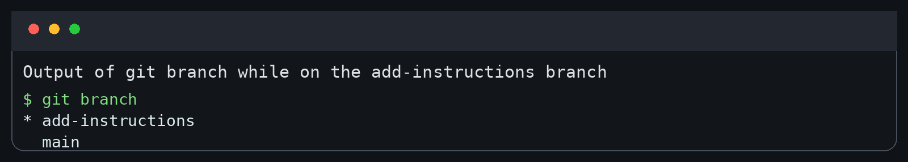
This confirms the current branch is add-instructions.

Screenshot 2. Commit history showing the branch commit.
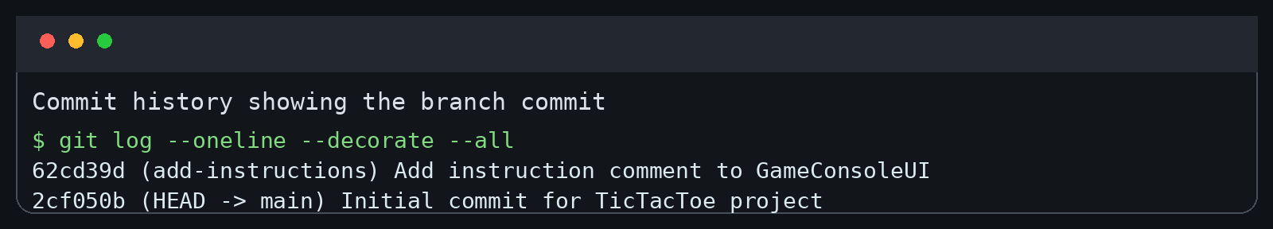
This confirms the changes were committed on the branch.

Screenshot 3. ui/GameConsoleUI.java with the added instruction comment on add-instructions.
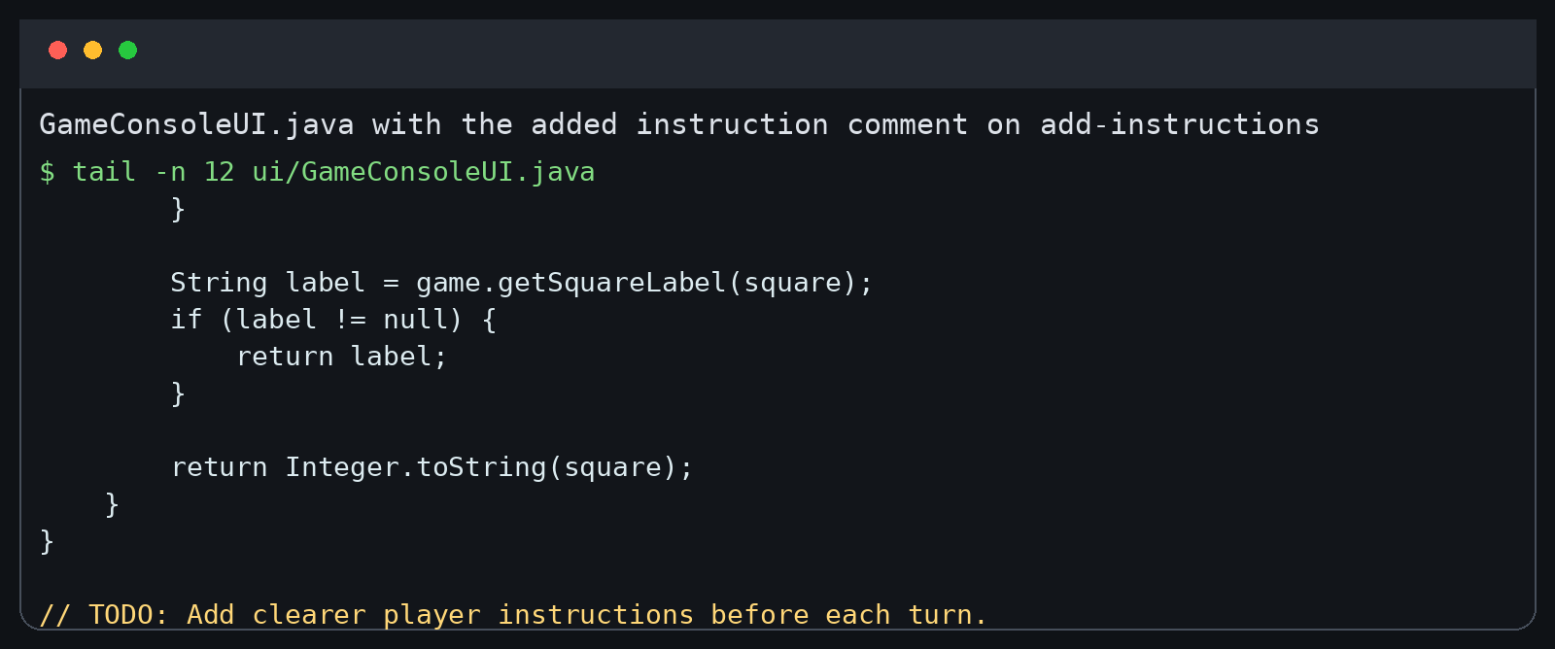
The instruction comment appears in the file while on add-instructions.

Screenshot 4. The same file after switching back to main, showing the instruction comment is not present.
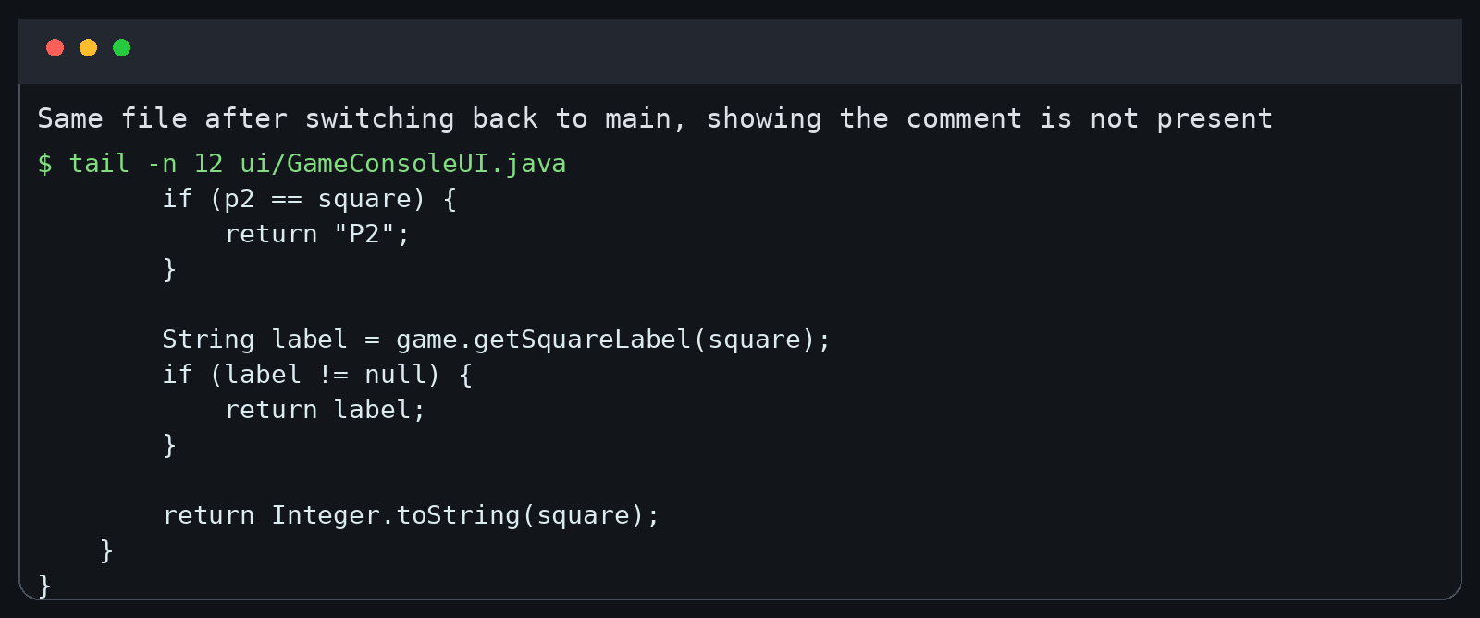
After checking out main, the same file no longer shows the added comment.

