Project #2

Dylan Washburne

CS 457

**Source Files**

ovals.rib

ovals.sl

disp.sl

**Explanation**

Adding the noise was the most involved part of this project for me. This was mostly a result of me not copy/pasting the algorithm for dist from the previous assignment. After that, it was me having dots which were too small to show up under my declared frequency.

Anyway, the noise works by taking the dots I had declared on the sphere previously and treating the points as though they were moved around slightly, as defined by a mathematic equation. This gave it a nice pattern which I describe as “Pangea-Like”.

Displacement took me the longest, though it wasn’t as involved as displacement. Basically, displacement takes each point on the sphere after it’s been moved around, and moves the actual locations of the sphere’s polygons to directly resemble that. This only took the longest because, until I found the proper bindings to set, it resulted in a sphere that “exploded”, having the polygons spread everywhere. Once that was resolved, it immediately became a recognizable result that coincided with the coloration from the noise.

Bump-mapping was the easiest part, and I figured it out before displacement. This is mostly because the shadows worked perfectly by simply altering the surface normal, without having to actually move the surfaces around. For this reason, I saw a completed sphere from bump-mapping first, until I went back and figured out how to properly bind the polygons.

**Images**

(scroll down)

Noise Only

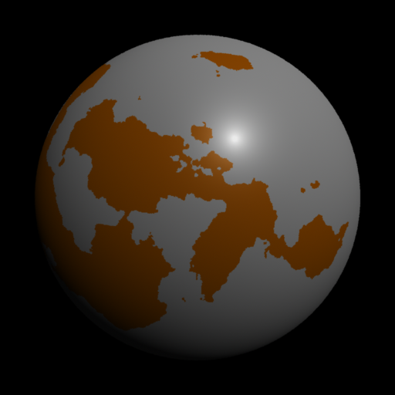

Noise + Displacement

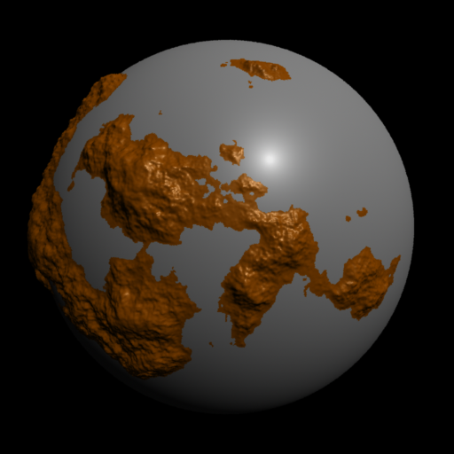

Bump-Mapping

