Dylan Cruz

CST141-SP17

Exam 1 - Part II, Due by: 3/29/2017

Main Program Source Code

------------------------

package cruzexam1;

import java.util.Scanner;

/\*\*

\* Dylan Cruz CST141-SP17 Exam 1 - Part II

\*/

public class CruzExam1 {

public static void main(String[] args) {

Scanner scan = new Scanner(System.in);

System.out.print("Enter species for animal 1: ");

String animal1Species = scan.nextLine();

System.out.print("Enter breed for animal 1: ");

String animal1Breed = scan.nextLine();

Animal animal1 = new Animal(animal1Species, animal1Breed);

System.out.print("Enter species for animal 2: ");

String animal2Species = scan.nextLine();

System.out.print("Enter breed for animal 2: ");

String animal2Breed = scan.nextLine();

Animal animal2 = new Animal(animal2Species, animal2Breed);

Pet pet[] = new Pet[2];

pet[0] = new Pet("Dog", "Beagle", "Max", 2);

pet[1] = new Pet("Cat", "Egyptian", "Felix", 5);

System.out.println("");

System.out.println(pet[0].toString());

System.out.println(pet[1].toString());

System.out.println("");

String statement = "I like coffee, I like tee";

String[] tokens = statement.split(",");

System.out.println(tokens[0]);

System.out.println(tokens[1]);

System.out.println("");

String stringNum = "345.8";

double nowANumber = Double.parseDouble(stringNum);

System.out.println("The converted number is " + nowANumber + " and adding 10 we have " + (nowANumber + 10));

System.out.println("");

System.out.print("Enter an integer: ");

int testInt = scan.nextInt();

try {

exceptionTest(testInt);

System.out.println("You entered: " + testInt);

} catch (ArithmeticException ex) {

System.out.println("ERROR: " + testInt);

}

System.out.print("Enter an integer: ");

testInt = scan.nextInt();

try {

exceptionTest(testInt);

System.out.println("You entered: " + testInt);

} catch (ArithmeticException ex) {

System.out.println("ERROR: " + testInt);

}

System.out.print("Enter an integer: ");

testInt = scan.nextInt();

try {

exceptionTest(testInt);

System.out.println("You entered: " + testInt);

} catch (ArithmeticException ex) {

System.out.println("ERROR: " + testInt);

}

}

public static void exceptionTest(int number) {

if (number > 10) {

throw new ArithmeticException("Number > 10");

}

}

}

Animal Class Source Code

------------------------

package cruzexam1;

/\*\*

\* Dylan Cruz

\* CST141-SP17

\* Exam 1 - Part II

\*/

public class Animal {

private String species;

private String breed;

public Animal(){

species = "dog";

breed = "lab";

}

public Animal(String species, String breed){

this.species = species;

this.breed = breed;

}

public String getSpecies() {

return species;

}

public void setSpecies(String species) {

this.species = species;

}

public String getBreed() {

return breed;

}

public void setBreed(String breed) {

this.breed = breed;

}

public String toString(){

return "Species: " + this.species + " Breed: " + this.breed;

}

}

Pet Class Source Code

------------------------

package cruzexam1;

/\*\*

\* Dylan Cruz

\* CST141-SP17

\* Exam 1 - Part II

\*/

public class Pet extends Animal {

private String name;

private int age;

public Pet(){

super();

name = "Sparky";

age = 2;

}

public Pet(String species, String breed, String name, int age){

super(species, breed);

this.name = name;

this.age = age;

}

public String getName() {

return name;

}

public void setName(String name) {

this.name = name;

}

public int getAge() {

return age;

}

public void setAge(int age) {

this.age = age;

}

public String toString(){

return super.toString() + " Name: " + this.name + " Age: " + this.age;

}

}

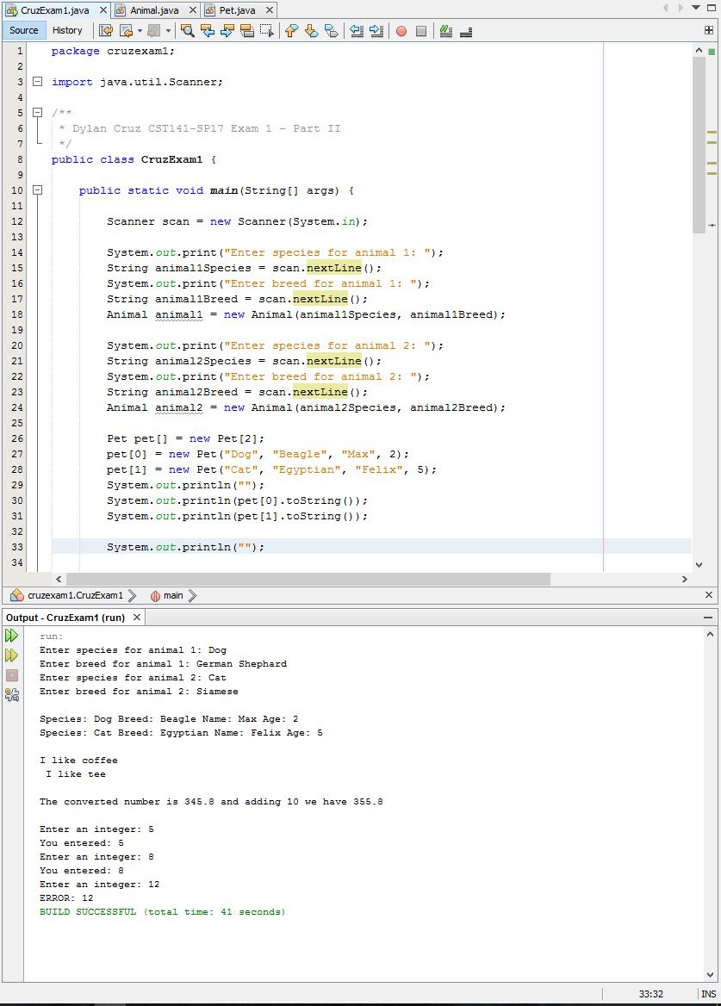Output Screen Shot(s)

--------------------------------------------------------------------------

I certify that the above work is my own. I did not copy work from the Internet or from a classmate. This project will count as part of my grade

for the Exam and course.