练习1：

datas='university/university.txt'

university={}

with open(datas,'r', encoding='utf-8') as files:

    for line in files:

        datapair=line.split()

        key,value=datapair

        university[key]=value

sorteduniversity=sorted(university.items(),key=lambda x:x[1],reverse=True)

rank=0

for groups in sorteduniversity:

    rank+=1

    print(f"大学数量第{rank}多的省是{groups[0]},为{groups[1]}所")

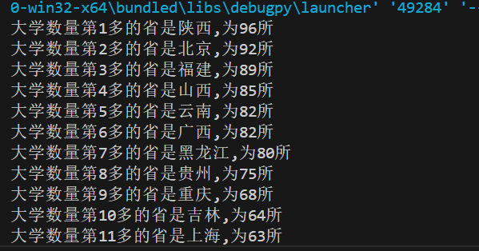

练习2：

datas='university/university1.txt'

university={}

with open(datas,'r', encoding='utf-8') as files:

    for line in files:

        datapairs=line.split()

        key,value1,value2,value3,value4=datapairs

        university[key]=(value1,value2,value3,value4)

provience=input()

print(f"{provience}大学数量:{university[provience][0]},双一流高校建设数量:{university[provience][1]}一流大学建设高校数量:{university[provience][2]}一流学科建设高校数量{university[provience][3]}")

sorteduniversity=sorted(university.items(),key=lambda x:(x[1][1],x[1][2]),reverse=True)

doublegood=0

good=0

for groups in sorteduniversity:

    print(f"{groups[0]}有{groups[1][0]}所大学，{groups[1][1]}所双一流高校，{groups[1][2]}所一流大学，{groups[1][3]}所一流学科建设高校。")

    doublegood+=int(groups[1][1])

    good+=int(groups[1][2])

print(f"中国共有{doublegood}所双一流高校，{good}所一流大学。")

