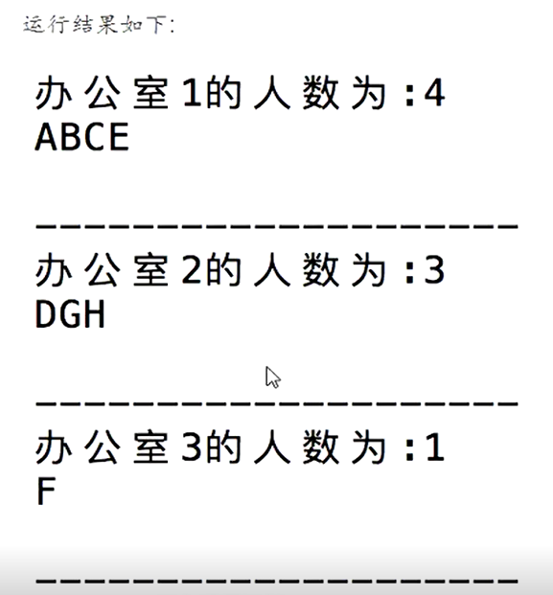

import random

teacher_list = ("ABCDEFGH")

school_list = [[],[],[]]

for name in teacher_list:

a = school_list[2]

b = school_list[1]

if len(b) >= 3:

index = 0

school_list[0].append(name)

elif len(a) >=1:

index = random.randint(0,1)

school_list[index].append(name)

else :

index = random.randint(0, 2)

school_list[index].append(name)

print("办公室1的人数为：4")

print(school_list[0])

print("-"*20)

print("办公室2的人数为：3")

print(school_list[1])

print("-"*20)

print("办公室3的人数为：1")

print(school_list[2])

print("-"*20)