GitHub Desktop Tutorial

# Set-Up

## Install GitHub Desktop

You can do this from the website: <https://desktop.github.com/>. At this point, if you do not have a GitHub account, now would be a good time to do so.

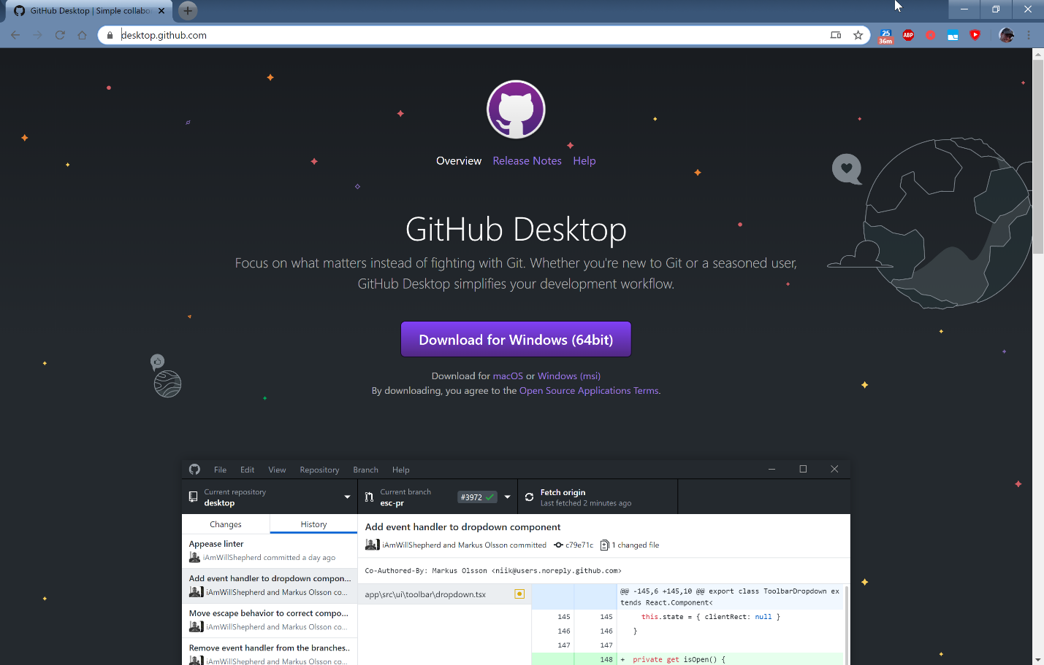

## Clone the repo onto your local machine

At this point, you are ready to go and it is time to move all files onto you own machine. This is called a “Cloning a repository” and is when you copy all the files of a repository onto your machine. Open GitHub Desktop and go to File->Clone a Repository, or use the shortcut Ctrl+Shift+O.

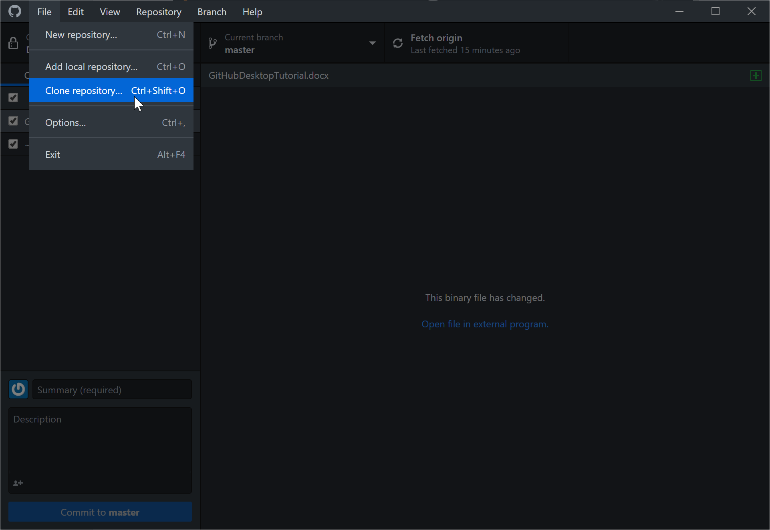

At this point, the easiest way should be to use the URL of the GitHub repo you want to clone. For the dashboard project, this url is: dyllbert/DungeonsAndDash. Type that in to the bar and hit enter. Because the repo is currently set to private, it should notify me that you have requested access. I will grant this as soon as I receive the notification.

# Using Git

## Adding to and modifying files in the repo

When you use GitHub Desktop, it will automatically track when you have changes that need to be contributed to the repo. You don’t have to publish them to the repo until you want to, but be aware that if you are working on changes, and someone else makes changes, you will have to get their changes before you can add your own. Getting someone else’s changes and syncing your local files is called a “Pull”.

A pull will not override additions you have made on your own local machine, unless they are in DIRECT conflict with something you’ve done. If there is a conflict, Git does a very good job of handling it (called a merge), and Desktop makes it even easier. It will handle almost everything thrown at it, but in the event it cannot, it will mark it as a conflict and halt the merge on your local machine. Conflicts do NOT affect the master repo.

When you have changes to commit it will look like this:

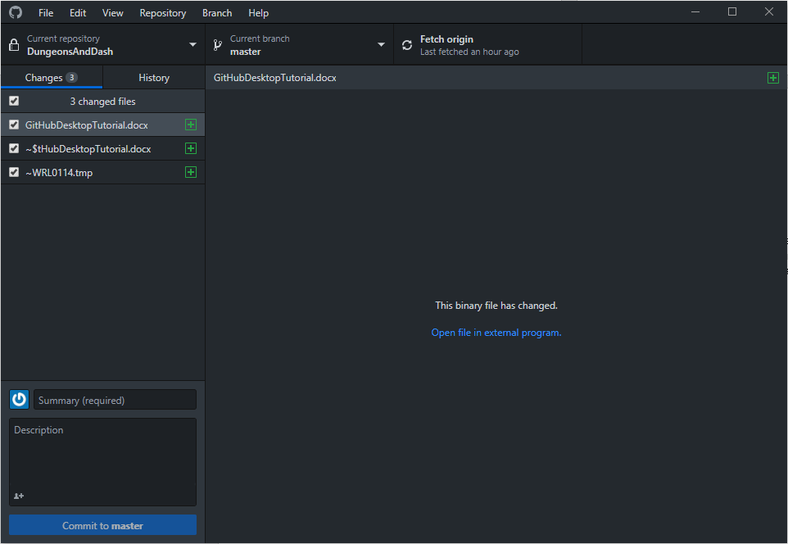

Simply add a summary and a description if needed and press commit.

Once you have committed, it will tell you that it is ready to push:

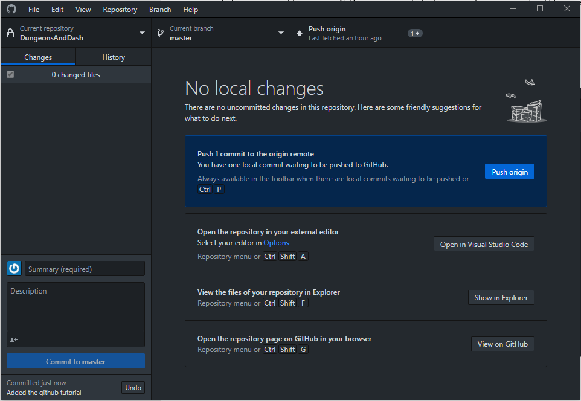

## Branches

You can also open a new branch at the top middle drop down tab. This branch will stay local until you decide to publish it