Jacob Dyrvig Sørensen

Kasper Rask Sørensen

28/9/2018

EASV Computer Science

GitHub: <https://github.com/dyller/TestDrivenDevelopment>

Indhold

First test and solution 3

Reflections on the test first approach and optimal pair-Programming 4

# First test and solution

**Push(double value).**

The way push should work, is that it should take the value and insert at top of the stack.   
So the first step we took, was to check after we pushed a number, that it is at the top of the stack.

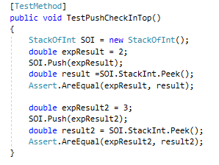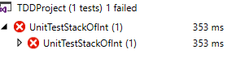

The reason we did it two times, was to be sure, that it wasn’t only working with 1 number because that already first in the stack.

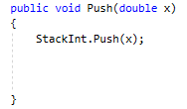

This is our solution to first test, and it passed the test after, so we decided not to make more test to this method, we were thinking it would be to most to test if the Stack was still saved like before just with the number we pushed at the top.

**Pop.**

Pop is a method that should remove the first number from the stack, and return the number it removes.

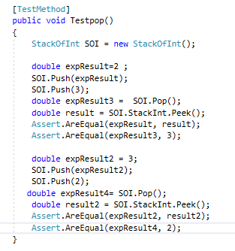

So in this case this need to be tested for 2 thing, for returning the value and that it removes the first number.

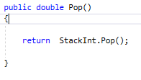

This was the solution for pop, and that passed the test.

# Reflections on the test first approach and optimal pair-Programming

We started out by coding the interface at first, and then went on to doing the test individually, every time checking that the test could run, by having them fail, and then programming a method, so that the tests would pass.

Pros about TDD would absolutely be that it minimizes room for error, it helps you catch a small error before it becomes a larger issue later on. Cons might be that it takes a bit longer, and that you might not entirely know how to do the test at first, as your method could change over time.

Pros about pair programming is that it allows us to focus our resources on one problem, which also help eliminate small mistakes like typos or using the wrong method in places where it shouldn’t be.

However, doing pair programming also slows you down, because if you had 2 guys doing their own thing on different computers, this might speed up the process quite a lot. But as we’re not that experienced yet, pair programming works quite well for us.