Construction Progress and Inspection Report  U.S. Department  of Transportation Airport Grant Program  Federal Aviation Administration |  |  |  |  |  | Period Ending
Project Number
FAA AIP No. TBD
SFO Contract {{ contract_number}}
Airport Name
San Francisco International Airport (SFO)
Project Description  {{ project_name }} |  |  |  |  | Contractor’s Name  Granite Construction Company
- Contract Time  {{ contract_time }} |  | No. Days Charged to Date:  {{ days_charged }} | Last Working Day Charged (Date):  Friday, {{ period_end }}
- Brief Weather Summary this Period, including Approximate Rainfall and Periods of Below Freezing Temperature
(On earthwork jobs, include soil conditions.)
{{ weather_summary }}
- Rough Estimate of Percent Completion to Date of Construction Phases (Include items such as clearing, grading, drainage, base, surface, lighting, etc.)
{{ overall_completion_pct }}

- Work Completed or In Progress this Period
{{ work_summary }}
5a. Summary of Laboratory and Field Testing this Period (Note failing tests and any retests. Summarize out-of-tolerance.)
{{ lab_testing_summary }}
5b. Material (Identify material subject to pay reduction.)
{{ materials_summary }}
6. Description of Anticipated Work by Contractor for Next Period

Mobilization Activities:
- Continue traffic control and maintain low-profile barricades, delineators, and rope lines around the work area.
- Continue subsurface utility investigation and potholing to verify and protect existing FAA communication and power, airfield electrical, storm drain, water, industrial waste, gas, and power lines.

Asphalt Pavement Rehabilitation:
- Perform saw cutting of project paving limits.
- Begin milling of Taxiway Z with depths ranging between four and twelve inches.
- Conduct post-grind survey to verify grades.

Airfield Electrical:
- Continue electrical demolition, including removal of lights, conduit, and signage.

12kV Electrical Infrastructure:
- Excavation and installation of 12kV manhole and associated shoring boxes.
- Begin excavation and placement of the lower 12kV duct bank.

Environmental and Stormwater Protection:
- Maintain SWPPP protections, including drainage inlet mats and surface sweeping.
- Environmental testing was performed on five samples taken throughout the site during utility potholing investigations. PFAS was identified in 2 of the 5 samples. Handling and disposal of contaminated waste is currently being discussed with the Contractor.
7. Problem Areas/Other Comments (Include revisions to plans and specifications approved or denied, delays, difficulties, etc., and actions taken.)
Bulletin Issuance:
- Bulletin #1 (5/19/2025): Revisions to the plans include utility lid adjustments, storm drain invert adjustment, additional storm drain details, callout references, marking details, electrical callouts, and 12kV manhole details.
- Bulletin #2 (7/18/2025): Revisions to the plans include the addition of addressable devices for inpavement runway guard lights, and additional elevated taxiway sign and base.
- Bulletin #3 (8/1/2025): Revisions to the plans include horizontal adjustment of inpavement taxiway centerline lights, 12kV grounding wire and rods.
- Bulletin #4 (8/15/2025): Revisions to the plans include the removal of temporary blackout striping along the centerline.
Other:
- Additional milling was required along the 12kV trench due to the existing pavement thickness being greater than the 3 inches shown in the plans. The extra asphalt millings removed were tracked on a Force Account basis.
- QA laboratory test results for the P-401 control strip did not pass. Another control strip will be placed.
- The 12kV duct bank alignment is under redesign to account for existing utility depths.
SPONSOR’S INSPECTOR OR REPRESENTATIVE
Date  8/27/2025 | Typed or Printed Name and Title  Daniel Castillo, EIT, CMIT  Resident Engineer |  |  | 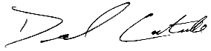  Signature

Photos of Select Construction Activities

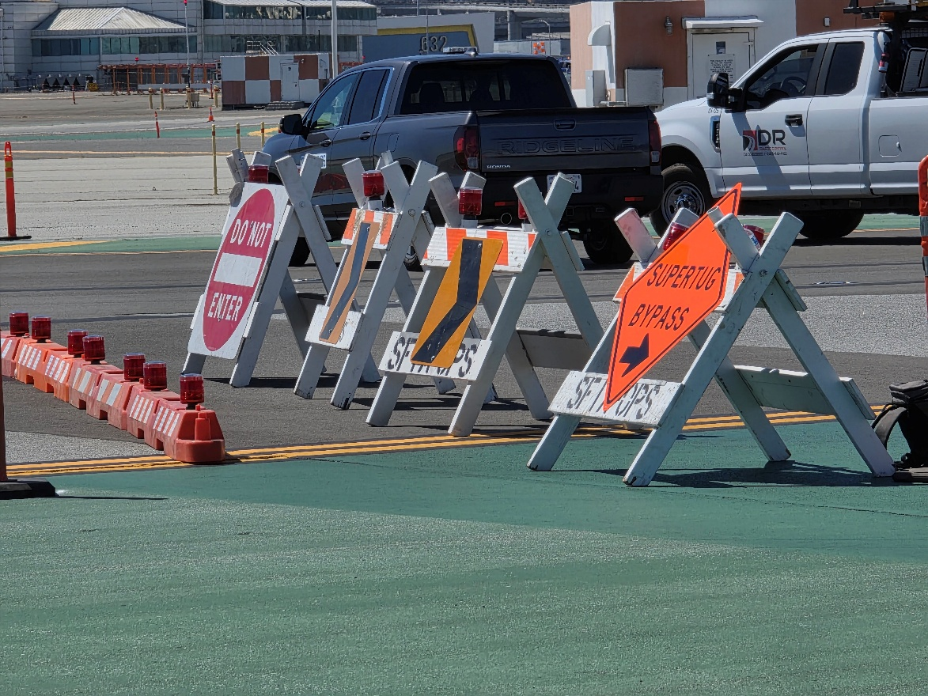
Figure 1: Site Limits and Traffic Control Signage for Deadhead Tug Route

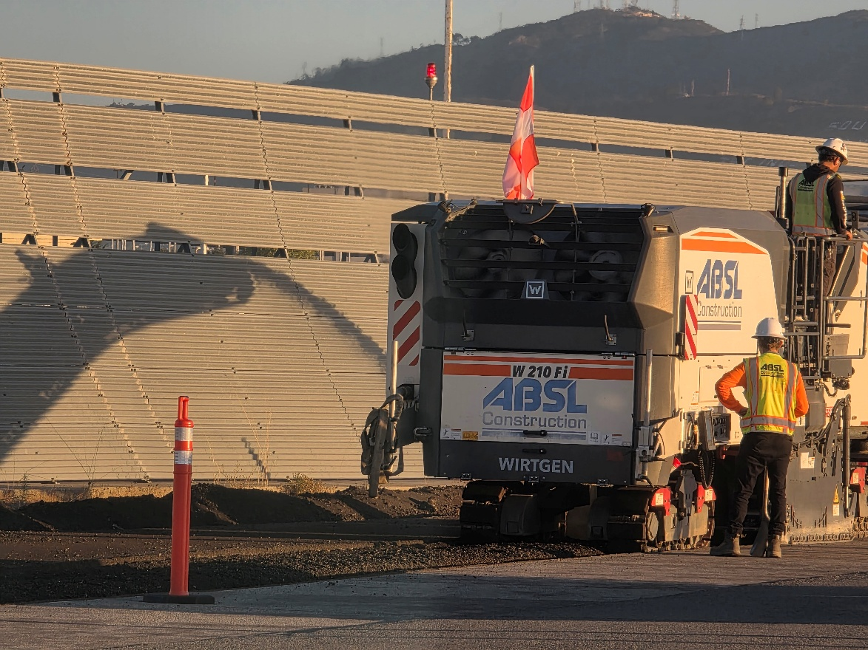
Figure 2: Milling Asphalt Prior to 12kv Ductbank Excavation

Photos of Select Construction Activities

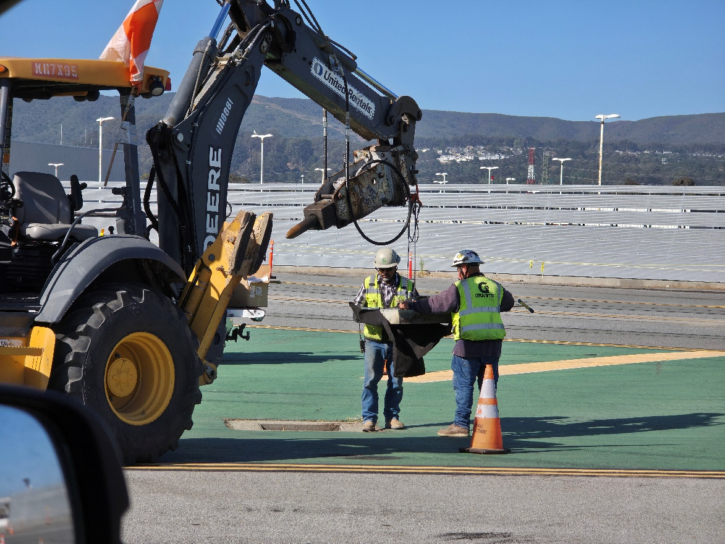
Figure 3: Installation of Drainage Inlet Mats for SWPPP

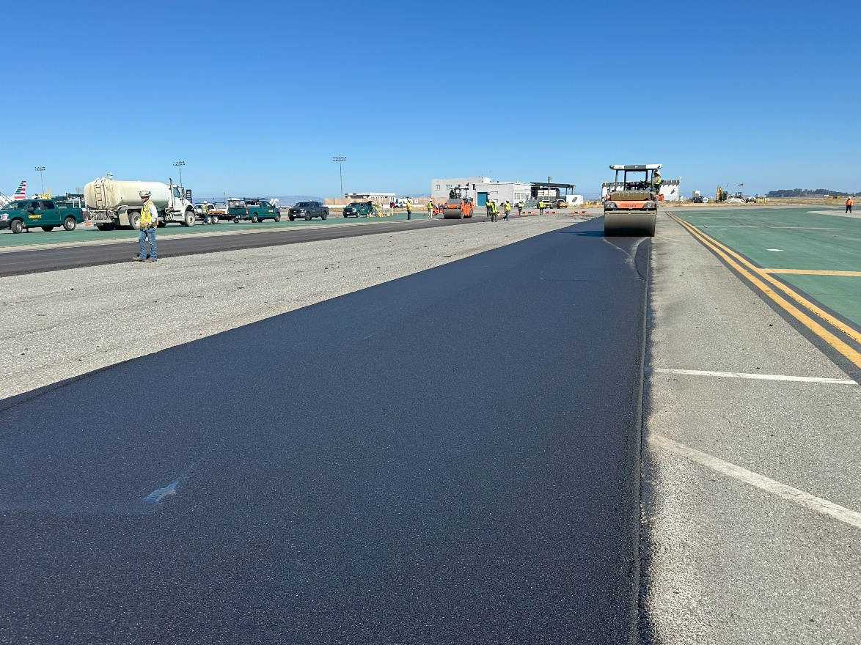
Figure 4: P-403 Asphalt Base Course Control Strip Placement

