Construction Progress and Inspection Report  U.S. Department  of Transportation Airport Grant Program  Federal Aviation Administration |  |  |  |  |  | Period Ending  {{ period_end }}
Project Number
FAA AIP No. TBD
SFO Contract {{ contract_number}}
Airport Name
San Francisco International Airport (SFO)
Project Description  {{ project_name }} |  |  |  |  | Contractor’s Name  Granite Construction Company
- Contract Time  {{ contract_time }} |  | No. Days Charged to Date:  {{ days_charged }} | Last Working Day Charged (Date):  Friday, {{ period_end }}
- Brief Weather Summary this Period, including Approximate Rainfall and Periods of Below Freezing Temperature
(On earthwork jobs, include soil conditions.)
{{ weather_summary }}
- Rough Estimate of Percent Completion to Date of Construction Phases (Include items such as clearing, grading, drainage, base, surface, lighting, etc.)
{{ completion_narrative }}

- Work Completed or In Progress this Period
{{ work_summary }}
5a. Summary of Laboratory and Field Testing this Period (Note failing tests and any retests. Summarize out-of-tolerance.)
{{ lab_testing_summary }}
5b. Material (Identify material subject to pay reduction.)
{{ materials_summary }}
6. Description of Anticipated Work by Contractor for Next Period

7. Problem Areas/Other Comments (Include revisions to plans and specifications approved or denied, delays, difficulties, etc., and actions taken.)
SPONSOR’S INSPECTOR OR REPRESENTATIVE
Date  8/27/2025 | Typed or Printed Name and Title  Daniel Castillo, EIT, CMIT  Resident Engineer |  |  | 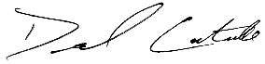  Signature

Photos of Select Construction Activities

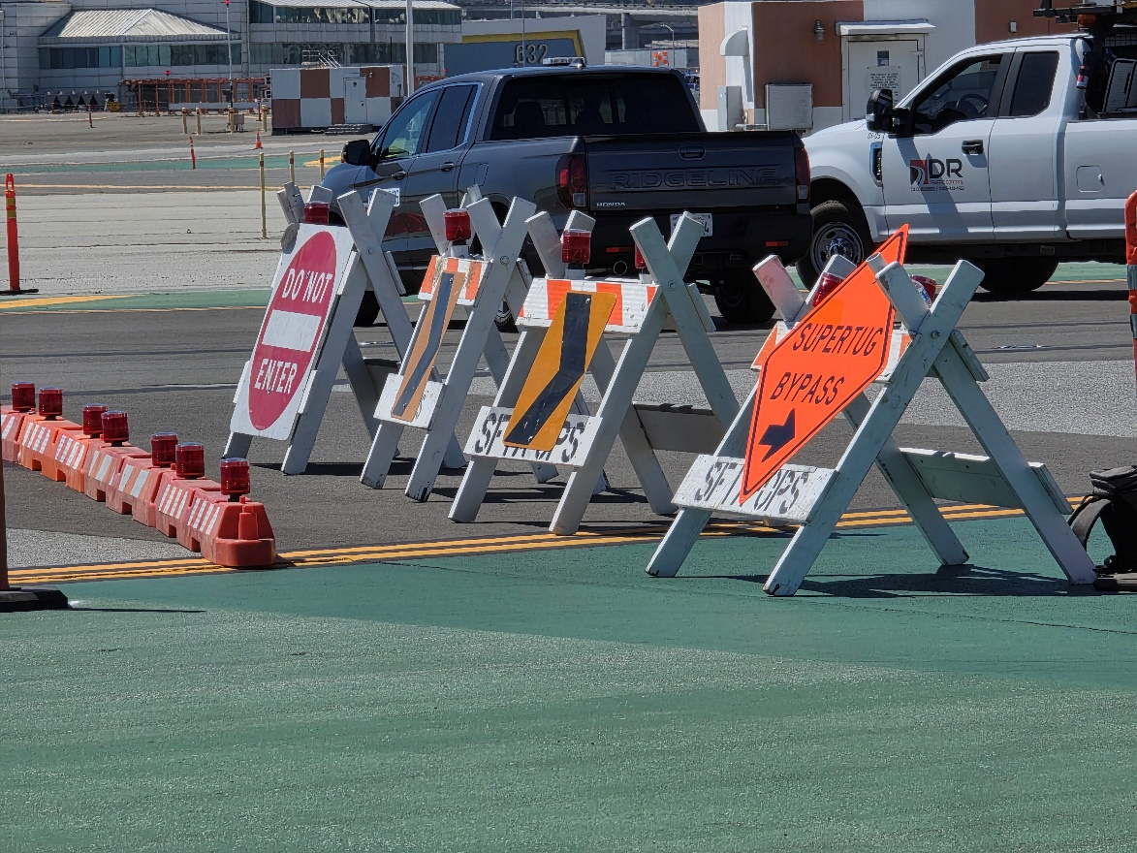
Figure 1: Site Limits and Traffic Control Signage for Deadhead Tug Route

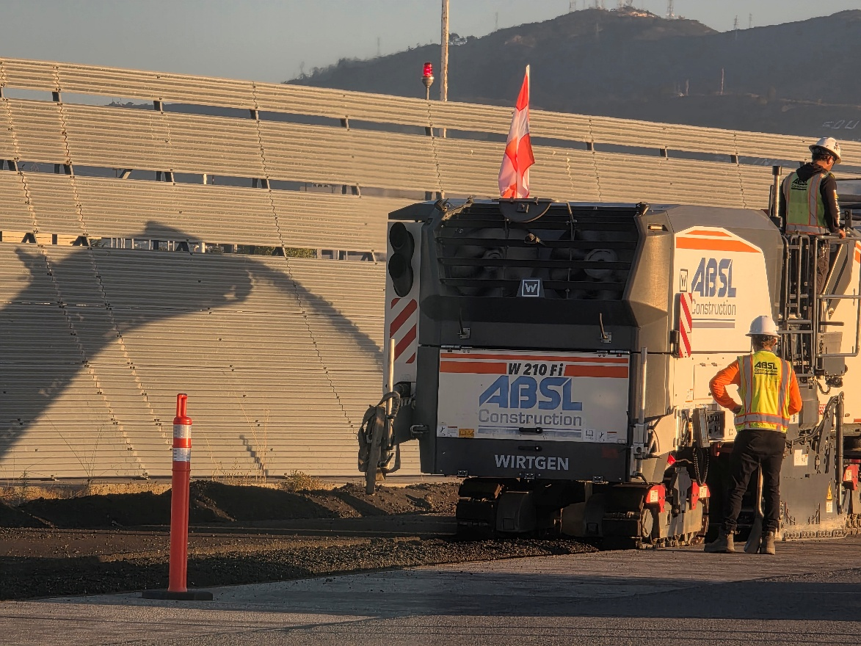
Figure 2: Milling Asphalt Prior to 12kv Ductbank Excavation

Photos of Select Construction Activities

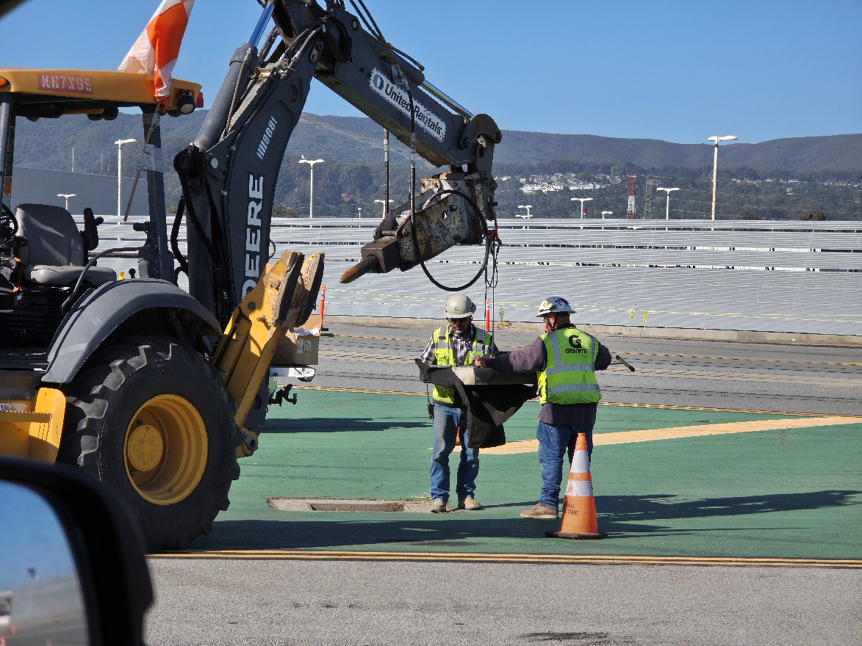
Figure 3: Installation of Drainage Inlet Mats for SWPPP

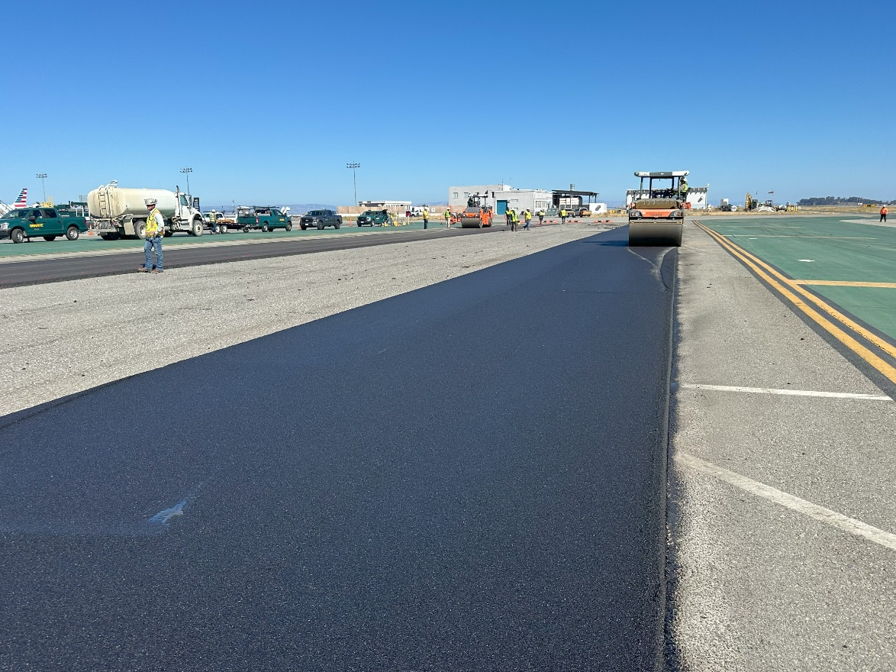
Figure 4: P-403 Asphalt Base Course Control Strip Placement

