This is Dip28 CalculiX Converter ( http://dip28p.web.fc2.com/calculix/ )
(free, as is, no warranty or support, etc)

Copy dip28 folder into C:\ drive and run dip28converter.exe

Set up path to the file (with certain extension) and press "convert" buttom
The new folder with two files (in and out) will be created.
For more information and samples – read PDF docs in the help_files folder
These scripts were tested with gmsh-2.6.1 (you can obtain it here: http://geuz.org/gmsh/bin/Windows/ or here: http://yadi.sk/d/2wuAUgppBbAuc )
and with Netgen: http://sourceforge.net/projects/netgen-mesher/ (or here http://yadi.sk/d/7ASU_poN3MwcG )

Note, the open-source software may changes permanently (file formats, etc). So, if you tested something with version N, there is no guarantee that it will work with N+1, etc. Try to keep all binaries and sources, to avoid these issues

Table 1 – Dip28 Converter Features
Type of mesh | Element Types, etc | Saving Options
GMSH .INP>> >>CalculiX INP | 2D-Tri(C2D3 , C2D6) or  (with 2 S option)  3D-Tetra(C3D4 , C3D10) only  (with 3 C3 option) | 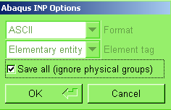
GMSH .MSH >>  >>CalculiX INP | 3D Mesh only | 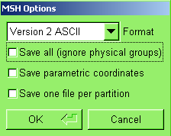
GMSH .UNV >>  >>CalculiX INP | 3D Mesh only | 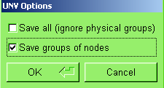
NETGEN Volume mesh*>>CalculiX INP | 3D-Tetra (C3D10), second order is mast! | Apply second order for elements and save as .vol file
*also in Netgen you are able to export INP file without groups

http://www.calculixforwin.com/

