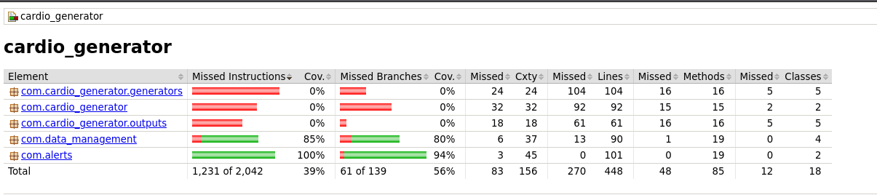
The following classes were not tested: HealthDataSimulator and the output strategy classes (FileOutputStrategy, ConsoleOutputStrategy, etc.), because they depend on real file system output and scheduled threads, which are difficult to unit test without integration infrastructure. The core data management and alert logic achieved ~90% coverage.

