**Computer Vision – Programming Project 1**

**王順興 0210184**

**Introduction**

Originally, I was going to work on Gesture Recognition. However, the dataset consists of various size of photo taken in various background. At that time, the solution to the issue regarding overflow of det(sigma) is not yet known to me, and the scale of the interest (hand) is another complex problem, so I decided to work on easier problem, Letter Recognition.

* 1. **The Dataset**

The dataset I am using can be found [here](http://ai.stanford.edu/~btaskar/ocr/)(http://ai.stanford.edu/~btaskar/ocr/). Each sample is a 16x8 binary image of an English alphabet (letter) taken from a written word (as opposed to test subjects writing individual letters), this makes the recognition more difficult.

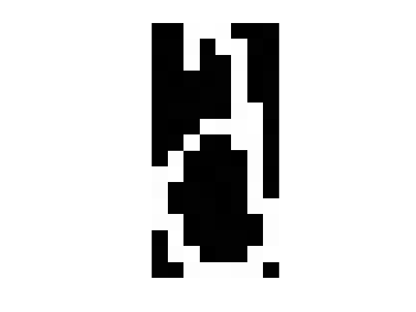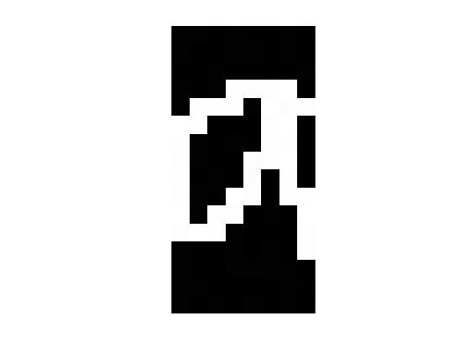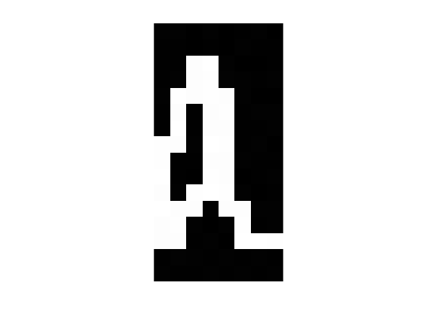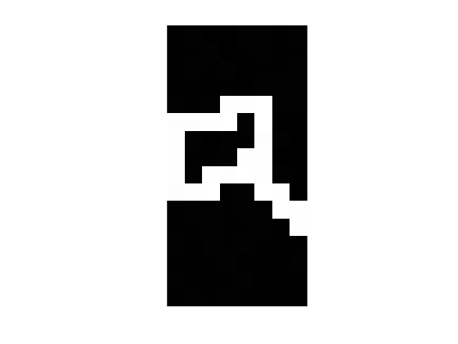

Some sample of ‘a’

* 1. **The Goal**

In this project, I hope to be able to classify a given letter to one of 26 classes. Originally, I was going to implement Gaussian MLE then MoG. But, when賈恩宇 told me that he found a paper regarding the usage of Bernoulli distribution, I wondered if Gamma distribution will be a good distribution to fit an image.

Also, as this project is dealing with letters coming from words, I hope that in the future this can be the basis of a Word Recognition program.

* 1. **Why Gamma Distribution?**

Because Gamma is more flexible!

|  |  |
| --- | --- |
| Fitting of Gaussian noise w/ mu=0, sigma=0.1 | |
|  |  |

|  |  |
| --- | --- |
| Fitting of Gaussian noise w/ mu=0, sigma=0.1 | |
|  |  |

Gamma can do whatever Gaussian can, and some times better!

**Introduction**

1. **Gaussian Maximum Likelihood**

Gaussian Maximum Likelihood is pretty straight forward, since its means and covariances have closed form.