Programming Assignment 2

Student ID: 0660004

Name: 王順興

#### 2-opt

##### Concept

Check if the route can be shortened by reversing a segment of route; if so, reverse the route

##### Make it faster

* A reversed segment has the same route length, the total route distance is changed at the start and the end of the segment
* If every segment on a route is only processed by one thread, threads can work on the route simultaneously

#### Route Splitting

To process 2opt operation on every route:

for (depth = 1; depth < num_city - 1; ++depth) {

for (start = 1; start < num_city - depth; ++start) {

2opt_swap(start, start + depth);

}

Idea: Split start threads, and avoid "contention". The splitting is fair because each thread is processing segments with the same length.

#### Contention

Contention is where two or more thread works on neighboring/crossed segment, and race condition may happen.

To avoid this, start is splitted in chunks, so contention will only happen between two consecutive threads.

With contention only happening between two consecutive threads, it's easy to check if contention happens, and the thread with the smaller thread_num can simply wait until the next thread moves on:

In thread(i):

while (segment_start_index[i + 1] <= segment_end_index[i] + 1)

wait;

Example of Contention and Untangling:

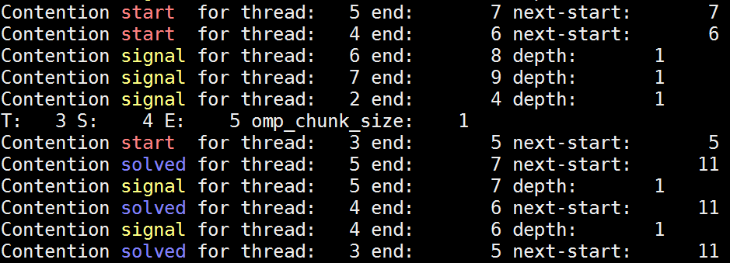

Thread 5 waits for Thread 6

Thread 4 waits for Thread 5

Thread 6 moves on, Thread 5 can move on now

Thread 3 waits for Thread 4

Thread 5 moves on, Thread 4 can move on now

Thread 4 moves on, Thread 3 can move on now

Thread 3 moves on

*Signal: A thread finishes the chunk it’s assigned to*

# Performance analysis with 1, 2, 4, 8, 16 thread(s)

How may 2-opt comparison do you perform within 30 seconds?

Plotting 100 test11 tests for 1/2/4/8/16 threads:

|  |  |  |  |
| --- | --- | --- | --- |
| 2opt_swap() in 30s for 1/2/4/8/16 threads | | | |
|  | Min. | Avg. | Max. |
| 1 | 144761129 | 152364134 | 155959630 |
| 2 | 97657334 | 184866656 | 220036168 |
| 4 | 163315241 | 281305296 | 389912734 |
| 8 | 205886137 | 322610031 | 535044391 |
| 16 | 335246148 | 358494872 | 387077157 |

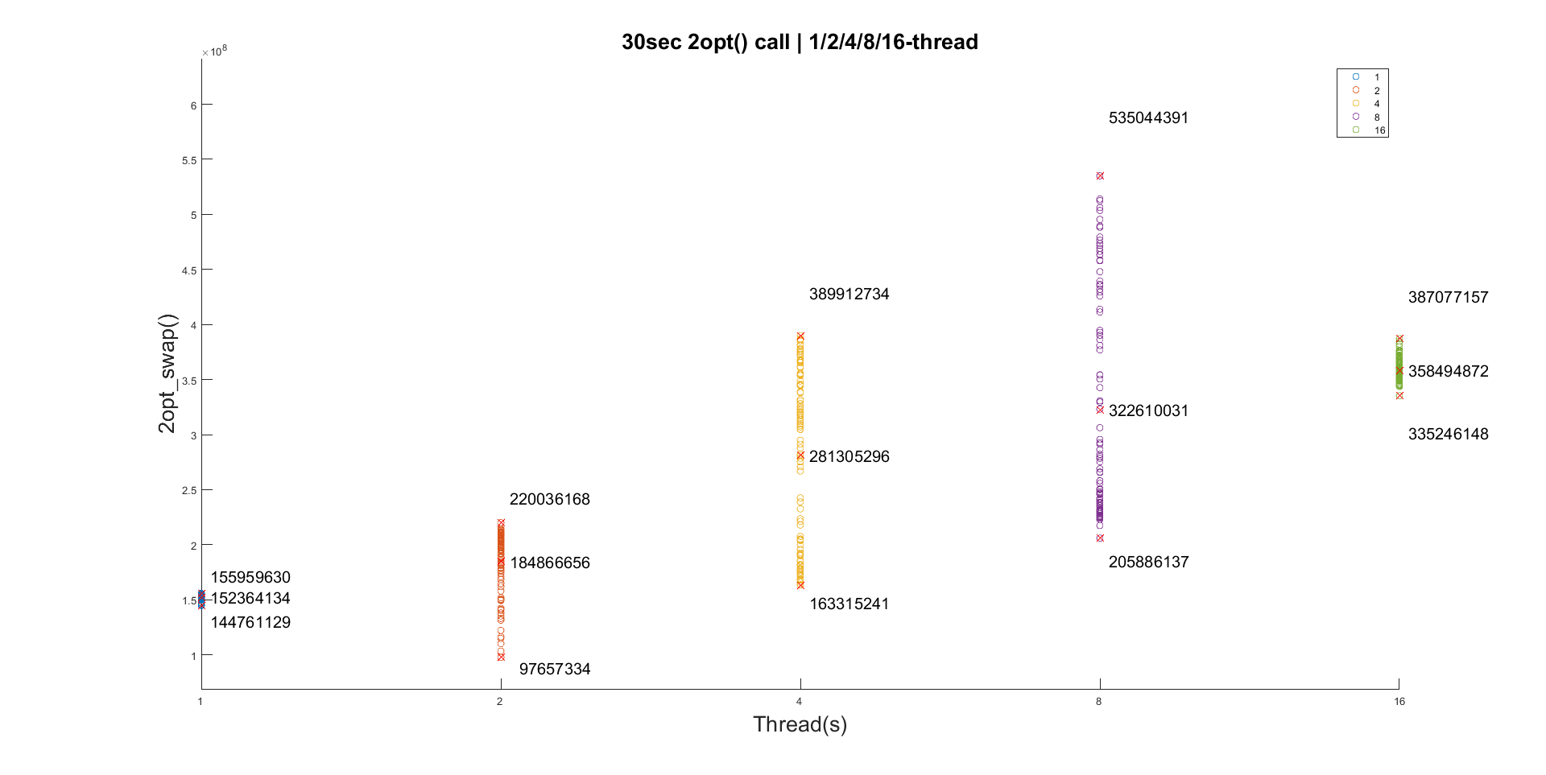

For reasons I can’t find out, 2/4/8 thread’s performance varies a lot; while 1/16 threads performance are relatively consistent. No contention happens in any case, so the only overhead for multi-threading is to check if contention happens.

Even when removing operations in 2opt_swap(), leaving only counter, the situation persists.

# Compare your results with the un-parallel version of your code (with test8)

Do you use any random functions in your code? **No**

If not, then your answer should be equal. Otherwise, there are **race condition** unhandled in your code.

The distance is not equal because in my program, a thread can process the part of route that other thread is working on, even though there’s no race condition.

Log 1: 4- thread / Test 0 / 2opt_swap(): 8 / Final distance: 594

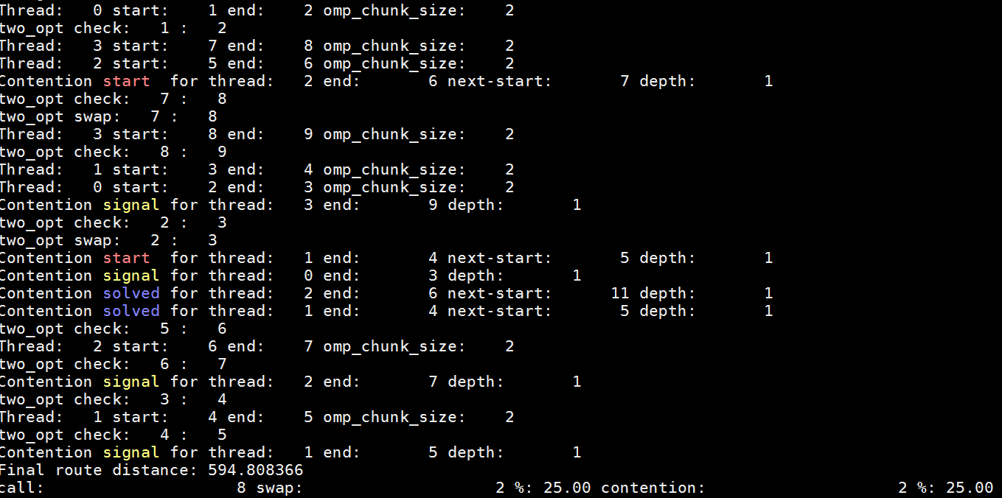

Log 2: 4- thread / Test 0 / 2opt_swap(): 8 / Final distance: 530

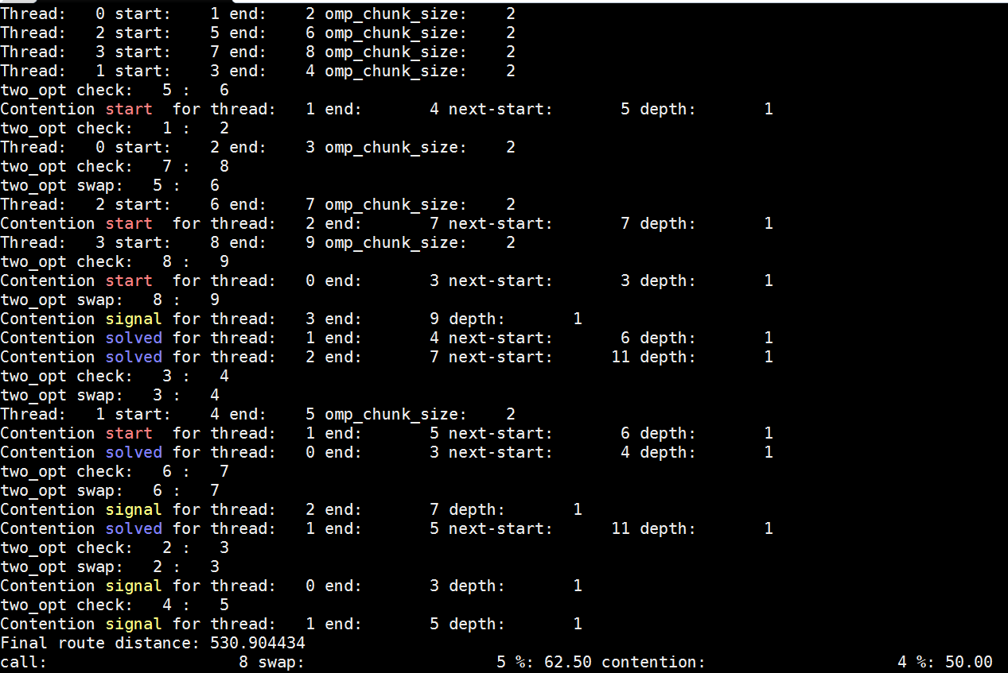

Both example the execute 2opt_swap(i, i+1) once, so 2opt_swap() is called 8 times each (10 node with the first node untouched). Yet the route changes and final distance are different due to the randomness in thread job scheduling by OS.

# Record your distance every 30 seconds with **test11**

Please observe if the distance improves within 10 minute.

|  |  |
| --- | --- |
| Time | Distance |
| 0m 30s |  |
| 1m 00s |  |
| 1m 30s |  |
| 2m 00s |  |
| 2m 30s |  |
| 3m 00s |  |
| 3m 30s |  |
| 4m 00s |  |
| 4m 30s |  |
| 5m 00s |  |
| 5m 30s |  |
| 6m 00s |  |
| 6m 30s |  |
| 7m 00s |  |
| 7m 30s |  |
| 8m 00s |  |
| 8m 30s |  |
| 9m 00s |  |
| 9m 30s |  |
| 10m 00s |  |

# Discussion

* If there’s any race condition in your code, please describe how you handle them?

See *Contention*

* What is the most difficult part of this assignment?

Dealing with the edge cases regarding contention and debugging the problem mentioned in part 4.

* What is the bottle neck of your program? Do you think that it can be improved?

There’s bottleneck caused contention checking and

Can the number of thread be more than the number of core, please justify your answer?

Which do you prefer, pthread or OpenMP, why? What are their pros and cons?

Please describe your findings in this assignment and discuss them.

# Feedback

Feel free to fill in this section.

Additional reference

If you want to see threads: <http://ask.xmodulo.com/view-threads-process-linux.html>

Processes v.s. Threads in linux: <http://www.thegeekstuff.com/2013/11/linux-process-and-threads>

Clone(): <http://man7.org/linux/man-pages/man2/clone.2.html>