**Font Awesome:**

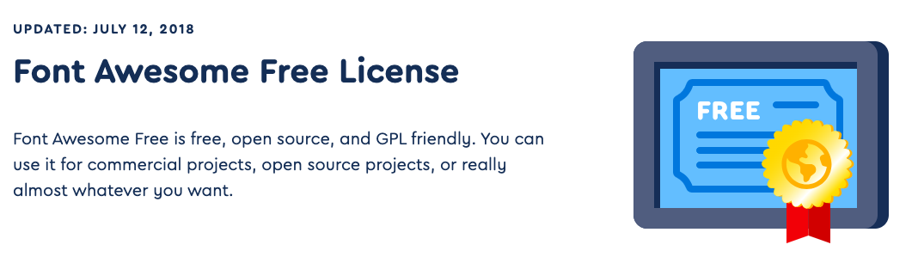

**Image:**

The following images are from freepik.com (Free license)

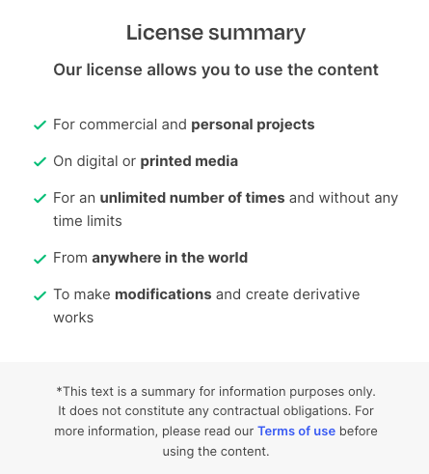



Original: Flat-illustration-secretary-s-day-celebration

URL: <https://www.freepik.com/free-vector/flat-illustration-secretary-s-day-celebration_39431981.htm#fromView=search&page=1&position=17&uuid=97e8b831-4d8f-4239-b9e1-85d94658596e>

Author: pikisuperstar

License: Freepik.com (Free License)

Note: login_page_img.jpg is referenced from this image.



Original: flat-illustration-secretary-s-day-celebration

URL: <https://www.freepik.com/free-vector/flat-illustration-secretary-s-day-celebration_39431982.htm#from_view=detail_serie>

Author: pikisuperstar

License: Freepik.com (Free License)

Note: register_page_img.jpg is referenced from this image.



Original: people-asking-questions-businesspeople_9176149

URL: <https://www.freepik.com/free-vector/people-asking-questions-businesspeople_9176149.htm#from_view=detail_alsolike>

Author: pch.vector

License: Freepik.com (Free License)

Note: banner_img.jpg is referenced from this image.



Original: job-interview-conversation

URL: <https://www.freepik.com/free-vector/job-interview-conversation_9650007.htm#fromView=search&page=1&position=0&uuid=af7932aa-cc8b-44c3-a8e0-82412b1c6625>

Author: pch.vector

License: Freepik.com (Free License)

Note: fuction_img.jpg is referenced from this image.



Original: partners-holding-big-jigsaw-puzzle-pieces

URL: <https://www.freepik.com/free-vector/partners-holding-big-jigsaw-puzzle-pieces_7732651.htm#fromView=search&page=1&position=0&uuid=979c01e9-99d3-4d4f-b74b-97949b806609>

Author: pch.vector

License: Freepik.com (Free License)

Note: fuction_two_img.jpg is referenced from this image.

**Pexels API For Free Avator**

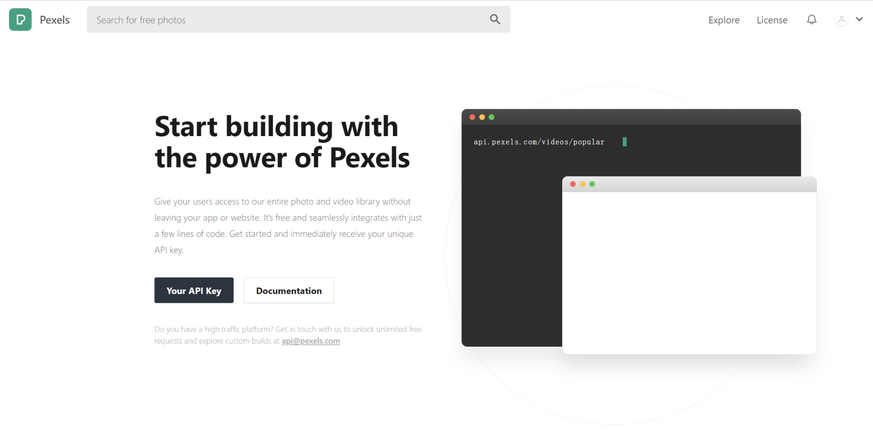

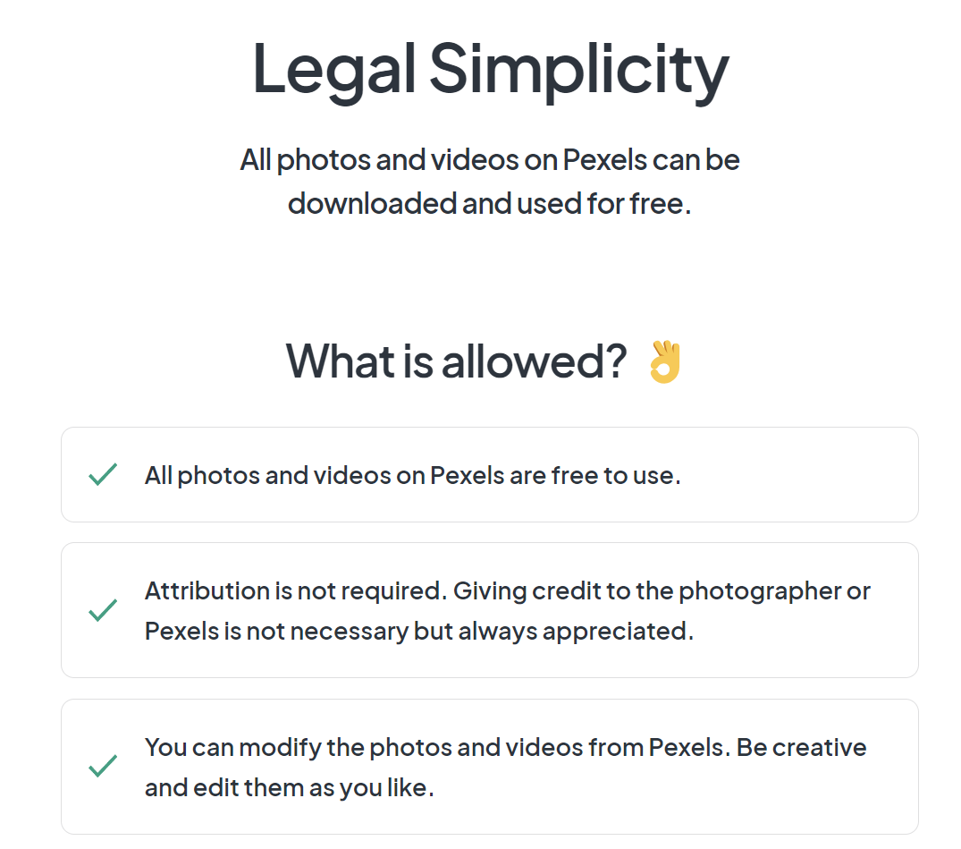

**Wikipedia API:**

It can be viewed on the answer_request page. When users search for relevant content, they can click on the Wikipedia Article to view it.

