Administrator Login
email: admin@gmail.com
password: admin@123

User Login
email: test@user.com
password: test@123

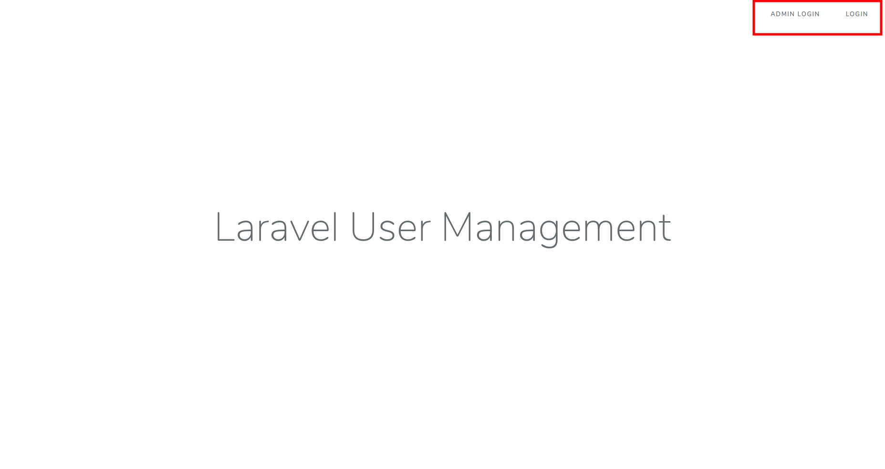
After login in as administrator you will see below screen.
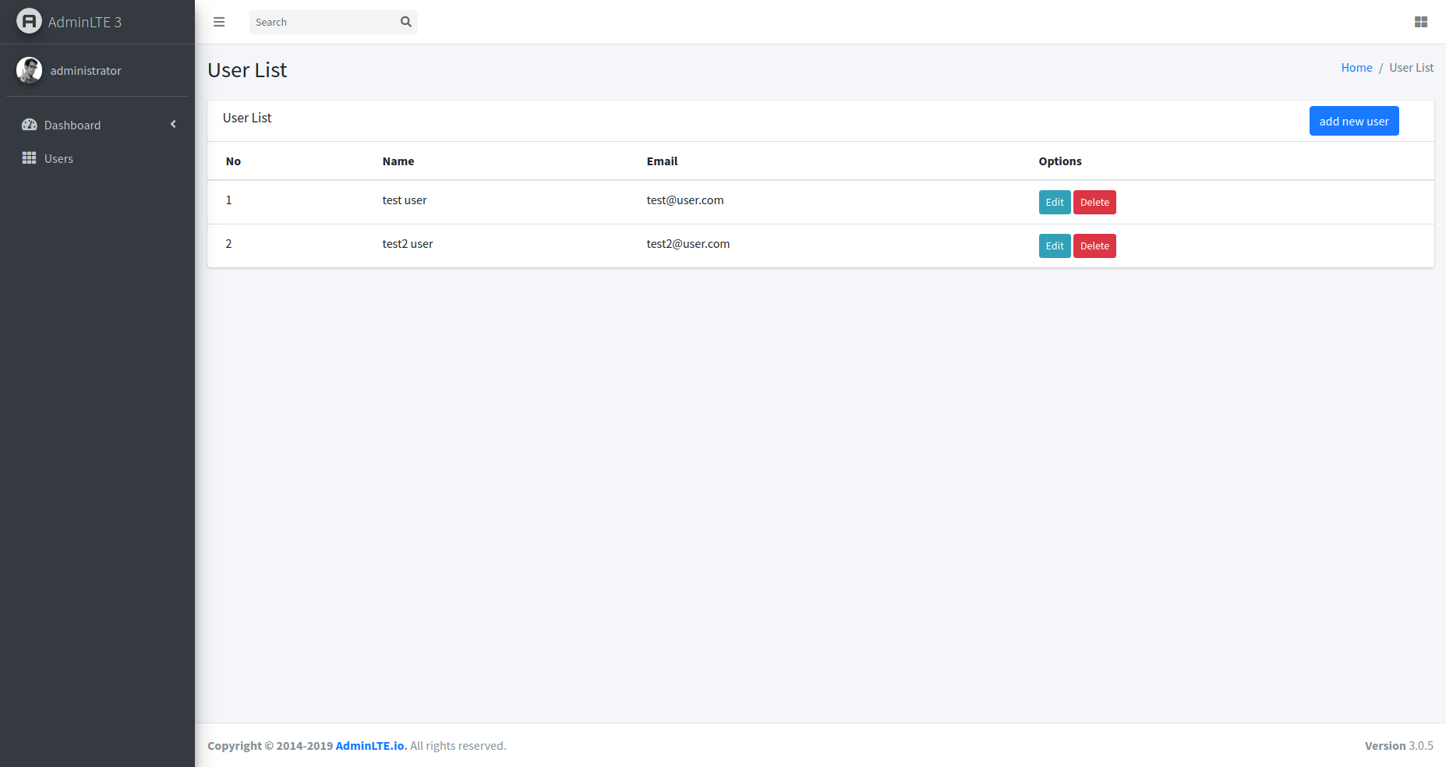

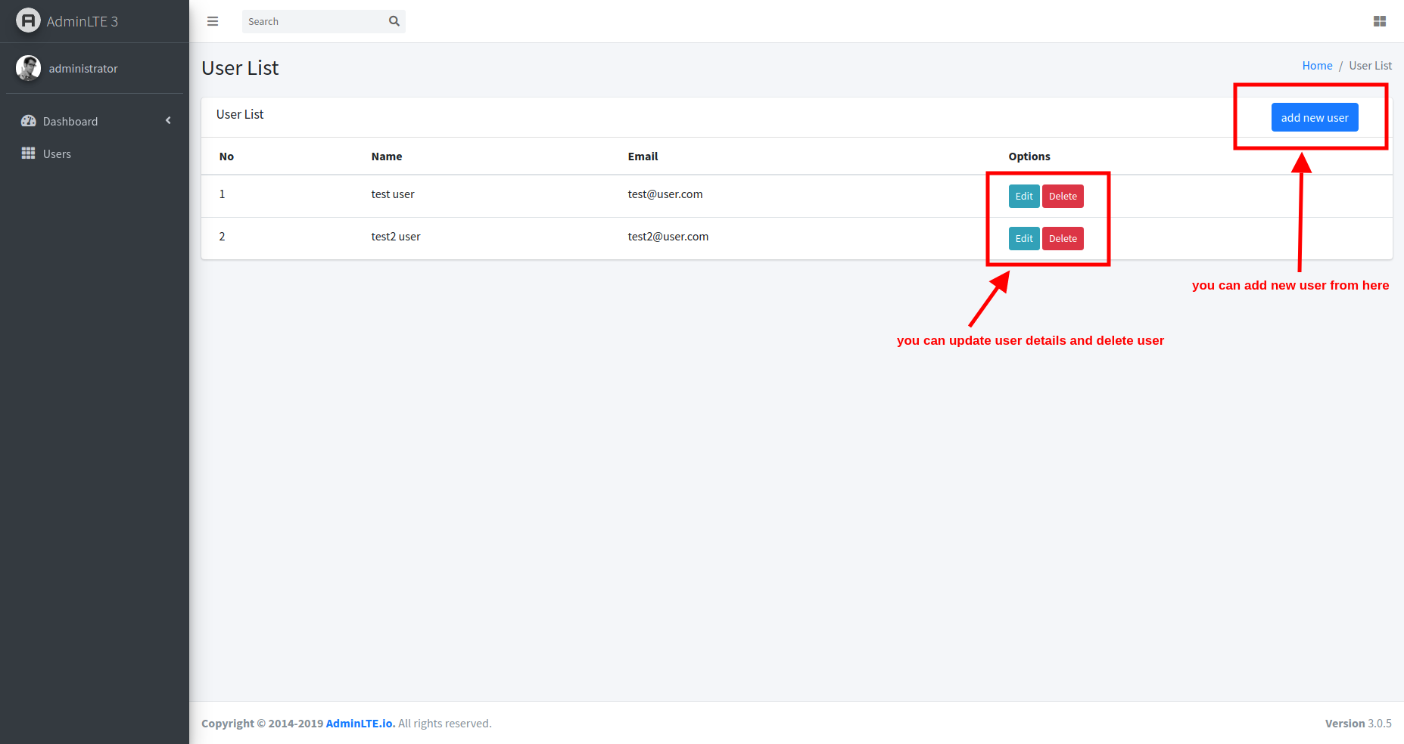
Administrator can manage user

add new user form
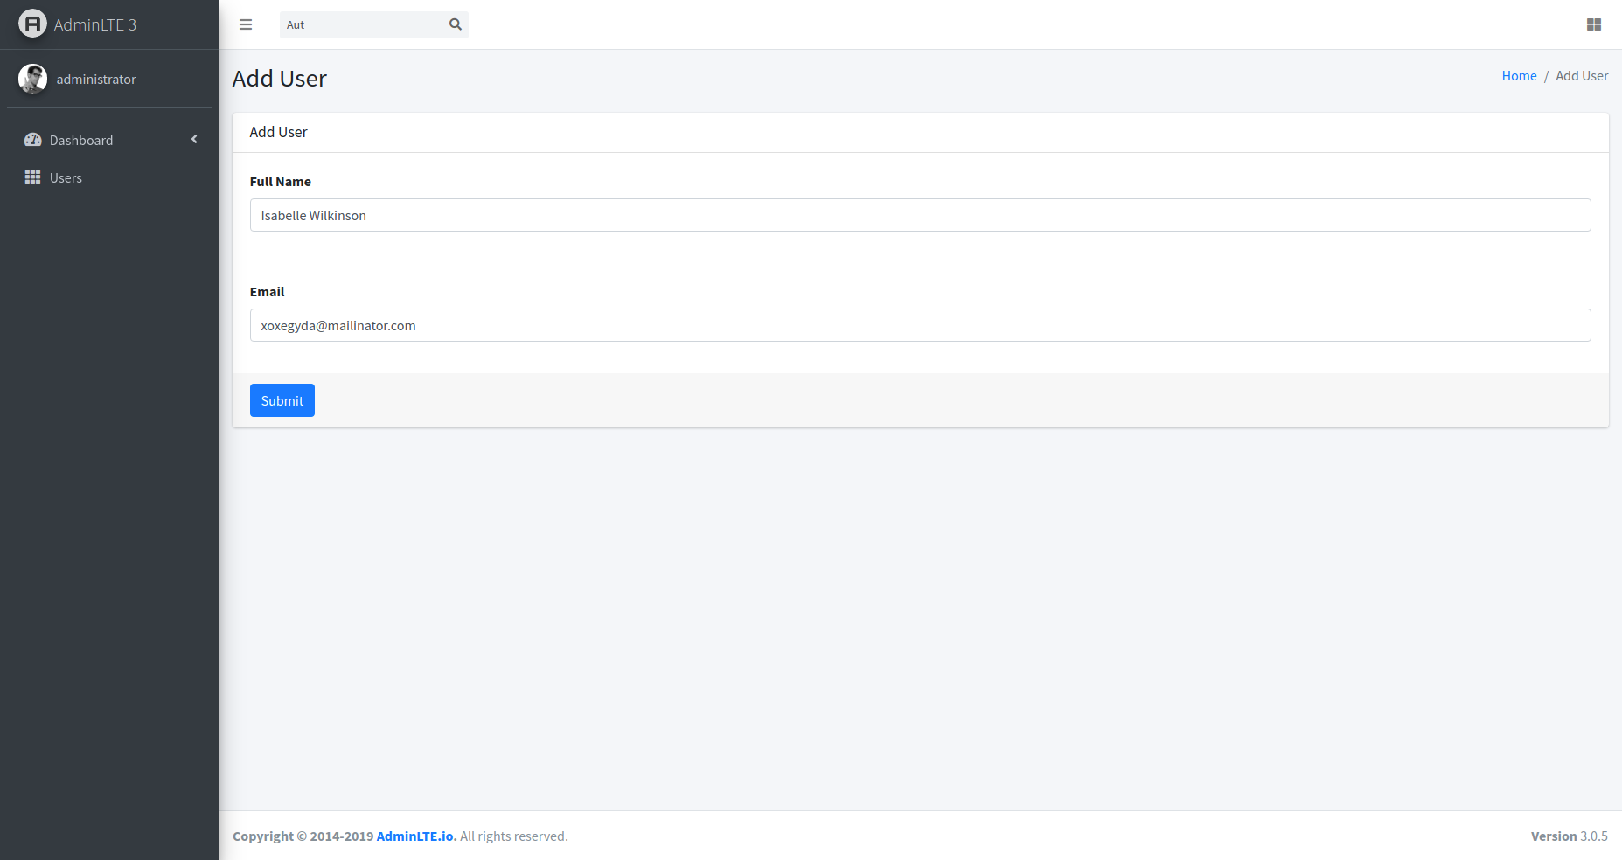

Note: default password for new user is “123456789”

edit user form

