Pitch your best beat

Must have jar reader installed. Double click .jar file

Pitch your best beat explains the concept of beat frequency to Gr. 11 students with a demonstration and lesson

The program is intuitive and requires a mouse, keyboard, and speakers.

The demonstration allows you to experience beat frequencies, therefore you should have speakers to accomodate.

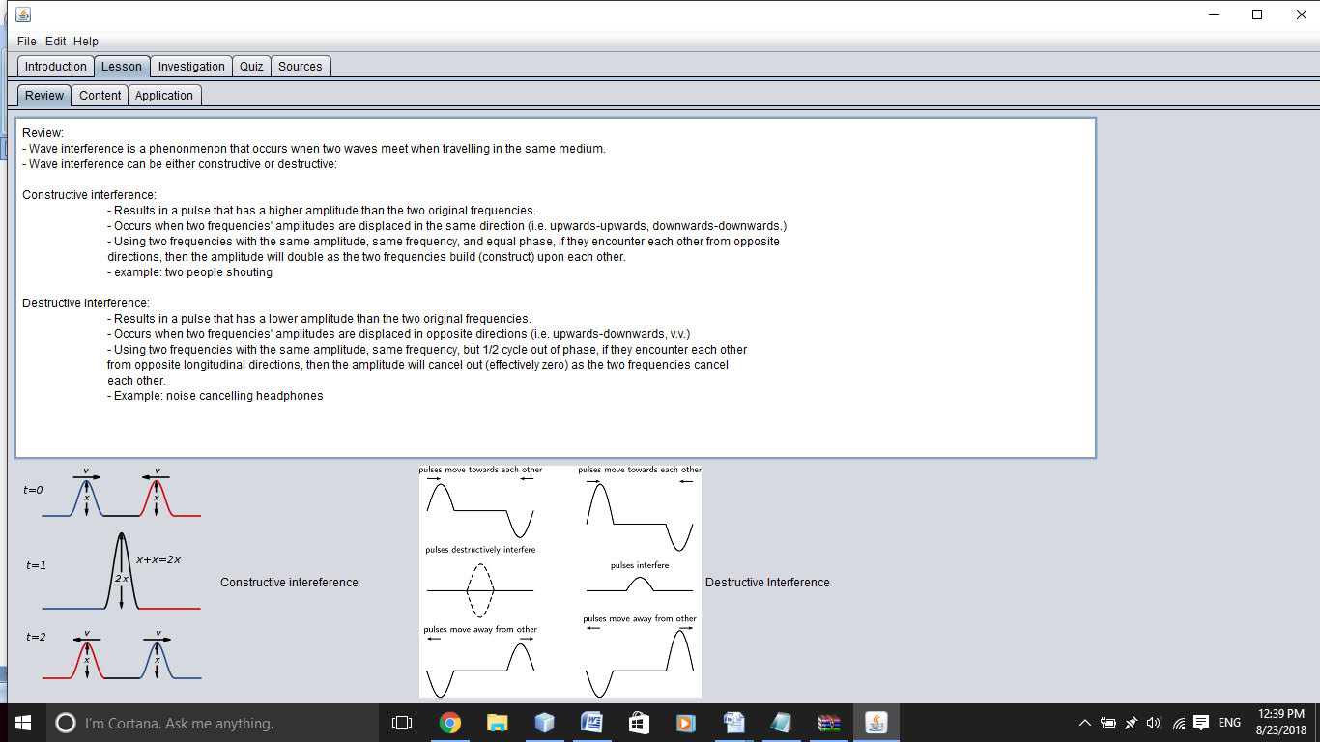

To go through the different content In the lessons, click through the tabs under Lesson.

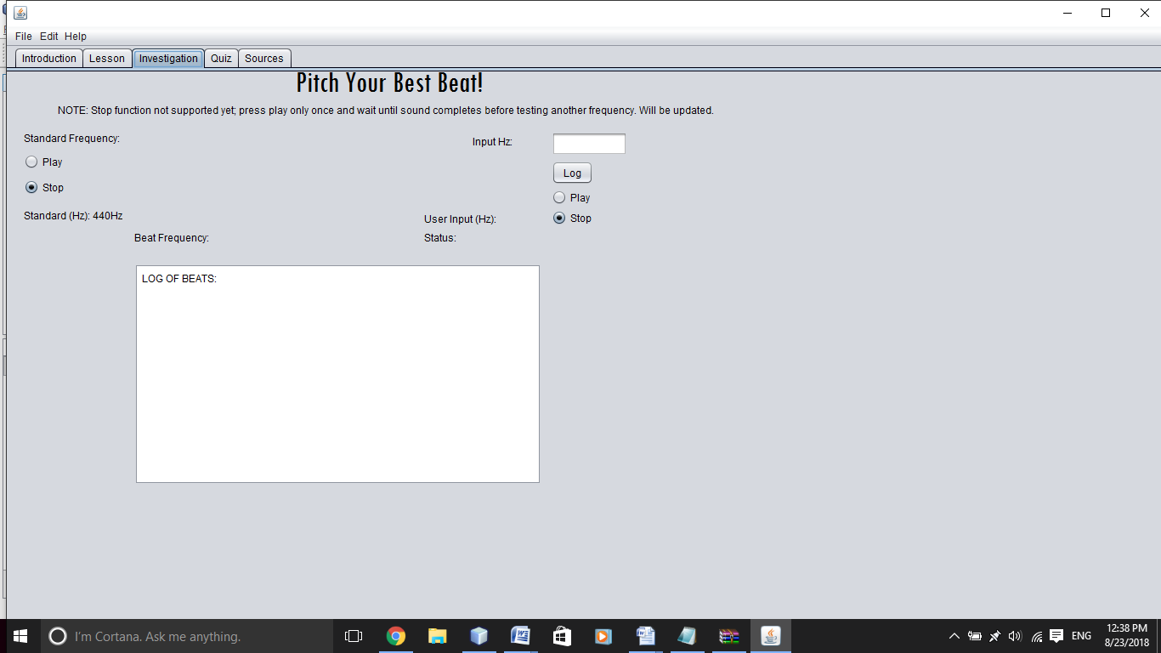

To see a log of frequencies, you must click log. The beat frequency will also be displayed for you.