
ICT application in society
Lab Number 1 Report


Submitted To:
Adnan Jelani
Submitted By:
Muhammad Ibrahim Siddiqui
Reg Number: DATE:
260401092 26/10/2026

Table of Contents
1. Introduction i
2. ICT in Education i
a. Definition of ICT i
b. Evolution of ICT i
3. ICT In Key Sectors ii
a. ICT In Education ii
b. ICT in Healthcare ii
i. Telemedicine ii
4. Challenges and Future of ICT iii
a. Digital Divide and Cybersecurity iii
b. Emerging Technologies iii
i. Artificial Intelligence iii

Figure 1 ICT in Education ii
Figure 2 Artificial Intelligence and ICT iv

Table 1 ICT in Education i
Table 2 ICT in Healthcare iii

Introduction
I
nformation and Communication Technology, often referred to as ICT, is one of the most significant forces shaping the modern world. It encompasses the integration of computing, telecommunications, and information processing to enable people to connect, share, and create knowledge. ICT is not a single invention or tool but rather a combination of many evolving technologies that continue to transform society.

ICT in Education

ICT Tool / Technology | Use in Education
  Benefit
Learning Management Systems (LMS) | Sharing lectures, assignments, and grades online | Keeps all course material in one place
Online Classes (Zoom, Teams) | Live lectures and discussions through video calls | Allows learning from anywhere
Digital Libraries | Access to e-books, journals, and research papers | Saves time and cost compared to printed books
Table 1 ICT in Education

Meaning of ICT
ICT is the use of digital technologies to collect, process, and exchange information. It includes hardware such as computers and smartphones, software such as word processors and browsers, and communication networks such as the internet.

Analysis of ICT
ICT has changed greatly over time, from early telegraphs and telephones to modern computers and the internet. The invention of personal computers in the 1980s and smartphones in the 2000s made technology available to almost everyone.

ICT In Key Sectors

ICT In Knowledge

In education, ICT supports online classes, digital libraries, and learning management systems. Students can access lectures, submit assignments, and research topics easily, which makes learning more flexible and interactive.

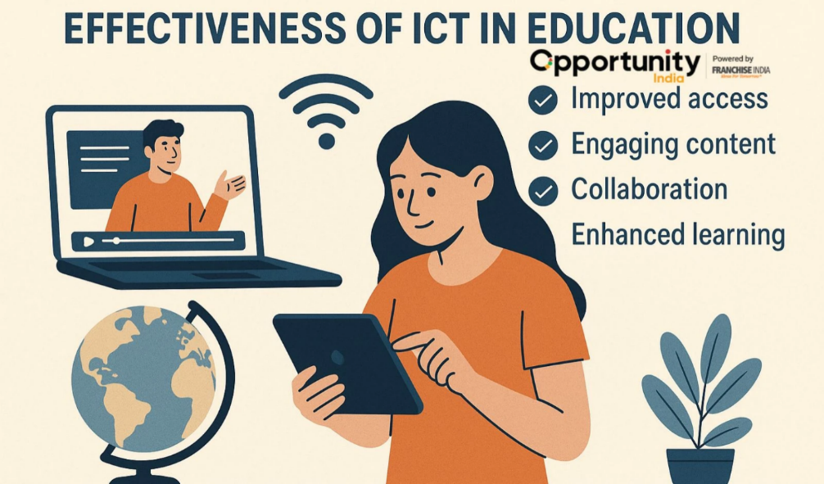

Figure 1 ICT in Education

Information And Communication Technology in healthcare
In healthcare, ICT helps hospitals maintain electronic patient records, schedule appointments, and share medical information securely. It allows doctors to make faster and more accurate decisions about patient care.

Telemedicine
Telemedicine allows patients to consult doctors through video calls or phone calls without visiting a clinic. It is especially useful for people living in remote areas and reduces both travel time and cost.

ICT Tool / Technology
  Use in Healthcare
  Benefit
Electronic Health Records (EHR) | Stores patient history, test results, and prescriptions digitally | Quick access to accurate patient information
Telemedicine |  | Saves travel time and reaches remote patients
  Online consultations through video or phone calls
Online Appointment Systems | Booking and managing doctor visits through websites or apps | Reduces waiting time and paperwork
Table 2 ICT in Healthcare

Challenges and Future of ICT

Digital Divide and Cybersecurity
The digital divide is the gap between people who have access to technology and those who do not. Cybersecurity is also a growing concern, as hackers and malware can steal personal data, so strong passwords and updated software are essential.

Development of Technologies
Emerging technologies such as cloud computing, the Internet of Things, and blockchain are changing the way people use ICT. These technologies make systems smarter, faster, and more connected.

Artificial Intelligence
Artificial Intelligence (AI) enables machines to learn from data and perform tasks that normally need human intelligence, such as speech recognition and decision making. AI is already used in chatbots, recommendation systems, and self-driving cars.
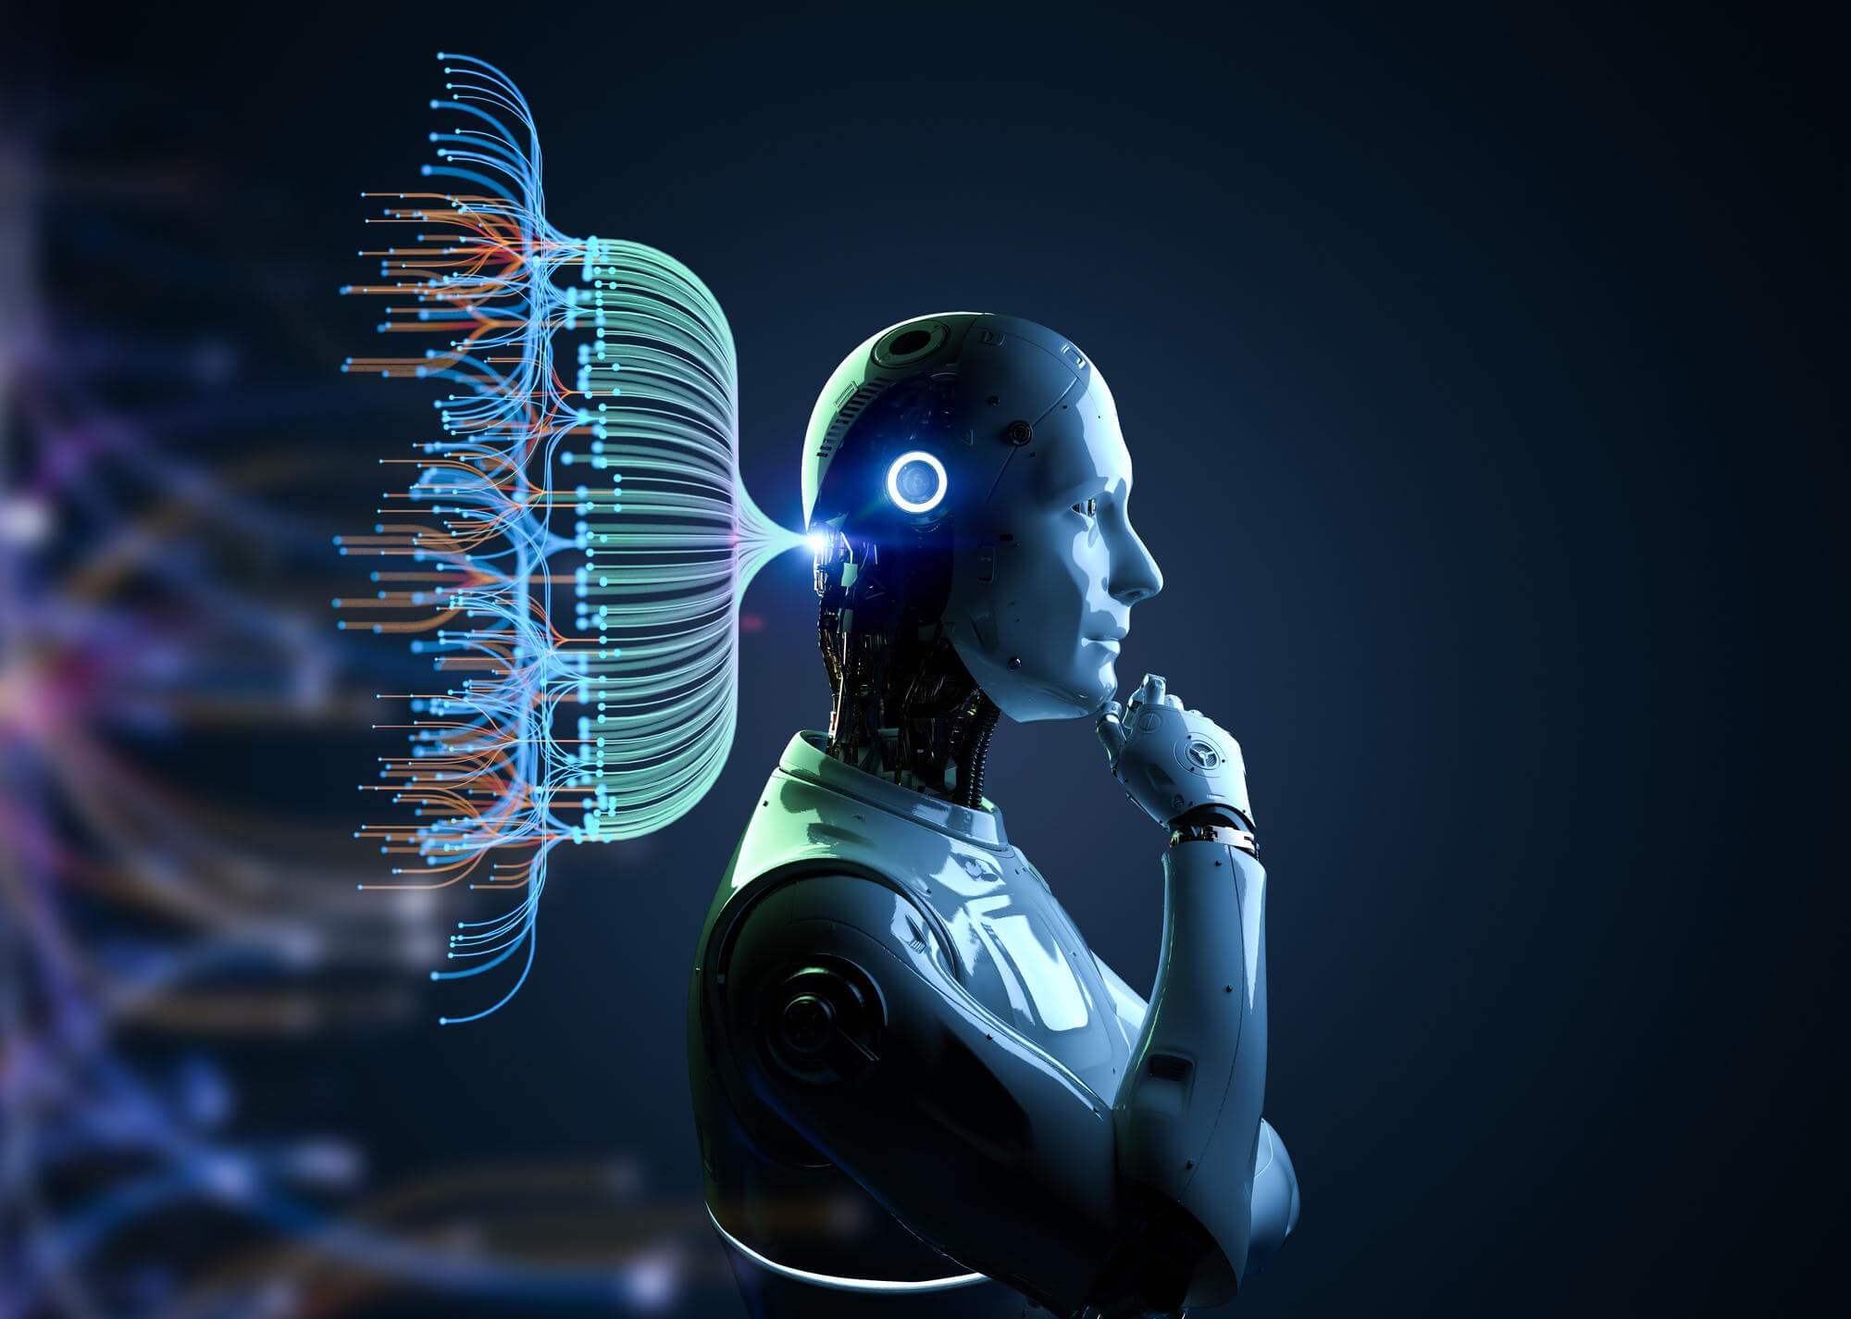
Figure 2 Artificial Intelligence and ICT

Artificial Intelligence, ii, iii, iv
Digital Divide and Cybersecurity, ii, iii
Emerging Technologies, ii, iii
ICT, i, ii, i, ii, iii, iv
Telemedicine, ii, iii

CPU
Control Unit
ALU
Input Unit
Output Unit
Memory Unit
Output Unit
ALU

Meaning of ICT
Importance of Cyber Security

