# Adding Text

1. Add text **between** quotation marks

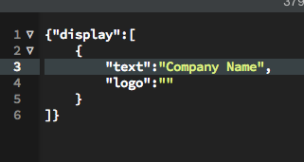

1. Save and refresh page

# Adding an Image

1. Make sure the logo is located in the “**show-me**” directory.  
   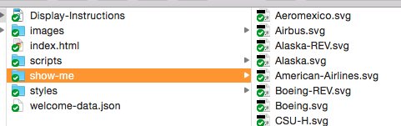
2. Add filename of image **exactly** as it appears on hard drive **between** the quotation marks.  
   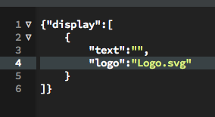
3. Save and refresh page

# Adding more than 1 company

1. Make sure all logos are located in the “show-me” directory.
2. Copy **{"text":"Company Name", "logo":"LOGO-1.svg"}** and paste it after the previous one with a **comma** separating them. Note: The last company section should **NOT** have a comma after it.  
   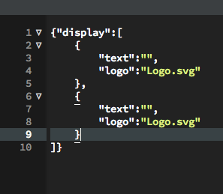
3. Save and refresh page

# No companies

1. Remove all content from between the quotation marks but make sure to **leave the quotation marks** there. It doesn’t matter if there are multiple company sections as long as they all have nothing between the quotations.   
   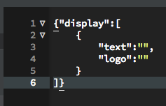  
   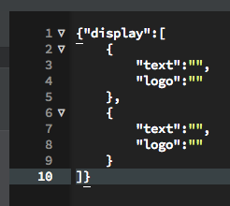
2. Save and refresh page

You can have any combination of text and logos you wish.

* Text and Logo for company(s)
* Text for 1 company and logo for the other
* Only text for company(s)
* Only logos for company(s)

|  |  |
| --- | --- |
| Mac HD:Users:sean.king:Desktop:Screen Shot 2015-07-30 at 12.16.24 PM.png | Mac HD:Users:sean.king:Desktop:Screen Shot 2015-07-30 at 12.15.40 PM.png |
| Mac HD:Users:sean.king:Desktop:Screen Shot 2015-07-30 at 12.16.03 PM.png | Mac HD:Users:sean.king:Desktop:Screen Shot 2015-07-30 at 12.16.17 PM.png |