Dynatrace Observability Enhancement – Technical Solution Design
Oct 11, 2026 · Pradeep Kumar K

Document control
Version 1.0 is issued for client review; sign-off starts Phase 0 (discovery).
Item | Detail
Document | Technical Solution Design – Dynatrace Observability Enhancement
Client | [Client name]
Version | 1.0 (draft for client review)
Audience | Lending business owners, application owners, IT operations, infrastructure, security and compliance
Purpose | Agree how Dynatrace will deliver loan business KPIs and close the 12 gaps found in the current setup
Approver | [Name, role]

1. Executive summary
Dynatrace can show near real-time counts of loan applications, disbursements and collections once 12 monitoring gaps are closed, 4 of them critical.
What the business wants. Hourly, daily and monthly counts of loan applications, disbursements and collections. A clear view of where customers drop out between application and disbursement.
What we found. Dynatrace watches servers and services today, but not what customers experience on web and mobile, and not the loan journey itself. One ActiveGate is a single point of failure. Alerts go to several channels, such as Microsoft Teams and WhatsApp, without clear ownership.
What we propose. Five workstreams, delivered through an indicative 12-week plan (section 12):
- Loan business observability – record each loan step as a Dynatrace business event, then build KPI dashboards, funnel views and business alerts on top.
- Customer experience – Real User Monitoring (RUM) on the web portals and the iOS and Android apps, with user tagging.
- Resilience – a second ActiveGate, so data collection has no single point of failure.
- Governance – one tagging standard, with management zones and segments per application.
- Operations – a unified operations dashboard, end-to-end and infrastructure dashboards, and one alert routing model by severity.
Outcome. Business and IT teams share one view of volumes, conversion, failures and the technical cause behind them. The loan systems stay the system of record for financial reporting; Dynatrace provides operational visibility.

2. Business requirements and scope
Three counts drive this design: loan applications, disbursements and collections, each viewed hourly, daily and monthly with trends.
ID | Requirement | Source
BR-01 | Count of loan applications submitted, hourly, daily and monthly, with trend | Client requirement
BR-02 | Count of loans disbursed, hourly, daily and monthly, with trend (amount optional) | Client requirement
BR-03 | Count of loan collections, successful and failed, hourly, daily and monthly (amount optional) | Client requirement
BR-04 | Funnel from application to disbursement, with conversion and drop-off at each step | Gap assessment (G-06)
BR-05 | Breakdown of all counts by channel, product and region | Gap assessment (G-04, G-09)
BR-06 | Alerts when loan volumes drop or failure rates rise abnormally | Recommended
In scope
- Dynatrace configuration: business events, OpenPipeline processing, dashboards, Business Flow, alerting, web and mobile RUM, ActiveGate high availability, tagging, management zones and segments.
- Implementation guides, code snippets and validation support for the web, mobile and backend teams.
- Production, plus one pre-production (UAT) environment for testing.
Out of scope
- Code changes and app store releases in client applications; application teams own these, with our guidance.
- Financial, regulatory or audit reporting; the loan systems remain the system of record.
- License procurement and commercial changes.
- Applications outside the agreed inventory.

3. Current state and gap assessment
The assessment found 12 gaps: 4 critical, 6 high, 1 medium and 1 low. All 4 critical gaps block customer or business visibility.
Current state
- Dynatrace monitors infrastructure and application services today.
- One ActiveGate routes data and runs extensions.
- Infrastructure dashboards exist, without trend or capacity views.
- Management zones exist but do not follow application boundaries.
- Alerts reach several channels, including Microsoft Teams and WhatsApp.
Priority definitions
- Critical – blocks a business requirement or leaves a customer channel unmonitored; addressed first.
- High – material risk to resilience, operations or governance.
- Medium – improves day-to-day operational efficiency.
- Low – enhancement to an existing capability.
Gap register
ID | Area | Finding | Priority | Business impact | Recommendation
G-01 | Deployment & infrastructure | Only one ActiveGate routes data and runs extensions | High | Single point of failure: losing it can stop data collection, synthetic monitoring, cloud integrations and extensions | Deploy at least two ActiveGates in a high-availability setup (§8)
G-02 | Applications | Web applications are not configured for the banking portals | Critical | No end-user view of portal performance, user behavior or business transaction flows | Create a Dynatrace web application per portal and business domain (§6)
G-03 | Applications | Real User Monitoring is not enabled for web applications | Critical | No data on user experience, page performance, JavaScript errors or customer journeys | Enable and validate RUM on all customer-facing portals (§6)
G-04 | Applications | User tagging is not configured | High | Users cannot be segmented by channel, region, customer type or journey | Configure user tagging and session properties (§6)
G-05 | Mobility | iOS and Android apps are not instrumented with the Dynatrace mobile agent | Critical | Little visibility of crashes, app start time, network issues and mobile customer experience | Instrument both apps with the Dynatrace mobile SDK; guides and scripts shared with app teams (§7)
G-06 | Dashboards & reporting | No funnel dashboards for loan applications, disbursements and collections | Critical | Conversion and process efficiency cannot be measured | Build funnel views and dashboards from business events (§5, §10)
G-07 | Dashboards & reporting | No end-to-end performance dashboards | Medium | Operations lacks one view across applications, services, APIs, infrastructure and databases | Create application and platform dashboards: response time, throughput, errors, resource use (§10)
G-08 | Dashboards & reporting | Infrastructure dashboards need enhancement | Low | Limited trend and capacity insight for infrastructure | Add utilization trends, forecasts and capacity metrics (§10)
G-09 | Dashboards & reporting | No business KPI dashboards for loan applications, disbursements and collections | High | Business stakeholders cannot track volumes or trends in real time | Build business dashboards with hourly, daily and monthly views and trends (§5, §10)
G-10 | Dashboards & reporting | No central dashboard for operational issues | High | Troubleshooting spans many screens, which slows incident resolution | One operations dashboard for problems, failures, alerts, service health and key KPIs (§10)
G-11 | Configuration & governance | Management zones are not aligned with applications | High | Governance, access control, reporting and ownership are hard to manage | Define application-level tags, management zones and segments, so dashboards, access and alerts filter by application (§9)
G-12 | Alerting | Alerts are not tuned and go to several channels, such as Teams and WhatsApp | High | Alert fatigue and risk of missed incidents | One routing model by severity and owner, tuned thresholds, one primary channel per severity (§11)

4. Target solution overview
The target design adds four things to the existing Dynatrace tenant: business events for each loan step, real user monitoring on web and mobile, a resilient ActiveGate pair, and one governance and alerting model.
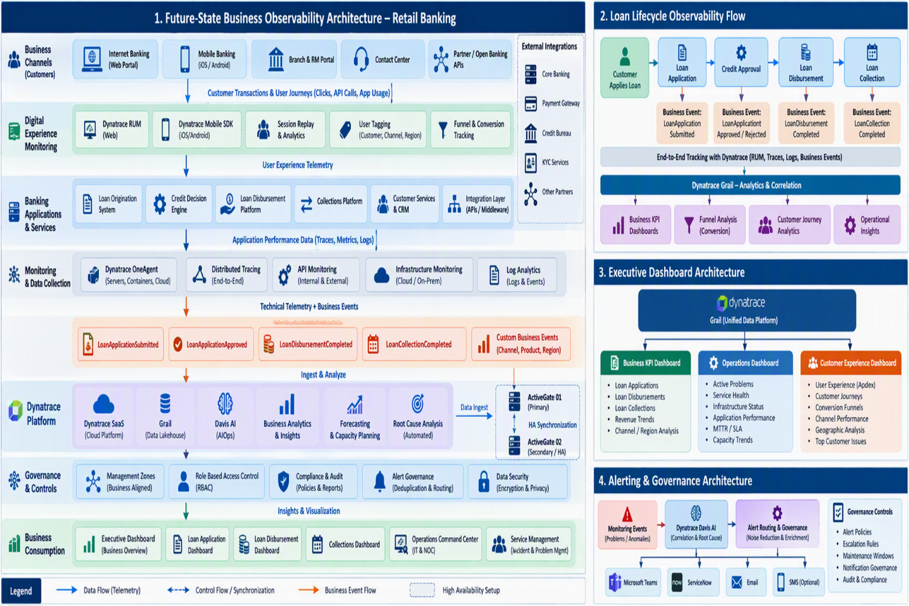
Figure 1. Future-state business observability architecture

5. Loan business observability
Each loan step is recorded once as a Dynatrace business event, linked by the loan application ID. Every count, funnel and business alert is built from these events (BR-01 to BR-06; G-06, G-09). Panel 2 of the architecture template in §4 shows the journey.

5.1 Event catalogue
Step | Event type | Typical source | Recommended capture | Feeds
Application started | LoanApplicationStarted | Web portal or mobile app | RUM business event | Funnel entry and drop-off
Application submitted | LoanApplicationSubmitted | Loan origination service API | OneAgent capture rule | BR-01
Credit decision | LoanApplicationApproved, LoanApplicationRejected | Loan origination or credit decision service | OneAgent capture rule | BR-04
Loan disbursed | LoanDisbursementCompleted, LoanDisbursementFailed | Loan management or payment service | OneAgent capture rule; API ingest for batch payouts | BR-02
Repayment collected | LoanCollectionCompleted, LoanCollectionFailed | Collections service, payment gateway or batch file | API ingest or log extraction | BR-03
Event names follow the architecture template, so each outcome has its own event type. The final source and method for each event are confirmed with the application teams in Phase 0.
Standard attributes. Every event carries these as top-level fields; nested JSON objects are stored as text, so attributes stay flat.
Attribute | Example | Purpose
event.provider | loan-origination | Source system
loan.application_id | APP-000123 | Correlation ID linking all steps (mandatory)
loan.txn_id | DSB-778812 | Unique reference for the step, used to remove duplicates
loan.failure_reason | DOCS_PENDING, BANK_REJECTED | Reason code on rejected and failed events
loan.product | PERSONAL, HOME | Product split
loan.channel | WEB, MOBILE, BRANCH | Channel split
loan.region | SOUTH | Region or branch split
loan.payment_mode | AUTO_DEBIT, ONLINE | Collections only
loan.amount | 250000 | Optional: amount applied, disbursed or collected
loan.txn_time | 2026-10-11T10:42:00Z | Optional: business time of the step, for batch events
Customer names, phone numbers, email addresses, national ID numbers, and account or card numbers are never captured.

5.2 Capture methods
Method | How it works | Code change | Best for
OneAgent capture rules | OneAgent reads named fields from the JSON or XML payload of a matching request and creates the event | None | Online steps on a monitored service: submit, decision, disbursement
Business events API | The system or batch job posts events to /api/v2/bizevents/ingest as JSON or CloudEvents (5 MB per request) | Small | Batch steps such as collection files; systems without OneAgent
Log extraction | An OpenPipeline rule turns matching log lines into business events | None, if logs already reach Dynatrace | Systems that log each transaction with its ID and status
RUM business events | The page or app sends an event through the RUM JavaScript API or mobile SDK | Small | Front-end-only steps, such as application started
- OneAgent capture needs Full-Stack Monitoring on the host and a supported runtime: Java, .NET, Node.js, Go, or Apache, NGINX and IIS web servers. The application process restarts once after enabling. Rules can be scoped to a host group.
- Default safeguards are about 100 capture rules per environment and about 64 KiB of captured body; larger payloads use API ingest.
- Official counts come only from server-side methods. RUM events show funnel entry and drop-off, because browsers and phones can block or lose events.

5.3 Processing, storage and access
- Pipeline. A dedicated OpenPipeline pipeline for loan events masks or drops any field outside the agreed list, normalizes values, and adds the business date in the bank's time zone.
- Metrics. The pipeline extracts counter and value metrics: counts and amounts by step, outcome, channel and product. Metrics are kept for 15 months by default and keep dashboards and alerts fast.
- Bucket. Loan events go to a dedicated Grail bucket. The default business events bucket keeps 35 days; a custom bucket can keep 1 day to 10 years. Proposed: 13 months, to compare with the same month last year (to confirm with compliance and cost).
- Access. IAM policies limit the bucket to named business and support groups.

5.4 KPI definitions
KPI | Definition | Source events | Views
Applications submitted | Distinct application IDs submitted | LoanApplicationSubmitted | Hourly, daily, monthly; by channel, product, region
Approval rate | Approved ÷ (approved + rejected) applications | LoanApplicationApproved, LoanApplicationRejected | Daily, monthly
Loans disbursed | Distinct completed disbursements; amount optional | LoanDisbursementCompleted | Hourly, daily, monthly
Application-to-disbursement conversion | Disbursed ÷ submitted, per application cohort | LoanApplicationSubmitted and LoanDisbursementCompleted, joined on application ID | Daily, monthly
Turnaround time | Median and 90th percentile, submission to disbursement | LoanApplicationSubmitted and LoanDisbursementCompleted | Daily, monthly
Collections | Distinct completed collections; amount optional | LoanCollectionCompleted | Hourly, daily, monthly
Collection success rate | Completed ÷ (completed + failed) collections | LoanCollectionCompleted, LoanCollectionFailed | Daily, monthly; by payment mode
Top failure reasons | Most frequent reason codes per step | LoanApplicationRejected, LoanDisbursementFailed, LoanCollectionFailed | Daily
Count accuracy rules
- Count distinct business references with countDistinctExact, so retries are not counted twice. Above 1 million distinct values per query, use the extracted metrics instead.
- Count only final outcomes, not intermediate API calls.
- Daily and monthly views use the bank's time zone and business-day cut-off, so totals line up with system-of-record reports.
- Batch events carry their business time (loan.txn_time), so late files land on the right business date.
- During hypercare, daily counts are reconciled against the loan system's reports; every difference is explained before sign-off.

5.5 Funnel and journey tracking
- The Business Flow app models the origination journey as steps joined by loan.application_id. It reports completed flows (conversions), average completion time, business exceptions and one business KPI, such as amount disbursed.
- Approved and rejected paths are branches. Limits: 20 nodes per flow, 5 branches per step, 5 events per step.
- The flow is registered as an entity, so Dynatrace problems show which loan process they affect.
- Collections repeat every month, so they are tracked on the KPI dashboard rather than in the origination funnel.
- Business Flow alerting works only for flows that average under 30 minutes. Loan journeys take days, so alerts use the step-level custom alerts below.

5.6 Business alerts (BR-06)
Alert | Logic | Example
Volume drop | Seasonal baseline on 1-minute counts per step | Submissions far below the usual level for that hour
Failure-rate spike | Static threshold on the failure share per step | Disbursement failures above the agreed percentage
No events | No loan events for an agreed period in business hours | A broken capture rule or a real outage
These are custom alerts in the Anomaly Detection app, built on DQL time series at a 1-minute interval. They follow the routing model in §11; business owners set the thresholds.

6. Web experience monitoring
Each banking portal gets its own Dynatrace web application with Real User Monitoring (RUM) and user tagging, closing G-02, G-03 and G-04.

6.1 Web applications
- One web application per portal and business domain, such as internet banking, the loan portal and the repayments portal. The final list comes from the portal inventory (§13).
- Detection rules by domain or URL pattern keep production and pre-production apart.
- New frontends use the New RUM Experience, which stores data in Grail next to business events and is generally available on SaaS tenants. Existing classic RUM settings can be upgraded per frontend.

6.2 RUM configuration
Item | Design
Injection | Automatic through OneAgent on the server that delivers the HTML; JavaScript snippet for portals on a CDN or third-party host
Key interactions | Consistent names for loan steps, such as Apply for loan, Upload documents, Submit application and Pay installment
Errors | JavaScript and request errors captured; known noise filtered out
Front-to-back tracing | Each API allows Dynatrace's trace headers in its CORS settings, so browser requests link to backend traces
Session Replay | Optional; only with all inputs masked and after security approval
Synthetic (recommended) | Keep existing monitors; add a browser clickpath on the loan application journey to catch out-of-hours failures

6.3 User tagging and session properties
- User tag. A non-personal customer reference, such as a hashed customer ID, set with the RUM JavaScript API (dtrum.identifyUser) after login. The same call works in the New RUM Experience.
- Session properties. Channel, customer type (new or existing), region, product of interest, language and app version.
- Link to business events. Where privacy rules allow, the loan application ID is added as a property, connecting a session with its loan events.
- Properties are defined in Dynatrace before capture and are billed per property per session, so only agreed properties are added.

7. Mobile app monitoring
Both mobile apps get the Dynatrace mobile agent in their next scheduled release, closing G-05.
Platform | Instrumentation
Android | Dynatrace Android Gradle plugin; instruments app start, user actions, web requests and crashes at build time
iOS | Dynatrace iOS agent added to the Xcode project; covers the same areas automatically
Cross-platform | Dynatrace plugins for React Native, Flutter, Cordova, Xamarin and .NET MAUI, if the apps use one of these frameworks
Configuration
- The same hashed customer reference as web, set with identifyUser.
- Named actions for key loan steps: apply, upload documents, e-sign and pay installment.
- Business events from the app for front-end-only steps, such as application started.
- Crash reporting and app start metrics on by default; app requests carry W3C trace headers, so actions link to backend traces.
- User opt-in mode where the consent policy requires it; until the customer agrees, no monitoring data is sent.
Delivery approach
- We create the mobile app entries in Dynatrace and give each app team the configuration file, a setup guide and a validation checklist.
- App teams add the agent on a feature branch; we validate a UAT build together.
- The agent ships in the next scheduled store release, with a staged rollout where the store allows it.
- We confirm sessions, crashes and actions in production, then close G-05.

8. ActiveGate high availability
A second Environment ActiveGate removes today's single point of failure; each ActiveGate role then fails over automatically (G-01).
ActiveGate role | How high availability works
OneAgent traffic routing | Both ActiveGates join the same network zone. OneAgents use an ActiveGate in their zone and switch automatically if it stops; alternative zones and the "any ActiveGate" fallback add further routes.
Extensions | Monitoring configurations are assigned to an ActiveGate group holding both ActiveGates. One member runs each configuration; if it stops, another member takes over.
Private synthetic locations | If used, each private location needs its own synthetic-enabled ActiveGates, which run synthetic monitors only. Dynatrace recommends at least two per location for failover.
Other ActiveGate integrations | Reviewed one by one (for example VMware or cloud integrations) and placed so that losing one ActiveGate does not stop them.
Build and placement
- Separate hosts, ideally on different hypervisors or availability zones.
- Sized so either ActiveGate can carry the full load alone.
- Firewall: OneAgents reach the ActiveGates on port 9999; ActiveGates reach the Dynatrace tenant on port 443 and extension targets on their own ports.
- An alert fires if either ActiveGate disconnects.
Validation. In an approved change window, stop one ActiveGate and confirm that OneAgents reconnect, extensions keep reporting and no data gap appears. Then repeat for the other ActiveGate.

9. Governance: tagging, management zones and segments
One tagging standard drives every filter: dashboards, access, alert routing and reports all select data by application, environment and owner (G-11).
Tag | Example | Used for
app | loan-origination | Segments, dashboard filters, alert routing
env | prod, uat | Separating production from test
domain | lending | Business-level views
owner | los-support | Alert routing and ownership
tier | 1, 2, 3 | Alert severity
- Source. Tags are set where the data starts: OneAgent host groups and host tags, Kubernetes labels and cloud tags. Auto-tagging rules cover services and process groups. In the latest Dynatrace they surface as primary Grail tags (primary_tags.*), used by segments, IAM and workflow filters.
- Segments. One segment per dimension, not one per old zone; for example, app = loan-origination and env = prod, combined as needed. Segments integrate with IAM access control.
- Management zones. Kept only where classic features still need them, rebuilt from the same tags, one per application and environment. Segments keep classic compatibility until those features are retired.
- Access. IAM policies give each team its own applications and Grail buckets.
- Coverage. Before any old zone is retired, at least 95% of signals must carry the mandatory tags. A quarterly review adds new applications to the standard.

10. Dashboards and reporting
Five dashboards serve four audiences and close G-06 to G-10.
# | Dashboard | Audience | Key content | Gaps
D1 | Loan business KPIs | Business heads, product and operations | Applications, disbursements and collections for today, this month and trend; hourly, daily and monthly views; comparison with the previous period; splits by channel, product and region; top failure reasons | G-09
D2 | Loan funnel and journey | Product, business operations and digital teams | Conversion and drop-off per step, approval rate, turnaround time; drill-down to one application in Business Flow | G-06
D3 | Unified operations | Operations, support and incident managers | Open problems by application and severity, affected business KPIs, service health, synthetic availability, ActiveGate and agent health | G-10
D4 | End-to-end application performance, one per application | Application and platform teams | Front end (experience scores, key interactions, errors), services and APIs (response time, throughput, failure rate), databases and hosts, with drill-down to traces | G-07
D5 | Infrastructure capacity and trends | Infrastructure and capacity teams | Utilization trends over 30 and 90 days, Davis AI forecasts, headroom and top consumers | G-08
Dashboard standards
- Built in the new Dashboards app on Grail, with segment filters and variables for application and environment.
- Named <Domain> – <Dashboard> – <Env>, with the owner shown on each dashboard.
- Business dashboards read extracted metrics where possible, which keeps them fast and limits query cost.
- Each dashboard is reviewed with its audience before sign-off.

11. Alerting and notification design
Proposed: every alert has one owner and one primary channel set by severity, replacing today's mix of channels (G-12).
Severity and routing matrix (proposed; agreed in Phase 0)
Severity | Examples | Primary channel | Also informed
P1 Critical | Loan portal down; disbursements failing above threshold; core service outage | ServiceNow incident (auto-created) and on-call paging | Operations Teams channel
P2 High | Slowdown on a key interaction; error spike on a loan API | ServiceNow incident | Application team's Teams channel
P3 Medium | One host saturated; non-critical service degraded | Application team's Teams channel | Daily email digest
P4 Low | Capacity warnings; non-production issues | Dashboard and weekly report | None
Where WhatsApp or SMS escalation is required for P1, the incident or on-call tool sends it, not Dynatrace, so there is one record and one escalation path.
Implementation
- Dynatrace Workflows with a Problem trigger replace classic alerting profiles and problem notifications. One workflow can hold the filters of several classic profiles, with no one-zone-per-profile limit.
- Triggers fire on problems, not raw events, so related alerts arrive as one notification. They filter on the tags in §9 and wait for root cause analysis.
- Connectors: ServiceNow, Microsoft Teams and email. A service user runs each workflow, so routing does not break when a person leaves.
- Each notification carries what and where, severity, business impact, owner, start time, problem link and runbook link. Open and close are both sent.
- Problems inside maintenance windows are filtered out.
Tuning plan
- Review 30 to 60 days of problems and notifications; list noisy, duplicate, flapping and unused alerts.
- Tune anomaly detection thresholds and sensitivity; prefer automatic baselines for key services.
- Use maintenance windows for planned changes and patching.
- Keep non-production out of P1 and P2 routing.
- Add the business alerts from §5.6.
- Run old and new routing side by side for at least one full business cycle (proposed: two weeks); switch off the old channels once volumes match.
- Review alert quality monthly: volume, false positives and time to acknowledge.

12. Implementation plan
An indicative 12-week plan in six overlapping phases, with three sign-off gates; mobile go-live follows the app release calendar.
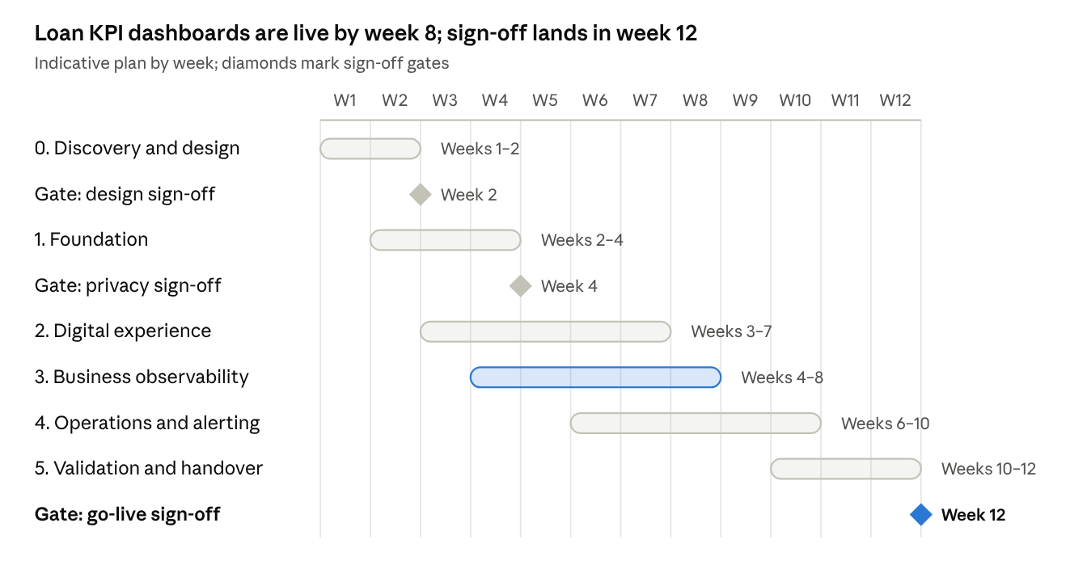
Figure 2. Implementation roadmap: 6 phases, 3 gates
Phases overlap: business observability starts in week 4, and mobile go-live follows the app release calendar.
Phase | Key activities | Gaps closed | Exit criteria
0. Discovery and design sign-off | Workshops on loan steps, IDs, payloads, privacy rules, portal and app inventory and the alert matrix; consumption estimate | None | Design and event catalogue signed off
1. Foundation | Second ActiveGate and failover test; tagging standard; segments, zones and IAM; alert baseline review | G-01, G-11 | Failover test passed; mandatory tags on in-scope entities
2. Digital experience | Web applications, RUM and user tagging (UAT, then production); mobile guides; app teams build and test | G-02, G-03, G-04, G-05 | RUM live on all portals; mobile agent in a release build
3. Business observability | Capture rules, API and log sources; OpenPipeline and bucket; KPI dashboard; Business Flow; business alerts | G-06, G-09 | Events flowing for all five steps in production
4. Operations and alerting | Unified operations, end-to-end and infrastructure dashboards; new alert routing in a parallel run | G-07, G-08, G-10, G-12 | Old alert channels switched off
5. Validation and handover | Count reconciliation; UAT and business sign-off; runbooks; training; two weeks of hypercare | All | Acceptance criteria in §15 met

13. Roles, responsibilities and client inputs
Delivery involves six parties, and the client inputs below are needed in Phase 0 to hold the plan.
Party | Responsibilities
Dynatrace team | Design, Dynatrace configuration, dashboards, alerting, guides and scripts, validation and training
Application teams (web, mobile, loan systems) | Confirm payloads and IDs; make the small code changes (mobile agent, user tag, API events); test in UAT
Infrastructure and network | Server for the second ActiveGate; firewall rules; change windows
Security and compliance | Approve the privacy design, retention, consent approach and Session Replay decision
IT operations and ITSM | Agree the severity matrix and owners; ServiceNow and Teams integration; on-call setup
Business owners (lending) | Agree KPI definitions and alert thresholds; sign off dashboards
Client inputs needed in Phase 0
- ☐ Inventory of portals (URLs), mobile apps (platform, framework, release dates), loan services, APIs and batch jobs
- ☐ Masked sample request and response payloads for each loan API, and sample log lines for batch steps
- ☐ Agreed correlation ID and how it maps across systems
- ☐ Privacy decisions: field list, masking, consent model, Session Replay yes or no
- ☐ Server for the second ActiveGate, with firewall approvals
- ☐ Dynatrace admin access, ServiceNow integration details, Teams channels and webhooks
- ☐ Alert routing matrix with owners and on-call groups
- ☐ Approval of the consumption estimate
- ☐ Mobile release slots

14. Assumptions, risks and mitigations
The design rests on four assumptions; the main delivery risks and their mitigations follow.
Assumptions
- Dynatrace SaaS on a Dynatrace Platform Subscription (DPS) with Grail. Business events, OpenPipeline, Business Flow, the New RUM Experience and the new Dashboards depend on it; a Managed or classic-licensed tenant needs a revised design.
- OneAgent runs in Full-Stack mode on the loan application hosts and containers.
- Each loan step's outcome is visible in an API payload, a log line or a batch file.
- Application teams have capacity for the small code changes in this plan.
Risks
Risk | Impact | Mitigation
Personal data reaches Dynatrace | Compliance breach | Field allow-list at capture; OpenPipeline masking; security review before production
IDs differ across systems | Funnel cannot link the steps | Agree the correlation ID in Phase 0; systems that only know the loan account also emit the application ID
Mobile release slips | G-05 closes late | Instrument in the next release; validate early in UAT
Consumption above budget | Unplanned cost | Estimate in Phase 0; metrics-first dashboards; budget alert
Counts differ from the system of record | Loss of trust in the dashboards | Accuracy rules (§5.4); daily reconciliation during hypercare
API payload changes break capture rules | Silent drop in counts | No-events alert (§5.6); capture-rule check in the release checklist
New alert routing misses an alert | Delayed response | Parallel run before old channels are switched off

15. Acceptance criteria and next steps
The work is accepted when every requirement and gap below meets its criterion.
Area | Acceptance criterion
Business KPIs (BR-01 to BR-03) | D1 shows hourly, daily and monthly counts for applications, disbursements and collections. Daily counts match the loan system's reports over an agreed validation period (proposed: 10 business days), or each difference is explained.
Funnel (BR-04) | Conversion, drop-off and turnaround time shown per step, with drill-down to one application ID
Breakdown (BR-05) | All counts filter by channel, product and region
Business alerts (BR-06) | Volume-drop, failure-rate and no-events alerts tested in UAT
Web RUM (G-02 to G-04) | All in-scope portals report sessions, interactions and errors; user tag present on logged-in sessions
Mobile (G-05) | iOS and Android report sessions, crashes and app start in production
ActiveGate HA (G-01) | Failover test passed with no data gap
Governance (G-11) | Mandatory tags on in-scope entities; dashboards and alerts filter by application
Dashboards (G-06 to G-10) | D1 to D5 delivered and signed off by their audiences
Alerting (G-12) | Routing matrix live; each alert has one owner and one primary channel; notification volume below the agreed target
Next steps
- ☐ Review this design and confirm scope and priorities
- ☐ Schedule the Phase 0 discovery workshops
- ☐ Share the Phase 0 inputs listed in §13
- ☐ Approve the consumption estimate and the plan

Appendix
Reference material for the build teams: an example event, sample queries, a glossary and the Dynatrace pages behind this design.

A. Example business event (API ingest)
{
"specversion": "1.0",
"id": "5f0c9a3e-1d2b-4c7a-9e11-2b7d3c4a9f10",
"source": "loan-management",
"type": "LoanDisbursementCompleted",
"time": "2026-10-11T10:42:00Z",
"data": {
"loan.application_id": "APP-000123",
"loan.txn_id": "DSB-778812",
"loan.product": "PERSONAL",
"loan.channel": "MOBILE",
"loan.region": "SOUTH",
"loan.amount": 250000
}
}
Sent with POST /api/v2/bizevents/ingest and Content-Type: application/cloudevent+json. Dynatrace maps source to event.provider, type to event.type and id to event.id.

B. Sample DQL queries
Illustrative only; production versions add segment filters and the agreed bucket.
B1. Hourly successful counts per step, last 24 hours
fetch bizevents, from: now()-24h
| filter in(event.type, array("LoanApplicationSubmitted", "LoanDisbursementCompleted", "LoanCollectionCompleted"))
| makeTimeseries count = count(), by: { event.type }, interval: 1h
B2. Daily distinct counts by business day, last 30 days. The time zone is an example; use the bank's own. For batch events, group on loan.txn_time instead of timestamp.
fetch bizevents, from: now()-30d
| filter in(event.type, array("LoanApplicationSubmitted", "LoanDisbursementCompleted", "LoanCollectionCompleted"))
| fieldsAdd business_day = formatTimestamp(timestamp, format: "yyyy-MM-dd", timezone: "Asia/Kolkata")
| summarize count = countDistinctExact(loan.txn_id), by: { business_day, event.type }
| sort business_day asc
B3. Period funnel, last 30 days. Business Flow gives the per-application cohort view.
fetch bizevents, from: now()-30d
| filter in(event.type, array("LoanApplicationSubmitted", "LoanApplicationApproved", "LoanApplicationRejected", "LoanDisbursementCompleted"))
| summarize
submitted = countIf(event.type == "LoanApplicationSubmitted"),
approved = countIf(event.type == "LoanApplicationApproved"),
rejected = countIf(event.type == "LoanApplicationRejected"),
disbursed = countIf(event.type == "LoanDisbursementCompleted")
| fieldsAdd approval_rate_pct = round(100.0 * approved / (approved + rejected), decimals: 1),
disbursal_rate_pct = round(100.0 * disbursed / approved, decimals: 1)
B4. Custom alert input: submissions per minute. No from or to; the Anomaly Detection app sets the window.
fetch bizevents
| filter event.type == "LoanApplicationSubmitted"
| makeTimeseries submissions = count(default: 0), interval: 1m

C. Glossary
Term | Meaning
ActiveGate | Dynatrace component that routes monitoring traffic and runs remote checks and integrations
Business event | A record of one business step, such as a loan disbursed, with its details
Business Flow | Dynatrace app that links business events into an end-to-end process view
Davis AI | Dynatrace's built-in AI for anomaly detection and root cause analysis
DPS | Dynatrace Platform Subscription, the consumption-based license
DQL | Dynatrace Query Language, used to query stored data
Grail | Dynatrace's data store for logs, events, metrics and traces
Management zone | Classic Dynatrace grouping of monitored entities for access and filtering
OneAgent | The Dynatrace agent installed on servers and containers
OpenPipeline | Dynatrace processing layer that filters, masks and enriches data as it arrives
RUM | Real User Monitoring: what real customers experience in the browser or app
Segment | Filter model of the latest Dynatrace, built from tags and attributes
Session Replay | Masked, video-like replay of a user session
Workflow | Dynatrace automation that routes alerts and runs actions

D. References
Dynatrace documentation used for this design, checked on 11 October 2026:
- Get business events via OneAgent
- Ingest business events via API
- Business Flow
- How to organize your data stored in Grail
- DQL aggregation functions
- Anomaly Detection DQL writing guide
- Private Synthetic locations
- Best practices for upgrading management zones to segments
- Upgrade from Classic problem notification to simple workflows
- Dynatrace pricing rate card

