Devuan Conference
10 April 2019, Amsterdam
Last weekend (5th -7th of April) took place the first ever conference for the free and open source operating system Devuan GNU+Linux.
The conference took place in Amsterdam in one of the rooms of a building that is floating on the water and looks a lot like an anchored submarine. This white submarine gives home to offices of Dyne.org, a non-profit foundation dedicated to free software, art and sustainability. Developers at Dyne.org adopted Devuan in the EU funded project DECODE and for the next two years will also be mentoring a public fund for F/OSS developers: the "venture builder for human-centric solutions" (LEDGER project).

From so far to so close
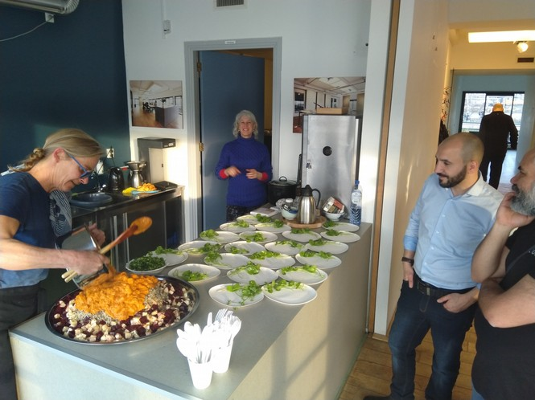
There were tables, a couch and a kitchen with food provided by chef Renate from URBANIA HOEVE, an organisation founded by artist Debra Solomon and dedicated to making urban food forests in the public space.

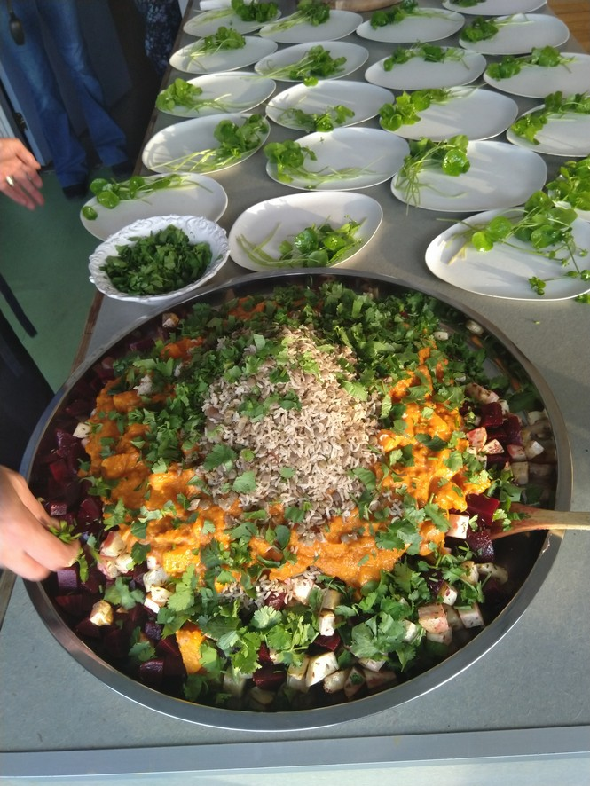
And then views of water, sun and loads of positive energy. Each day was filled with a lot of interesting speakers and intermittent hack sessions where participants got the chance to exchange ideas, share knowledge and plan future steps regarding their role in the open source community. It is overwhelming to watch people that put their time and energy in sustaining the community, expanding their knowledge and tackle innovative ideas for fun. Most of them saw the faces behind the avatars used to identify themselves online for the first time. What a feeling must have been to see a lady that is providing community support and is also a former Buddhist monk dressed up completely in yellow coming all the way from USA.
Or to talk to a tall blue-eyed and warmhearted man that has a company selling speech driven media devices for blind people in the UK, that came all the way from Australia just to meet the crowd. There was an omnipresent feeling that all the people attending the conference were super heroes finally being able to put on their suits. That same tall blue-eyed man from Australia is actually from Sweden and has been living in Australia for 25 years with his wife because of the nice weather. He was working in an Australian institute for artificial intelligence in the early 90s, but, because the system got the strong hierarchy in place, he decided to fly solo. In his words open source is important because: “it is keeping the knowledge.” Especially for newcomers and young people.
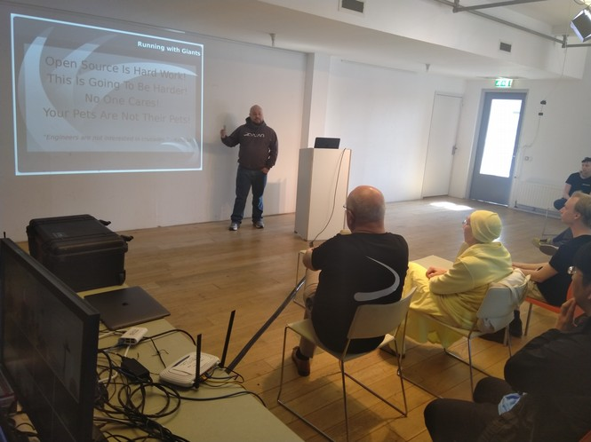

Would you like an Apple?
Knowledge was certainly one of the most important ingredients of the first Devuan Conference. There were knowledgeable technology connoisseurs like a former Apple employee who retired just a month ago and the first thing he did was to apply for the open source conference that he wasn't allowed to attend during his career. Or a freelance system developer engineer from France that is working for various employees in order to earn enough money so that he can take a year off, finish his init system and potentially make sustainable income working as a designer of new open source solutions.
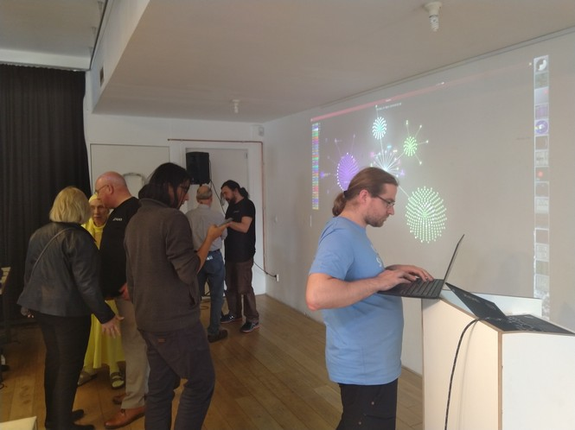
On the other hand conference was also interesting for people just trying to find their place in the community, like a young municipality support engineer from Sweden that would like to incorporate open source software in his systems at work, or a Spanish developer working on numerous tools and support systems as well as his own Devuan based operating system that is learning English and would like to code full time but for the time being is working with CAD/CAMs.

Can we all stop Gophering around?
An abundance of interesting people were trying to participate in mind stretching new ways of using the internet.
One of the progressive minds was a young Devuan wizard that got a hold of his linux OS in elementary school through free Ubuntu copies arriving on his doorstep on an Island in a middle of Croatia, because that is what Free software does. He progressed in his knowledge, met some nice people in the FOSS community, used his last Bitcoins (before the Bitcoins were a thing) to get to Amsterdam and now among other things is working with others on Devuan OS for mobile phones, because :”It’s fun!”
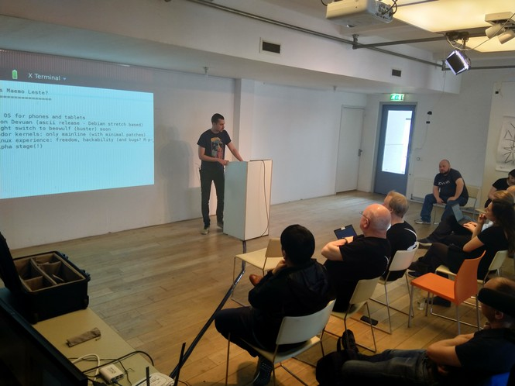
One of the activists of brain and productivity was a numerous PhD holder from Sicily living in London and promoting minimalism. Why would you use flashy web pages when you can save some energy, still share information, minus ads and flashy signs? I do not know.
Another Italian magician with an education in philosophy was trying to explain why we should have the awareness about the gadgets we use and where do the information about our internet searches go while we sleep. Can we protect the data about our internet connections through a little device tracking our digital movements that keeps everything safe from outside introuders?
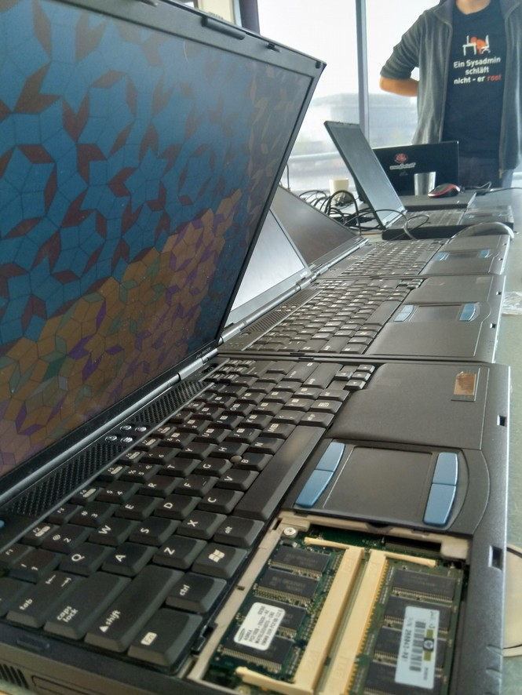
That fisherman looking bridge of consciousness and overall thinker was also managing the streaming and other transmission technology throughout the Conference along with his rock-star looking director friend that among other things won awards during 80s in Greece for his erotic film-making abilities. This lovely duo was walking among technology nerds making sure everything is up to standard.
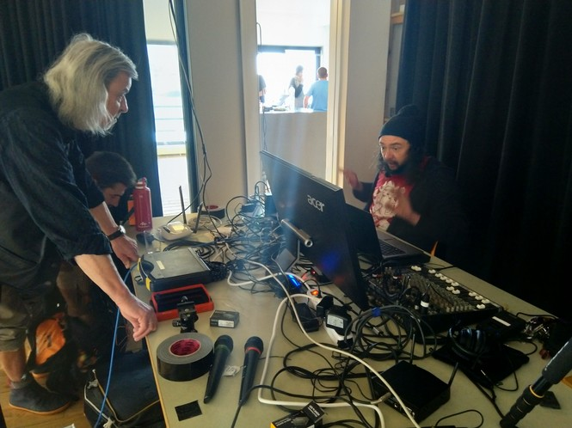

While you’re at it, save your data!
Productivity and minimalism are important, but we should also think about saving our data. Can we create our own Data center?
One of the exciting participants were also the members of Data Center team from Switzerland wearing matching “No systemd” t-shirts. Apparently, systemd sucks. Their founder is a young German citizen saving as much energy, time and space while trying to create a working Data center and going through Swiss naturalization process to become more active on the political scene of the community and maybe help some more. His team was trying to teach us how to make our own Data Center using Devuan, or another operating system that “just works”.
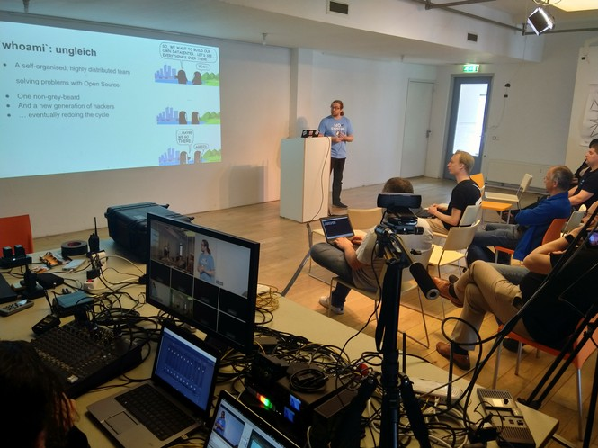
One of their team members was a former Robotics factory employee that had to leave his job, because he did not want to produce robots with a glitch. Having a 3 piston robot that uses a 4 piston robot’s software makes quite a difference in a robot’s world. Even though he insisted, his bosses didn’t twitch to change the glitch, so he had no choice but to leave. The team has also a South Korean citizen remotely working for their company as well as a young musician using Apple for music, Microsoft for playing games and Linux for work. Who says we have to be exclusive. Every software has its use.
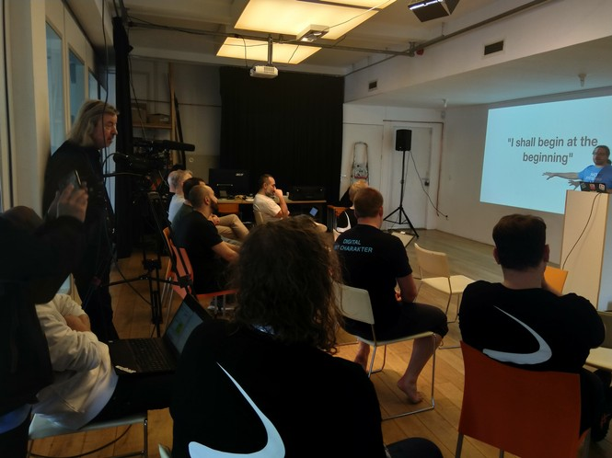

Hack in the class
Maybe the best argument why Devuan and the FOSS community are in good hands is a Dutch technology and programming teacher that is encouraging his students to hack systems. He has explained and shown his students the limits and said to go and play with them. He entered the Linux world in 1995. through Slackware that his Math teacher gave him and he is not backing up. Even though some of his coworkers don't look favorable towards his techniques. That doesn't come as a surprise when you realize that one of his colleagues is a former Bell Labs employee.
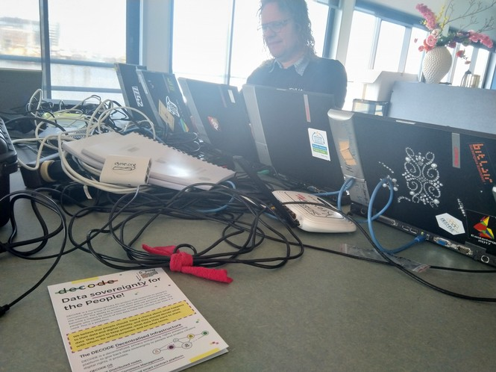
The submarine looking building gave home to an event gathering open source super heroes and all sorts of magical creatures because to quote the first Devuan docsprint in December 2016 from a booklet called ‘Software freedom your way’ : “We must apply thought and attention to software development and we share responsibility, as users and developers of software systems, to foster values of cooperation in the spirit of science, human cultures, and the diversity of life.”
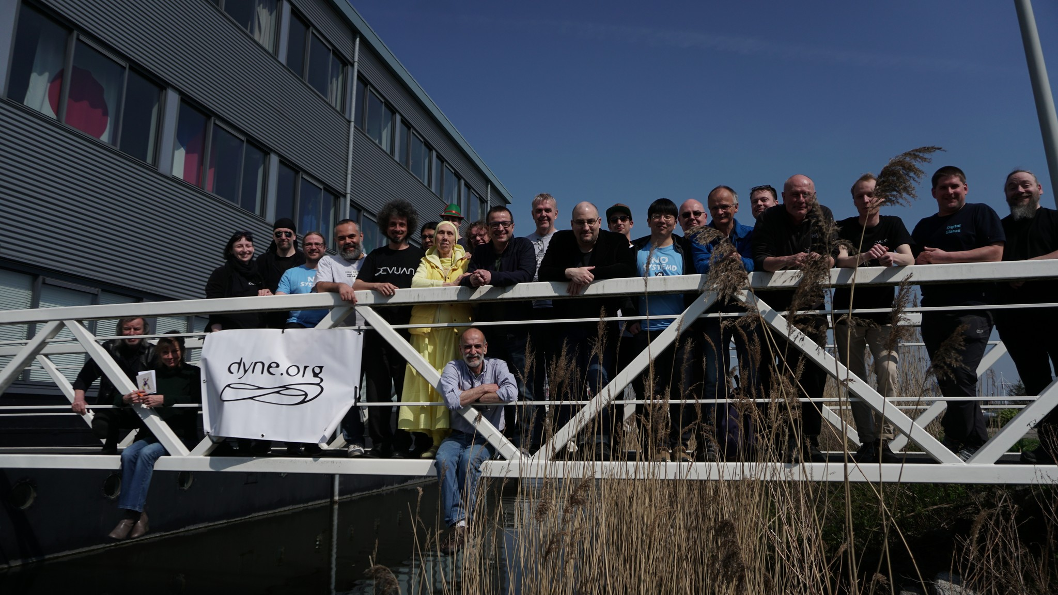
All the stream of presentations is available on the Dyne.org You tube channel, still unedited (audio may be missing in some parts). Final edits will be online soon.

Devuan Conference Day 1

raw video stream day 1
- The Importance of Minimalism and Modularity - by Katolaz
- Demystifying init - by Skarnet
- CI Galore: the Devuan SDK and the Docker Toaster - by Jaromil & Parazyd
- Make Your Own Distro - by Fsmithred

Devuan Conference Day 2

raw video stream day 2
- hacking session in the morning: "Devuan with s6 and s6-rc" - by Skarnet
- Running a Devuan data center - by Nico & the Datacenterlight crew
- Maemo Leste - by Parazyd
- Competing with Giants: How to Sell Devuan to Your Company - by Linux O'Beardly
- Dowse: the Rod for Local Area Network Awareness - by Fredd & the Dyne.org crew

In addition to all the Devuan community members we would like to thank Elena, Manuela, Aspasia, Fredd, Viktor, Tarek, Debra, Renate and Myrthe for their help producing this event, the soul food and the documentation materials.

